RUTLAND NATURAL HISTORY SOCIETY 2019

AMPHIBIAN AND REPTILE REPORT Recorder: Dr Charles Gallimore

Amphibian records were fewer than usual and spawning of frogs in particular seemed restricted, probably due to the very wet weather which made some usual sites unsuitable. The usual examination of the ponds on the Rutland Water Nature Reserve was impeded by the high water level in most ponds.
It is the fourth year in succession with no Slow Worm records which is a bit worrying. Grass Snakes appear to be thriving (when not ending up as road casualties). The Bisbrooke record is only the second from that parish, the previous report being in 1997, and the Teigh record was the first since 1960, while there have been no previous records from Glaston.

Common Frog Rana temporaria

Frogs were recorded at 14 sites in seven parishes (Barrowden, Exton, Hambleton, Langham, Leighfield, Tinwell and Wing) and evidence of breeding was found in five parishes (Barrowden, Exton, Hambleton, Langham and Wing). The first spawn was found on 22 February in Barrowden and spawning occurred elsewhere until 3 April. Spawning was reported to be much less than usual or absent from traditional sites and I only received records of spawning in two ponds in gardens. Whether this was a blip perhaps due to the weather or is more significant remains to be seen. Certainly, in Wing the oxbow ponds by the River Chater were flooded at the usual spawning time.

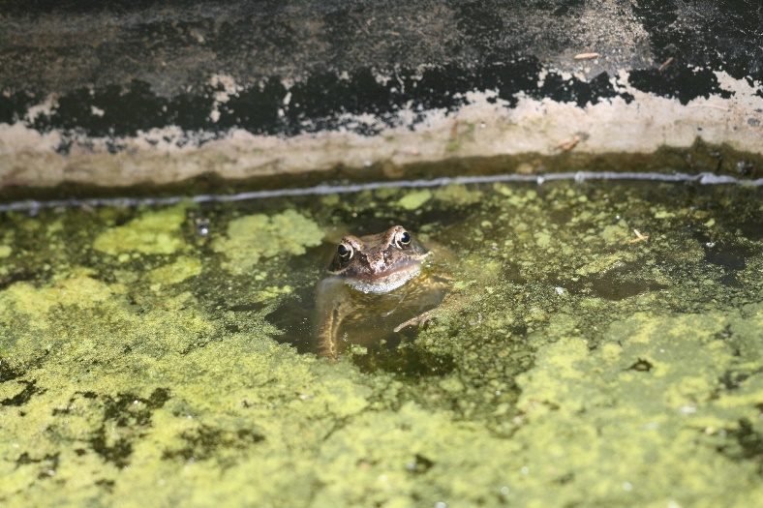

Common Toad Bufo bufo

Common Toads were recorded from nine sites in seven parishes (Exton, Hambleton, Ketton, Langham, Leighfield and Wing) with evidence of breeding in Exton and Leighfield. The first record was on 16 March in Exton and the last live record was on 11 August, although dead road casualties were observed up until 13 October.

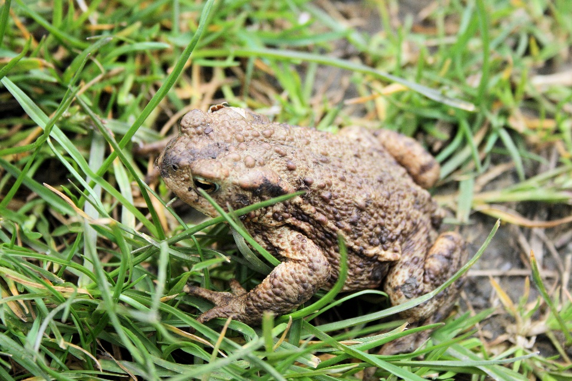

Smooth Newt Triturus/Lissotriton vulgaris

Smooth Newts were recorded in Barrowden, Hambleton, Langham and Wing. The first record was on 7 February in Wing and the last live record was in Barrowden on 24 May, although a dead road casualty was seen in Wing on 6 October.

Great Crested Newt Triturus cristatus

Great Crested Newts were only recorded from Belton and Wing. The first recorded sighting was on 1 January in Wing in the recorder’s pond and they were subsequently seen there until 19 February when visiting Mallards made the pond opaque. The last sighting was on 15 December in the recorder’s cellar in Wing.

Viviparous Lizard Zootoca vivipara

There were just three records of lizards, with two in Ketton on 19 April and 16 July and one near Market Overton on 23 June, which was the first record from there since 1970.

Slow Worm Anguis fragilis

There were no records of Slow Worm in 2019.

Grass Snake Natrix natrix/Natrix Helvetica

Grass Snakes were widely recorded from eleven parishes (Barrow, Barrowden, Bisbrooke, Exton, Glaston, Hambleton, Ketton, Langham, Oakham, Teigh and Wing). The first record was from Teigh on 13 February, an exceptionally early date. There was an earlier record on 25 January 1997 of a dead snake without its head, but the Teigh record was very much alive. The earliest previous live records have been 01 March 1978 and 3 March 2006. This was the first record from Teigh since 1960. The Glaston record of a sloughed skin was the first record from Glaston.

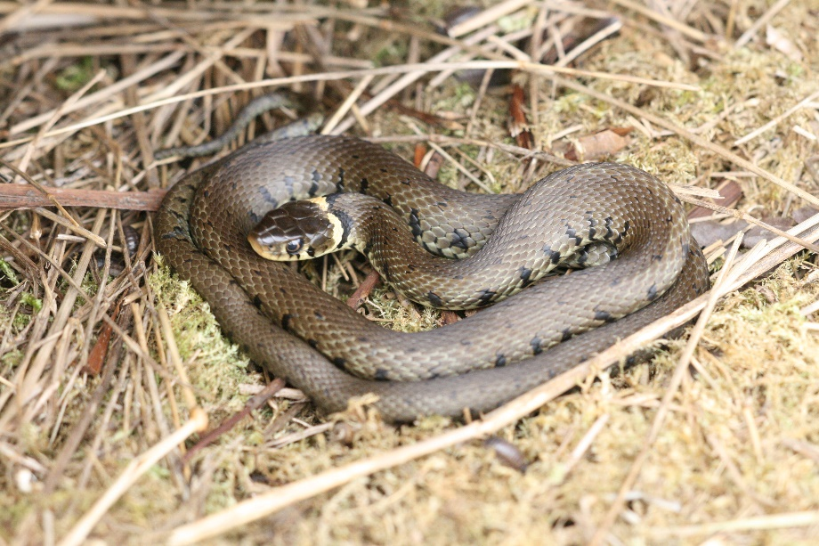

Adder Vipera berus

Adders were seen at Ketton Quarry on 29 March and 6 May.

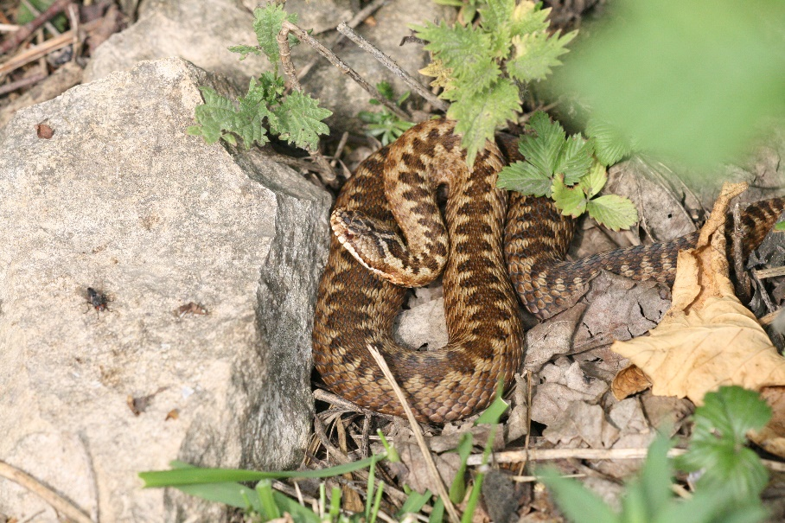

Records were contributed by:
T. Appleton, D. & J. Ball, P. Bennett, T. Caldicott, L. Clark, H. W. Ellis, M. Grimes, A. Hill, R. Jones, P. Killips, R. Lemmon, M. Markham, T. Mitcham, A. C. M. Moyce, D. Needham, S. Smalley, A. Tebbit, C. Tring and L. Worrall

