Mammal report 2019
This report is compiled from the list of all records received by your recorder for 2019, with the exception of records from a trail camera in the Langham garden of Mrs Marian Markham. These valuable records will almost certainly be repeat reports of the same animals, and complicate the picture on a county basis. The Langham records have been the subject of a separate report published as part of the mammal record for 2019, and to be found below.
Where possible locations are listed, except where the species is at risk from “persecution”?
Eg badger, brown hare
The good news in 2019 has been the discovery of a “new” colony of water voles on the Gwash at Shacklewell hollow, and the rediscovery of another on the Chater at Wing. It is not known whether the Shacklewell colony has been present for many years or whether the voles have recolonised from the reintroduction project at Rutland Water. The owner of the land says that he remembers that water voles were there when he was a child. At Wing on land held by the Ahimsa project, there were records of a colony dating back to the 1970s, but they have not been recorded since.
Other species reports are very similar to recent years. Fewer fallow deer have been recorded, but roe appear to be increasing. Muntjac have become ever more numerous, and are commonly seen.
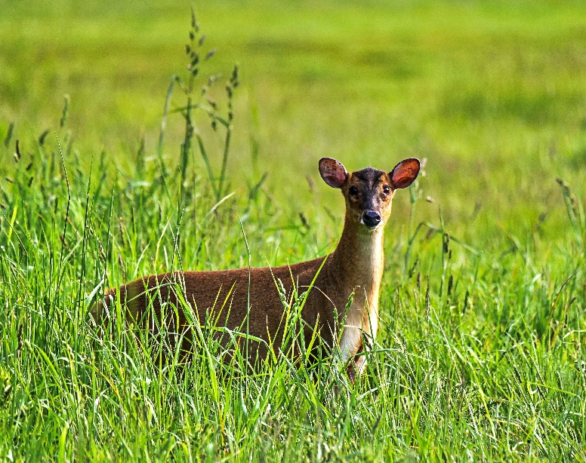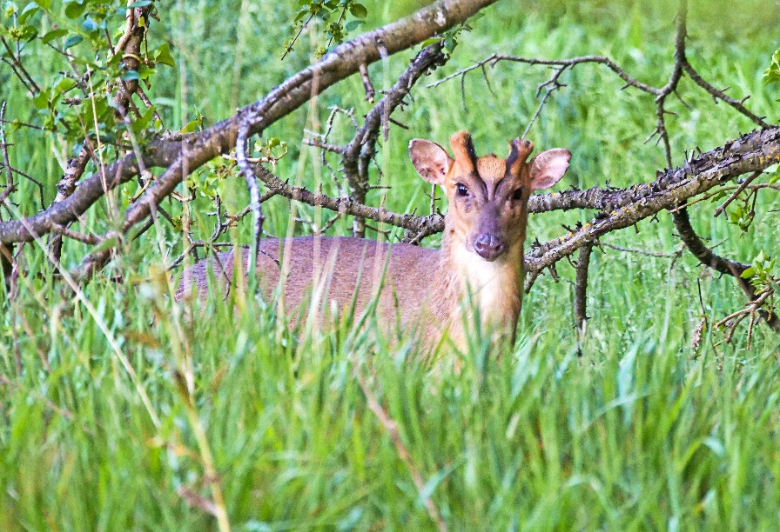
The order of presenting the list of species summaries has been changed this year, in accordance with the most recently published Review of the Populations and Conservation Status of British Mammals (Matthews et al 2018)

The list of contributors to the report is included, and we are most grateful to those members who have taken the time to record their observations. Special thanks go to Marian Markham of Langham who has faithfully reported daily trail camera video recordings during the year, and has written up a special report to cover these sightings.

Trailcam Tails of Langham 2019 - RNHS

On New Year’s day evening a healthy female fox with a distinctive bushy tail with big white tip visited to nibble on dog biscuits. She continued to visit almost nightly through January to April, with a male fox with dark tail visiting occasionally singly. They both appeared together on the 2nd February which was the only time the trailcam recorded two together all year. A third fox made an occasional visit during February, distinguished by a kink at the top of its tail. The female was the only fox visiting during May to August although visits becoming less frequent. By September the female and the fox with the kinked tail were both making regular appearances, which continued through to December. In November and December the male fox with the dark tail was back visiting again a few times.
During the times when the hedgehog and fox were present together the situation was amicable, ie. no one was tried to be eaten! On 1st March the female fox was recorded carrying a woodpigeon though!
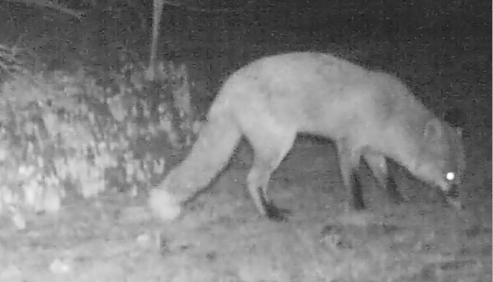
A muntjac with fawn were recorded regularly during January and February, nibbling on fruit tree leaves. They were recorded together again on 23rd March with the adult seen in daylight the next day. They were again recorded regularly together during April. A male muntjac was recorded twice in June and one on 11th September.
The first hedgehog record for the year was on 19th February with a further nine appearances that month; a single animal usually in the small hours of the morning between midnight and 3am. Visits increased during March to June with one or two present most nights. On 16th May there were three hedgehogs present together. By July, some hedgehogs were showing territorial behaviour, with one being shoved by another. A rolled-up hedgehog can be shoved quite a long way! A variety of sizes of hedgehog were present by July with one half the size of the others – this year’s young hedgehogs continued to appear on the trailcam regularly until December.
A late September brood was seen on 21st September with the female emerging at 1pm to feed on fat nibbles and sunflower seeds near the hedgehog nesting box. She was accompanied by four small young. Food was placed out for the family for the next couple of months in the hope of them gaining enough weight for hibernation. On 23rd October one youngster was recorded passing the trailcam with a mouth full of leaves, planning ahead for winter! Some of the youngsters continued to use the hedgehog nesting box under the hedge. One was seen wandering in daylight on 3rd November. It was put on the kitchen scales and weighed in at a mere 350 grams, not enough for hibernation. On 9th November a different youngster seen at 11am wandering in the garden was weighed, this one was 260 grams. It was taken straight to Oakham Vets to be taken into their excellent care for the winter. By 13th November a second youngster was also in trouble. It was found curled up in the open, cold and the ticks crawling away!. This one weighed 300 grams and so was also taken to Oakham Vets for care. The remaining two youngsters were regularly recorded on the trailcam throughout December, along with the occasional adult.
A brown rat was recorded on the trailcam for the first time on 19th September. It was recorded three times that month. By October it was a regular visitor which continued through to the end of the year.
The supporting cast by day was grey squirrel and by evening wood mouse. A common shrew was disturbed in the garden shed on 30th January. Bank voles were recorded in July and December.

Hedgehog Erinaceous europaeus 234 reports 3 dead (206 Langham trailcam)
The first reports of the year were both from Oakham, in neighbouring gardens in Barmstedt Drive, on 4th and 23rd March, and the last were at Langham on 30th and 31st December. Hedgehogs were reported from several areas, regular visitors to a garden in Whissendine, and seen in Barrow, Burley, Cottesmore, Langham churchyard, and Wing. Dead hedgehogs were found by Dr Gallimore in his garden on two dates in July, one just paws and skin remaining. He suggested a badger to be the culprit, but no evidence was found to prove the case. Mating behaviour was seen by several recorders, and youngsters were also recorded from the end of July onwards. One 300g hoglet was rescued by Marian Markham in November. It was found after being in the garden all day, taken to vet and warmed and fed. two youngsters were seen together on 6th December, and the last small hog was seen on 23rd December
Mole Talpa europaea 13 reports all evidence
No live animals were reported in 2019. Molehills were seen through the year, though few in the summer months. The location showing most activity was Clipsham Park Yew Tree Avenue where 620 molehills were counted in February, and on the woodland trail 45 were seen. Other reports came from Langham, RWNR Fishponds fields, Exton village, Prior’s Coppice, Barrow, and Stretton.
Common Shrew Sorex araneus 4 reports 5 live animals 3 dead ( 1 Langham trailcam)
Seen only in January, June and July. Reports from Wing, Barrow, Langham and RWNR Waderscrape hide.
Pygmy Shrew Sorex minutus 2 reports 2 live animals
One was seen from Deep Water hide at RWNR in July and another in November near a nest in logs in a Barrow garden.
Water Shrew Neomys fodiens 2 animals both dead
One was found in February by Lagoon 3 RWNR, and another by a ditch in Pickworth Wood in July.

Rabbit Oryctolagus cuniculus 19 reports 22+ live animals 2 dead
Evidence in the form of holes and droppings was found at Walk Farm, Pickworth, Tolethorpe, Ryhall Heath. Live animals including juveniles, were seen at Barrow, Ketton, Quarry Farm Great Casterton, Uppingham and Greetham, and at Market Overton several were seen suffering from myxomatosis.
Brown Hare Lepus europaeus 57 reports 140 animals 1 evidence 1 dead
There were more reports of brown hare in 2019 than in either of the previous two years, and they were seen in every month except September. Hares were reported widely across the county. They were mainly seen in ones and twos but on one estate a total of 18 were seen on one occasion. Because of the danger of hare coursing the locations of sightings are not published here.
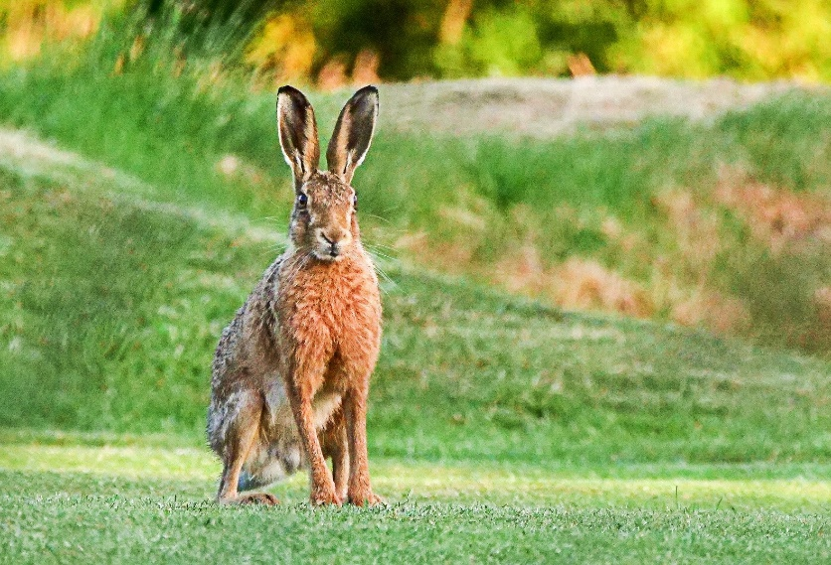
Grey Squirrel Sciurus carolinensis 146 reports (100 Langham trailcam)
Numerous reports of one to three animals, seen in many areas of the county, from Uppingham, RWNR, Pickworth, Barrow, Langham, Ketton, Manton. One unusual report from Uppingham was of a squirrel being chased around a tree by a blackbird.
Bank Vole Myodes glareolus 15 reports 2+ animals 1 dead (12 Langham trailcam)
Many records from the trail camera in Langham, but also regular reports from the Willows in Barrow of an animal feeding on the patio. One dead bank vole was found on the common at Langham.
Field Vole Microtus agrestis No records were received in 2019
Water Vole Arvicola amphibius ( terrestris) 37 reports 8 live animals
There was some very good news in 2019. Water voles were discovered in May on the Gwash at Shacklewell Hollow, following placement of rafts in October 2018. Seven rafts of the ten placed were found and every one had droppings. Cropped lawns and holes were found on the bank. We do not know whether this colony has been present for many years, or whether the voles have recolonised from Rutland water. Another very active population of water voles was rediscovered at Wing on the Chater on land belonging to the Ahimsa farm. A single water vole was seen on Oakham canal south in February. All other animals were reported from Waderscrape hide at RWNR, one in March, three occasions in April and one more in June. The remaining reports are evidence, droppings or footprints on mink rafts or water vole rafts as part of the continued monitoring of water voles at RWNR and Oakham canal.
Wood Mouse (Long-tailed Field Mouse) Apodemus sylvaticus 67 reports (64 Langham trailcam)
Fieldmice were reported throughout the year at Langham on four or five occasions each month. At Whissendine from April 23rd they were seen two or three times per week, and one other report came from an Oakham garden in October and November. This animal is really numerous, but only seldom seen and reported by members.
Brown Rat Rattus norvegicus 43 reports 45 live animals ( 42 Langham trailcam)
Reported only from Langham and Uppingham. This animal is far more common than reports indicate.
Red Fox Vulpes vulpes 107 reports 3 dead 3 juvenile (87 Langham trailcam)
Many reports were from the trail camera in Langham, a regular female, and at least three males identified by their tails – bent, thin, bushy and dark. In January the female was seen on the same night as two males, all seen separately. In Uppingham a vixen was seen several times, early in April as a nursing mother, then later in the season looking much thinner, and a second fox was seen later in the same area. At Banthorpe a vixen with two cubs was seen in June and in July the cubs were observed without the vixen. Other foxes were seen in Oakham, Wing, RWNR Waderscrape and Deep Water hides, Exton, Burley, Barrow and Ketton.
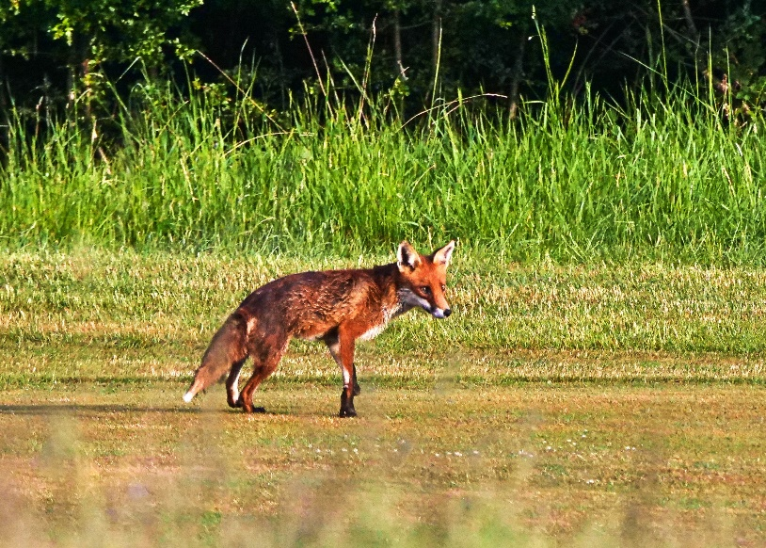
Badger Meles Meles 19 reports 2 live 9 dead 5 evidence
Badgers are still common, with evidence of their presence, such as diggings, active setts, tracks and latrines seen in many areas. Road casualties were sadly all too common, but there have been fewer recorded than in 2017 or 18. The only encounter with a live animal recorded in 2019 was in a local woodland, when two observers were standing together, and were approached by two badgers, growling and snarling, which ran towards them and split up one veering off, the other ran between them.
Otter Lutra lutra 51 reports 13 live animals
The majority of reports were of evidence, either prints in clay of mink rafts, or spraint on top, gathered during regular monitoring of mink rafts as part of the continuing water vole project. Evidence was also seen at Fort Henry ponds, where a large bream was found in January, a decapitated eel in April, and fresh spraint in November.
A number of reports concerned live animals mainly observed at RWNR. Two animals were seen from Shelduck Hide in January, one near Gibbet Gorse and two from Bittern Hide in March. In April one was seen between Tufted Duck and Deep Water hides, and ne was also seen from Tufted Duck hide in October. At the end of December three otters, including one young one, were observed from Waderscrape Hide.
Elsewhere in June an otter appeared at Leighfield by the bridge, and also at the bridge at Eyebrook one swam down the stream with a large fish flapping in its mouth. In November an otter crossed the track towards the fishponds at Stretton Wood.
Stoat Mustela erminea 16reports 17 animals 2 dead
Four stoat reports came from RWNR, Badger Hide meadow, VTC, Deep Water Hide and Whitwell Creek. Others were reported from Barnsdale, Exton, Uppingham, Shacklewell, Martinsthorpe, Pilton, Greetham and Ketton Quarry.
Weasel Mustela nivalis 10 reports 10 live animals
At RW Lyndon Top a weasel was observed in March, and in May a weasel crossed a drive in Wing. Other weasels appeared crossing roads, tracks and footpaths in the Pilton area, Pickworth, Greetham, at RW Gibbet Gorse, Oakham, Braunston and Ridlington.
Polecat Mustela putorius No records in 2019
Fallow Deer Dama dama 15 reports 29animals 2 dead 2 juveniles
Fewer fallow deer reports and smaller numbers of deer were again recorded in 2019. This is undoubtedly because of increased culling in most local woods, and in addition there have been incidents of deer poaching. The largest number seen at one time was a group of five seen in July between Fort Henry and the A1, two adult females each with a fawn, and one immature female. A group of four was seen in Pickworth Wood in May. Other reports were mostly of single animals seen at RWNR Shallow Water Hide, Shacklewell, Exton, Pickworth and Pickworth Wood, Walk Farm Great Casterton and Barnsdale.
This is a far cry from the years when we recorded hundreds of deer often in groups of 50-80.
Roe Deer Capreolus capreolus 6 reports 6 live animals
Slightly fewer reports and animals in 2019 than in 2017 and 18, which is disappointing, as it had appeared that roe deer numbers were increasing in the local area. Culling by official marksmen should not have had any effect as roe deer are supposedly not controlled in this area. All animals were recorded as single animals at Ketton Quarry, Burley Wood, Exton, Pickworth and near Ridlington.
Reeves’ Muntjac Deer Muntiacus reevesi 53 reports 62 animals 6 juveniles 16 Langham trailcam
Muntjac were the most commonly observed deer, in spite of their generally skulking behaviour, and were often seen in gardens and populated areas. They were reported from Wing, Barrow, Ketton, Ketton Quarry, Uppingham, Manton, Prior’s Coppice, Preston, Egleton, Burley Wood, Hambleton Wood and several areas of RWNR, in spite of culling taking place.
Records in 2019 were received from: -
Jane and Duncan Ball
Carolyn Baxter
A Biddle
R and L Brown
Tim Caldicott
Alan and Julie Comber
Charles Gallimore
Martin Grimes
J Harris
V and A Hemsley
Phil Langstone
Roy Lemmon
Maggie Manson
Marian Markham
Diana Masters
Terry Mitcham
D Needham
Lloyd Park
J and A Pearce
Rebecca Pitman
Jan and John Rodgers
Phil Rudkin

Summary of Mammal Numbers 2019, 2018 and (2017)

Species | Number Reports | Number live | Number dead | Evidence | Number single site  Trailcam reports | Comments
Hedgehog Erinaceous europaeus | 236 79 (157) | 341 107  (223) | 1 5 (7) | 1 (1) | 214 49 Often several visits per night max 3 animals at one time
European Mole  Talpa europaea | 14 16 (18) | 0 3 (1) | 0 2 (1) | 14 13 (17)
Common Shrew  Sorex araneus | 4 2 (21) | 5 4 (23) | 3 4 (8) | 0 0 (0) | 1
Pygmy Shrew  Sorex minutus | 2 0 (3) | 2 0 (3) | 0 0 (2) | 1 0 |  | No reports 2018
Water Shrew Neomys fodiens | 2 0 (2) | 2 0 (1) | 2 0 (0) | 0 0 (1) |  | No water shrews recorded 2018
European Rabbit Oryctolagus cuniculus | 19 6 (6) | 30 10 (10) | 2 0 (7) | 5 1 (0) | 0 1 | 3 with myxomatosis
Brown Hare Lepus europaeus | 57 38 (56) | 140 60 (108) | 4 1 (3) | 1 2 (1) |  | 2 reports of young
Grey Squirrel Sciurus carolinensis | 147 40 (71) | 177 44 (73) | 0 0 (0) | 0 (0) | 130 36 Seen almost daily often 2 or three times.  Up to 3 seen at one time
Bank Vole Myodes glareolus | 15 3 (9) | 2 3 (13) | 1 0 (0) | 0 0 (0) | 12 0
Short-tailed Field Vole Microtus agrestis | 4 3 (4) | 4 2 (4) | 4 2 (4) | 0 0 (0)
Water Vole Arvicola amphibius | 38 40 (52 | 8 0 (0) | 0 0 (0) | 32 40 (52)
Wood Mouse Apodemus sylvaticus | 66 3 (9) | 71 3 (9) | 1 0 (0) | 0 (0) | 62 2
House Mouse Mus musculus | 0 1 (2) | 0 1 (1) | 0 0 (1) |  |  | No records 2019
Brown Rat Rattus norvegicus | 43 3 (5) | 45 3 (5) | 0 0 (0) | 0 1 (1) | 42 0 September to December Often several appearances per night
Red Fox  Vulpes vulpes | 109 89 (131) | 127 112 (133) | 0 1 (4) | 3 (2) | 89 68 Two individuals identified, male and female. Often female only sometimes male only. Once or twice 2 together | One report of cubs in June, 2 cubs Exton, 1 dead cub on Oakham bypass
Badger Meles meles | 19 45 (33) | 436 (4) | 9 17 (15) | 8 11 (12) | 1 12
Otter Lutra lutra | 52 36 (50) | 13 14 (11) | 0 1 (1) | 44 25 (45) |  | Prints of small otters seen in Mink rafts -evidence of breeding
Stoat Mustela erminea | 16 16 (11) | 17 16 (12) | 2 0 (1) | 0 0 (0)
Weasel Mustela nivalis | 10 4 (7) | 10 4 (8) | 0 0 (0) | 0 0 (0)
Polecat  Mustela putiorius | 0 0 (0) |  |  |  |  | No reports 2019 2018
Mink Neovison vison | 0 1 (0) | 0 1 (0) | 0 0 (0) | 0 0 (0)
Fallow Deer Dama dama | 15 22 (23 | 29 85 (125) | 2 1(0) | 3 (2) |  | 2 does with fawns seen in July
Roe Deer Capreolus capreolus | 6 10 (11) | 6 26 (16) | 0 0 (0) | 0 0 (0)
Reeves’ Muntjac Deer Muntiacus reevesi | 53 66 (40) | 62 86 (45) | 0 1 (0) | 3 (1) | 16 14  Occasional visits June – July otherwise January only

