RUTLAND NATURAL HISTORY SOCIETY

PLANT GALLS 2019 Recorder: Roy Lemmon

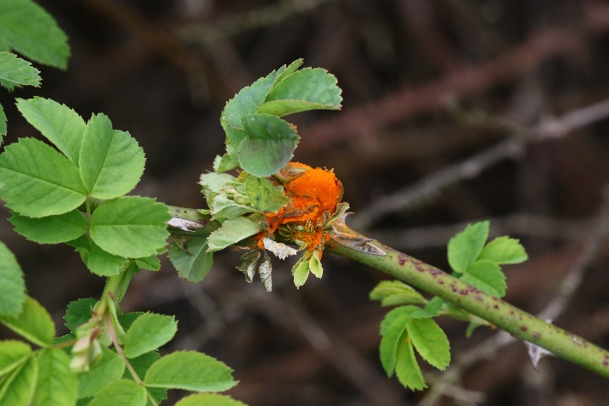

In 2019 our members visited 35 different sites in Rutland and sent in 443 reports comprising a total of 115 species of gall, nine of which were new to our records. Both the number of sites visited, and the number of reports were up on 2018 but the number of species of gall reported was down by 19, i.e. some 16%. It is difficult to come up with a viable explanation for this decline. In last year’s report mention was made of the paucity per leaf of Spangle and Silk button galls on Oak and this year the same phenomenon was noted; and despite there being an increase in numbers of reports of these species it was obvious that numbers of galls per leaf were still in single figures. In the past it was usual to count them in tens, or even hundreds, per leaf.

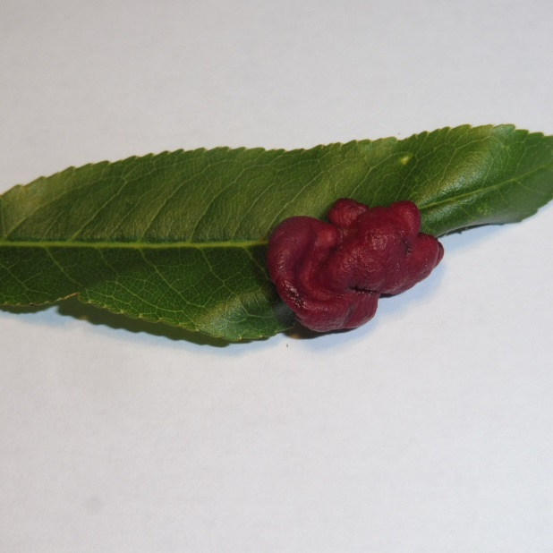
Picture provided by Martin Grimes:
Taphrina deformans on Almond in Empingham

On Sunday 1 September the Society held its annual joint meeting with the British Plant Gall Society (BPGS), this time in Burley Wood by permission of our President, Mr. Josh Hanbury. The event was enjoyed by twelve participants and produced a total of 34 species of gall, ten of which were on Oak. Five of our Society Recorders were present, which ensured a broad cover of reports for the day.

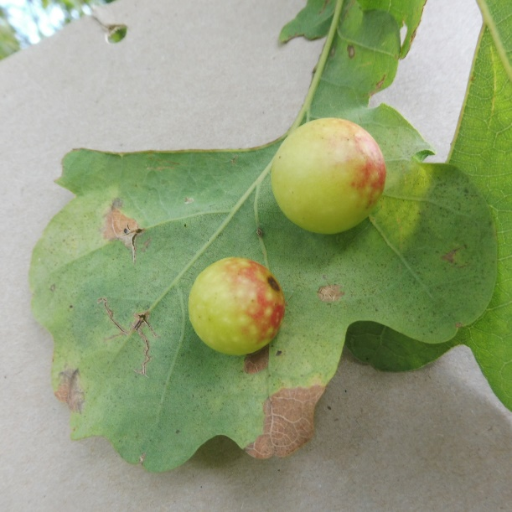
Picture provided by Martin Grimes:
Cherry Gall I(Cynips quercusfolii) on Oak in Priors Coppice

Contributors were: - L. Clark, M. Grimes, T. Higginbottom BPGS, R. Lemmon and P. Rudkin.

