Rutland Natural History Society

GLOW-WORM REPORT, 2020 Recorder: Linda Clark

Only two Rutland sites that were known to have Glow-worms in the past were surveyed in 2020. The sites surveyed were at Barrowden and Ketton Quarry.

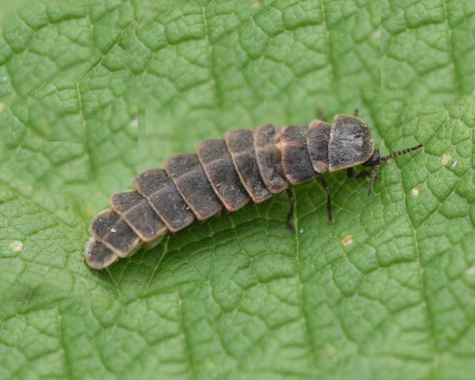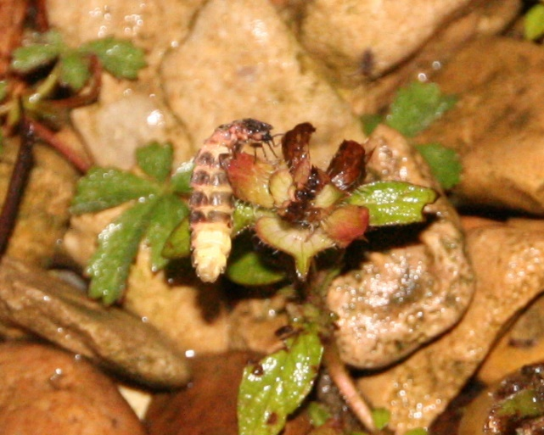

Photo – Peter Scott Photo – Peter Scott

Glow-worms had been seen in the summer of 2019 at Collyweston Great Wood but this area is in Northamptonshire. The same wood was searched again in the summer of 2020, on two nights, but no glows were spotted. This may have been because tree felling was undertaken at the site between the seasons, causing a great deal of destruction and possibly leading to death of beetles and larvae. Glow-worms have a two-to-three-year life cycle and generations overlap most usually over two years - so if there is, for example, a weather disaster one year causing failure of the two-year-old larvae to pupate and mate, there is a backup of one-year-old larvae who will pupate and mate the following year. The problem is that now, not only are the colonies so small in the number of individuals each contains, but these colonies are usually isolated, meaning that this strategy for survival is very precarious.

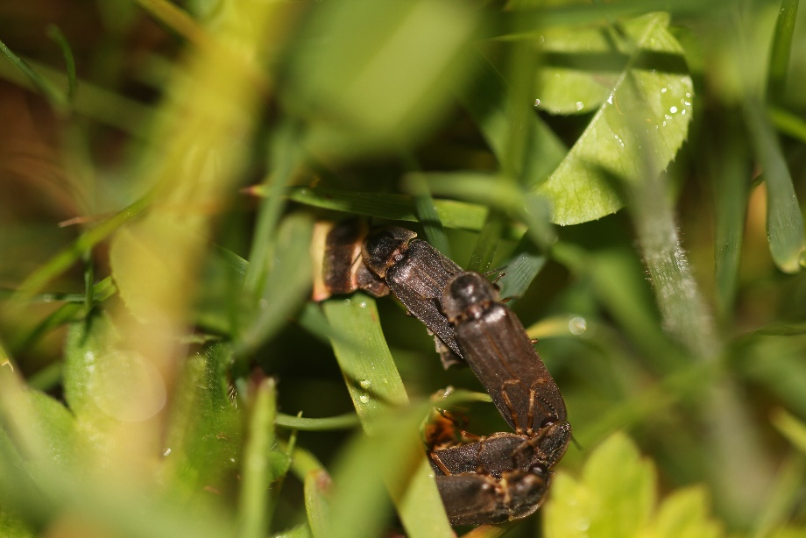

Photo – Peter Scott

The Glow-worms at Barrowden were reported between 9 and 28 June. The areas were Barrowden Back Road SK94460053, SK94490026; Luffenham Road SK94680044, SK94690053, SK94690056, SK94700080; and The Drift SK94560031. The first record was of seven glows and it is thought that altogether over this period there were about 13-14 individuals (females) some showing on several nights before disappearing.

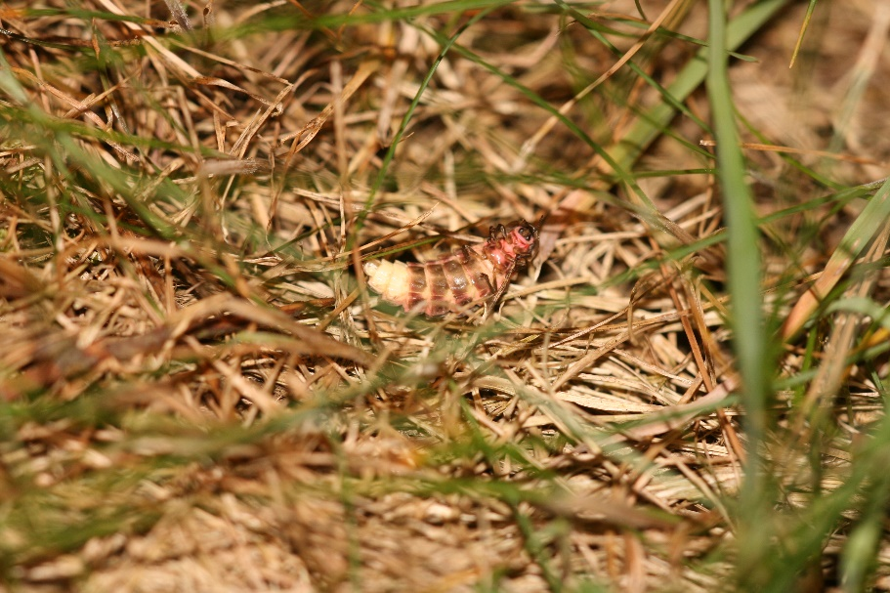

Photo – Peter Scott

The area searched at Ketton was a different one to where the beetles had been recorded in past years. This site, SK97780512, was visited on three nights between 29 June and 7 July and in total seven glows were seen with a possible two repeats.

Records were contributed by R Fraser, L Clark. Thanks to Linda Worral for Glow-worm information.

