RUTLAND NATURAL HISTORY SOCIETY
MAMMAL ANNUAL REPORT 2018 Recorder: Linda Biddle
The report for 2018, as all reports for Rutland Natural History Society, depends entirely on the records submitted by our members. We are fortunate that there are a number of members who reliably send their sightings for our use, in order for us to forward them on to other bodies so that they may be included in national statistics. Our thanks go to all those members, and particularly to Marian Markham who recorded on a trail camera in her Langham garden and sent the list of species seen, times and dates every month, which was a mammoth task. Many of these Langham records will concern the same individual animals, so that numbers of animals recorded should not be taken as an indication of the size of populations.
Otters and Water voles were once again prominent among species records, and it is very pleasing that they were once again established as resident in Rutland. Hedgehogs were frequently seen, Fallow deer were reducing in number, but Roe Deer were far more often seen than in previous years. Other species reports remain fairly similar to those for previous years.
It remained the case that reports reflected not necessarily the spread of populations, but the spread of member activity, and there were few reports from the western parts of Rutland.

Hedgehog Erinaceous europaeus 79 reports 107 animals 5 dead (49 Langham trail camera)
The first Hedgehog reported in 2018 was on 15th March crossing the road at Cottesmore, and the following day droppings were found in Linda Worrall’s garden in Barrowden. At Langham the first appearance on the trail camera was on 25th March. By 20th October a hedgehog had taken up residence in the hedgehog house in a Barrowden garden. Latest reports were on 17th November at Morcott, and in Oakham on 24th November and 2nd December.
At Barrowden hedgehogs were seen occasionally during the summer, and the Langham trail camera recorded hogs regularly during April and September, but only occasionally in the summer months. Similarly, some members feeding in their garden in Oakham reported regular visits in April, but then hedgehogs were not seen until September, after which they continued to visit almost nightly. Conversely another Oakham member reported many visits in July and August, but the hedgehogs disappeared in September. Was it a case of disloyal hedgehogs? At Barrow from March to June hedgehogs came for food almost every night, and at Whissendine two different adults regularly visited during September.
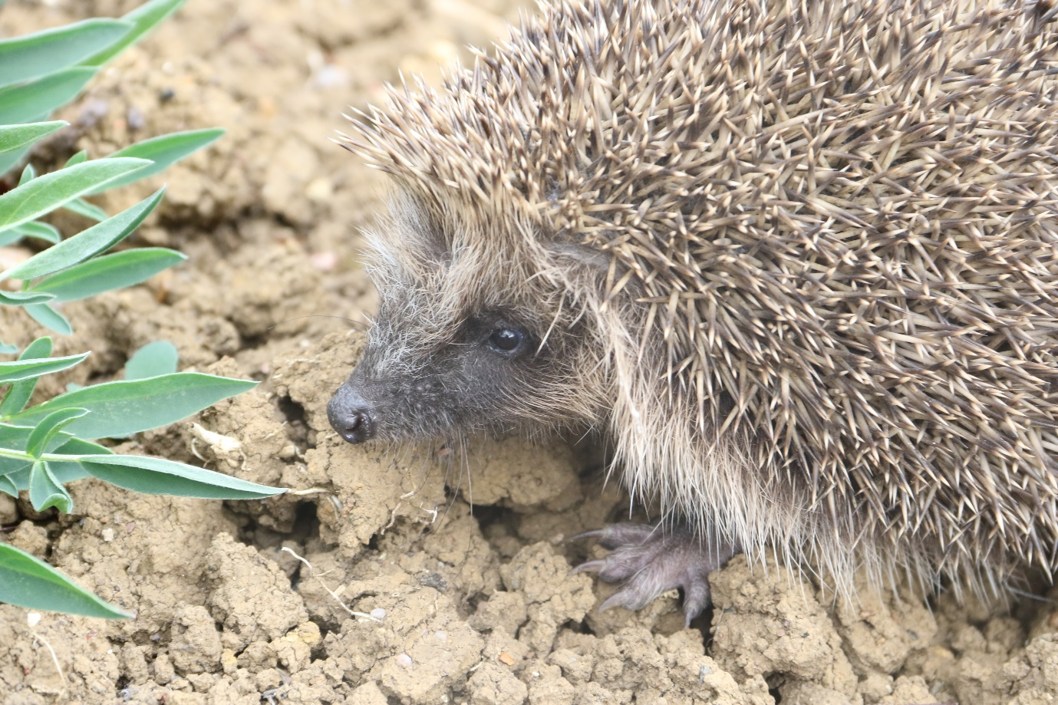
European Mole Talpa europaea 16 reports 3 animals 2 dead
Almost all reports were of molehills, and these were widely reported across the county, following an appeal for members to make notes of the presence of moles. The three dead animals were all found during July, two at RWNR and one at Oakham Canal. At Tolethorpe a large number of hills were seen in January. Reports also came from Exton, Tickencote, Shacklewell, Ryhall, Langham, Pickworth, Greetham and Barrow.
Common Shrew Sorex araneus 2 reports 4 animals 4 dead
One animal was found behind Shallow Water Hide, RWNR, the other three in rides in Clipsham Park Wood.
Pygmy Shrew Sorex minutus No reports in 2018
Water Shrew Neomys fodiens No reports in 2018
European Rabbit Oryctolagus cuniculus 6 reports 10 animals 1 evidence (1 trail camera record)
Rabbits were very under-recorded, but were seen at Greetham Valley Golf Club, Barrow and Langham, and evidence was seen in the form of holes along a hedgerow between Tolethorpe and Ryhall.
Brown Hare Lepus europaeus 38 records 60 animals 4 dead 1 evidence
Hares were reported from many parts of the county, from Thorpe by Water in the south, to Banthorpe in the east to Beaumont Chase further west. In the spring groups of up to four were reported from Pickworth, Exton, RWNR and Greetham valley.
Grey squirrel Sciurus carolinensis 40 reports 44 animals (36 Langham trail camera)
Grey Squirrels were seen at Pickworth, Greetham, Exton, Barrow and very frequently recorded at Langham.
Bank Vole Myodes glareolus 3 records 3 animals 1 dead
The reports came from Langham, Barrow village, and Barrowden, the dead animal was found in a Langham garden, with no sign of damage. The other two healthy animals were feeding on garden patios.
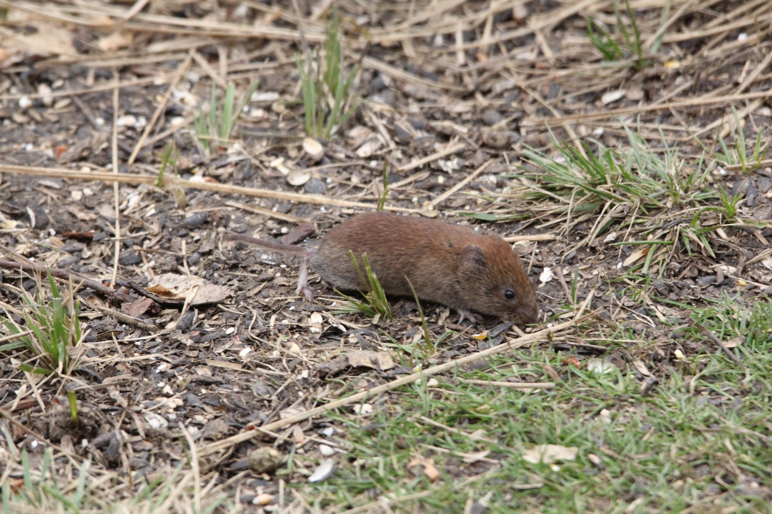
Short Tailed field Vole Microtus agrestis 3 reports 2 live animals 2 dead
In January two single animals were found under reptile shelters along a limestone bank in Exton Park. In October, November and December holes and runs were found in The Willows garden at Barrow.

Water Vole Arvicola terrestris 40 reports all evidence no live animals seen
Evidence of water voles was found on the River Gwash at Braunston in April by Lloyd Park. Every other record in 2018 came from regular monitoring of mink rafts and water vole rafts at RWNR and Oakham Canal. The only evidence found in January was at Badger hide bridge when droppings were found on the mink raft. In February evidence was found at Pollards, Dog kennel, Reedbeds, Shoveler and Snipe hides, Field 16 ponds and Burley Fishponds, but no signs at Oakham Canal. In April happily evidence was found at both ends of Oakham Canal as well as at the RWNR sites listed above. By July Oakham Canal showed signs only at the north end, but all sites at RWNR again showed positive signs. In September the mink raft at Redshank Hide had water vole droppings, and in October most sites at RWNR and both ends of Oakham Canal showed signs of water vole activity.
Wood mouse Apodemus sylvaticus 3 records 3 animals seen 2 evidence
At Langham one was seen on camera eating fat on two nights in July, and at Oakham one was seen regularly eating food put out for hedgehogs.
House Mouse Mus musculus 1 report 1 animal
This report came from Langham where it was seen on camera in October.
Brown rat Rattus norvegicus 3 reports 3 animals 1 evidence
All three reports came from RWNR, one seen at Egleton BWC, one from Smew Hide, and the third report was of footprints in clay on mink raft at Manton Bay.
Red Fox Vulpes vulpes 89 reports 112 animals 1 dead 3 evidence (68 Langham trail camera)
In Langham a fox was recorded on the camera almost every night during March and April, but later in the year only occasional visits were made by a nervous male and a small female which were seen interacting during July. They continued to appear separately at intervals later in the year, and some nights a second female was also recorded.
Foxes were also reported from Ayston, Ketton, Whissendine, George Henry Wood, Clipsham Park Wood, Empingham, Gunthorpe, Greetham Valley Golf Club, Seaton Grange and RWNR Smew Hide on three consecutive days in October, Field 17, Lagoon 4, and Lyndon Bay.

Badger Meles meles 45 reports 36 animals 17 dead 11 evidence (12 Langham trail camera)
In January footprints in sand of bunkers at Greetham Valley Golf Club betrayed visits, and seven nights recording on a camera at Lagoon 3 of RWNR showed a single badger. Two young badgers ran across the road near Normanton in February. Eight road casualties were recorded in April. In Wing a badger had dug out a wasps’ nest during August, and as in 2017 at Barrowden badgers made a nuisance of themselves by digging up garden lawns.

Otter Lutra lutra 36 report 13 animals 1 dead 25 evidence
Otters were seen at RWNR in January and February, on two occasions from Lapwing Hide, and later observed at the back of Lagoon 3. Sadly, an adult male otter was found as a road casualty on the Hambleton peninsula road, a beautiful young healthy animal. In March otter prints were seen in snow at Langham close to the bridge in Church Street. In June an otter was observed in front of Smew Hide, where on 22nd October and daily until the 28th one or two animals were seen. All other reports were of spraint or footprints on mink rafts as part of the regular water vole monitoring programme, and otter signs were recorded at least once during the year, and most rafts showed spraint or footprints every month.
Stoat Mustela erminea 16 reports 16 animals
Stoats in ermine were reported from Lyndon Centre RWNR on two occasions during January, and in February another animal, not in ermine, was observed on the track by 360 Hide. In March a stoat was seen in Leighfield, south of the fishponds, and in April there were three sightings in the same area and one in Martinsthorpe. Other reports came from Greetham Valley Golf Club, Empingham, Clipsham, Cottesmore, Lyndon Top, and the final record of the year came from south of Pilton, where one was seen running along a field.
Weasel Mustela nivalis 4 reports 4 animals
There were only four reports of weasels during 2018. One was seen in April in RWNR Field 16, hunting among logs and emerged with a vole. In August, a weasel appeared in a garden at Normanton, and then disappeared into an adjacent grass paddock, and another was seen crossing the road near Cottesmore. At Fort Henry in October a weasel crossed the track by the lower lake and disappeared into the plantation.
Polecat Mustela putorius No reports in 2018
Mink Neovison vison 1 report 1 animal
In December a single animal was seen on the banks of the Welland just below the pumping station at Tinwell.

Fallow Deer Dama dama 22 reports 85 animals 1 dead 3 evidence
Fallow deer were reported from Pickworth, Clipsham, Exton, Greetham Valley Golf Club, Burley Wood, Tickencote, Tunnely Wood and Banthorpe, where the largest group was seen consisting of twelve animals.
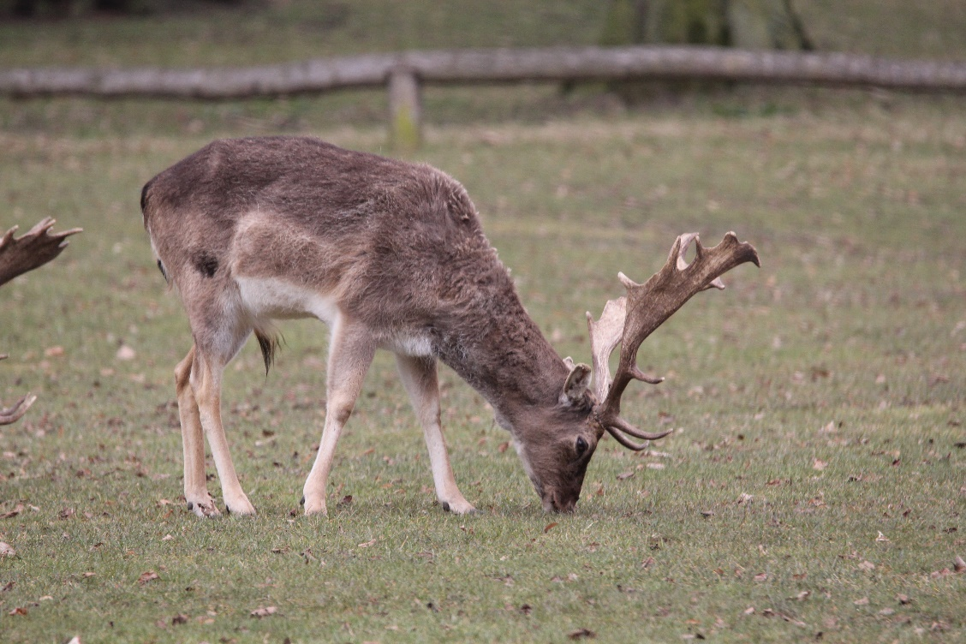
Roe Deer Capreolus capreolus 10 reports 26 animals
Four Roe deer were seen in January close to Banthorpe gravel pits as they ran across winter cereal fields. Single animals or pairs were then seen at Ketton Quarry, Bloody Oaks, Pickworth, and on two occasions in Chater valley near Ridlington. Unusually a group of eight were observed near the centre of Burley Wood during October.
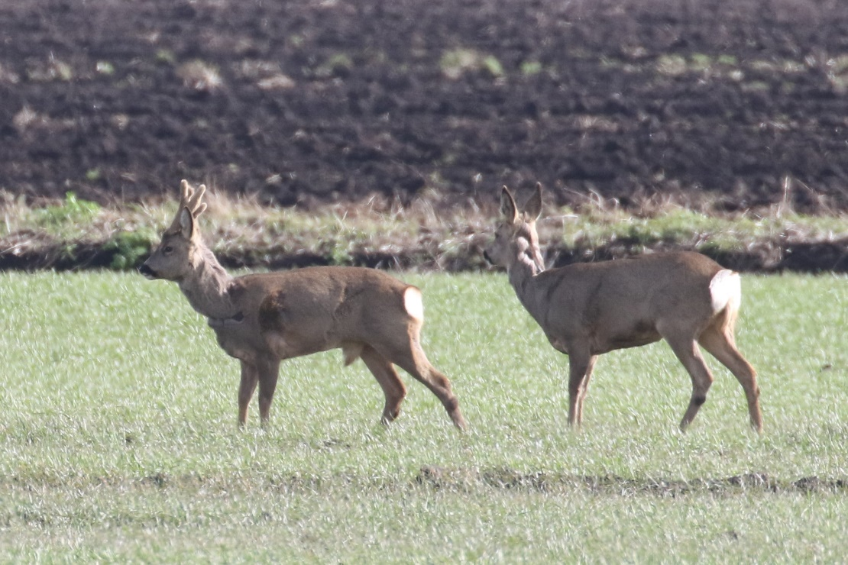
Reeves’ Muntjac Deer Muntiacus reevesi 66 reports 86 animals 1 dead 3 evidence (14 Langham trail camera)
Animals were commonly seen in much of the county, often browsing in gardens. Females with young were seen at Greetham Valley Golf Club and in Barrow. Records came from Langham trail camera where in October a male and female visited almost every night, and also from Barrow, Barrowden, Ketton Quarry, Barnsdale, Burley and Clipsham Woods, Greetham Valley and Luffenham Heath Golf Clubs, Normanton, RWNR Lyndon Bay, Field 16, Pickworth, Hambleton, Wing, Pilton, Gunthorpe, Preston and Barrow.

Recorders were:

D and J Ball
C Bacon
P Bennett
A Biddle
T Caldicott
J Davis
C Gallimore
G and M Griffin
M Grimes
V Hemsley
H Hucknall
P Langston
R Lemmon
M Manson
M Markham
D Masters
T Mitcham
L Nicholls
D Needham
L Park
J Pearce
P J Rudkin
N Webb
L Worrall

