RUTLAND NATURAL HISTORY SOCIETY

MOTH ANNUAL REPORT 2019 Recorder: Paul Bennett

After a hot and dry summer in 2018 perhaps it was to be expected that 2019 would see a comparative fall in moth numbers. The area around Lyndon Visitor Centre was trapped on 16 occasions and while the total of species recorded was good the numbers recorded for most of the regular species were down, in some cases by 25% or more. The most frequently recorded moth was Small Quaker (188) although nearly all these records came on one date, otherwise there were no century counts out of one trap for an individual species. The lower totals can be put down to two factors: firstly, nature’s way of levelling out after a bumper year and secondly many larval foodplants prematurely dried up in 2018 preventing many larvae from feeding on them which had a knock-on effect for the rest of the moth’s life cycle. Other sites trapped were Shacklewell, Bloody Oaks and the south side of Egleton Visitor Centre and it is hoped to continue with them in the future.

However, the year was also notable for some rare finds, all seemingly triggered by short periods of very hot weather accompanied by strong southerly breezes. Orange Underwing moths have not been recorded in Rutland for many years but these spring day-flyers were seen in good numbers in Pickworth Wood over the (late) Easter week-end flying at head height instead of in the tree canopy (as is more usual) and occasionally landing on bare ground to bask in the warm afternoon sunshine. Clifden Nonpareil, or Blue Underwing, as it is more commonly known, had not been recorded in Rutland since 1902 but eight of these moths were seen last summer.

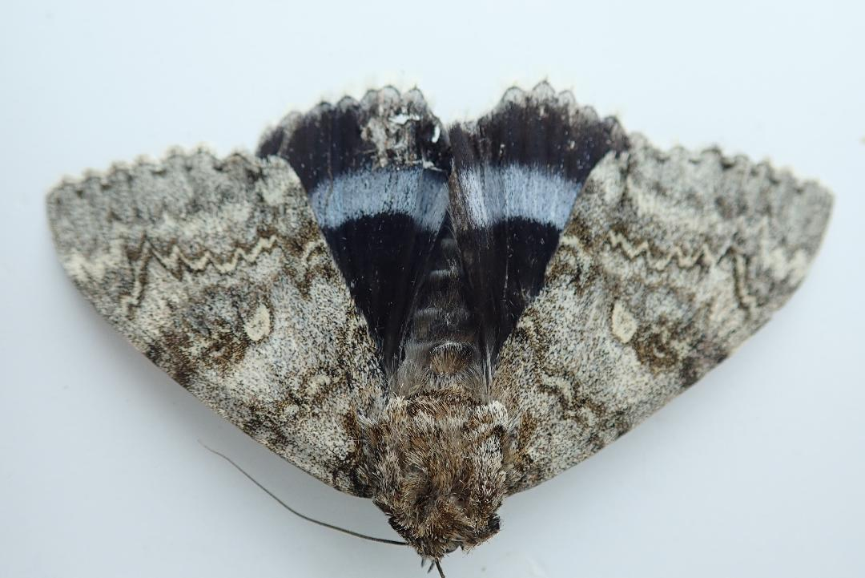

Blue Underwing

The major local highlight of the year however was a first Leicestershire and Rutland record of Beautiful Marbled, a small macro moth classified as a rare immigrant and even rarer this far inland.

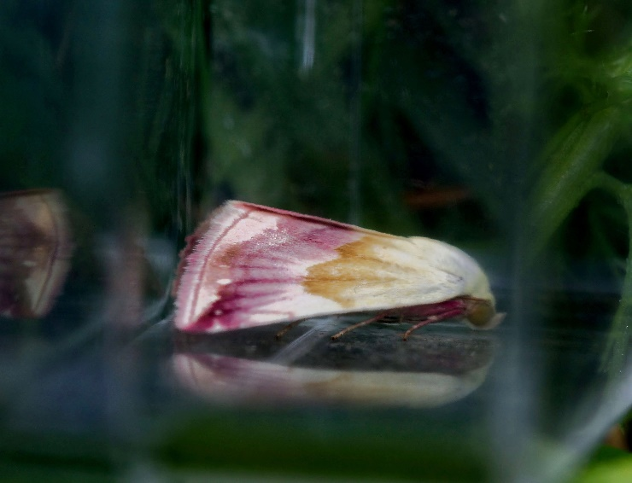

Beautiful Marbled

One other potential record that is worthy of mention is a report of Jersey Tiger in a garden in Manton. Unfortunately, there is no photograph to confirm this sighting but there is no reason to doubt its provenance and as this moth has been moving rapidly northwards in recent years it is a species worth looking out for in future. Other records of note were Reddish Light Arches and Four-spotted along Pickworth Drift; and Dotted Border and Oak Nycteoline, both being new records for a frequently trapped garden in Edith Weston.

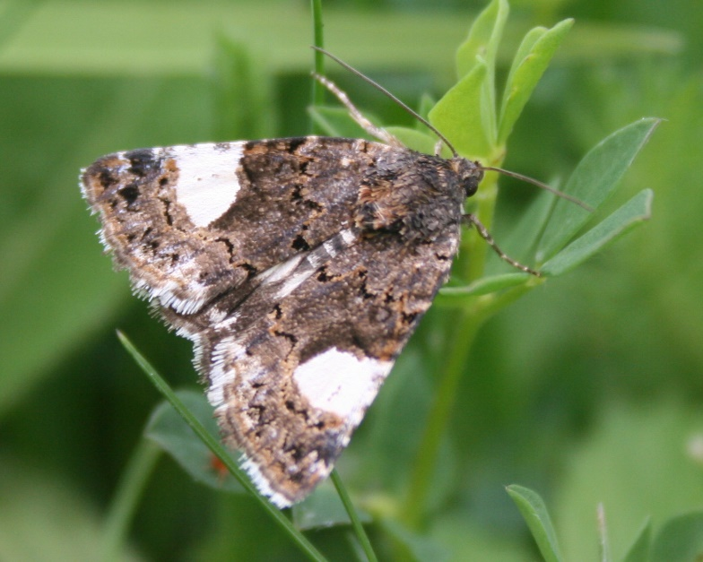

Four-spotted
While nothing can be concluded from an individual record or one good year for a particular species, with Lyndon having been trapped by our group since 2012 and with our changing climate so prominent an issue at the moment, there are two points that are worth making in this respect. Firstly, all our Lyndon records of locally rare moths are of species being seen well to the north of their normal range and often from the south or south-west coast. Secondly, there are moths such as Least Carpet and Square-spotted Clay that are now being recorded in small numbers both in successive years and in more than one locality. I am not a scientist but in our own small way I think that we are contributing some evidence to the climate debate. Another related factor is the big increase we have seen in the various species of Footman moths, which are all lichen feeders and therefore good indicators of air quality in Rutland. It should also be mentioned that all the Peppered Moths we have recorded since 2012 have been of the pale variety, which benefit from the camouflage of lichen-covered trees.
I have condensed the Lyndon figures by splitting them into families with individual highlights which hopefully will make them more digestible. The remainder are mainly day-flying records submitted by individual members.

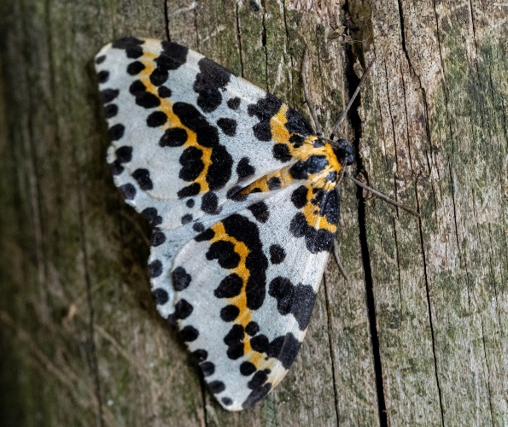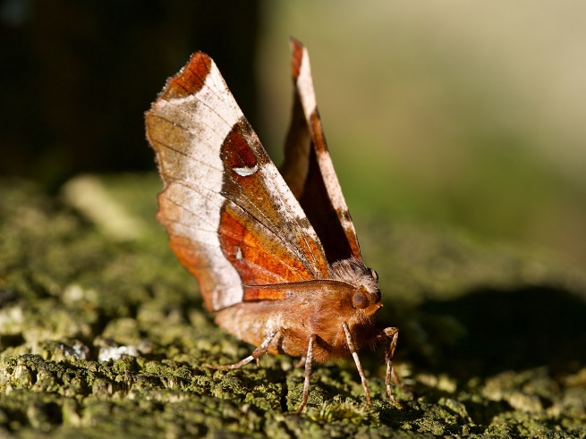

Magpie Moth Purple Thorne

Photographs courtesy Roy Edwards and Peter Scott

RUTLAND MOTH RECORDS 2019 (MISCELLANEOUS)
Dotted Border | Edith Weston | 28th February
Oak Nycteoline | Edith Weston | 20th March
Orange Underwing | Pickworth Wood | 23rd April
Lackey | Stretton Wood | 22nd May
Yellow-tail | George Henry Wood | 23rd May
Emperor Moth | Barnsdale | 25th May
Coxcomb Prominent | Ryhall | 27th June
Clouded Border | Barrow | 3rd July
Large Yellow Underwing | Barrow | 4th July
Copper Underwing | Whissendine | 5th July
Scarlet Tiger | Edith Weston, Market Overton | 11th July
Dark Arches | Langham | 14th July
Mottled Beauty | Whissendine | 14th July
Narrow-bordered Five-spot Burnet | Brooke | 14th July
Common Footman | Oakham | 22nd July
Vapourer | Whissendine | 23rd July
Marbled Beauty | Oakham | 25th July
Yellow Shell | Whissendine | 26th July
Cinnabar Moth | Whissendine | 29th July
Old Lady | Oakham | 29th July
Hummingbird Hawk-moth | Exton, Hambleton, Manton, Wing | July-September
Silver Y | North Luffenham, Whissendine | July/August
Riband Wave | Barrow | 3rd August
Beautiful Golden Y | Langham | 4th August
Orange Swift | Langham | 5th August
Clifden Nonpareil | Oakham | 10th September

RUTLAND NATURAL HISTORY SOCIETY
ANNUAL REPORT, LYNDON CENTRE MOTHS 2019
SPECIES DETAILS | Number | Comments
HEPIALIDAE - Swift moths
2 species, 91 moths
Common Swift | 90
COSSIDAE - Leopard and goat moths
1 species, 1 moth
Leopard Moth | 1
DREPANIDAE - Hook tips and lutestrings
4 species, 6 moths
Peach Blossom | 2
LASIOCAMPIDAE - Eggar and lappet moths
2 species, 6 moths
Drinker | 5
SPHINGIDAE - Hawk-moths
5 species, 33 moths
Lime | 1
Eyed | 2
Poplar | 15
Privet | 3
Elephant | 12
SPECIES DETAILS | Number | Comments
GEOMETRIDAE
Sterrhinae - Mochas and waves
7 species, 50 moths
Riband Wave | 17
Least Carpet | 3 | First records for site
Small Scallop | 1 | First record for site
Larentiinae - Carpets, pugs and allies
27 species, 96 moths
Green Carpet | 20
Grass Rivulet | 1 | First record for site
Pugs (8 species) | 30
Ennominae - Thorns, beauties, umbers and allies
17 species, 80 moths
Scalloped Oak | 13
Oak Beauty | 1 | First record for site
Thorns (4 species) | 9
SPECIES DETAILS | Number | Comments
NOTODONTIDAE - Prominents, kittens and processionary moths
8 species, 30 moths
Buff-tip | 8
Prominents (4 species) | 17
EREBIDAE - Tussocks, ermines, tigers and relatives
18 species, 167 moths
Pinion-streaked Snout | 1 | First record for site
Beautiful Marbled | 1 | Rare immigrant, first Rutland record
Ermines (2 species) | 19
Footmen (4 species) | 78
NOCTUIDAE
Plusiinae - Silver & Golden Y's, gems, brasses and allies
5 species, 25 moths
Burnished Brass | 12
Silver Y | 7
Eustrotiinae
1 species, 1 moth
Marbled White Spot | 1 | First record for site
Acronictinae - Daggers
3 species, 11 moths
Coronet | 4
Amphipyrinae
1 species, 3 moths
Copper Underwing | 3
Psaphidinae
1 species, 1 moth
Green-brindled Crescent | 1
Heliothinae - Straws and clovers
1 species, 4 moths
Bordered Sallow | 4
Xyleninae
35 species, 437 moths
Dark Arches | 121
Uncertain | 54
Treble Lines | 42
Common Rustic | 35
Hadeninae - Brocades, quakers & leaf-eating wainscots
12 species, 356 moths
Small Quaker | 188
Common Wainscot | 66
Common Quaker | 30
Noctuinae - Darts, yellow underwings, clays and allies
14 species, 529 moths
Setaceous Hebrew Character | 106
Square-spot Rustic | 87
Heart & Dart | 54
Yellow Underwings (5 species) | 209
NOLIDAE
1 species, 1 moth
Short-cloaked Moth | 1
SPECIES DETAILS | Number | Comments
MICRO MOTHS
TINEIDAE
1 species, 1 moth
Nemapogon clematella | 1
YPONOMEUTIDAE
1 species, 13 moths
Bird Cherry Ermine | 13
PLUTELLIDAE
1 species, 2 moths
Diamond-back Moth | 2 | Immigrant
BLASTOBASIDAE
1 species, 1 moth
Blastobasis adustella | 1
TORTRICIDAE
21 species, 104 moths
Acleris forsskaleana | 23
CRAMBIDAE
23species, 218 moths
Chrysoteuchia culmella | 55
Crambus perlella | 34
Mother of Pearl | 22
Water Veneer | 18
Rusty-dot Pearl | 2 | Immigrant
Recorder: Paul Bennett

