Rutland Natural History Society
ORTHOPTERA ANNUAL REPORT 2020 Recorder: Phil Rudkin

This season will never be forgotten, I am sure! Covid-19 virus resulted in a country-wide lock-down from 23 March 2020, that altered many things! There were no new species recorded for the May-June period. However, six members were involved in areas of Rutland near their homes. The Wing village allotments were well covered by the tenants. Manton, Ketton Quarries, and the Bloody Oaks nature reserve were visited.

I was contacted (via Nature Spot), by a non-member who was carrying out surveys around the Eye Brook Reservoir, and I received some particularly good images of the Orthopterans. The reporter agreed to check the Rutland side; and sent in some records as a result. This was important because we have not had records from that region for many years.

During the July, August, and September period, when we were released to go further I at last got started, on 30 July. The annual orthoptera surveys at Rutland Water were carried out on the Lyndon reserve on 1 September; and the Egleton reserve on 9 September. It was pleasing to report that several new sites elsewhere in Rutland were found, which will be listed in the species accounts below.

Following normal Orthoptera recording procedure on the species list, new sites only are recorded, with map references, and any unusual occurrences.

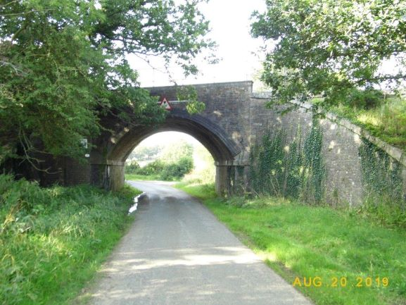

Photo – Phil Rudkin – Pilton near Wing an area for: -
Long-winged Conehead, Roesel’s Bush Cricket Speckled Bush Cricket, Dark Bush Cricket

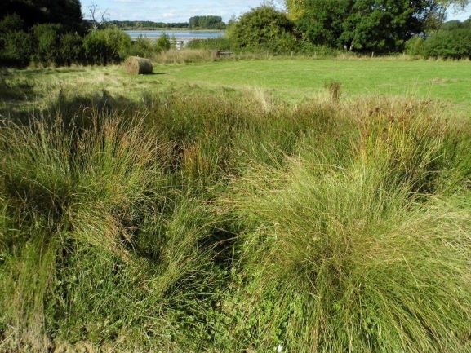

Photo – Phil Rudkin - an area of Junctus near Tufted Duck Hide Lyndon:-
a Short-winged Conehead site

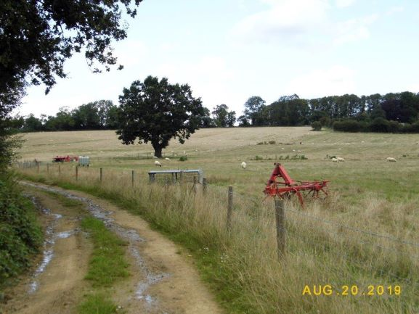

Photo – Phil Rudkin – Wing Fishing Lakes an area for: -
Long-winged Conehead, Roesel’s Bush Cricket, Speckled Bush Cricket, Dark Bush Cricket

Rutland Orthoptera Distribution Maps

We have arrived at a very auspicious moment: the final Rutland Orthoptera Distribution Maps have been updated from 2016 to the present 2020. This was achieved by the ultra-professional, Paul Willoughby-Ellis. Paul has done a magnificent job; and it is much appreciated. There are 14 maps, and I stress FINAL! The first ever distribution maps for the Rutland Natural History Society, were produced from 2007 up to 2011. These were digitised by Elaine Connor, the Ecology Enquiry Officer of the Leicestershire and Rutland Environmental Records Centre, Leicestershire County Council. The maps were printed in the 2013, January ‘Fieldfare’.

After five years, the maps were updated from 2011 to 2016 by Paul Willoughby-Ellis and Richard Brown. These were printed in the 2016 Annual Report: the first to go on-line.
Four years later, the small orthopteran recording team had made a big effort to spread out to areas of Rutland which had little coverage. Paul updated the maps to the present day, 2020. These brilliant charts represent the culmination of 14 years of extensive survey work, by members in the field.
I leave these maps as my legacy, to the Rutland Natural History Society and future researchers.

Phil Rudkin

In order to gain the best results from these maps produced by
Paul Willoughby-Ellis they have been attached as a separate file.

Many thanks to my contributors during this pandemic year:
Carolyn Baxter, Linda and Anthony Biddle, Tim Caldicott, Linda Clark, Roy Edwards,
Craig Mabbett, Marian Markham, Diana Masters, David Needham, Lloyd Park,
Philip Rudkin, Peter Scott, Jayne Walker.

Crickets

Oak Bush Cricket, Meconema thalassinum
One male, in a member’s kitchen, Windsor Drive, Oakham. 12 August. SK854083

Dark Bush Cricket, Pholidoptera griseoaptera
A pair, observed on the verge at Luffenham Road, Barrowden. 13 July. SK946004.
A large colony found in the extensive nettle-bed, in front of the Badger Watching Hide, Egleton Reserve, Rutland Water. 9 September. SK879073.

Roesel’s Bush Cricket, Roeseliana roeselii
Circa 58 stridulating males, in grass verges along a lane outside Preston village. 30 July. SK873024.

Speckled Bush Cricket, Leptophyes punctatissima
A female, found in a member’s garden, Exton village. 29 July. SK925109.
A male, found in a member’s garage, Oakham. 31 August. SK864096

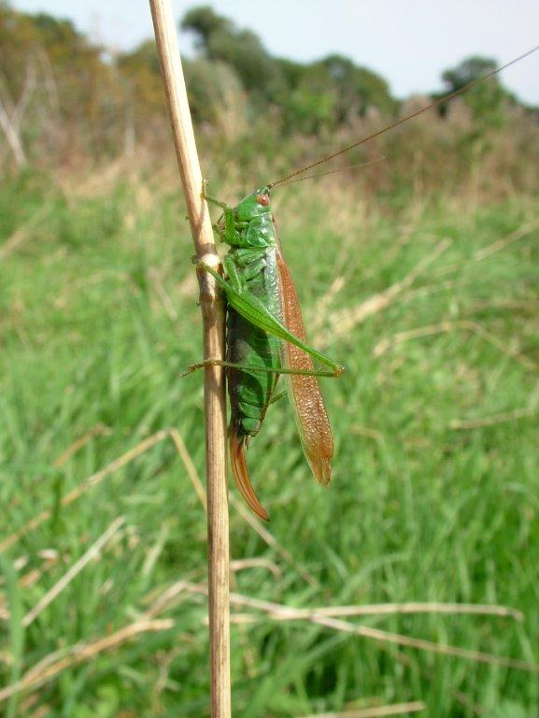

Photo – Phil Rudkin – Short-winged Conehead

True Crickets

House Cricket, Acheta domesticus
Stridulating male found in a single-story extension, 9.30pm. 24 August. Heard again
on 2 September, 8.45pm. Lammas Close, Braunston. SK833066.

Groundhoppers

Common Groundhopper, Tetrix undulata
One found in Wing village allotments, 4 September. SK889028

Grasshoppers

Meadow Grasshopper, Chorthippus parallelus
One nymph observed in Cribbs Meadow nature reserve, 19 July. SK899188.

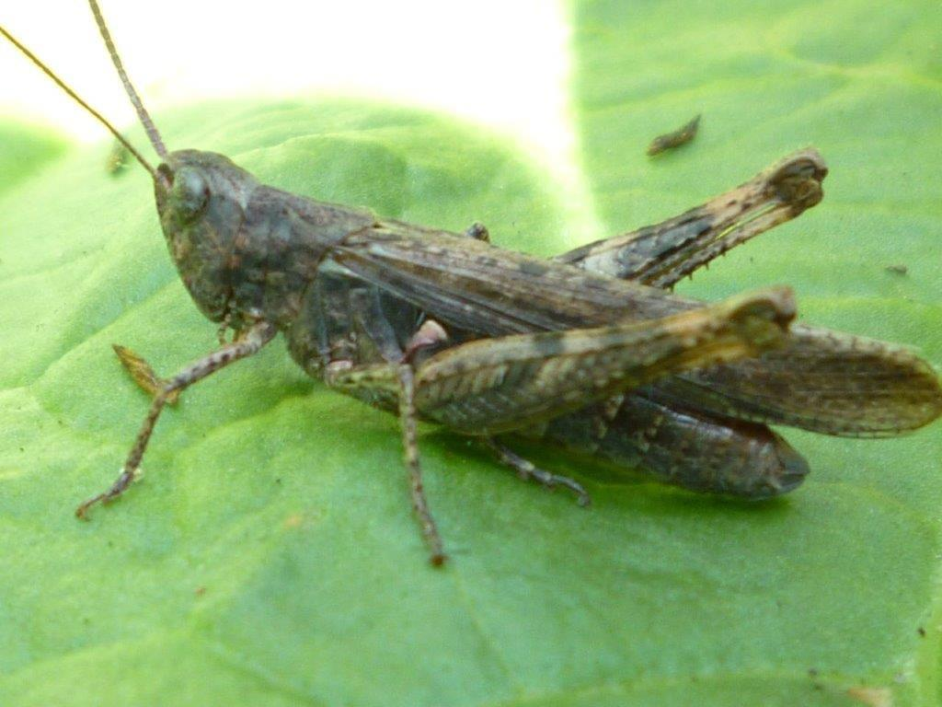

Photo – Phil Rudkin – Field Grasshopper

