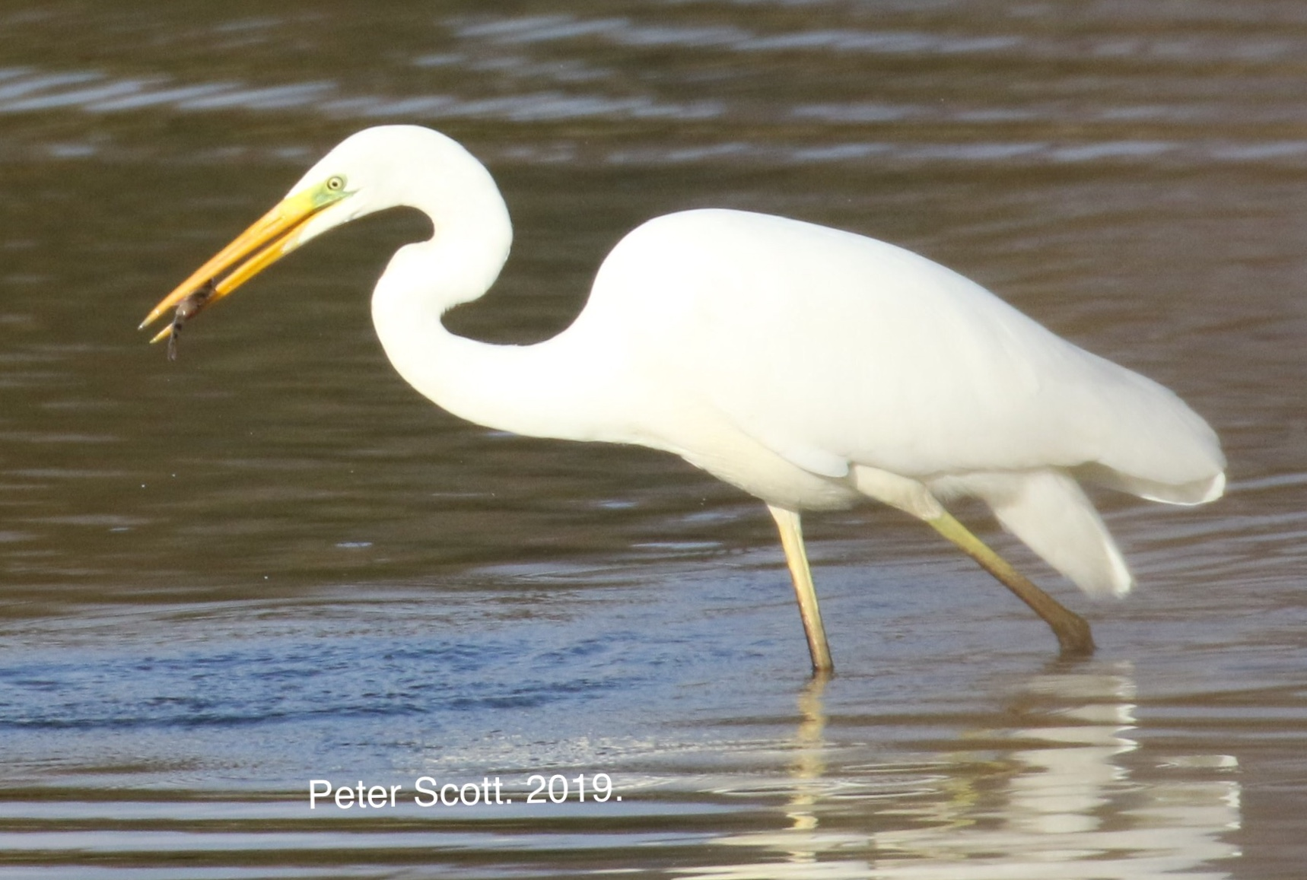
Indoor events (black) are held at the Hub (Voluntary Action Rutland, Lands End Way, Oakham LE15 6RB). Visitors welcome.

Rutland Natural History Society.

Annual Programme 2020

Outdoor events (green) for full details see our website: www.rhns.org.uk. If the weather is bad check the website or call the ‘Queries’ phone number for changes.
Please note All outdoor events are likely to be on rough or muddy ground so be sure to wear suitable footwear and clothing, and carry drinks and suncream etc. to suit weather conditions.

Tuesday 7 January 7.30pm Goshawks to Humpbacks. By Richard Baines.
Richard, an experienced ornithologist, naturalist and wildlife guide will speak about the varied habitats and wildlife of the North Yorkshire Moors and coastline.

Sunday 12th January. 10am. A Winter Walk. Exton Park.
Leaders. Linda and Anthony Biddle. Meet at the Trout Farm, Exton Park, between Exton and Empingham. Map Ref. SK951105. Park with care on roadside verge, by the stile next to the Trout hatchery.
Queries. Linda Biddle. 01780762108/07749636919. abiddle21@talktalk.net

Tuesday 4th February 7.30pm. Northamptonshire’s changing flora. By Brian Laney.
Brian Laney is a self-taught botanist who is joint recorder for plants and recorder for reptiles and amphibians in Northamptonshire.

Saturday 22nd February 10.00am. Winter Birds at Vine House Farm.
Leader. Nicholas Watts. Keen environmentalist farmer and producer of bird foods on a large scale. Meet at Vine House farm main entrance, off the A1175, Main road, Deeping St Nicholas, Spalding. PE11 3DG.
Queries. Jayne Walker 07957340545. jayne8586@hotmail.com

Tuesday 3rd March 7.30pm. AGM and Bird Migration and Ringing. By Lloyd Park.
The Society’s AGM followed by a talk by Lloyd Park.
Lloyd is reserves officer at RWNR. Well known to members he is an experienced licensed bird ringer and was the youngest person to qualify as a bird ringing trainer.

Saturday 14th March 10.00am. Migrant Birds. Rutland Water.
Meet at Anglian Birdwatching Centre Egleton. Map Ref SK879071 LE15 7RT. AW Permit may be needed. £5 for LRWT members Queries. Linda Biddle, as January.

Tuesday 7th April 7.30pm. Meadows. By Joe Costley of Plantlife.
Joe is reserves officer for Plantlife and has visited us before to tell us about the work of Plantlife. He also introduced and supervised our annual botany surveys of Seaton Meadows until nesting curlews prevented us from continuing.

Sunday 19th April 9.30am - 12.30pm. Migrant Birds of Tunnely Wood.
Leader Terry Mitcham. Meet at the NW corner of Tunnely Wood, park on the verge or area of hard standing just west of corner. (Map Ref. SK 931124) members can drive up and need not walk in from Exton Village Queries. Jayne Walker as February.

Saturday 2nd May. 3.45am. Dawn Chorus.
Booking essential Meeting place and Map ref withheld until leaders contacted
Leaders. Linda and Anthony Biddle. Warm clothing suitable footwear and a torch essential. A picnic chair, hot drink and breakfast also recommended! Queries. Linda Biddle, as January.

Saturday 16th May. 10.30am. Hampton nature Reserve. (Froglife reserve)
Leader Ross Edgar of Froglife. Hampton reserve is on Natures Way off Lincoln Road and Werrington Parkway in Peterborough. Meet along Natures way on a short track on the right hand side, which is almost opposite the turn for West Lake Avenue. (Map Ref. TL1648294309 ) PE78FW
Queries. Jayne Walker as February.

Saturday 20th June. 12noon. Wild Flower Walk. Merry’s Meadows.
Leader John Bristow. Conservation Officer LRWT. Meet on Thistleton Lane at the entrance track opposite Great Lane from Greetham Village. Please note that Great Lane is gated so the meeting place is not directly accessible from Greetham village. (Map Ref. SK9280615463). Queries. Jayne Walker as February.

Saturday 4th July. 10am. Flora of Cossington Meadows.
Joint meeting with LRWT local group
Investigate the wonderful wetland wildlife of this important Soar valley site
Leader Chris Hill LRWT Conservation Officer. Meet at the main entrance along Syston Road in Cossington. (Map Ref. SK 5951131) Nearest postcode is LE7 4UZ. Queries. Jayne Walker as February.

Saturday 25th July. 10.30am - 12 noon. 1.30pm - 3pm. Family Bug Hunt.
Exploring nature for children of all ages
Booking essential. Children must be accompanied by a responsible adult
Meeting at the Scout Hut, Pit Lane Ketton MR SK977055 Contact Jayne Walker or Linda Biddle

Saturday 8th August 11am. Butterflies and Insect walk. Ketton Quarry.
Leader Our RNHS butterfly recorder Richard Brown. (Map Ref. SK978053) PE9 3SZ
Queries Jayne Walker as February.

Friday 11th September 7.00pm. Bat Walk.
Leader. Jenny Harris, our RNHS bat recorder. Meet at 19.00 at Lyndon LRWT Visitor Centre located down a lane from the Manton to Edith Weston Road opposite the turn to Lyndon Village. As part of the walk will take place after dark bring a torch, warm clothing and a bat detector if you have one.
Queries. Jenny Harris 01572755274/07897123566. jennyharris221@gmail.com

Tuesday 6th October. 7.30pm. Recent Ramblings of a wildlife photographer. By John Tinning.
John has been a keen birdwatcher and naturalist all his life. He developed a special interest in natural history photography after he met and accompanied Martin Withers on many photographic jaunts into the E Midlands countryside

Friday 9th October 10.00am. Fungal Foray.
Leader. Ben Devine LRWT conservation officer. Hambleton Wood Rutland Water. Meet at the LRWT training centre. Right hand turn off the road into Hambleton village, small sign ‘VTC.’ ( Map Ref SK883083 )
Queries Jayne Walker as February.

Tuesday 3rd November 7.30pm. Birds of the water - underwater filming. By Jack Perks.
Jack Perks is a professional wildlife photographer who has appeared on Springwatch and other programmes.

Saturday 14th November. 10.30am. Winter Birds. Attenborough Nature Reserve.
Meet at the Attenborough Nature Reserve Café entrance, Barton Lane, Attenborough, Nottingham NG9 6DY. Map Ref SK516339 The centre and reserve is situated just off the A6005 between Beeston and Long Eaton.
Queries Jayne Walker as February

Tuesday 1st December 7.30pm. Members/Recorders evening.
As usual members will update on events of 2020, and we will see the entries to the photographic competition

