Rutland Natural History Society.
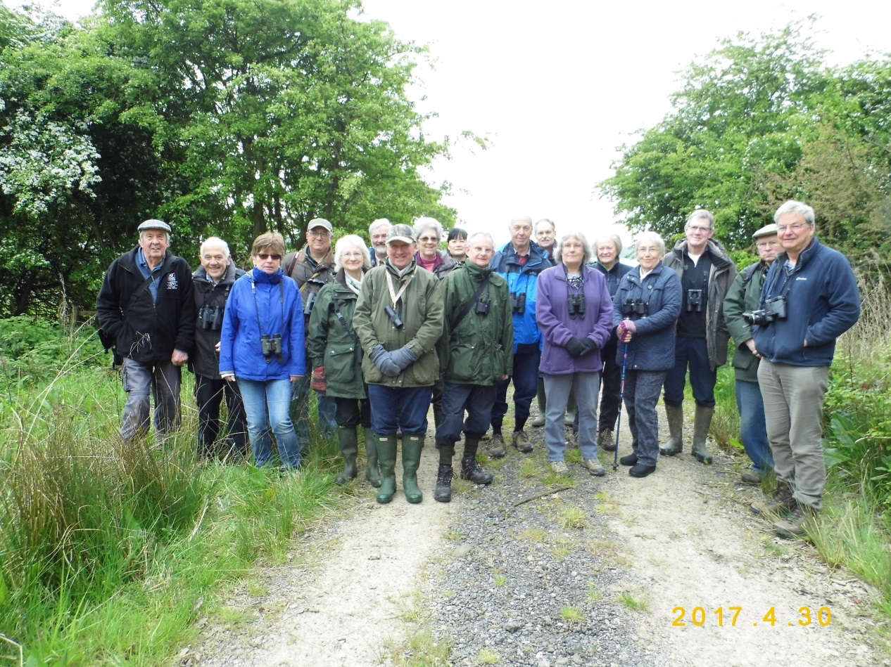
BURLEY WOODS, Oakham, Rutland
Field Meeting. Sunday 30 April 2017. 9.30am.
Leader: Philip Rudkin
Entry, by kind permission of: Mr. Joss Hanbury, the Society’s President.

On the last day of April; a cool, dry morning, with 5/8 cloud, and a force 3 wind, 19 members of Rutland Natural History Society assembled at the entrance gate to Burley Woods. The leader Phil Rudkin gave a brief outline of what to look out for, and the group then set off on their quest.

Along the lower woodland ride (heading west), the summer migrant birds: Garden Warbler, Blackcap, Willow Warbler, Chiff Chaff and Cuckoo were in good voice, along with the resident singers: Chaffinch, Wren, Nuthatch, Great and Blue Tits. On the dry muddy track, Anthony Biddle spotted the tiny Slender Groundhopper, where the regular small colony exists.
Reaching the Deer Hide area, new Bat boxes were noted, and Linda Biddle explained the Society’s new project details.

The members then turned right into the next ride, and headed north up the hill, where the fantastic carpet of Bluebells provided a stunning scene, interspersed with the colourful flowers of Bugle, and the white of Greater Stitchwort. The ancient part of the wood proved rewarding, with songs of Tree Creeper, Goldcrest, and more of the warbler species heard earlier; plus sightings of Raven and Buzzard overhead. In this area, the leader took members into the untouched SSSI location, where everyone clustered around the old gnarled trees, to photograph and inspect the rare lichen: Graphis Scripta; a memorable moment indeed!
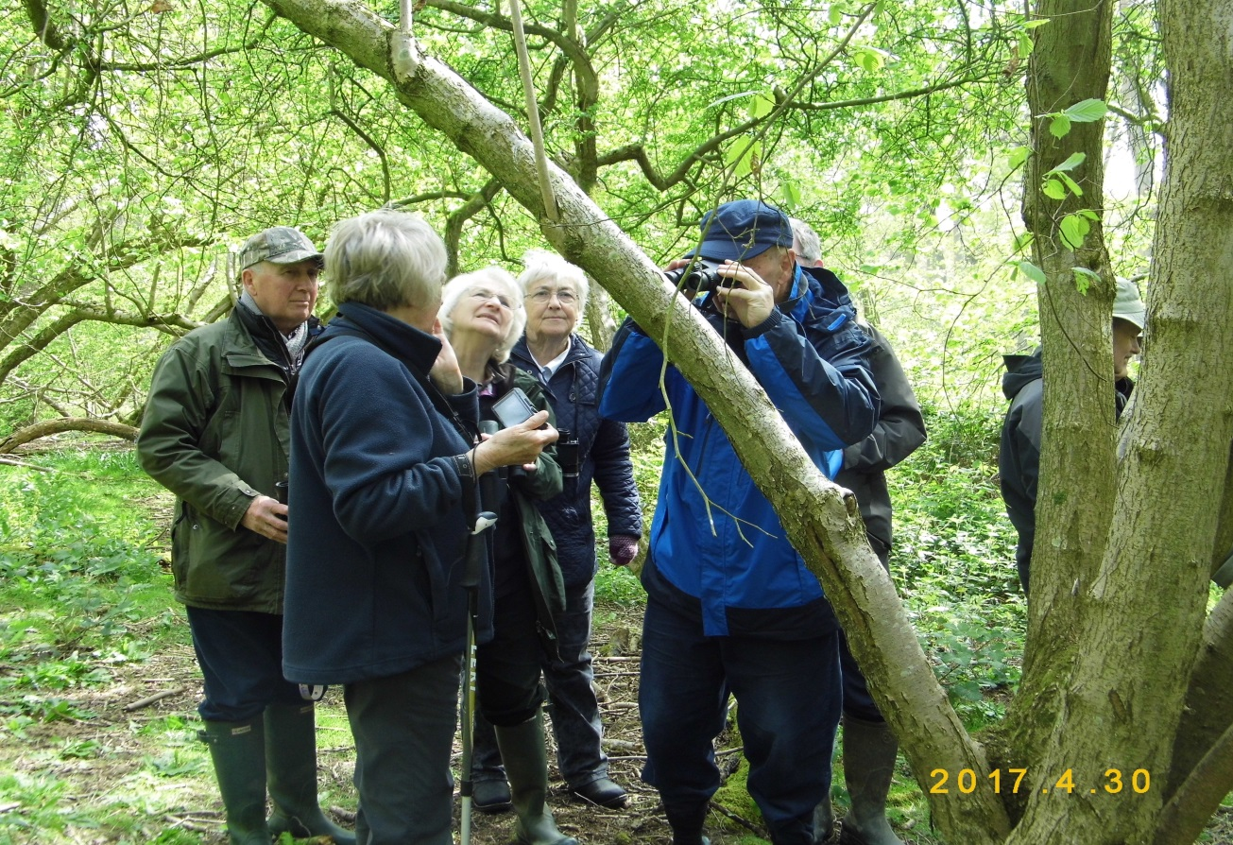
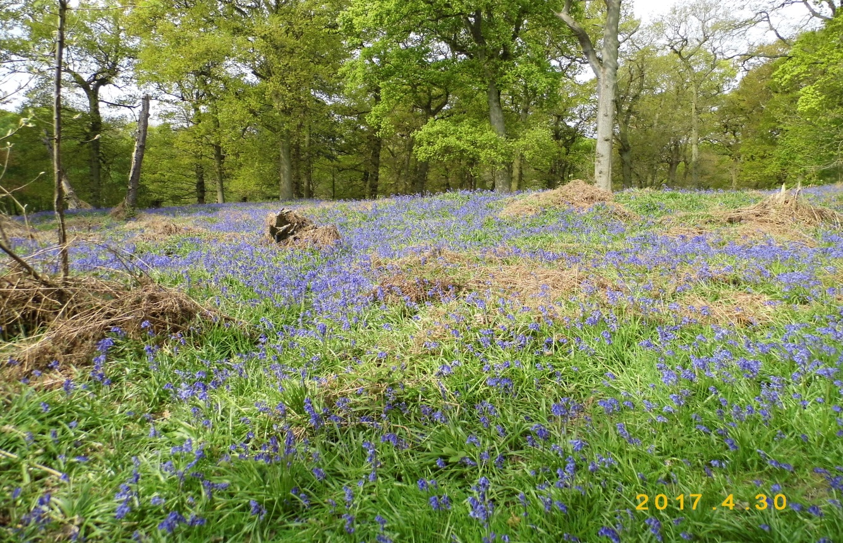
Meanwhile, Galls and Rusts recorder Roy Lemmon had been foraging in the scrub and verges, and his report states: “mushrooms and toadstools were in very short supply, with only one small group of Velvet Shank located. The rusts however, seem to have benefited from the warm winter, and three species produced galls on their respective hosts: Meadowsweet, Bramble and Dog’s Mercury; the latter’s gall was well advanced, causing one stalk to bend parallel to the ground. Roy also noted that snails were scarce (no doubt due to the very dry conditions), but he found the shells of the Kentish snail and the Brown lipped snail”.
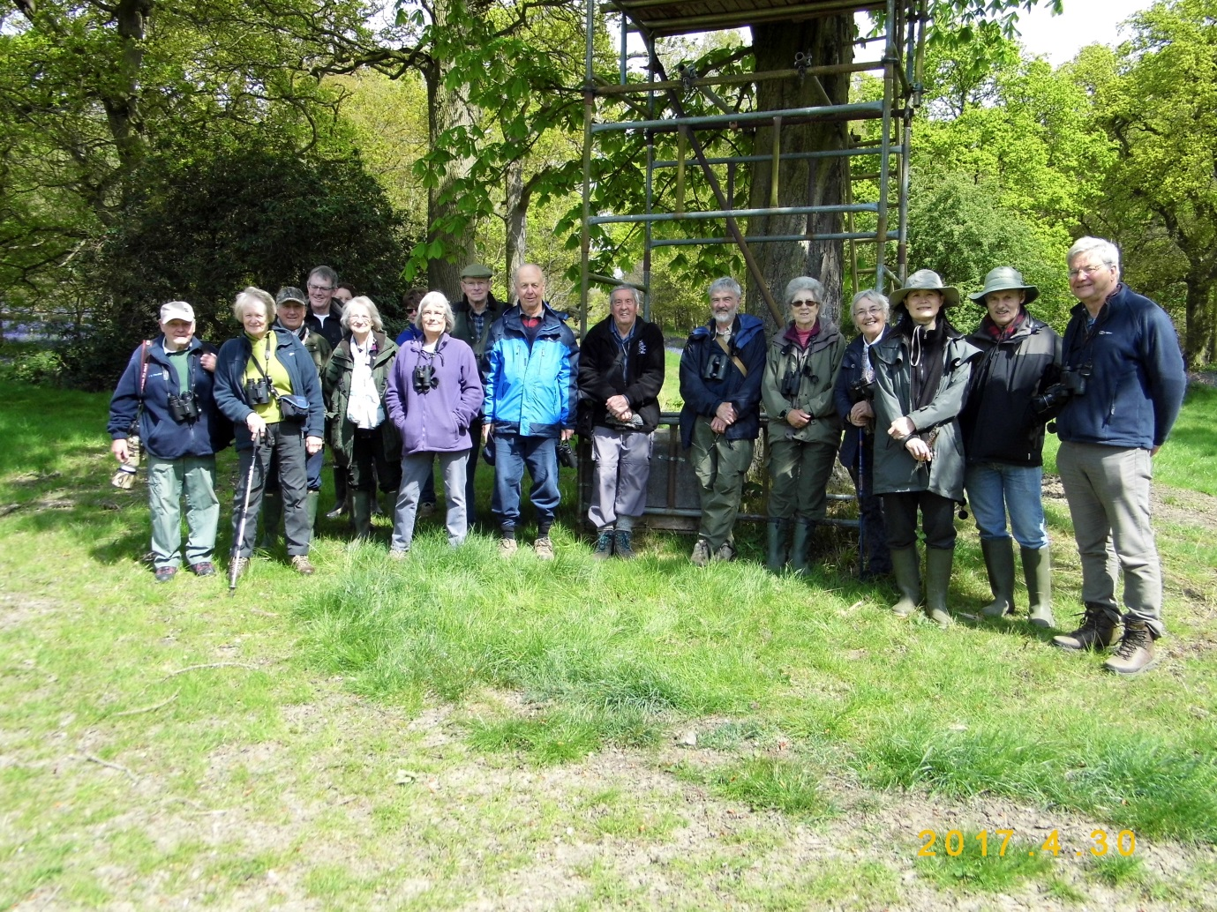
At 11.15am. as the entourage headed down (south-east) towards the Eight Riding Tree, the clouds cleared, and the sun shone; which enticed out the butterflies, including: Orange Tip (males and females), Brimstone (males and females), Peacock, Holly Blue and Comma. Heading along the ride towards the entrance, the final species to add to the list was a Great Spotted Woodpecker, heard ‘drumming’ on the tree trunk.

Phil Rudkin. 3 May 2017

