Rutland Natural History Society
AMPHIBIAN AND REPTILE REPORT
FOR 2023 Recorder Dr C. H. Gallimore

Records were received of all eight indigenous species in 2023, although there were few records for any of the amphibians. Whether this truly reflects abundance however is uncertain. Reptiles, on the other hand fared better. The translocation of Viviparous Lizards from Wing Water Treatment Works in 2007, after 16 years believing it was a failure, now appears to have been a success, as lizards were found in three areas of Lax Hill, at Rutland Waer, whither the translocation took place. In many years there are no records of Slow Worms, although they had been recorded from Burley Wood in 15 out of the last 40 years. Refugia were placed in Burley Wood in 2022 and a thriving population was revealed in a relatively small section of the wood. Our two snake species also seem to be doing satisfactorily.
If, like me, you are not wholly enamoured with the changes from on high of scientific and common names, I have put the old familiar name in brackets after the new(ish) name. [Just thank your lucky stars that you don’t live in America, where there is a move afoot to rename all eponymous bird names in case the person celebrated had links to slavery or had other imperfections.]
Common Frog Rana temporaria
Frogs were recorded at only eight sites in six parishes (Leighfield, Little Casterton, Oakham, Ridlington, Tickencote and Wing) and evidence of breeding was found at only four sites in four parishes (Little Casterton, Oakham, Ridlington and Wing). This equals the lowest number of records of spawn in the last 40 years. The first record of the year was on 18 February in a garden in Oakham. The first spawn was found on the 7 March in a pond at Quarry Farm, Stamford. Although this is near the average date for the first spawn it was not in a garden pond, which usually precede field ponds. Froglets were seen in July in Oakham and Ridlington. The last record of the year was at Prior’s Coppice on 19 October.
Common Toad Bufo bufo
Common Toads were recorded from ten sites in eight parishes (Clipsham, Ketton, Leighfield, Manton, Normanton, Oakham, Wardley and Wing) with evidence of breeding at one site in Wardley when toadlets were seen in July. Toads have not been recorded in Wardley before and nor have they been recorded in Normanton, although there is anecdotal evidence of their presence there many years ago. The first record of the year was not until 9 May at Clipsham and the last was from Prior’s Coppice on 16 October.
Smooth Newt Lissotriton vulgaris (Triturus vulgaris)
Smooth Newts were recorded in Braunston, Hambleton, Oakham and Wing. The first record was on 10 April in Wing and the last on 6 June in Braunston.
Great Crested Newt Triturus cristatus
The only records of Great Crested Newts were two records from Wing, one of a live one in a garden pond on 21 April and the other a road casualty on 1 July.
Viviparous Lizard Zootoca vivipara (Lacerta vivipara)
Viviparous Lizards were found in four parishes (Clipsham, Hambleton, Ketton and Tickencote). They were seen at Bloody Oaks on many occasions between 30 March and 6 October – as many as twelve on one occasion. At Rutland Water, lizards were also seen in various parts of Lax Hill between 11 May and 13 September. These are presumably descendants of the lizards that were translocated from Wing Water Treatment Works in 2007, which was originally thought to have been an unsuccessful translocation.
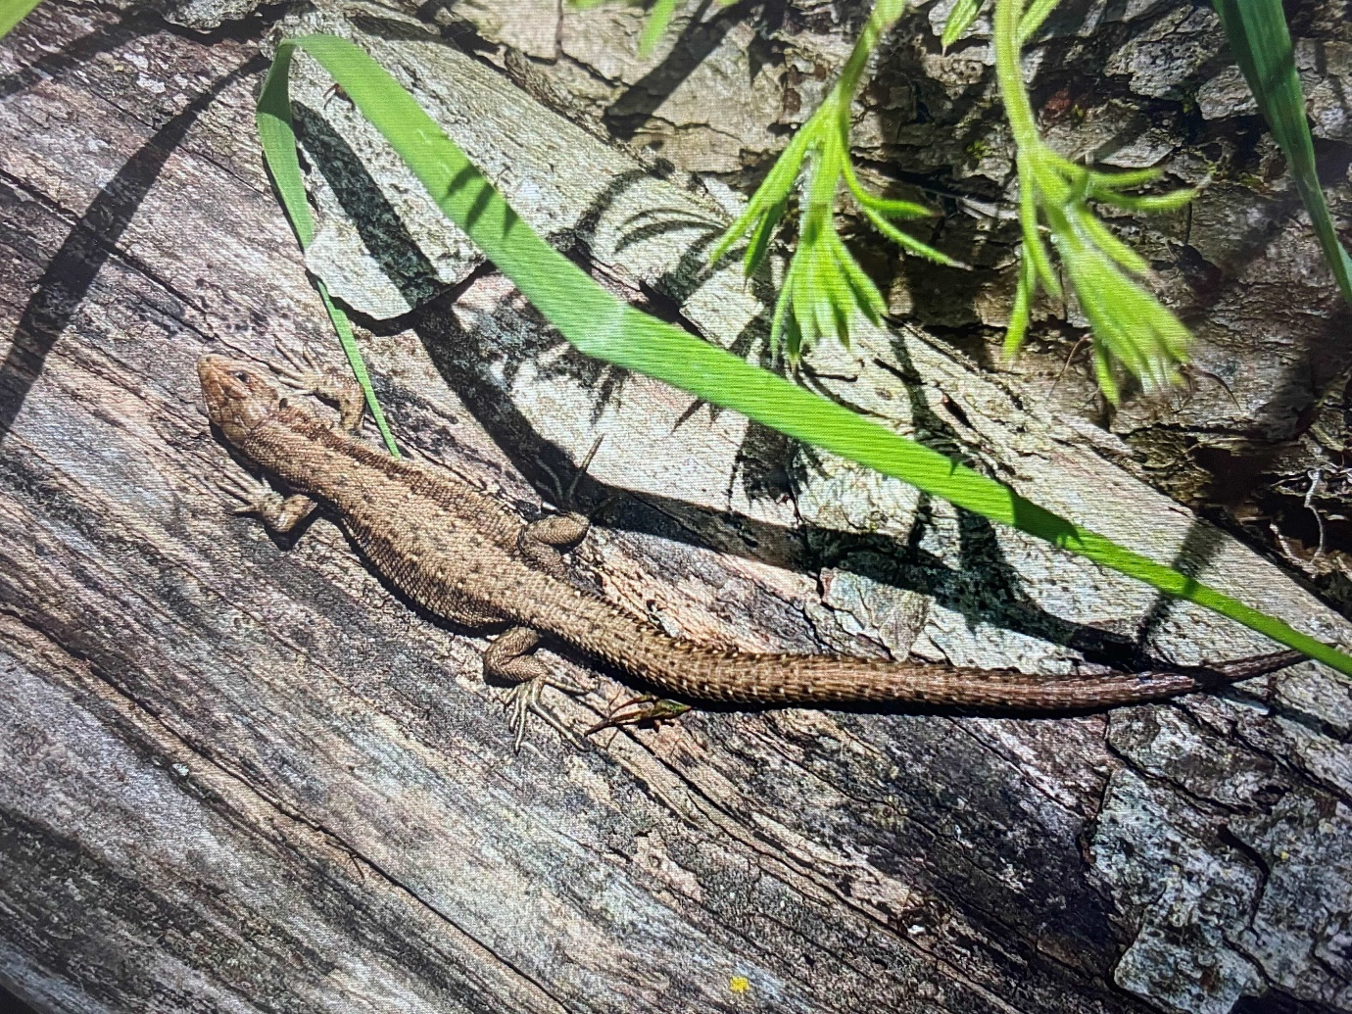
Viviparous Lizard

Slow Worm Anguis fragilis
The reptile refugia that had been placed in a section of Burley Wood yielded very satisfactory results with Slow Worms of various ages being found under six of the 16 refugia with as many as four under one. A minimum of eight Slow Worms were seen between 8 June and 25 August, although clearly there are many more there. A Slow Worm was also found in Berrybutts Spinney, Rutland Water, which is a new site.
Barred Grass Snake (Grass Snake) Natrix helvetica (Natrix natrix)
Grass Snakes were recorded at eleven sites in eight parishes (Barrow, Braunston, Burley, Egleton, Empingham, Hambleton, Leighfield and Wing). The earliest record was from Empingham on 23 March and the last live record from Egleton on 29 July, although a dead one was found in Wing on 20 August. As usual a number of dead snakes were found, one of which was a large female in Braunston with seven eggs.
Adder Vipera berus
Up to four Adders were seen at Ketton Quarry between 3 April and 1 May.
Records were contributed by:-
T Appleton, D & J Ball, C Baxter, T Caldicott, L Clark, J Colaco, R Edwards, C H Gallimore, G Griffin, J Harris, A Hill, D Masters, T Mitcham, J Morrell, D Needham, S Nicol, P Scott, T Sexton, K Walkling and G Williams.

