Rutland Natural History Society

AMPHIBIAN AND REPTILE REPORT 2021 Recorder Dr. C Gallimore

Another year in which lockdown has limited our natural history observations has meant that there have been few records of some species. Amphibians tend to be more obvious in the early months of the year when they are breeding, and Lockdown Three was not helpful. Frog records were thin on the ground again and both species of newt produced a total of just three records. Reptiles appeared a bit more numerous with a thriving population of lizards at Clipsham. However, among those few records were a number of new sites for frogs at Martinthorpe, Smooth Newts at Barrow and lizards at Seaton.

Common Frog Rana temporaria
Frogs were recorded at only twelve sites in five parishes (Exton, Great Casterton, Martinsthorpe, Oakham and Wing) and evidence of breeding was found at five sites in four parishes (Exton, Great Casterton, Oakham and Wing).The first spawn was found on the 11 March in Wing. The first record of the year was on 29 January on a road in Oakham.There have been no previous records of frogs from Martinsthorpe.

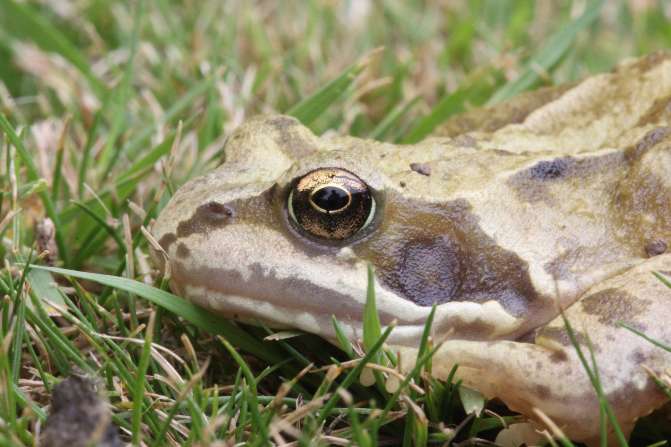

Photo Common Frog © Peter Scott

Common Toad Bufo bufo
Common Toads were recorded from ten sites in six parishes (Barrow, Egleton, Exton, Great Casterton, Leighfield and Wing) with evidence of breeding at three sites in three parishes (Egleton, Exton and Great Casterton). The first record was on 19 March in Great Casterton and the last record was on 30 September in Barrow. The Barrow record was the first from that parish since 1987.

Smooth Newt Triturus/Lissotriton vulgaris
Smooth Newts were only recorded in Wing in a garden pond in June and on the utility room floor of a house in Barrow on the late date of 11 November. This was the first record from Barrow.

Great Crested Newt Triturus cristatus
The sole record of this species was of one in the ringing hut at Rutland Water (Egleton) on 8 April.

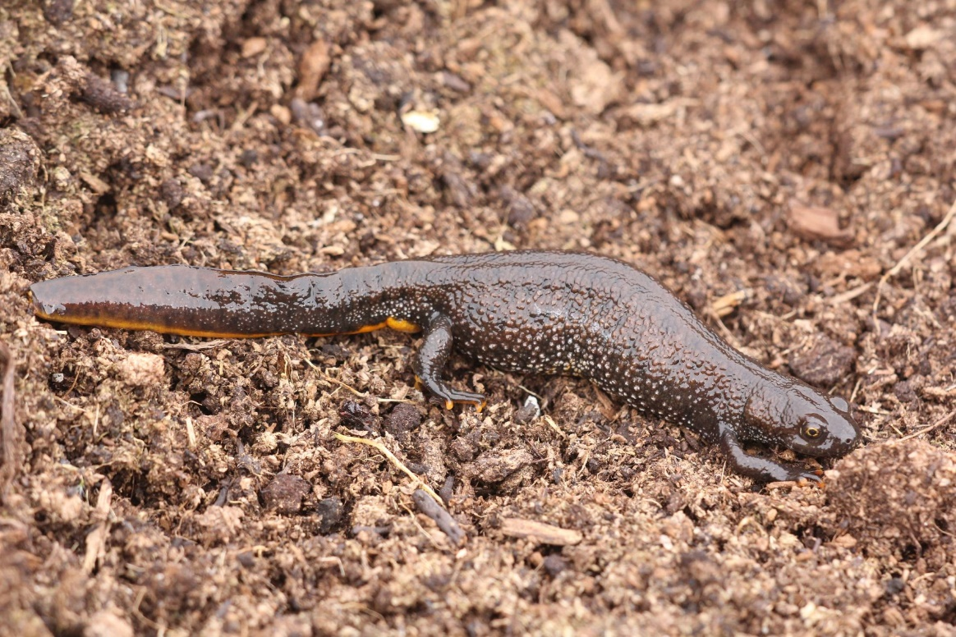

Photo Great Crested Newt © Peter Scott

Viviparous Lizard Zootoca vivipara
Viviparous Lizards were found in four parishes (Clipsham, Ketton, Seaton and Tickencote). The first record was on 12 April at Ketton and the last at Clipsham on 26 September. The Clipsham population appeared very healthy with sightings in various parts of the wood and young seen on two occasions. Lizards have not been recorded from Seaton before and was particularly unusual as it was found on a hall carpet.

Slow Worm Anguis fragilis
There was a single Slow Worm recorded near Burley Wood in April.

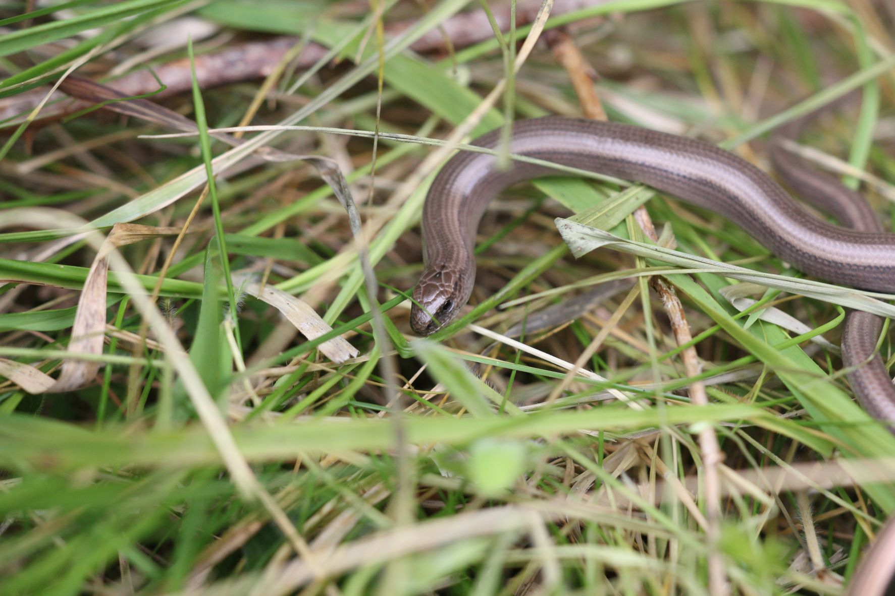

Photo Slow Worm © Peter Scott

Grass Snake Natrix natrix/Natrix helvetica
Grass Snakes were recorded in five parishes (Brooke, Exton, Hambleton, Stoke Dry and Wing). The earliest record was from Rutland Water Nature Reserve on 7 May and the last in Wing on 27 Oct. There were many records from Wing village especially in and near the allotments.

Adder Vipera berus
Adders were seen at Ketton Quarry in two areas on 9 and 12 April.

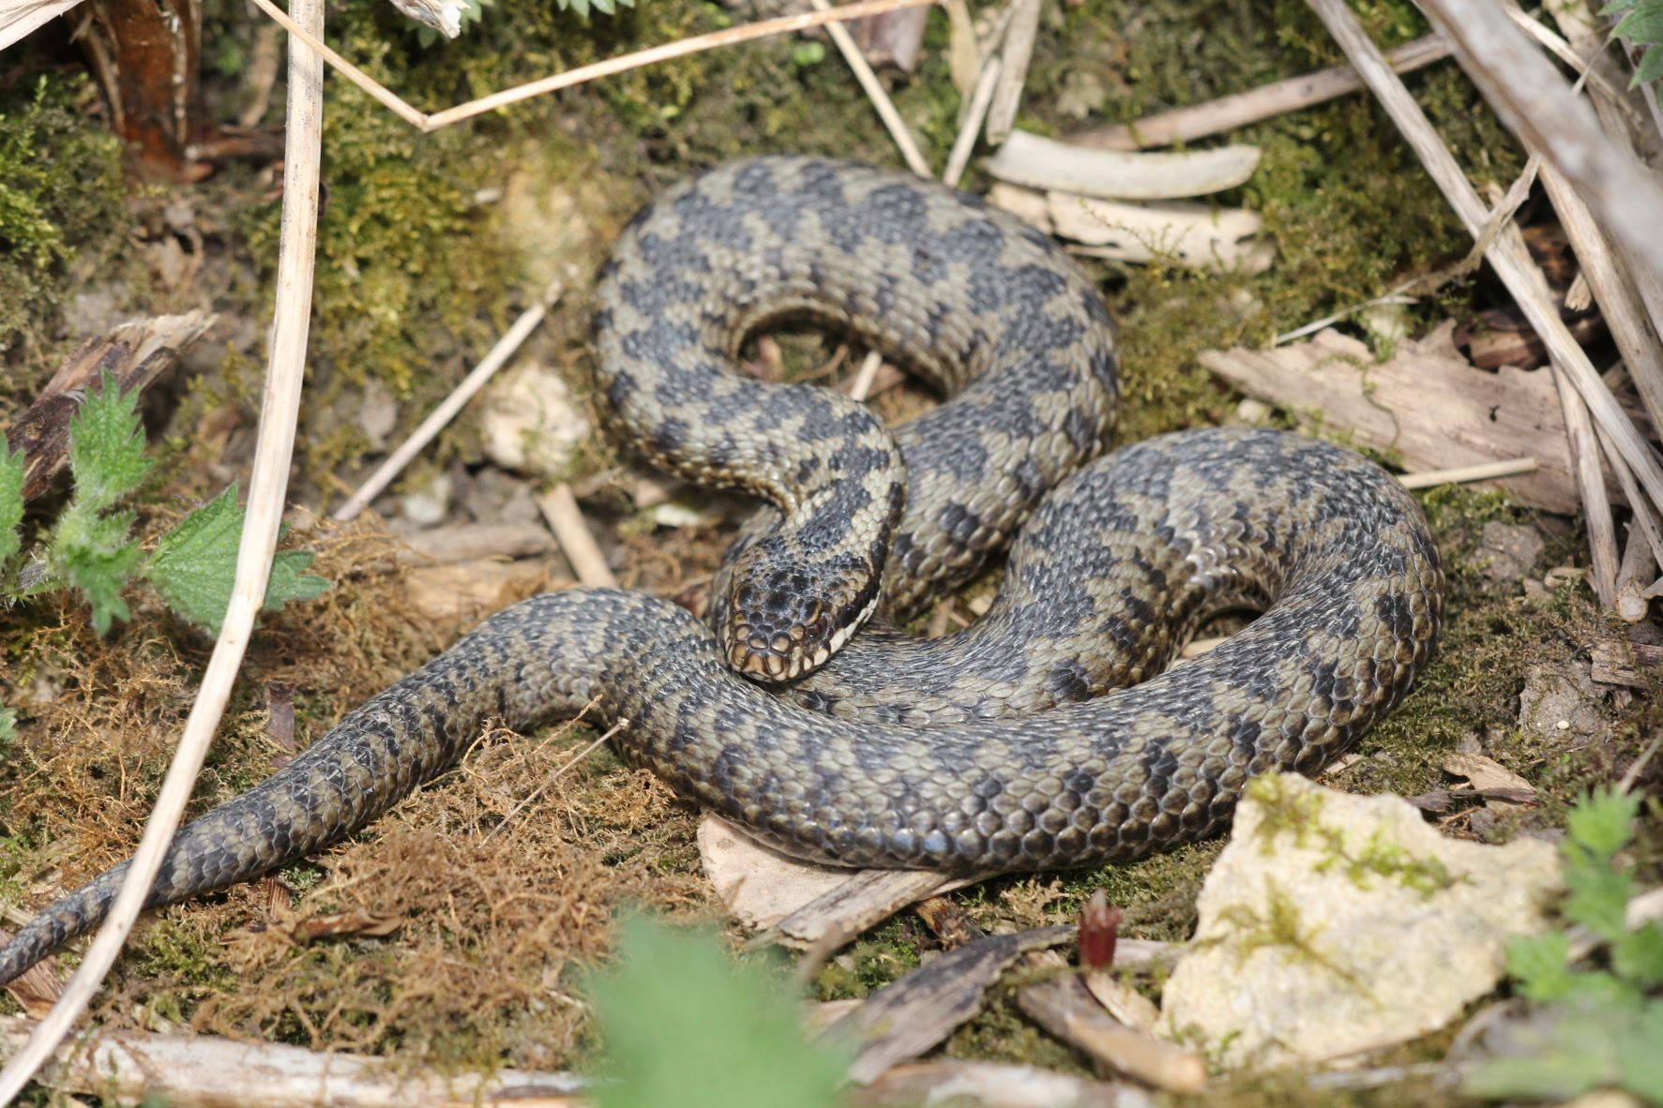

Photo Adder © Peter Scott

Records were contributed by:_
T Appleton, D & J Ball, T Caldicott, L Clark, I Day, R Edwards, M Grimes, A Hill, J Harris, P Langston, R Lemmon, D Masters, T Mitcham, D Needham, P Scott, T Sexton and C Tring.
Dr C H Gallimore

