**ANNUAL REPORT – BUTTERFLIES 2019**

**OVERVIEW**

2019 was a good year for Rutland’s butterflies. The season started well, with 5 species on the wing in February, fully a month earlier than 2018. Last observations were in October, with 4 species seen, compared to 5 in 2018. In 2019 we had no observations at all in November/December, in contrast to two singletons seen in November 2018 (Red Admiral) and December 2018 (Small Tortoiseshell).

Overall, during the year 32 species were observed. Notable species present included a Purple Emperor, a Black Hairstreak, and no less than three Clouded Yellows. Notable absentees included the White Admiral, and the Chalkhill Blue.

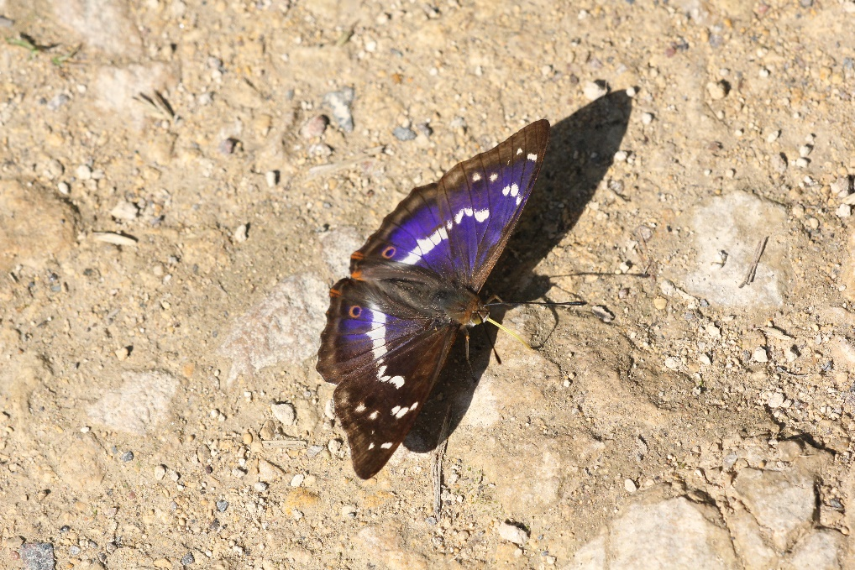

Purple Emperor

Among the Nymphalidae the happiest finding was of a single Purple Emperor. This continues our recent sequence, there having been a single at Rutland Water in 2014, another single in 2015, none in 2016, three singletons in 2017 (at Clipsham and Pickworth), and none in 2018. The 2019 finding was again at Pickworth. Note the preponderance of our observations to the north-east of the county, which corresponds to the sightings of the species in south-west Lincolnshire.

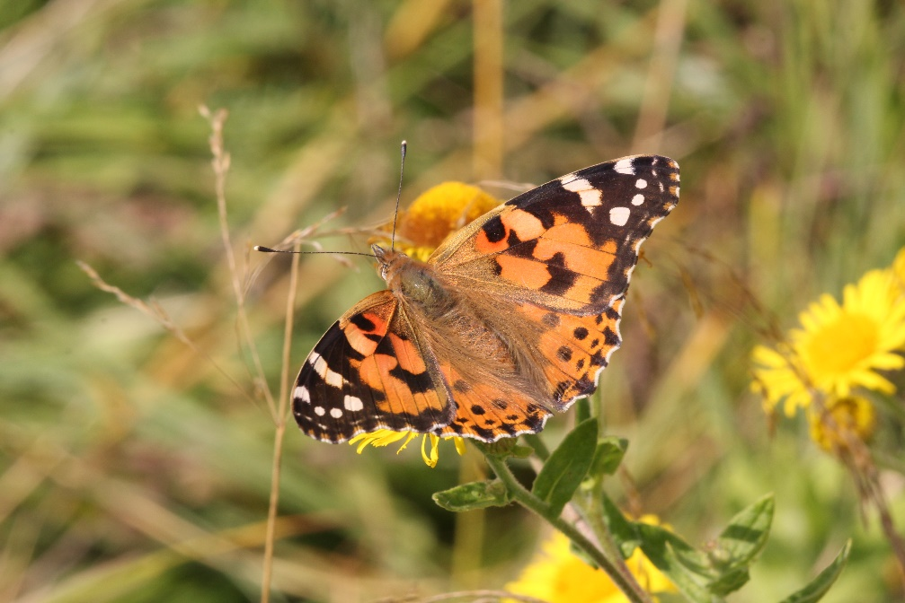

Painted Lady

2019 proved a moderate year for Painted Lady migration, with double the number of sites and records compared to 2018, though never any large numbers during any one sighting. Peacock, Red Admiral, Comma and Small Tortoiseshell all had a much better year than 2018. Our two Fritillaries remain confined to their traditional sites in quarries and at Bloody Oaks. More striking is the number of Dark Green Fritillaries now to be found – 70 plus at Bloody Oaks, 45 at Clipsham and 20 plus at Ketton. Remarkable for a species that only began to be regularly found in Rutland from 2010 onwards.

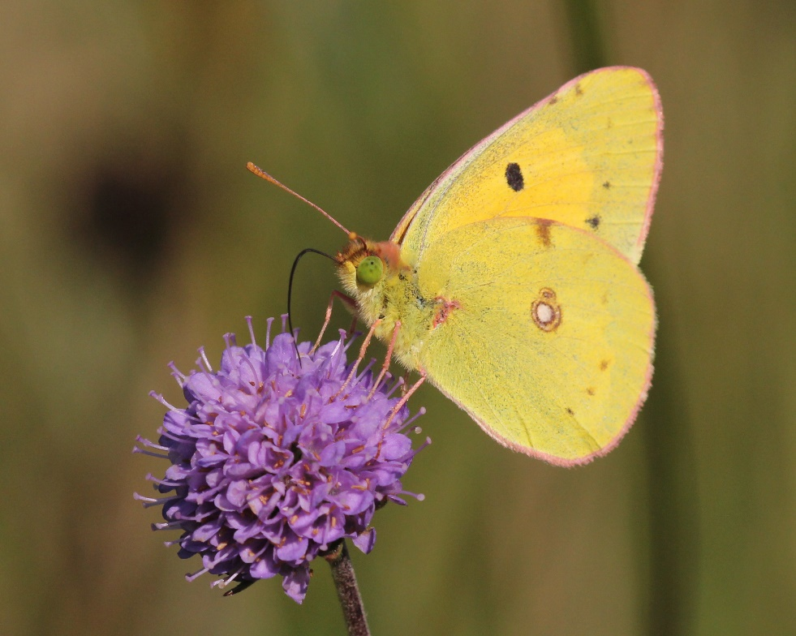

Clouded Yellow

Among the Pieridae the striking event of the year was the arrival of three Clouded Yellows, including one unusually early in the year on 21st April. Brimstone, Large White and Orange Tip fared as usual, but both Small White and Green-veined White had poor years.

The Nymphalidae had a moderately successful year, with numbers and sites for Gatekeeper, Meadow Brown, Ringlet, Small Heath and Marbled White all better than usual. Only the Speckled Wood showed no increase over 2018.

The Hesperidae, Skippers, remain relatively scarce in Rutland. Dingy Skippers are still only found at 4 sites, though with good numbers (between10 and 20) at three of these sites. Grizzled Skipper is found at three sites, with small numbers at each site. Large and Small Skippers remain uncommon, and the Essex Skipper was only identified once, as in 2018. It is not difficult to believe that a close look at the antennae of a few “Small Skippers” might boost the Essex numbers a bit. And of course no sign of the Chequered Skipper…..yet?!

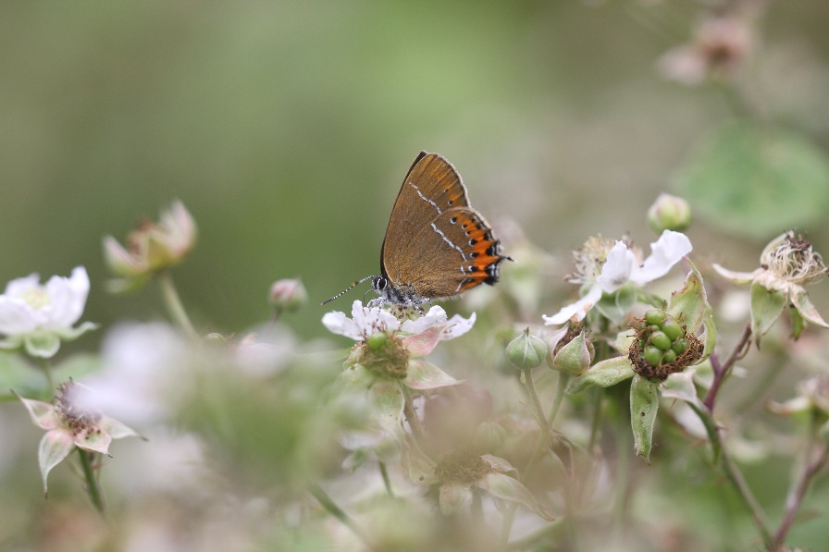

Black Hairstreak

Finally, the Lycaenidae, that is the Hairstreaks, Coppers and Blues. 2019 has been notable for the finding of 3 species of Hairstreak. As in 2018 Ketton Quarry provided the single sighting of Black Hairstreak, and Ketton remains the stronghold of the Greens. Single examples of Purple Hairstreak were observed only twice. The Society has had no observation of White-letter Hairstreak since 2017. Other species in the group, that is Brown Argus, Small Copper, Holly Blue and Common Blue had an unremarkable year. One disappointment was the absence for yet another year of the Chalkhill Blue from its former colony at Bloody Oaks Quarry. The last record of the species there now goes back to 2016.

As usual an acknowledgement to the contributors to this report – both the number of contributors and the number of their records are increased this year, a welcome trend for which many thanks.

**Richard Brown**

**Photographs: Peter Scott (All taken at sites outside Rutland)**

**SUMMARY OF ANNUAL OBSERVATIONS**

|  |  |  |  |  |  |  |  |  |
| --- | --- | --- | --- | --- | --- | --- | --- | --- |
|  | 2012 | 2013 | 2014 | 2015 | 2016 | 2017 | 2018 | 2019 |
| Number of species recorded | 29 | 33 | 32 | 31 | 30 | 30 | 31 | 32 |
| No. of recorders contributing |  |  | 45 |  | 16 | 17 | 19 | 27 |
| No. of sites from which records received |  |  | 48 |  | 37 | 40 | 33 | 52 |
| Total no. of records received |  |  | 727 |  | 686 | 435 | 446 | 523 |