Rutland Natural History Society

AMPHIBIAN AND REPTILE REPORT
FOR 2022 Recorder Dr C. H. Gallimore

Records were received of all eight indigenous species in 2022. No new sites were discovered, but some species were recorded after long absences, such as Common Toad in Stoke Dry and Smooth Newt in Ridlington, which had both eluded observation for 50 years. Focused searches for reptiles and amphibians in Burley Wood and Wing Water Treatment Works were unrewarding, but both species of newt were still doing well in the ponds of Rutland Water Nature Reserve.
With only eight species in these two Classes in Rutland, plus the occasional introduced species, one would have expected the scientific and common names to have changed little in the 38 years that I have been recorder. However, two reptiles and one amphibian have had their scientific name changed (37.5%) and one reptile has had its common name enlarged. I am uncertain whether all these name changes are universally accepted, or indeed necessary, or whether they create confusion or clarity. I will put the old familiar name in brackets after the new name in this report.
(I still use abbreviations of the scientific name in the same way as common names are used by the BTO, e.g. BT for Blue Tit. Unfortunately, Lv for Lacerta vivipara, Viviparous Lizard, now stands for Lissotriton vulgaris, Smooth Newt, so I am sticking with the old names for personal use).

Common Frog Rana temporaria
Frogs were recorded at only 13 sites in nine parishes (Braunston, Burley, Essendine, Exton, Leighfield, Little Casterton, Oakham, Ridlington and Wing) and evidence of breeding was found at nine sites in seven parishes (Burley, Essendine, Exton, Little Casterton, Oakham, Ridlington and Wing). The first record of the year was on 30 January in a garden pond in Wing. The first spawn was found on the 8 March in garden ponds in Oakham. Usually, the first spawn in field and other non-garden ponds occurs a week or two later, but in 2022 spawning occurred in Burley Wood by 12 March and Quarry Farm on 13th. It is 17 years since Frogs have been reported from Ridlington.

Common Toad Bufo bufo
Common Toads were recorded from 13 sites in eight parishes (Barrow, Braunston, Hambleton, Leighfield, Pilton, Ridlington, Stoke Dry and Wing) with evidence of breeding at two sites in two parishes (Leighfield and Ridlington). The first record was on 14 January in Wing, when one was found by an Openreach engineer in a drain. The last record was on 5 October when a road casualty was observed in Wing. Although there have been occasional records from Ridlington, this is the first time there has been proof of breeding. The last record of a Toad in Stoke Dry was exactly 50 years ago in 1972.
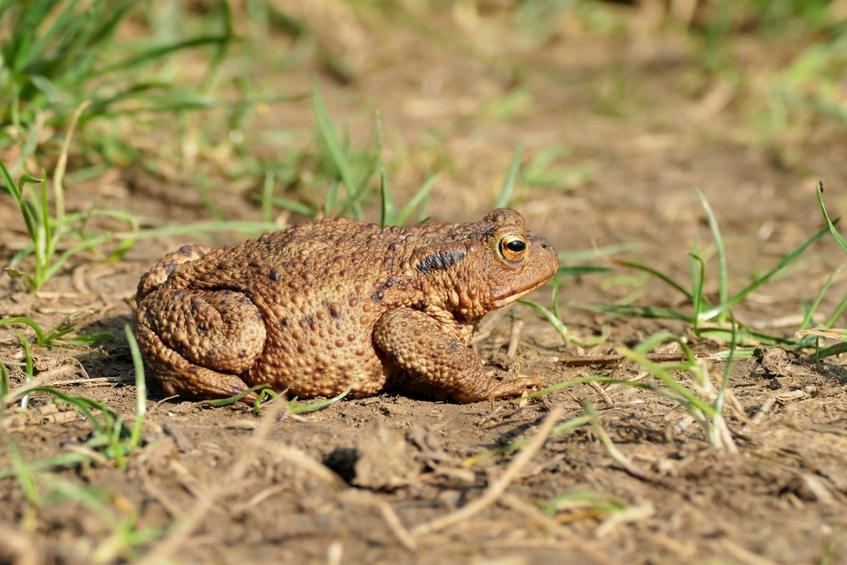
Photo Common Toad © Carolyn Baxter
Smooth Newt Lissotriton vulgaris (Triturus vulgaris)
Smooth Newts were recorded in Hambleton, Ridlington and Wing and at 14 sites at Rutland Water Nature Reserve. It is 51 years since the last record from Ridlington.
Great Crested Newt Triturus cristatus
Evidence of Great Crested Newts was recorded in Barleythorpe, where eggs and many folded leaves were found in a pond. They were also seen in Braunston, in Hambleton and in Wing, where a dead one was found on the road on 3 March. They were found in seven ponds in Rutland Water Nature Reserve – one pond containing 32 newts. The Braunston record (in the recorder’s new pond) is the first record for that parish since 1989 when he found them in two ponds at the other end of the parish, about a mile away.
Viviparous Lizard Zootoca vivipara (Lacerta vivipara)
Viviparous Lizards were found in only two parishes (Clipsham and Ketton). The first record was on 17 April in Ketton and the last on 11 May also in Ketton.
Slow Worm Anguis fragilis
There was a single Slow Worm record near Burley Wood on 8 May.

Grass Snake (Barred Grass Snake) Natrix helvetica (Natrix natrix)
Grass Snakes were recorded at 16 sites in nine parishes (Barleythorpe, Barrow, Empingham, Hambleton, Horn, Langham, Leighfield, Stoke Dry and Wing). The earliest record was from Rutland Water Nature Reserve on 1 May and the last live record from Stoke Dry on 5 September. There were many records from Wing village especially in and near the allotments.
Adder Vipera berus
Adders were seen at Ketton Quarry in two areas between 17 April and 13 May.
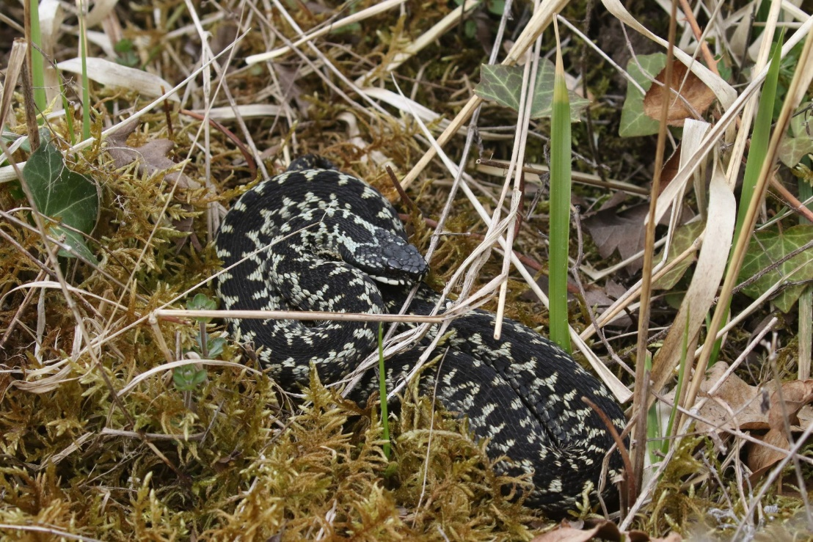
Photo Adder © Peter Scott

Records were contributed by: _
R Anderson, T Appleton, D & J Ball, C Baxter, L Biddle, T Caldicott, L Clark, J Dejardin, C H Gallimore, J Harris, A Hill, A Johnson, A Lawrence, R Lemmon, D Masters, T Mitcham, T Moffatt, J Morrell, D Needham, P Rogers, P Scott, T Sexton, W O Smith, D Walker and J Walker.
Dr C H Gallimore

