Rutland Natural History Society

AMPHIBIAN AND REPTILE REPORT FOR 2020

Recorder: Dr. C. Gallimore

The restrictions of lockdown due to the pandemic meant that the number of records received was significantly less than usual. In particular, records of Common Frogs, Smooth Newts and Grass Snakes were the lowest number recorded in any year in the past 40 years. On the plus side, however, sightings of all eight native species were recorded, as well as one American alien. Also on the plus side, there were Slow Worm records from two sites after five barren years, as well as the rediscovery of Great Crested Newts in Barleythorpe after a 31 year gap, a Slow Worm in Uppingham after a 23 year hiatus and Grass Snakes in Market Overton, Lyndon and Morcott, after absences of 20, 18 and 11 years respectively, which gives cause for some cheer.

Common Frog Rana temporaria
Frogs were recorded at only nine sites in five parishes (Braunston, Exton, Leighfield, Oakham and Wing) and evidence of breeding was found at five sites in four parishes (Braunston, Exton, Oakham and Wing), although spawn was only found in Exton and Wing and the evidence in Braunston and Oakham was the presence of froglets in July and August. The first spawn was found on 9 March in Wing and spawning was recorded at two sites in Exton on 14 March. The first record was on 15 February on a road in Oakham at night and the last record was in a compost bin on 18 October, also in Oakham, about a hundred yards distant from the previous record.

Common Toad Bufo bufo
Common Toads were recorded from eight sites in four parishes (Braunston, Exton, Horn and Wing) with evidence of breeding at four sites in three parishes (Braunston, Exton and Wing), although the evidence was amplexus at one site and the presence of toadlets at the other three. The first record was on 14 March in Exton and the last record was on 4 October in Wing. There was only one record of a road casualty, possibly a benefit of lockdown on their hazardous breeding migrations.
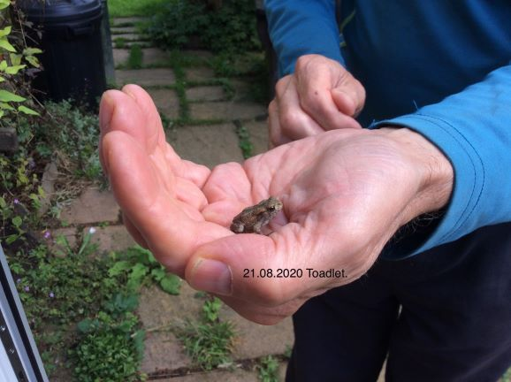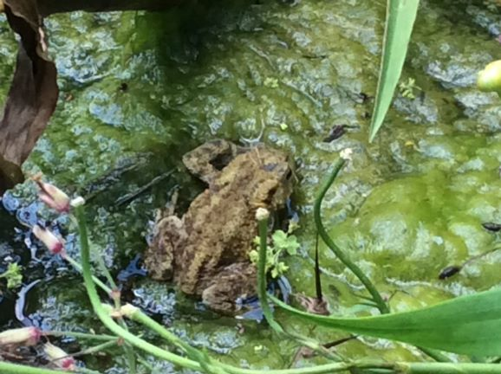
Photo – Linda Clark – Toad, Wing Photo – Linda Clark – Toad, Wing
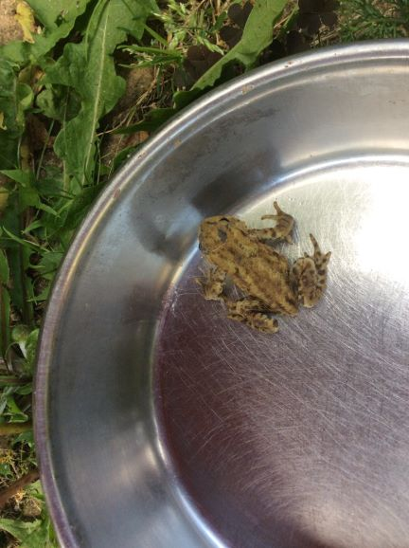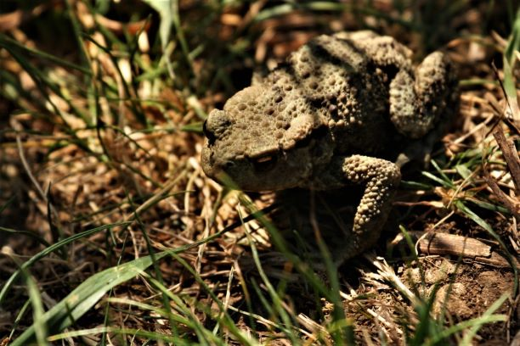
Photo – Linda Clark – Toad, Wing Photo – Malcolm Dixon – Toad, Fort Henry

Smooth Newt Triturus/Lissotriton vulgaris
Smooth Newts were only recorded in Wing in three garden ponds between 22 April and 22 May. In the past 39 years there has never been only one parish in which they have been recorded.

Great Crested Newt Triturus cristatus
A dead Great Crested Newt was found on a wall in Wing on 10 January and one was found in the Recorder’s former cellar in Wing in February. However, in June a number were found in a wood pile in Barleythorpe. They have not been recorded in Barleythorpe since 1989 until now.
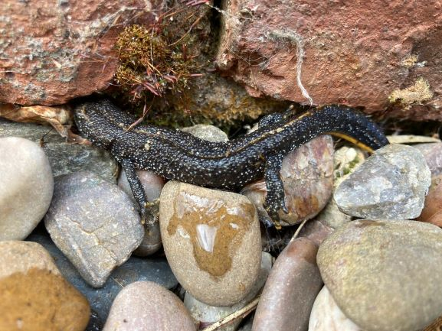
Photo – Carolyn Baxter – Great Crested Newt, Barleythorpe

Red-eared Slider Trachemys scripta
One of these introduced American reptiles was seen and photographed on 25 May in Eye Brook Reservoir very close to where one was seen in 2003. From the estimated size given by the two observers it is highly likely that this was the same individual.
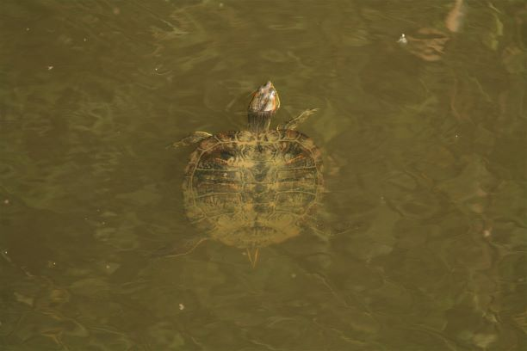
Photo – Malcolm Dixon – Red-eared Slider, Eyebrook
Viviparous Lizard Zootoca vivipara
There were four records of lizards – the first in Ketton on 19 April (the same date as the first last year) – and singles at Bloody Oaks and George Henry Wood at Stretton in early May. Lastly, on 23 August one was seen near the railway line in Wing.
Slow Worm Anguis fragilis
After five years with no records of Slow Worms one was seen basking in Burley Wood on 26 April. Then on 27 September one was seen basking in a garden in Uppingham. The last record from Uppingham was in 1997 although there are earlier records in 1947 and 1903.

Grass Snake Natrix natrix/Natrix helvetica
Grass Snakes were recorded at only seven sites in five parishes (Hambleton, Lyndon, Market Overton, Morcott and Wing). The first record was from Lyndon on 17 April and the last on 29 July in Wing. It is 20 years since there was a record from Market Overton, 18 years since there was a record from Lyndon and 11 years since there was one from Morcott.
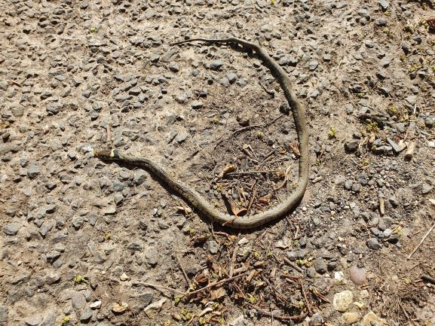
Photo – Peter Scott – Grass Snake, Morcott

Adder Vipera berus
Adders were seen at Ketton Quarry in two areas. The first sighting was on 16 March and the last on 8 June. On two occasions two adders were seen.
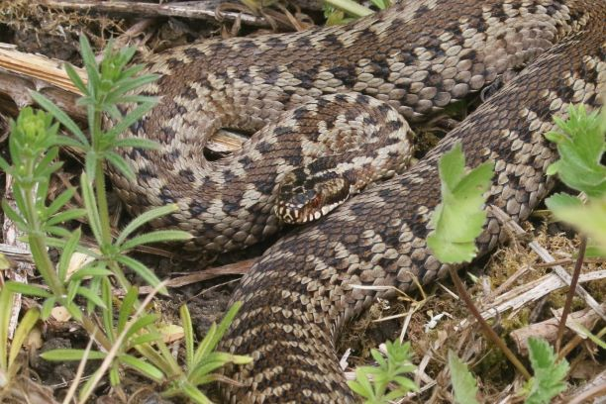
Photo – Peter Scott – Adder, Ketton

Records were contributed by: _
T Appleton, C Baxter, P Bennett, T Caldicott, R Castle, L Clark, C & P Comben, M Dixon, M Grimes, J Harris, A Hill, T Land, P Langston, R Lemmon, S Mackay, D Masters, N Messenger, T Mitcham, D Needham, L Park, P Scott, S Smalley, R & M Smith, P Speed and J Straubinger.

