Annual Bird Report 2019
A stalwart band of observers recorded birds on their local patches as well as at the major sites of Rutland Water and Eyebrook Reservoir. Wildfowl counts at five sites provided a clear picture of the comings and goings of these fascinating birds. Rare wildfowl included Bewick’s Swan, American Wigeon and Lesser Scaup, with escaped Bufflehead and Hooded Merganser offering added interest to a day’s bird watching. At Rutland Water Great White Egrets and Marsh Harriers were present for much of the year and it cannot be long before these species are added to the list of breeding birds at this fantastic reserve.
Other Rarities were Storm Petrel, Quail, Cattle Egret, White-rumped Sandpiper, Arctic Skua, Waxwing and Wryneck – few of them staying long to be admired. The Common Birds Census at Beaumont Chase Farm showed few changes in the fortunes of farmland birds with most species (except Rook) holding their own or showing a slight increase. Many resident and migratory species – owls, woodpeckers and warblers – were noted at usual well watched sites and it would be good to extend this coverage to give us a true county wide picture of their status.
Our local recording tallies with the national situation for many of our birds – disappearing Turtle Doves and Willow Tits, lost Lesser Spotted Woodpeckers and Corn Buntings but thriving populations of Buzzards, Red Kites and Ravens. Which species will be next to become established in Rutland ? Check the record of a Ring-necked Parakeet in Ridlington !
Terry Mitcham

Systematic List

See Also Monthly Wildfowl Counts.
Brent Goose. One was at RWDam on 02.01. and two were at RWEg1 on 05.11.
Canada Goose. Present at both reservoirs throughout the year with breeding confirmed at both. At FHP one or two were present between 24.02. and 03.06.
Barnacle Goose. On 03.06. a flock of presumed feral birds flew east over Man.
Greylag Goose. Present at both reservoirs throughout the year with breeding confirmed at both. High winter counts at FHP were 343 on 10.02., 293 on 01.11. and 296 on 01.12. 346 were by Rygate Lake in Ext Park on 27.01.
Pink-footed Goose. On 01.01. two were at EBR and RWLynd with two at EBR next day and one in RWNA on 06.01.One was at RWSA on 15.02. Three were at RWEg1 on 02.04. with four there 11.05. 52 flew north-west near Man on 29.10. and c.130 west over HM on 10.11. Three were in RWNA on 12.11. with four there on 24.11.
Mute Swan. Single pairs bred at FHP, Banthorpe GP and Rygate Lake in Ext Park. Five pairs with cygnets were at EBR on 06.07. Colour ringed birds were at EBR on 20.07. (ringed at Warwick on 21.06.06.) and RW on 12.10. (ringed at Scarborough in 2015).
Bewick’s Swan. A pair were at RWEg1 on 31.12.
Whooper Swan. 21 were in RWNA on 10.04. with a late bird at RWEg5 on 14.-19.05. Four at EBR on 21.09. were the first autumn arrivals with up to nine noted on five dates between 24.10. and 29.11. at EBR and RW.
Egyptian Goose. Present at RW throughout the year. Bred at Cott, where a pair had four goslings on 18.05. There was a pair at Leigh on 06.11. and 17 flew NW at Pilt on 27.12.
Shelduck. Reported from both reservoirs with breeding confirmed at RW. Present at FHP from 18.01. to 21.06. with a max. of five on 28.04.
Ruddy Shelduck A pair were at RWEg4 on 29.11. and in RWSA on 23.12.
Mandarin Duck. Now established in the Wg/Pilt area along the Chater valley with birds noted throughout the year and a max. of eight on 24.11. Single pairs bred at RWNorm and Mor (two and five young). Five were in Ext Park on 11.03. with single males at FHP on 03.06. and 13.07. and a pair were in Ext Park on 04.12. A pair were at Geest on 03.05.
Garganey. Between 10.05. and 21.06. up to three males were at RWEg, with a pair on the first date. A female was at EBR on 06.06. One or two were on the Wet Meadow at Eg between 11. and 19.07. and autumn singles were at RW on 11.08. and 15. and 20.10. and EBR on 25.08. and 01.09. A poor year for this species.
Shoveler. Present at both reservoirs and FHP with nos. peaking in autumn. At FHP two pairs bred with broods of five and two – the site is a key breeding site in Leics./Rutland.
Gadwall. Present at both reservoirs and FHP all year, with occasional birds at Rygate Lake in Ext Park. Nos. at FHP peaked at 100 on 25.09. Bred at RWEg and FHP, with three broods there and one at Rygate Lake in Ext Park..
Wigeon. A numerous winter visitor at the reservoirs with smaller nos. at FHP and Rygate Lake. The FHP max. was 184 on 09.03. and there were 108 at Rygate Lake on 15.02. Summer records from RW were three on 21.06., three on 06.07. and two on 14.07. 51 were on a flooded field near Cott on 16.11.
American Wigeon. A male was at RWLynd/NA and Eg throughout Jan. and from 15.03. to 12.04.
Mallard. A widespread species with breeding at both reservoirs, FHP, Ext Park, Cott and Geest.
Pintail. Noted at both reservoirs with peak counts in autumn. Early singles were at EBR on 06.07. and 08.08. at RWEg3. Singles at FHP on 12. and 27.10.were the only site records this year.
Teal. A common winter visitor at water bodies large and small. 20 were on a pool at KQ on 21.01. and 71 were at FHP on 09.03. Scarce in summer but ten were back at EBR on 29.06. The autumn max. at FHP was 55 on 14.09.
Red-crested Pochard. There were large nos. at RWLynd in Jan. with 51 on 01.01. and 63 on 06.01. These soon departed with just three on 25.01. None were reported until 05.08. when two were in RWSA and then between 14.09. and 06.11. up to eight (04.11.) were at RW on five dates. Three were at EBR on 04.11. and two on 19.11.
Pochard. Present in declining nos. at RW but four pairs had young at Eg in July. A winter visitor at EBR and at FHP, where there were one or two up to 09.03. and up to five (08.12.) between 01.11. and 19.12.
Tufted Duck. Present at both reservoirs and FHP all year with breeding at each site. There were counts at RW in autumn. At least four broods were noted at Eg in July and one pair fledged young at FHP.

Scaup. Very well reported with birds seen in all months except May and June. In the first winter period all records were from RW, with birds associating with Tufted Ducks. There was a max. of nine on 11.01. A male on 07.04. was the final sighting. Five on 28.07. were the first autumn birds with smaller nos. then present to the end of the year, four on 07.12. being the max. A female on 19.12.was the only record from EBR.
Lesser Scaup. A male of this North American species was at RWNA/Eg between 10 and 19.10.
Common Scoter. Four were at EBR on 31.07. A female was in RWNA between 04. and 17.11. and it or another at the Dam between 27. and 31.12.
Bufflehead. An escaped female was regularly seen at RW throughout the year
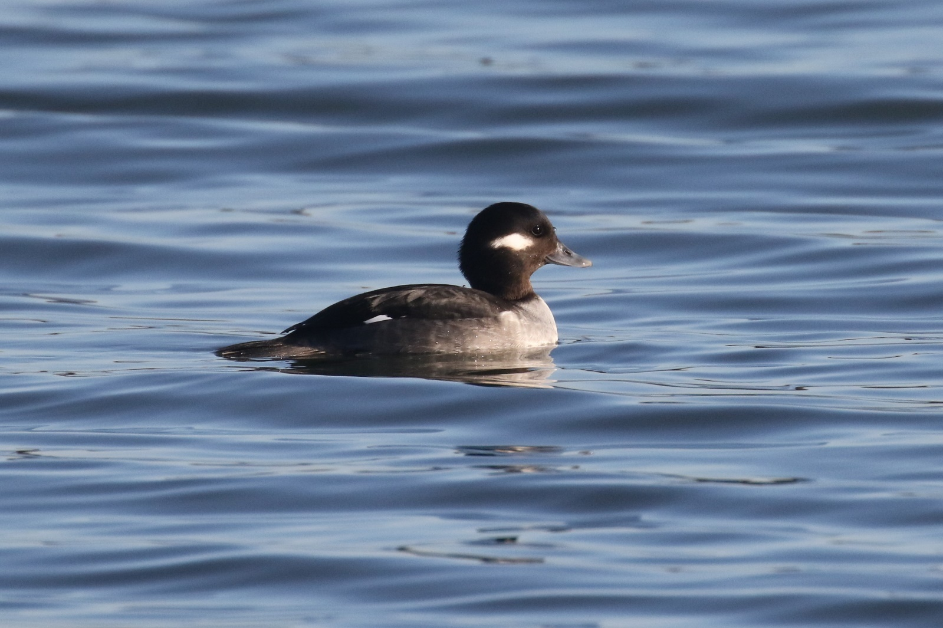
Goldeneye. A winter visitor at both reservoirs, with nos. building rapidly from Oct. A late male was at RW on 28.05. No first autumn date was received but one was at RW on 15.09.
Smew. Well reported from both reservoirs in both winter periods. At RW birds were present to 28.03. with a max. of 16 on 17. and 21.01. with five males noted (and also on 10. and 17.03.). EBR had birds between 01.01. and 03.02., peaking at 14 on 12.01 (five males). The first autumn arrival at RW was on 25.10. with nos. reaching a peak of ten by20.12. EBR had singles on three dates between 13.11. and 16.12.
Hooded Merganser. An escaped male was at RWEg/SA on 27.10.
Goosander. Up to six were on Rygate Lake in Ext Park between 05.01. and 11.02. Our last winter record was at RW on 25.03. Our first autumn record was at RWNorm on 15.10.
Red-breasted Merganser. A female was at RWDam between 19. and 24.11. with a second in NA on the last date.
Ruddy Duck. A female was at RWEg1 on 27.04. and 11.05.
Red-legged Partridge. Well distributed on farmland, with many released for shooting. Records came from Mounts Lodge, Pickworth, BCF, Ext Park and EBR.
Grey Partridge. Noted at RWLynd/Eg, Ext Park, FHP, Pick and GHW. Mainly pairs or singles but four at Lynd on 21.01. This species remains widely distributed but scarce.
Quail. A late bird was flushed at Luff Airfield on 14.10.
Pheasant. Common on farmland and in woodlands where it is preserved for shooting with hundreds released in autumn. Five white males were noted in Ext Park in Dec.
Red-throated Diver. A juv. had a long stay at EBR from 02.11. to 16.12.
Great Northern Diver. Two were in RWSA to 17.01. with one to 02.02. The only autumn bird was in RWNA on 14.11.
Storm Petrel. One in RWNA on 30.09. was the first Rutland record since one at EBR in July 1990.
Little Grebe. Rather local with largest nos. in autumn and winter when it was found on both reservoirs and at FHP. Present at FHP to 31.03. with a max. of 11 on 05.01. with autumn birds from 25.08. One was on Rygate Lake on 14.10. Breeding was confirmed at RWEg.
Red-necked Grebe. One was at RWSA from 01.01. to 28.03. with two reported from 01.01. to 03.02. What is presumably the same bird returned on 14.09. and was present to the end of the year, regularly seen in SA from the Old Hall.
Slavonian Grebe. Three were in RWNA from 01.01. to 22.03. with all seen in SA on 28.03. One or two were at RW on 18.10. with one from 26.10. to 30.11., seen in SA and NA.
Black-necked Grebe. Two were in RWNA early March with one to 31.03. One was in SA from 17.09. to 8.10. with two noted from 02.11. These relocated to NA from 20.12. and a third bird was at RWEg3 from 24.12. to the end of the year.
Spoonbill. One was at RWEg4 on 20.03. Four flew over Eg on 18.07. and one was on Eg1 from 06. to 15.10.
Bittern. All records (except one) were singles from the reed-bed on RWEg1 on 04.01., 10.-25.08. and 15.10. The remaining bird was at RWLynd on 02.06.
Cattle Egret. One was briefly at RWEg1 on 05.10.
Grey Heron. Regular at both reservoirs Rygate Lake and Banthorpe GP throughout the year with occasional records from FHP. There was a garden record from Oak on 05.02. Bred at RW.

Great White Egret. The colonisation of RW by this species has been remarkable. Six were at RWEg on 25.01. with five still on 01.03. and one on 30.03. One was present on 31.05. and 28.06. with regular sightings then to the end of the year leading to a max. of 17 in Oct. Records also came from Banthorpe GP on 08.01., two over Mthorpe on 31.03., one over Pilt on 10.06. and one at EBR on 06.07.
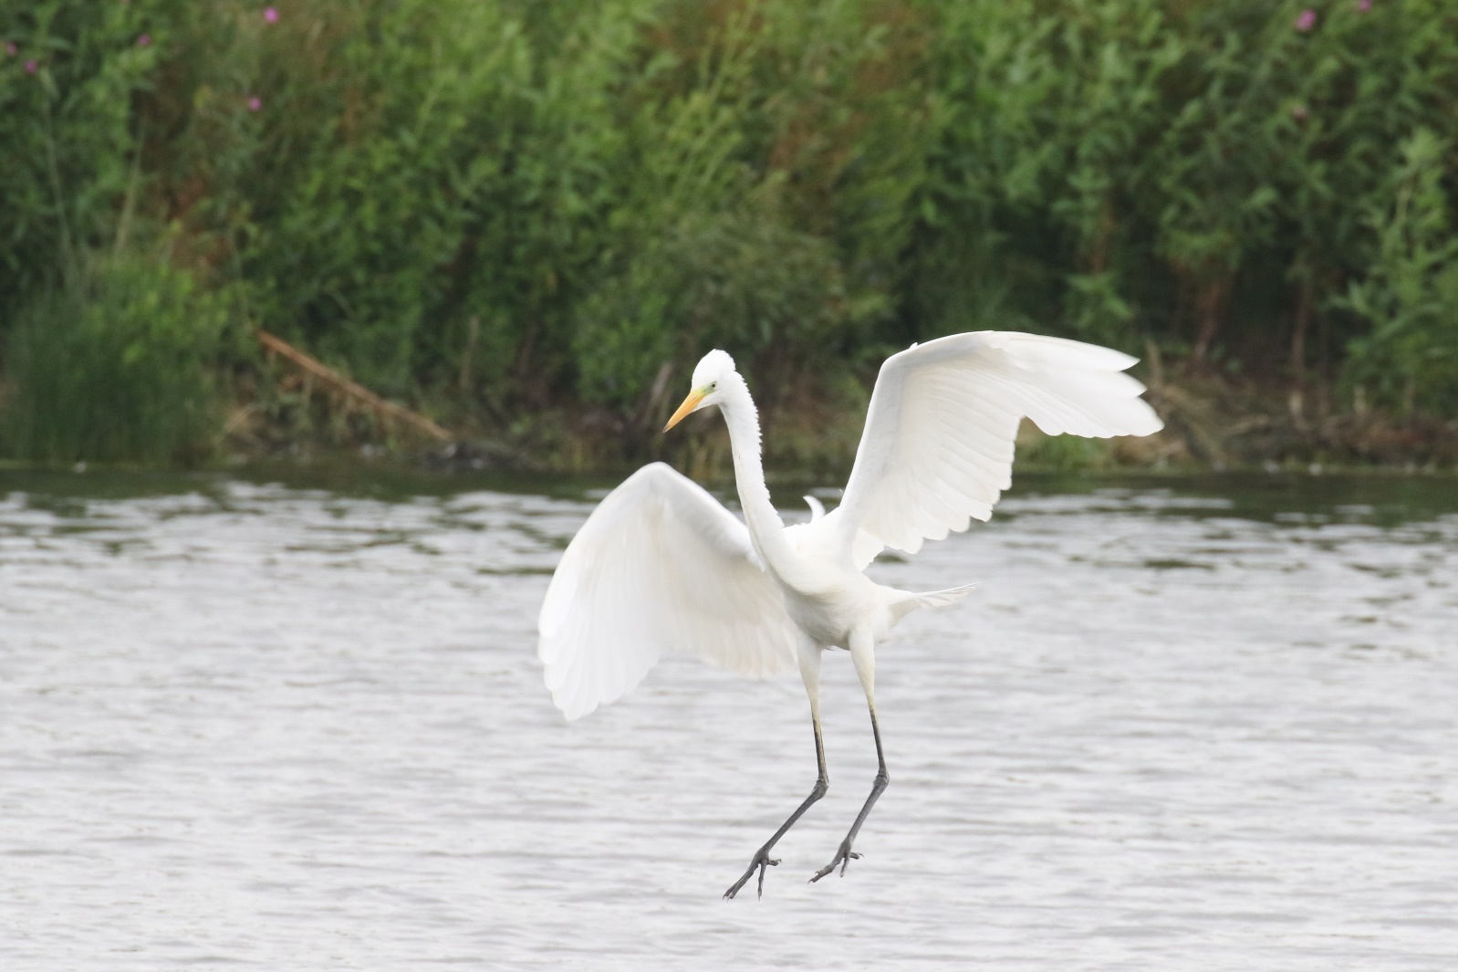
Little Egret. This species is well established and present throughout the year. There were reports from both reservoirs, FHP, Rygate Lake, Banthorpe GP and Greet Valley GC with birds over Stam on 22.01. and Pilt (six) on 26.05. 51 were at RWEg on 14.07. and breeding was confirmed there.
Shag. Two were at RWDam on 01. and 07.01. with one to 10.01.
Cormorant. Resident at RW and EBR, with breeding at the former site and regularly visiting FHP and Rygate Lake, where there were three on 05.01. and four on 18.01.
Osprey. The first RW bird returned on 14.03. with three present by 20.03. One was at EBR on 26.03. Ten pairs fledged 23 young – a very successful outcome. One was over Pick on 27.04. and HM, FHP and LFP were all visited. Three soared and called over TunnW on 29.07. Most had migrated by the end of Aug. with last on 03.09.
Sparrowhawk. Well distributed across watched areas at RW, EBR and FHP with garden records from Oak, Barrow and Stam and Woodpigeon and Greenfinch prey noted. Display was seen over WardW and Ext Park.

Marsh Harrier. A good year for this species, especially at RW where the first was seen on 19.01. (two next day) with the next on 04.03. Two were present at Eg on 30.03. with a female/imm. there through the spring and summer. Two were present on 11.08. with three on 07.09. remaining to at least 15.11. and two to the end of the year. There were records from EBR on 03.02., 31.03. and 06.07. One flew north at FHP on 27.03.and one was in Ext Park on 16.8. and 07. and 14.09.
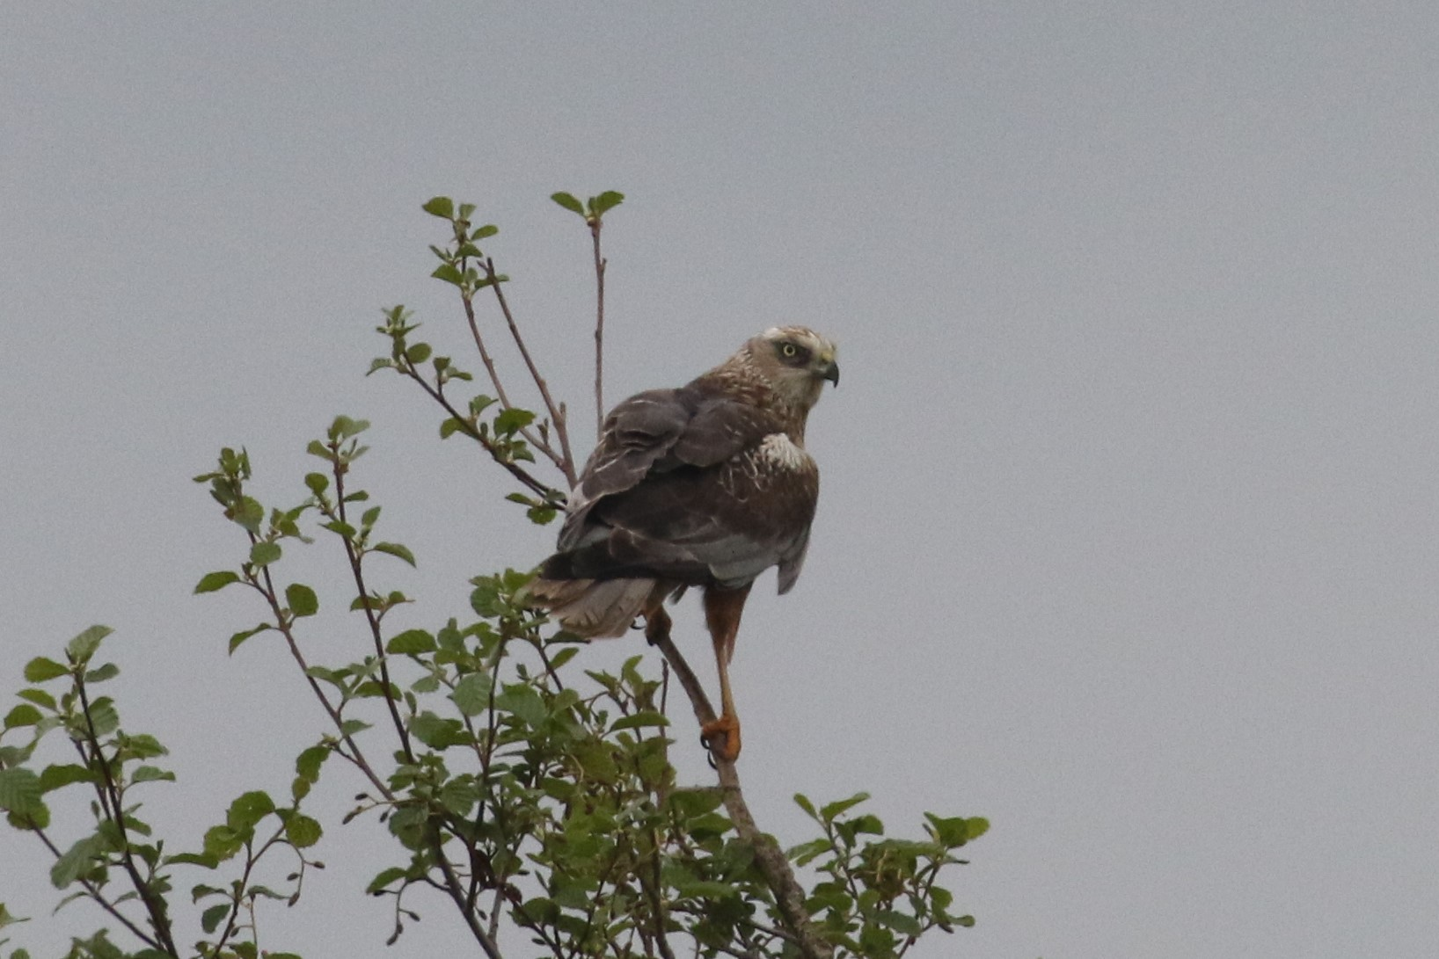
Hen Harrier. The only record was of a ringtail over game crops on Ryll Heath on 24.12.

Red Kite. A widespread and obvious raptor seen across the county over farmland, woodland and towns and villages. Visited a Stam garden in Aug. to scavenge barbecue leftovers. Three pairs bred in one wood and single pairs at two other sites – breeding must now be much under-recorded. Eight were over Tick on 22.03. and over farmland near Wg on 29.05. and ten soared together near HM on 08.12.
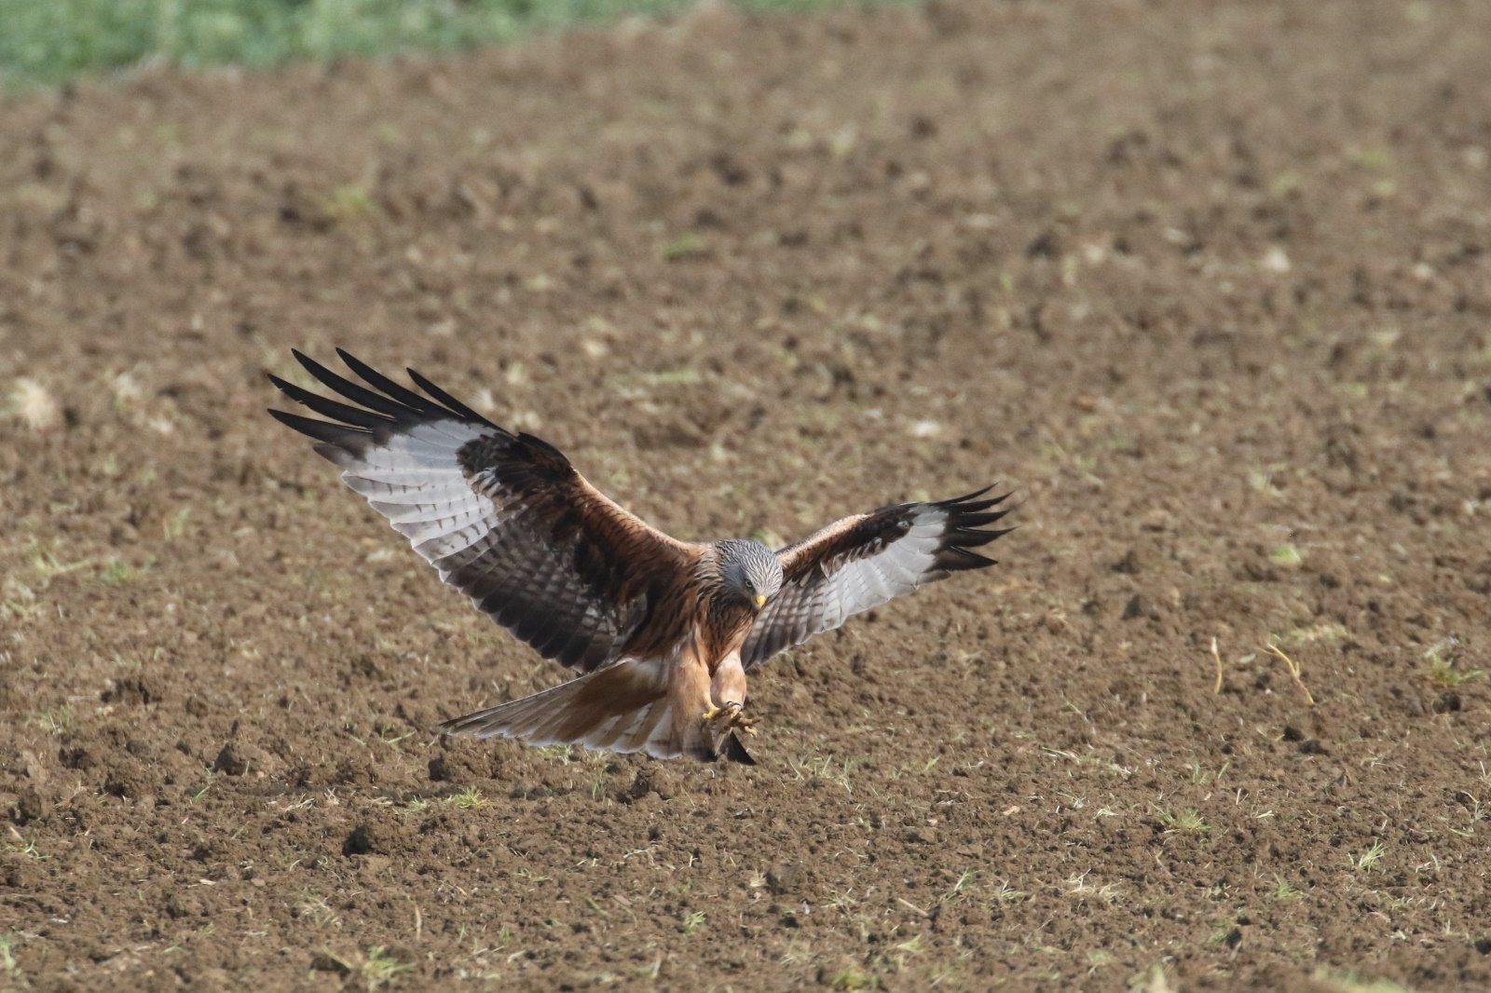
Buzzard. A common (and vocal!) species found in all our woodlands. Displaying birds were well reported in March and April. Six were over Wg on 11.03. and five over Tin Meadows on 03.04. Calling young, indicating successful breeding, were heard at KQ, Mor, FHP and Ext Park from May to Aug.
Water Rail. Present at RWEg all year. Other records were from FHP on 14.09., LFP on 07.12. and North Brook (HM) next day.
Moorhen. A common species on water bodies of all sizes and much under-recorded. The peak count at FHP was 33 on 14.09.
Coot. Resident on larger water bodies – the reservoirs, FHP, Rygate Lake and Banthorpe GP with large nos. at RW in winter. Peak counts at FHP were 95 on 04.01. and 91 on 06.10.
See Also Rutland Water Wader Counts.
Oystercatcher. Present from Jan. to at least 19.07. with breeding on Eg lagoons. One was at RWSA between 15. and 24.12.
Avocet. Two were at RWSA on 15.03. with singles at Eg on 17.and 20.03. Four were at Eg. on 20.04. One pair fledged two chicks which were still present on 08.09. One on Eg4 on 05.10. was our last record.
Lapwing. Common at the reservoirs in winter but with breeding birds remaining scarce. EBR counts were 1790 on 20.01., 1780 on 17.02., 40 on 29.06., 472 on 04.08., 201 on 17.11. and 400 on 15.12. Breeding was confirmed at RWEg and at Ext Park (four pairs in June) and a pair were at Banthorpe GP between 08.03. and 09.06. and Cott in May and June.
Golden Plover. Nos. were lower this year with no large flocks reported and we no longer see large nos. of birds on spring migration. Three were over Ext Park on 29.01. and 30 were at EBR on 17.02. 24 flew north-west over RW on 20.03., the only spring record. 20 were at RWEg on 12.10. 120 were at MM on 22.10. with 60 over Pilt on 27.10. and 75 over Martinsthorpe on 12.11.
Grey Plover. Singles were at RW on 18.-19.04. with up to four at Eg between 08. and 19.05. and one between 01. and 03.06. A late spring/early autumn bird flew over Wg Fishing Lakes on 27.06. Autumn singles were at RWEg4 on 04.09. and 23.10.
Ringed Plover. Present at RW from 31.03. to 11.06. with higher spring nos. between 24.05. and 08.06. (41 (on 28.05. and 36 on 31.05.). One flew over Pilt on 25.05. Autumn passage, between 06.08. and 27.09. was generally light with a peak of 11 on the first date. One flew over Pilt on 25.08. There were no EBR records this year.
Little Ringed Plover. One at RWEg4 on 20.03. was the first, followed by one at EBR on 22.03. Present at RWEg to at least 04.08. when seven were counted. Five were at EBR on 13.07. and our last was at RWEg3 on 22.09.
Whimbrel. An early bird was over RW on 28.03. with one at EBR on 14.04. One or two were noted at RW between 18.04. and 11.05. Five over RW on 25.07. were the first autumn birds with 13 over Luff Airfield on24.08. the last.
Curlew. Two were over Barrow on 28.02. with birds noted in the Barrow/Ashwell/Teigh area up to June. Noted at Cott Airfield from 23.03. and heard calling at Seat Meadow in April. These are all likely breeding sites. Autumn migrants called over Rid, Leigh, Pilt and RW from , 02.07. to 05.08. and four were at RWEg1 on 13.12., where there was a regular roost.
Bar-tailed Godwit. All records were from RWEg in spring with up to six (22.04.) present on 11 dates between 13.04. and 17.05.
Black-tailed Godwit. Four were at RWEg on 20.03. with a single on 07.05. Autumn passage, from 02.07., was stronger this year with 70 on this date and 31 on 07.07.. Nos. then decreased to single figures with the last on 27.09. EBR also had a good autumn passage with 50 on 01.07. and 13 on 26.07.
Turnstone. Seven were at RWEg on 09.05., with a further 19 flying over. Singles were seen on 15. and 17.05. and 06. and 08.06. Autumn passage was on six dates between 31.07. and 02.09. with a max. of five on 24.08. A late bird was on Eg1 on 23.11.
Knot. Noted at RWEg4 between 08. and 14.05. with two on the first date. Three there on 11.08. were the first autumn birds with up to six (11.09.) to 18.09. One was on Eg4 on 05.10. to be joined by 17 next day – a high inland count. One in RWSA on 09.11. was the final record.
Ruff. Two were at RWSA on 06.01. and two on Eg4 on 22.04., the only spring record. Autumn migration, between 09.07. and 06.10 was mainly at Eg with low nos. and a peak of only five on 25.09. Two were at EBR on 26.07.
Curlew Sandpiper. One was at RWEg4 on 28.31.05. and 12. and 25.09.
Sanderling. All records were from RWEg4 on spring passage between 23.04. and -8.06. with a max. of seven on 26.05.

Dunlin. 68 were at EBR on 08.01. with 46 on 20.01. RW had one on 19.01. and five in Sailing Club Bay on 23.01. Four were on Eg4 on 01.03. with spring birds present up to 11.06. High counts were 71 on 08.05. and 125 next day. The first autumn birds were at EBR, one on 26. and four on 28.07. 12 were at RWEg4 on 30.07. There were no Aug. reports but up to six were at RWEg from 01.09. to 13.10. At EBR there were 13 on 13. and 17 on 17.11. and 25 on 08.12.
Little Stint. Two were at RWEg4 on 30.07. with one remaining next day.
White-rumped Sandpiper. Different juvs. of this rare North American species were at RWEg4 on 15. and 28.10.
Woodcock. In the first winter period birds were flushed at TunnW, Greet GC, PGW, Pilt, RW and Wg. Most were singles but there were seven at TunnW on 11.02. and three at RWLax Hill on 15.03., the last record. No roding birds were reported. One in TunnW on 27.10. was the first autumn arrival with subsequent records of one or two from RWHamb, Wg, Pilt (four on 24.11.), Martinsthorpe, BW, PGW and Westland Wood to 03.12.
Jack Snipe. A well watched bird was at RWEg from 01. to 25.01. with two on 28.01. A late bird was there on 20.04. Autumn birds were at RWEg on five dates between 12.10. and 09.11. with two on 17.10. Two were at EBR on 17.11. with one on19.11.
Snipe. Five were at RW Sailing Club Bay on 03.01. with up to three there throughout Feb. and to 01.04. Two were at FHP on 18.01. and two at Banthorpe GP on 20.04. The first autumn bird was at RWEg3 on19.07. with two at Banthorpe GP on 02.09. and 14 at Eg on 22.09. Singles were at Pilt on 15. and 23.10. The low water level at EBR produced 60 on 17.11. with c.170 estimated there two days later – a very large count. Five were at Banthorpe GP on 15.11.
Common Sandpiper. Spring birds were at RW between 18.04. and 14.05. with one at Banthorpe GP on 20.04. Autumn passage was between 16.07. and 18.10., mainly at RW where there was a max. of four on the first date. One was at EBR on 20.07.with 12 there on 28.07. One flew over Man on 05.08 and one was at FHP on 07.09.
Green Sandpiper. One of the more widely distributed waders to visit Rutland, one or two were noted at Wg, RW, and Martinsthorpe up to 10.04. Autumn passage began with one at RW on 16.06. and birds were then present to the end of the year with records from RW, EBR, FHP, LFP, and Martinsthorpe. Seven were at EBR on 13.-14.07. and three flew over Martinsthope on 11.11.
Redshank. Present at RW all year. At least three pairs bred at Eg. Five were at EBR on 20.07. Nos. in the second winter period were low due to the high water level at RW.
Wood Sandpiper. One or two were at RWEg between 20.-22.04. One was at EBR on 28.07. and 26.08. with birds at RWEg from 27.08. to 12.09., peaking at four on 01.09.
Spotted Redshank. Singles were at RWEg on 17. and 22.04. and 17.05. and in autumn on 13.08. and 03.- 04.09.
Greenshank. All spring records were from RWEg between 18.04. and 20.05., with a max. of three on 19.04. An autumn bird was at EBR on 28.07. and at RW there were records from 14.08. to 25.09. with a peak of just two on three dates.
Kittiwake. Singles were at RW on 22.03.and 07.05.
Black-headed Gull. Present all year, a common winter visitor over farmland and built up areas with large roosts at the reservoirs. Bred at RW.
Little Gull. Noted on spring passage at RW between 05.04. and 11.05. with a max. of 19 on 09.04. A juv. was at RWSA on 28.08.
Mediterranean Gull. There were records of singles from RW and EBR in Jan. and Feb, with the latest on 24.02. Two were at RW on 16.04. Single adults roosted at RW on 06., 13. and 21.08. and again on 22. and 28.10. Singles were at EBR on 01. and 08.12.
Common Gull. The highest nos. were in winter and on spring passage. In Jan. there were 5500 at RW and 350 at EBR. Nos. fell with 300 at EBR in Feb. and 184 in March. 650 passed through RW in April with a large decline to 16 on 07.05., one in June and three in July, increasing to 14 on 01.08. 50 were at RW on 05.09 and 450 on 18.10. EBR had 300 on 17.11.
Great Black-backed Gull. Present at RW all year with highest nos. in winter when there were 300 in Jan. There were still 20 there on 28.05. and 22 on 11.06., increasing to 35 in July. Up to 30 were reported between 13.08. and 19.ll.
Iceland Gull. A second-winter bird roosted at EBR on 11.01.
Herring Gull. 400 were in the Jan. roost at RW. 24 were at EBR in Feb. Scarce in summer with one at RW in June but 70 there on 19.11.
Caspian Gull. An adult was at RW on 30.07.
Yellow-legged Gull. Singles were at RW in Jan. and on 05.04. Five were present on 27.06. increasing to 11 on 04.07. Three were at EBR on 20.07. At RW there were eight on 06.08., ten on 17.09. and 14 on 05.10.
Lesser Black-backed Gull. There were few records of this species which occurs mainly on passage. One or two were noted in winter roosts at RWEg but the only count was 12 there in April.
Sandwich Tern. There were spring singles at RWEg on 19.04. and 12.05. Autumn birds were seen on 05.08. and 14.09.
Little Tern. Three were at RWEg on 20.06. and six on 29.06. (five at Eg and one at Lynd).
Common Tern. One at RWSA on 05.04. was the first arrival with two at EBR on 09.04. One was at LFP on 26.04. 95 at RW on 14.05. probably included some still on migration as 71were noted on 09.07. and 74 on 13.08. and good nos. bred on the lagoons. There were still 35 on 15.09. and three on 13.10. with the last at the Dam on 27.10. Also present at EBR throughout the summer with ten present and at least two young on one of the rafts in July.
Arctic Tern. All records were from RW. Spring passage was from 09.04. to 27.05. with a max. of 24 on 04.05. There were autumn singles on 15.08. and 22.09.
Black Tern. Spring passage began with four at EBR on 22.04. and continued at RW until 18.05., peaking at ten on 07.05. Autumn migration was light with mainly singles at RW between 10.08. and 28.09. but ten on the first date and 03.09.
Arctic Skua. Two passed through RWEg on 01.10.
Feral Pigeon. No counts of the large nos. in Oak, Upp, Stam and Kett cement works were received. Suburban birds are now exploiting garden feeding stations in Stam.
Stock Dove. Well distributed across farmland and woodlands. Visited the garden feeding station at BCF in winter and bred in Barn Owl nest boxes at Geest and Ext Park.
Woodpigeon. Common but under-recorded with birds attending rural and suburban feeding stations. The largest flocks occurred in Nov. and Dec with 1030 passing over Wg on 06.11.
Turtle Dove. The only record was of one flying over RWEg4 on 05.06.
Collared Dove. A mainly suburban bird which remains widespread. Nos. feeding in a Stam garden peaked at only six on 06.10., indicating a local decline.
Cuckoo. Records of singing birds came from 14 sites (12 last year) between 24.04. (RWEg) and 14.06. (Ext). A juv. was at RWEg3 between 06. and 12.08.
Barn Owl. Recorded from 16 sites, a marked decline on the 22 last year. One was dead by the A1 at Tick on 05.05. Five nest boxes were occupied at RWNR with breeding also at four of our boxes and ten young ringed.
Tawny Owl. Records came from 14 mainly woodland sites (15 last year). A pair fledged three young in a nest box in TunnW on 22.05. and juvs. were at Wg Fishing Lakes on 27.06., Rid on 28.06. and Barrow on 23.07. One was dead by the A606 by BW on 28.06. and five were calling at dawn on 18.10. at Pilt, when young are trying to establish territories.
Little Owl. Reports came from ten sites (nine last year) with the most records from the Pilt area. Former regular sites at BCF, EBR and Bden seem to have been abandoned – or is this species just under-recorded ?
Short-eared Owl. The only record was of one reported by RWEg1 on 16.12.
Swift. One at RWEg on 18.04. was the first. In May and June there were screaming parties at Stam, Kett, Emp and Upp but nos. were all below 15. At Wg Fishing Lakes 43 flew south on 17.06. c.20 flew around Oak in July, hopefully using some of the nest boxes on a nearby house. One entered a nest site in Emp on the late date of 23.08. There were four Sept. records with two over Wg on 13. the last.
Kingfisher. Reported on the R. Welland at Tin in Jan. and May, on the R. Gwash at Martinsthorpe in May, at RW irregularly throughout the year with one on the R. Chater at Rid and Wg. In July. A juv. was ringed at Birdfair on 17.08. and one was at FHP on 07.09.
Wryneck. One was at RWEg3 on 15.09.
Great Spotted Woodpecker. Reported from 13 sites, eight fewer than last year, hopefully due to under recording. Drumming was heard between 03.01.and 18.04. at Mow Mires Spinney, BW, TunnW, Westland Wood, RWEg, Norm and CPW. Garden feeders were visited at BCF, Oak and Barrow, where juvs. also visited the garden.
Green Woodpecker. Noted at 12 sites (13 last year) especially at QF, FHP and a suburban Stam lawn. Fledged young were seen at Barrow on 10.07.
Kestrel. Hopefully under recorded as birds were only noted at ten sites (18 last year). Young were fledged from nest boxes at Hall Farm Ext, and Mor and they were predated from the nest box in Westland Wood, possibly by a Grey Squirrel. Two young fledged from a nest in the ruins of the old hall at Ext. Please submit all records of this species.
Merlin. Reported at Martinsthorpe on 24.01, ‘buzzing’ Red Kites over Tick on 22.03. and in flight near Stoke Dry on 12.12.
Hobby. There were records from eleven sites, the same as last year. The first was at RWEg on 26.04. and one or two were regular here throughout the summer, attracted by the large number of Sand Martins. Three pairs were confirmed breeding. The last RW bird was on 12.10. with the final sighting at FHP on 17.10.
Peregrine. Present throughout the year, Peregrines were regular at RW in both winter periods with birds seen at eight other sites with a regular breeding site still occupied.
Ring-necked Parakeet. One was heard in Rid and on 18.12. and seen there on 25.12.
Jay. Well distributed in woodlands and well-timbered hedgerows with reports from Ext woods, FHP, HM, Greet GC, CPW, RWEg and BW. Two were in a Barrow garden in Oct.
Magpie. Widespread and common especially where there is pasture and overgrown hedgerows in the west of the county. Also found in large suburban gardens.
Jackdaw. Common at quarries and on pastoral farmland where old trees provide nest holes and around farm buildings where there are many nesting opportunities e.g. BCF.
Rook. No rookery counts were received. The BCF rookery was abandoned for the first time since the CBC there was carried out in 1992.
Carrion Crow. Regular in suburban areas where they are not persecuted. Common in open countryside where hedgerow trees provide nest sites.
Raven. Well distributed with birds at or flying over 14 sites. Peak counts were 19 over Pilt on 29.05. and ten over Barrow on 18.11. Five regular nest sites were in use with young fledged at at least four.
Waxwing. One was at Kett on 13.11.
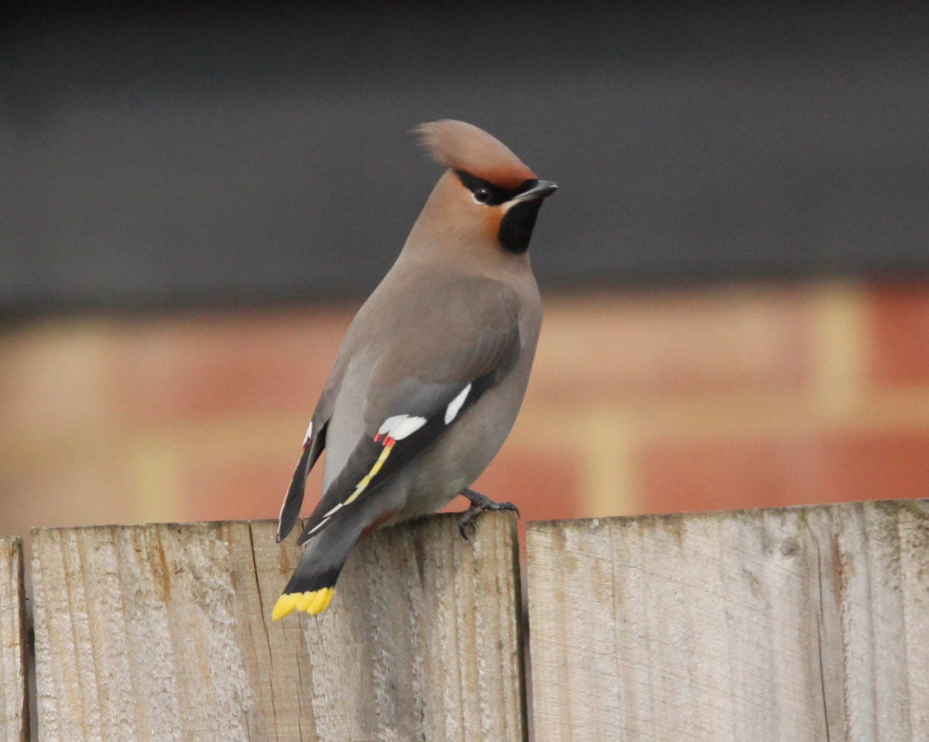

Coal Tit. Well distributed in coniferous and mixed woodland and regular at winter bird tables. Six were At feeders at BarnsG on 06.10. and three or four were regular at TunnW feeders.
Marsh Tit. Found mainly in deciduous woods – TunnW, PGW, BW, CPW (four on 23.03.) and Westland Wood but also in the west of the county with records from Wg Fishing Lakes, Rid, Wg and Leigh Feeders were visited at Oak, EBR and TunnW.
Willow Tit. A distinctly local species with justone observer submitting records of one or two from Wg, Leigh, Rid and Martinsthorpe. One was at RWLynd feeders on 16.11.
Blue Tit. A common and widespread species in woodlands and gardens. A successful breeding season was indicated by the ringing of over 140 on one day at Birdfair in Aug.
Great Tit. Well distributed in woodland and gardens. Nos. remained stable at BCF CBC site.
Bearded Tit. One flew past Dunlin hide at RWEg4 on 20.04.and four were in Eg3 reed bed on 02.-03.11.
Skylark. Present as a breeding bird of farmland and waste ground. Song was heard from 16.02. Breeding nos. increased slightly at BCF. There were no records of winter flocks but autumn passage was noted with 47 south at Rid on 23. and 76 south there on 30.09.
Sand Martin. An early bird was at RW on 01.03. with ten at Eg on 22.03. There were April records from EBR and FHP and the artificial ‘banks’ at Eg were well patronised. Five pairs bred in a stone wall at Norm. Our last record was at RWEg on 27.09.
Swallow. Few records were received. Singles at RWEg and Martinsthorpe on 31.03. were the first arrivals and there were three Oct. records; on 12. at FHP, 20. at Wg and 22. at Pilt.
House Martin. The first sightings were at RW on 31.03. and 03.04. It was interesting to receive details of urban nests in Oak in May and July with as many as 12 breeding pairs on High St./Mill St/Market Square areas. Two or three pairs still persist at Scotgate in Stam. A pair bred on a Wg house for the third time in 43 years. There were some good late summer and autumn counts: 110 at Pilt on 13.08. and 165 at Man on 11.09. Migrating flocks were 310 south-west on 28.09. and 315 south- west at Martinsthorpe. The last birds were three at Man on 119.10.
Cetti’s Warbler. One or two regular at RWEg throughout the year with one heard in SA on 31.10. A singing bird was heard at a new site between 03.05. and 14.06.
Long-tailed Tit. Regular in an Oak garden with up to four in Aug. Ten were in a Barrow garden in Nov. Generally widespread along hedgerows and in scrub with records of flocks of up to fifteen from five sites.
Willow Warbler. One at Martinsthorpe on 02.04. was our first record with song at RW next day and Westland W on 06.04. There were six singing at QF on 24.06. and 24 around Leigh on 26.04. Well reported at CPW on 07.05. with 15 singing along the woodland trail. Widespread in May and June. Our last bird was at Rid on 30.09.
Chiffchaff. Two were at Geest STW and five were ringed at RWEg on 11.01. There was early song at RWSA on 25.02. Passage really began from 16.03. (FHP) with birds at BCF, FHP, QF, TunnW and Banthorpe GP by the end of the month. A bird of the Siberian race was heard at RWGgorse on 09.04. 15 were in song at CPW on 07.05. One or two were regular throughout Sept. at FHP and one was Rygate Lake on 12.10. One was with a tit flock at RWBerrybut on 27. and 29.12.
Yellow-browed Warbler. Singles were at FHP on 06.10 and RWEg Centre on 19.-20.10. This Siberian species is rarely seen inland.
Sedge Warbler. RWEg and Lynd remain the strongholds for this warbler with the first at Eg on 12.04. One sang at LFP on 26.04. and one was at FHP on 21.07. with a migrant at LFP on 31.08. Our last record was at RWEg on 15.09.
Reed Warbler. The first record was at RWEg on 18.04. and there were good nos. there and at RWLynd by the end of the month. In May singing birds were at Pilt, QF and Geest with singles at LFP on 28.06. and Bden on12.07. Our last record was on the early date of 08.09.
Grasshopper Warbler. This species is now very local with singing birds near RWGgorse on 24.04. and in BW on 29.04. and 11.05. One was at EBR on 06.07.
Blackcap. Between 02.01. and 26.02. singles fed in three Oak gardens. Song was first heard at RW on 24.03. and seven were singing along the south shore on 28.03. One was again in an Oak garden between 01.-04.04. On 13.04. ten were singing in BarnsW with eight in BW on 21.04. 14 were singing at QF on 24.04. 22 sang around Leigh on 26.04. with 20 still present on 05.05. CPW had 15 singing on 07.05. There were few autumn reports but singles were at Wg and Pilt between 03. and 25.10 and females were in two different Oak gardens on 27. and 29.11. and on 31.12.
Garden Warbler. Much under-recorded, our first, at RWEg, was not until 26.04. with the next at RWLynd on 05.05. Nine were in song at CPW on 07.05. and two at QF on 26.05. One sang in BW on 06.07. Our last record was at FHP on 14.09.
Lesser Whitethroat. The first birds were at Leigh on 06.04. and Barrow on 10.04. Seven were singing at QF on 24.04. and a similar no. around Leigh on 26.04. with eight there on 05.05. One was at BCF on 29.06. and one at Banthorpe GP on 07.07. Autumn birds were at Wg and Martinsthorpe with the last on 29.09.
Whitethroat. First heard at FHP on 21.04. Eight sang at QF on 24.04. and 15 around Leigh on 26.04. and 18 on 05.05. This species is currently in good nos. across the county. Song also reported from Wg and CPW. One at Martinsthorpe on 29.09. was the final bird.
Goldcrest. A bird of coniferous and mixed woods with records from parkland and well timbered gardens (BarnsG, Wg, Ext).
Wren. Widespread and recovering from the cold weather of the previous winter.
Nuthatch. A vocal resident of RW and Ext woodlands with records also from CPW. Garden records are now more frequent with birds in Oak (three), Man and Barrow. Regular at TunnW feeders in both winter periods.
Treecreeper. Regular at FHP and in woods across Rutland. Redwood roosts were found in CPW, Ext Park and at FHP. Seven were at RWGgorse on 30.07.
Starling. One killed by a cat in a Stam garden on 19.04. had been ringed as a juv. at Wyberton (Boston) on 01.06.15. Autumn passage west past Pilt between 22. and 28.10 logged 5274 birds and 2202 passed over Wg on 29. and 31.10.
Blackbird. Common in woodlands, gardens and hedgerows with the largest nos. in winter when continental migrants are present. Nos. in a Stam garden peaked at ten in Jan. and Feb. Newly fledged young were at BarnsG on 09.04.

Fieldfare. Notable flocks in the first winter period were 400 around Man on 12.01. and 320 at Martinsthorpe on 13.02. 248 flew over Martinsthorpe on 31.03. April records came from Ext Park, Barrow, Greet GC and Upp. The largest flock was 320 over Leigh on 19.04. and 14 at Upp were the last on 22.04. The first autumn birds were two at GHW on 03.10. with 36 over Pilt on 16.10. Passage improved from 28.10. when 307 flew west at Pilt with 1044 north-west next day at Wg and 268 west on 30.10. Few birds seemed to stay with us and subsequent records were of double figure flocks e.g. c.30 by Oak Canal on 29.10. and c.20 at FHP on 10.11.
Redwing. Very few records in the first winter period with small nos. accompanying Fieldfare flocks. Four at Man on 20.04. were the last birds. There was a strong autumn passage between 03.10 and 29.10. On the first date 125 flew west at Luff Airfield whilst on 15.10 2581 flew west over Pilt. Between 16.10. and 22.10 a further 1567 passed through and at Wg 1545 were counted on 29.10. Despite the mild weather one was in an Oak garden on 29.11. and six in an Upp garden between 3.-9.12.
Song Thrush. Singing birds were widely if thinly distributed with records from eleven woodland and garden sites.
Mistle Thrush. This fine songster, much the scarcest of our resident thrushes, was noted at six woodland sites from March to May. As usual the peak nos. were in late summer and autumn when family parties flock together. 27 were over Pilt on 12.08. and 47 over Wg on 06.09.
Spotted Flycatcher. A pair at Upp on 15.05. were the first arrivals with birds subsequently at 15 sites, the same as last year. At least seven were at Stretton, hawking insects from tall trees – they were surely on migration. Birds were at likely breeding sites at Man, Pilt, Wg and Leigh with breeding confirmed at Upp. Records came from six sites in Sept with the last at Leigh on 21.09.
Robin. No counts were received but Robins were widespread and seem to have recovered their nos. from previous hard weather.
Nightingale. Our first record was from RWEg on 18.04. with three at this site during April and May. At PGW up to three were present from 28.04. to 30.05. (last record) and one was reported from Turnpole Wood, a first site for this species. Thus six or seven singing males were present, slightly up on last year.
Redstart. There were no spring records. Autumn passage was between 11.07. and 22.09. with birds at Wg, Luff Airfield (three on 24.08.) and FH. The final bird at Luff Airfield was trapped and ringed.
Whinchat. All records were between 11.08. and 16.09., singles or two at Luff Airfield, EBR, Ext Park, RWNA and RWEg.
Stonechat. A pair were by RW Sailing Club Bay for most of Jan. with another pair at Eg Centre and a pair at EBR. A female was at FHP on 18.01. and a female on RW south shore on 21.02. Autumn birds were noted from 22.09. (RWLynd) to the end of the year with records from Luff Airfield (five on 29.09.), RWEg, RWNA, EBR, Rid and Ext Park.
Wheatear. Spring passage was between 17.03. and 11.05. with birds at Luff Airfield, RWEg, Banthorpe GP, Cott Airfield and Ext Park (three on 19.04.). Autumn birds were seen from 30.07. to 20.10. at the same sites. Three at Luff Airfield on 11.08. was the peak count.
House Sparrow. Most of the few records were of garden flocks, maintained by regular feeding. Nos. in a Stam garden peaked at 53 on 27.01. c.25 frequented a Barrow garden in July and Aug. and there were c.65 at Pilt on 13.08.
Tree Sparrow. Recorded between Jan. and April at Hall Farm Ext, Man, RWLynd, EBR and Leigh with a max. of six at Man (20.01.). There were up to eight (16.12. at Rid) between 18.08. and 16.12. at Pilt, Rid, Wg and RWLynd feeders.
Yellow Wagtail. One at RWEg on 02.04. was the earliest. One or two passage birds were noted at Leigh, Pres, Martinsthorpe and FHP up to 19th May. Pairs on likely breeding territories were seen near Banthorpe GP, EBR, Pick, Pilt, Ext Park, Glas, Rid, Brk, Wg, Pres and Leigh up to 25.07. Flocks of 14 and 16 south over Pilt on 26.08. were migrants with up to four noted at four more sites to 03.10.
Grey Wagtail. Singles were reported between 11.01. and 21.02. from Geest STW, FHP and Oak. There were May birds at Geest STW and Braun and singles at Wg Fishing Lakes and Rid in June with an early autumn bird at RWNorm on 04.08. Singles were the noted between 06.10. and 03.12. at FHP, Geest and an Oak garden (08.11.)
Pied Wagtail. The only record was of 28 on filter beds at Geest STW on 01.02. Regular at RWDam and bred at BCF CBC site.
White Wagtail. This, the continental race of the Pied Wagtail, was recorded between 20.03.and 20.04. with singles at RWNA, RWDam, near Lynd and at Man. Three were at RWDam on 25.03.
Meadow Pipit. c.40 were along the shoreline at RW Sailing Club Bay on 11.01. with 21 nearby at Norm on 28.02. Spring passage saw 77 north-west there on 18.03. and 56 north-west on 27.03. 33 flew north-west at Martinsthorpe on 31.03. Display was noted at GHW, Luff Airfield and Cott Airfield in April and May. Three at FHP on 07.09. were the first autumn birds with passage over Martinsthorpe and Rid between 27.09. and 03.10 totalling 528 birds.
Tree Pipit. All records were of autumn passage singles between 02.08. and 22.09., mainly over Pilt, Wg and Man on nine dates. The final bird was over RWLynd.
Rock Pipit. Two on 09.10. (RWEg and SA) were the first autumn birds with singles one 15., 17. and 22.10.
Chaffinch. 50 were at Greet GC on 20.01. Full song was heard at CPW on 16.02. Remains widespread and common as a breeding bird but in reduced nos. e.g. only seven on BCF CBC site. c.20 were on BarnsG feeders on 06.10. Autumn passage flocks, flying north-west, were 90 at Pilt on 25.10. and 68 0n 29.10. at Wg. 60 were at Martinsthorpe on 11.11.
Brambling. In the first winter period, up to 10.04., birds were widespread with records from ten sites, including garden singles at Norm and Oak and up to four (19.03.) at RWLynd feeders. The peak count was 30 at RWLax Hill on 09.04. Autumn birds were seen from 29.09. with passage over Pilt on six dates between 15. and 30.10 totalling 31 birds. Two were in a Norm garden on 29.10. and one in an Oak garden on 03.11. Further movement over Pilt/Wg/Leigh between 04. and 22.11. produced eight birds with one in a Man garden on 27.11. and just one over Pilt on 29.12.
Hawfinch. One was at Leigh on 18.11.
Bullfinch. Widespread in scrub and overgrown areas with records from Ext Park, Kett, CPW and Tin. One visited an Oak garden on 27.06. and there were 16 around Leigh on 22.11.
Greenfinch. Visited garden feeders in both winter periods with a max. of only seven at one Stam garden in Dec. Ten were in song at Barns G on 09.04. with ten at Wg on 18.04. A flock of c.90 was at RWHamb on 11.11.
Linnet. Flocks in the first winter period were 50 at both Ext Park on 12.01. and by RW Sailing Club Bay on 25.01. One was in an Oak garden on 06.02. 30 in Ext Park on 20.03. and 60 at Leigh may have been on passage. Between 24.11. and 28.12. 150 to 350 were in the Pilt area, mostly associated with game crops.
Lesser Redpoll. 50 were in PGW on 01.01. Two were in an Oak garden between 03. And 12.03. and two were in TunnW on 20.03. It was a poor autumn with singles at Wg on 10. and 20.11. and RWEg2 on 13.12.
Crossbill. Singles were over RW on 20. and 28.03., over Pilt on 29.05. and Rid on 18.12.
Goldfinch. Widespread on waste ground with birds regular at garden feeders. c.120 were near Pick on 14.09. and 28 were in an Oak garden on 30.11.
Siskin. No flocks were reported this year. Three were in WestlandW on 12.01. and up to three visited gardens in Ext, Oak (two) and Stam between 09.01. and 10.04. Singles were at BW on 06. (breeding ?) and LFP on 19.05. Singles flew over RWGgorse on 25. and Rid on 30.09. and there were four in alders at RWEg2 on 15.12.
Yellowhammer. Flocks of 25 (31.01.) and 30 (09.03.) were in different parts of Ext Park. Four were singing at QF on 18.03. and breeding birds remain widespread in arable areas. 20 were near Pick on 11.09. and a large flock of c.120 was near Rid on 16.12.
Reed Bunting. 28 were by Banthorpe GP on 18.01. and one was in a Stam garden on 24.01. and 05.02. Breeding birds were noted at QF, Wg, FHP, RWLynd and RWEg. 20 were at Martinsthorpe on 09.11. and c.24 near Rid between 16.-18.12.
Snow Bunting. One remained at RWDam on 01.-02.01. and flew along the Dam on 22.10.

Rutland Water Wildfowl Counts

 | 20.1. | 17.2 | 24.3. | 16.4. | 17.5 | 11.6. | 9.7. | 13.8. | 15.9. | 13.10. | 17.11. | 15.12.
Canada Goose | 710 | 354 | 185 | 91 | 106 | 398 | 465 | 681 | 426 | 245 | 227 | 557
Greylag Goose | 154 | 436 | 295 | 254 | 262 | 495 | 907 | 789 | 789 | 763 | 468 | 588
Pink-footed Goose | 3 |  |  | 3
Mute Swan | 238 | 283 | 202 | 220 | 221 | 238 | 635 | 419 | 496 | 338 | 222 | 194
Whooper Swan |  |  |  |  | 1
Egyptian Goose | 28 | 25 | 24 | 23 | 26 | 22 | 37 | 40 | 73 | 8 | 15 | 24
Shelduck | 19 | 27 | 20 | 36 | 28 | 13 |  |  | 1 |  |  | 3
Ruddy Shelduck |  |  |  |  |  |  |  |  | 1
Garganey |  |  |  |  |  |  | 1
Shoveler | 98 | 47 | 73 | 137 | 6 | 26 | 11 | 22 | 197 | 112 | 48 | 9
Gadwall | 692 | 584 | 209 | 189 | 196 | 389 | 1704 | 783 | 1176 | 553 | 412 | 124
Wigeon | 3707 | 2772 | 814 | 284 | 1 |  | 5 | 11 | 531 | 1405 | 1632 | 1959
Mallard | 867 | 400 | 302 | 329 | 374 | 322 | 704 | 606 | 809 | 548 | 392 | 443
Pintail | 51 | 30 | 11 | 8 | 1 | 1 |  |  | 44 | 101 | 21 | 9
Teal | 1367 | 397 | 89 | 107 |  | 7 |  | 42 | 562 | 580 | 559 | 346
Red-crested Pochard | 8 |  |  |  |  |  |  | 2 |  |  | 4
Pochard | 106 | 50 | 18 | 19 | 14 | 21 | 32 | 62 | 73 | 39 | 35 | 80
Tufted Duck | 1755 | 1594 | 1465 | 835 | 183 | 162 | 1966 | 2191 | 4599 | 8870 | 2999 | 3278
Scaup | 3 | 1 |  |  |  |  |  | 3 |  | 1 | 3 | 2
Lesser Scaup |  |  |  |  |  |  |  |  |  | 1
Common Scoter |  |  |  |  |  |  |  |  |  |  | 1
Goldeneye | 286 | 371 | 183 | 1 | 1 |  |  |  | 1 | 3 | 282 | 370
Smew | 6 | 12 | 3 |  |  |  |  |  |  |  |  | 7
Goosander | 26 | 24 | 4 | 1 |  |  |  |  |  | 5 | 5 | 30
Red-breasted Merganser |  |  |  |  |  |  |  |  |  |  | 1
Great Northern Diver | 2
Little Grebe | 186 | 164 | 22 | 4 | 3 | 7 | 19 | 89 | 130 | 152 | 127 | 104
Red-necked Grebe |  | 1 |  |  |  |  |  |  | 1 | 1 | 1 | 1
Great Crested Grebe | 400 | 160 | 197 | 138 | 116 | 106 | 201 | 436 | 914 | 467 | 429 | 300
Slavonian Grebe | 3 | 3 | 1 |  |  |  |  |  |  |  | 1 | 1
Black-necked Grebe | 2 | 2 | 1 |  |  |  |  |  |  |  | 2 | 2
Spoonbill |  |  |  |  |  |  |  |  |  | 1
Grey Heron | 10 | 12 | 10 | 18 | 6 | 4 | 19 | 16 | 24 | 27 | 24 | 15
Great White Egret | 4 | 5 | 1 |  |  | 1 | 1 | 6 | 7 | 11 | 7 | 10
Little Egret | 5 | 7 | 10 | 11 | 3 | 6 | 72 | 39 | 80 | 27 | 46 | 17
Shag | 1
Cormorant | 295 | 270 | 248 | 154 | 130 | 93 | 209 | 605 | 960 | 1712 | 281 | 330
Water Rail | 10 | 1 |  | 6 |  |  |  |  |  |  | 4 | 2
Moorhen | 97 | 78 | 27 | 44 | 17 | 7 | 37 | 60 | 82 | 67 | 43 | 45
Coot | 2573 | 921 | 483 | 299 | 257 | 391 | 824 | 911 | 1622 | 3142 | 2441 | 1850
Kingfisher |  |  |  |  |  |  |  |  | 2 |  | 3
TOTAL | 13714 | 9030 | 4897 | 3211 | 1952 | 2709 | 7579 | 7813 | 13701 | 19180 | 10735 | 10667

Eyebrook Reservoir Wildfowl Counts

 | 20.1. | 17.2. | 24.3. | 21.4. | N/C | 16.6. | 7.7. | 4.8. | 15.9. | .10. | 17.11. | 15.12.
Canada Goose |  | 52 | 7 | 6 |  | 297 | 198 | 298 | 269 | 85 | 7 | 37
Greylag Goose | 46 | 145 | 6 | 12 |  | 265 | 197 | 195 | 462 | 226 | 162 | 73
Mute Swan | 94 | 107 | 46 | 51 |  | 68 | 97 | 120 | 176 | 101 | 201 | 117
Whooper Swan |  |  |  |  |  |  |  |  |  | 4
Egyptian Goose |  |  |  |  |  |  |  |  | 2
Shelduck |  |  |  |  |  |  | 2 |  |  |  |  | 4
Shoveler | 4 | 13 | 1 | 1 |  |  | 7 |  |  | 4 | 36 | 11
Gadwall | 19 | 119 | 12 | 12 |  | 5 | 6 | 204 | 116 | 10 | 137 | 141
Wigeon | 626 | 650 | 7 |  |  |  |  |  | 28 | 48 | 383 | 713
Mallard | 181 | 104 | 31 | 42 |  | 35 | 212 | 40 | 502 | 53 | 197 | 192
Pintail | 3 |  |  |  |  |  |  |  | 4 |  | 9 | 30
Teal | 339 | 292 | 55 | 2 |  |  |  |  | 14 | 88 | 595 | 557
Red-crested Pochard |  |  |  |  |  |  |  |  |  | 1
Pochard | 5 | 53 |  |  |  |  |  |  | 20 | 91 | 298 | 161
Tufted Duck | 414 | 120 | 24 | 31 |  | 19 |  |  | 227 | 23 | 698 | 483
Goldeneye | 75 | 33 |  |  |  |  |  |  |  |  | 45 | 9
Smew | 5 |  |  |  |  |  |  |  |  |  |  | 2
Goosander |  | 1
Red-throated Diver |  |  |  |  |  |  |  |  |  |  | 1
Little Grebe | 1 | 4 |  |  |  |  |  |  | 3 | 11 | 1 | 2
Great Crested Grebe | 69 | 9 | 14 | 41 |  | 28 | 33 | 74 | 96 | 10 | 20
Grey Heron | 2 | 1 |  |  |  | 1 |  | 2 | 4 | 1 |  | 2
Little Egret | 2 |  | 4 | 1 |  |  | 9 | 10 | 2 | 1 | 2 | 1
Cormorant | 54 | 31 | 21 | 10 |  | 18 | 10 | 12 | 24 | 6 | 21 | 20
Moorhen |  | 2 | 2 |  |  | 2 | 3 |  | 6 | 3 | 8 | 5
Coot | 216 | 82 | 8 | 34 |  | 97 | 86 | 168 | 494 | 434 | 363 | 553
Kingfisher |  |  |  |  |  |  |  |  | 1
TOTAL | 2156 | 1818 | 238 | 243 |  | 835 | 860 | 1123 | 2450 | 1200 | 3184

Fort Henry Ponds and Exton Park Lake Wildfowl Counts

 | 18.1. | 15.2. | 23.3. | 21.4. | 19.5. | 16.6. | 7.7. | 2.8. | 14.9. | 12.10. | 18.11. | 14.12.
Canada Goose |  | 1 |  | 1 | 2
Greylag Goose | 133 | 25 | 7 | 5 | 5 | 1 |  |  |  | 45 | 38 | 64
Mute Swan | 10 | 10 | 9 | 9 | 5 | 6 | 6 | 6 | 15 | 17 | 14 | 14
Egyptian Goose | 5
Shelduck | 1 | 3 | 3 | 4 | 1 | 2
Mandarin Duck |  | 5 | 2 | 4 | 5
Shoveler | 8 | 1 |  | 4 | 2 | 2 | 1 | 4 | 30 | 18 | 1 | 4
Gadwall | 84 | 64 | 42 | 27 | 31 | 36 | 18 | 35 | 78 | 79 | 28 | 63
Wigeon | 184 | 198 | 31 |  |  |  |  |  | 5 | 3 | 23 | 71
Mallard | 247 | 164 | 94 | 70 | 78 | 105 | 92 | 194 | 192 | 162 | 93 | 139
Pintail |  |  |  |  |  |  |  |  |  | 1
Teal | 13 | 37 | 9 | 3 |  |  |  |  | 55 | 38 | 19 | 6
Pochard | 1 |  |  |  |  |  |  |  |  |  | 1 | 1
Tufted Duck | 62 | 64 | 59 | 40 | 22 | 21 | 37 | 10 | 16 | 8 | 19 | 44
Goosander | 6
Little Grebe | 10 | 5 | 2 |  |  |  |  |  | 4 | 1 | 2 | 7
Great Crested Grebe |  |  |  | 1
Grey Heron | 1 |  | 1 |  | 1 | 2 | 2 | 1 | 1
Little Egret |  | 1
Cormorant | 5 | 1 |  | 1 |  | 2 |  |  | 1 |  | 1
Water Rail |  |  |  |  |  |  |  |  | 1
Moorhen | 25 | 8 | 13 | 9 | 6 | 6 | 11 | 13 | 40 | 9 | 5 | 6
Coot | 96 | 82 | 48 | 36 | 39 | 48 | 44 | 54 | 88 | 91 | 89 | 70
TOTAL | 891 | 670 | 320 | 214 | 197 | 231 | 211 | 317 | 526 | 472 | 342 | 489

Banthorpe Gravel Pit Wildfowl Counts

 | 18.1. | 15.2. | 22.3. | 20.4. | 17.5. | 14.6. | 7.7. | 2.8. | 13.9. | 10.10. | 15.11. | 11.12.
Greylag Goose |  | 4 | 27 | 30 | 10 |  |  |  |  |  |  | 42
Mute Swan | 2 | 3 | 3 | 3 | 2 | 2 | 2 | 2 |  |  | 1 | 1
Mandarin Duck |  |  |  |  |  |  |  |  |  |  |  | 2
Gadwall |  |  |  | 2
Mallard | 1 | 56 | 6 | 2 | 2 | 30 | 2 | 2 |  | 9 | 65 | 54
Teal | 47 | 50 | 4 |  |  |  | 1 |  |  | 7 | 4 | 44
Tufted Duck |  | 3 | 2 |  | 2 |  |  |  | 1 |  | 2 | 2
Little Grebe |  |  |  |  |  |  |  | 1
Grey Heron | 1 |  |  |  |  |  |  |  | 1 | 1 | 4 | 2
Little Egret | 1 |  | 1 |  |  |  |  | 1 | 1 | 1
Cormorant |  |  |  |  |  |  |  |  | 1 |  | 1 | 1
Moorhen |  | 2 | 1 | 1 |  |  |  | 1 |  |  |  | 1
Coot |  |  | 2 | 4 | 6 | 3 | 2 | 2
TOTAL | 52 | 118 | 46 | 42 | 22 | 35 | 7 | 9 | 4 | 18 | 77 | 149

Greetham Valley Golf Course Wildfowl Counts

 | 20.1. | N/C | 23.3. | 24.4. | 18.5. | 16.6. | N/C | 4.8. | 14.9. | N/C/ | 16.11. | 15.12.
Greylag Goose |  |  | 4
Mute Swan | 2 |  | 2 | 2 | 2 | 2 |  |  |  |  | 2
Egyptian Goose |  |  |  |  |  |  |  |  |  |  |  | 1
Gadwall |  |  |  |  | 2
Mallard | 32 |  | 47 | 48 | 26 | 41 |  | 55 | 82 |  | 11 | 41
Little Grebe |  |  | 1 | 1
Grey Heron |  |  |  | 1 | 1 | 1
Little Egret |  |  | 1 |  |  | 1
Cormorant |  |  | 1 | 1 |  | 1
Moorhen | 27 |  | 23 | 13 | 14 | 18 |  | 25 | 13 |  | 27 | 25
Coot |  |  | 12 | 4 | 10 | 15 |  | 2 | 3 |  | 1 | 1
TOTAL | 61 |  | 91 | 70 | 55 | 79 |  | 82 | 98 |  | 41 | 68

Holywell Lake Wildfowl Counts.

 | 19.01. | 16.02. | 23.03. | 10.09 | 09.10. | 17.11. | 13.12.
Canada Goose | 34 | 34 | 19 | 5 | 55 |  | 1
Greylag Goose | 4 | 27 | 25 | 59 | 20 |  | 53
Mute Swan |  | 2 | 2 |  | 2 | 2 | 2
Shoveler | 1 | 1 |  |  | 1
Gadwall | 48 | 24 | 16 | 5 | 3 |  | 6
Wigeon | 81 | 48 | 8 |  | 1 | 26 | 46
Mallard | 138 | 83 | 32 | 48 | 81 | 85 | 119
Teal | 6 | 31 | 8 | 3 | 16 | 4
Tufted Duck | 32 | 6 | 18 | 5 | 4 | 21 | 18
Little Grebe | 12 | 8 | 6 | 14 | 16 | 35 | 18
Little Egret | 2 | 4 | 3 | 2 | 1 | 1 | 1
Moorhen | 21 | 16 | 11 | 16 | 14 | 14 | 4
Coot | 1 | 3 | 8 | 2 |  | 2
Kingfisher |  |  |  |  | 1
TOTAL | 380 | 287 | 156 | 159 | 215 | 190 | 268

Rutland Water Wader Counts
 | 20.1. | 17.2. | 24.3. | 16.4. | 14.5. | 11.6. | 9.7. | 13.8. | 15.9. | 13.10. | 17.11. | 15.12.
Oystercatcher | 2 | 20 | 16 | 27 | 21 | 19 | 3
Avocet |  |  |  |  | 2 | 1 | 2 | 2
Lapwing | 2003 | 994 | 37 | 51 | 38 | 27 | 155 | 276 | 139 | 233 | 770 | 496
Golden Plover |  |  |  |  |  |  |  |  |  | 1 | 231
Grey Plover |  |  |  |  | 3 | 2
Ringed Plover |  |  |  | 1 | 7 | 8 |  | 3
Little Ringed Plover |  |  |  | 1 | 3 | 5 | 6
Curlew | 1 |  | 3 | 6 |  |  |  |  | 3 | 2 |  | 7
Bar-tailed Godwit |  |  |  |  | 1
Turnstone |  |  |  |  | 1
Knot |  |  |  |  | 1 |  |  | 1
Ruff | 2 |  |  |  |  |  |  |  | 4
Sanderling |  |  |  |  | 3
Dunlin | 46 | 38 |  | 1 | 12 | 26 |  | 3 | 2 | 1
Snipe | 6 | 13 | 5 | 5 |  |  |  |  | 21 | 15 | 5
Common Sandpiper |  |  |  |  | 3 |  | 2 | 9 | 3 | 1
Green Sandpiper | 1 | 2 | 1 |  |  |  | 3 | 5 | 19 | 2 | 3
Redshank | 18 | 7 | 8 | 14 | 7 | 6 | 3 | 3 | 4 | 2 | 6 | 10
Spotted Redshank |  |  |  |  |  |  |  | 1
Greenshank |  |  |  |  | 3 |  |  | 1 | 1
TOTAL | 2079 | 1074 | 70 | 106 | 105 | 93 | 172 | 302 | 196 | 257 | 1015 | 513

