Rutland Natural History Society

BIRDS 2020 Recorder: Terry Mitcham

2020 will be seen as the year when the Covid-19 pandemic deprived many of the opportunity to visit nationally important wildlife sites – no Puffins or Razorbills on the Farne Islands for me – but it did encourage, through local exercise, a closer examination of sites which may have been previously overlooked. Riverside walks and an exploration of Rutland’s woods, farmland and open country revealed what diverse wildlife we have on our doorstep, truly ‘Much in Little’. The Common Birds Census at Beaumont Chase Farm was also completed thanks to Max Collins stepping in as lockdown struck. There were downsides, of course, as wildfowl counts were disrupted, regular monitoring of breeding birds became difficult and there was limited coverage of spring migration at the reservoirs; but birds were still present and carried on their lives as normal.

One of the highlights of 2020 was the increase in Great White Egret numbers, joining Little Egrets as regulars at the reservoirs and appearing at other sites. Cattle Egrets visited both reservoirs, Bitterns were at Rutland Water and even a Glossy Ibis was noted. Visits at Rutland Water by a juvenile White-tailed Eagle from the Isle of Wight were fleeting but raise the prospect of further sightings – and could they eventually breed with us? Marsh Harriers were virtually resident at Rutland Water and must surely nest in the not-too-distant future.

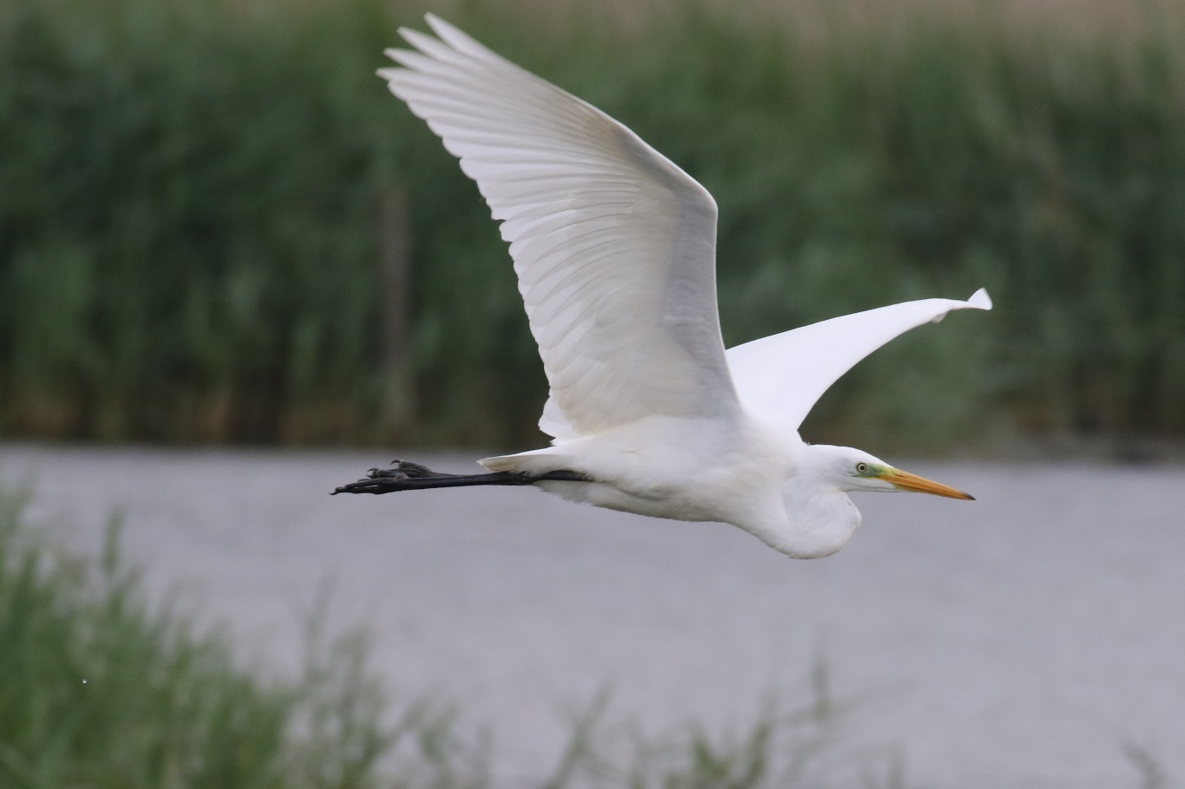

Photo – Peter Scott – Great White Egret

Scarcer visitors included Green-winged Teal, Red-breasted Merganser, Quail, Fulmar, Manx Shearwater, Stone Curlew, White-rumped Sandpiper, Long-eared Owl, Hoopoe and Golden Oriole. A late summer influx of Shags at Rutland Water was noteworthy. Autumn saw Stonechats arrive in good numbers and Great Northern Divers at Rutland Water increased to nine in December, a remarkable number for an inland site. Garden birdwatchers reported Long-tailed Tits, Blackcaps and Lesser Redpolls but generally mild winter weather resulted in few surprises at our feeders. My thanks to members and others who submitted records during this difficult year. Without your support our knowledge of Rutland birds would be much the poorer:

T. Appleton, R. Backer, R. Baker, D. & J. Ball, P. Bennett, A.J. & L. Biddle, C. & P. Brown, T. Caldicott, J. Clarke, L. Clarke, D. P. Cole, M. Collins, T. Collins, A. & J. Comber, J. Davis, M. Eaton, Dr. C. H. Gallimore, M. Grimes, M. & G. Griffin, A. H. J. Harrop, K. Holderness, T. Land, P. Langston, LROS, R. Lemmon, S. Lister, A. Mackay, T. Macrill, D. Masters, K. Mather, I. Misselbrook, T. Mitcham, B. Moore, J. W. Nourish, C. I. Park, L. Park, J.S. & J. Rodgers, P. J. Rudkin, RWNR, P. Scott, J. Walker, J. Wheeler, S. Williamson-Noble.

Systematic List
(For Abbreviated Site Names see RNHS website). Initials of non-members accompany some records.

See Also Monthly Wildfowl Counts.

Canada Goose. Present all year and breeding at both reservoirs. Two or three visited FHP
up to 30.05. and up to 36 between 04.10 and 27.12.
Barnacle Goose. Two were in RWNA on 21.12.
Greylag Goose. Present all year and breeding at both reservoirs. Large flocks away from RW
were 293 at FHP on 02.02. and 115 by Rygate Lake in Ext Park on 28.11. A pair had five goslings in Ext Park on 09.05. and at BGP there were 16 adults and 24 goslings on 24.05.
Pink-footed Goose. In the first winter period 52 flew west at Norm on 10.01. One was at RW
Sailing Club on 15.01. A flock of 250 flew west over Strett on 19.01. when there were three at RW Hamb Pen, these relocating to the VTC on 22/23.01. Autumn records were of 45 north at Man on 29.09., 30 east at RW on the same date, 96 south-east at RW on 11.10., one at EBR on 06.12. and 200 west over Oak on 22.12.
White-fronted Goose. Five were in Sailing Club Bay at RW on 09.01, with six near the VTC on
21.-24.01. A movement of birds from Europe saw 13 at EBR on 01.12., rising to 24 on 05. 12, with 23 still present on 15.12.

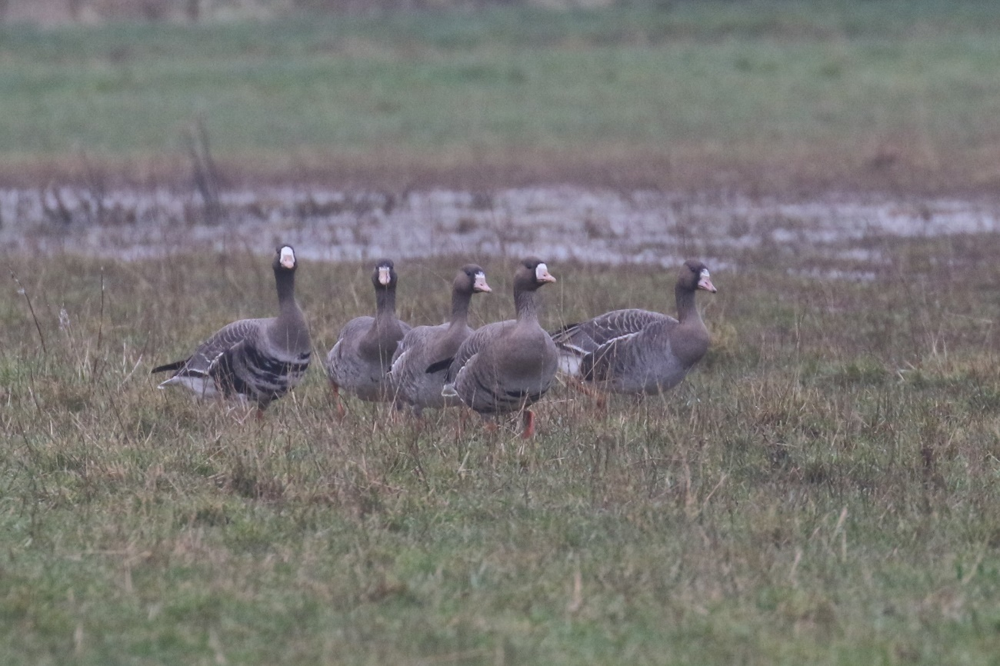

Photo – Peter Scott – White-fronted Goose

Lesser White-fronted Goose. A flock of nine were in RWNA on 11.07. Genuine wild birds are now
very rare visitors to Britain and these were presumably part of a reintroduction scheme in Scandinavia.

Mute Swan. Present at both reservoirs throughout the year with breeding confirmed at both. A
pair had three cygnets at EBR on 07.06. Also bred at BGP (two cygnets), Geest (three cygnets), FHP (five cygnets) and Rygate Lake (seven cygnets). There were 116 at EBR on 20.07.
Bewick’s Swan. Eight were at EBR on 29.11.
Whooper Swan. A group of 24 flew north-west over RW on 06.02. and six were at RWEg4 on 21.03. An
unusual summer record was a single bird north-west over Wg on 04.06. The first autumn birds were five in RWNA on 27.09. with one there on 29.09. On 11.10. three flew east over RW Dam and 11 were in RWSA. Five flew south-west over Ext Park on 22.11. and four were in RWNA on 04.11.
Egyptian Goose. Resident at RW, where breeding was confirmed. Away from RW, one was by
Rygate Lake in Ext Park on 11.04. with a pair on 17.10. Two were at FHP on 10.04. with one on 25.04.
Shelduck. Present at RW with breeding confirmed. At FHP, formerly a regular site, singles were
noted on only five dates between 17.02. and 09.05., with no attempt at breeding.
Mandarin Duck. Regular throughout the year in the Wg area with presumed breeding in the area.
Three were on Rygate Lake, Ext Park on 02.02. with a pair present in Nov. and Dec. There were records of singles from FHP in May, June, Sept., and Nov. A pair at RW Norm were seen between 06.03. and mid-May. A pair were flushed from a pond in TunnW on 14.03. and 10.04. and one flew around QF Wood on 13.04. Broods of five and seven were reared at Mor, with a peak of 17 there in June and July (DC).
Garganey. A male was at RWEg1 on 22.03. A female was on RWEg4 on 28.06. The first autumn bird was
at RWLynd between 15.-30.07. with one or two regularly at RWEg from 15.08. to 29.09. One was at EBR on15.09.
Shoveler. Two were on flooded fields at Cott on 03.02. Present at RW all year with peak nos. in
autumn. A pair were at EBR on 15.05. At FHP two pairs were present from 11.04. to 13.06. but breeding was not confirmed. The first double figure autumn count there was 23 on 05.09. with a max. of 44 on 23.10. and birds present to the end of the year. Eight were on the Welland valley floods at Seaton on 06.12. (TC).
Gadwall. Present at both reservoirs throughout the year with breeding confirmed at both.
Present all year at FHP with winter peaks of 61 on 04.01. and 109 on 07.11 and 21.11. Two pairs bred at FHP and one on Rygate Lake in Ext Park. Five flew south over Wg on 15.05. and four on 19.05. There were 15 on the Welland floods at Seaton on 06.12.(TC).
Wigeon. A common winter visitor at both reservoirs and other wetland sites with one or two
remaining into the summer. There were 132 on a flooded field at Cott on 10.01. Present at FHP to 11.04. with a max. of 128 on 27.02. and from 05.09. to the end of the year with a peak of 66 on 28.11. One was at EBR on 17.08. A total of 1150 was on Welland valley floods at Seaton on 06.12. with 1420 on the floods between Harringworth and Turtle Bridge on 27.12.(TC)
Mallard. A common resident on all water bodies – few records were received. A count of 164 on 01.08.
was the peak at FHP. Breeding was noted at both reservoirs, FHP, Rygate Lake and in an Oak garden, where a brood of eight was hatched without the owner’s knowledge.
Pintail. Reported from both reservoirs with highest nos. in autumn. Up to three were at FHP
between 04.10.and 28.11. Forty were in Man Bay RW on 03.12. and 25 were on the Welland valley f loods at Seaton on 06.12.(TC).
Teal. Regular at both reservoirs with lowest nos. in summer. 31 were on a flooded field at Cott
on 08.02. Present at FHP to 18.04. with a peak of ten on 20.03. and from 25.07. to the end of the year with a peak of 89 on 21.11. Six were on a pond at QF on 09.11. and 60 were on Welland valley floods at Seaton on 06.12. with 215 on the floods between Harringworth and Turtle Bridge on 27.12.(TC)
Green-winged Teal. One was at EBR from 30.05. to 08.06. with one reported there on 21.10.
Red-crested Pochard. Up to eight were in RWNA/SA to 26.01. Two were in SA on 09.08. with
one there on 07.09. A male was at FHP on 14.11. Nineteen were in Man Bay RW on 27.11. with 17 there on 05.12.

Pochard. Present at both reservoirs, mainly in autumn and winter but breeding was confirmed at
RWEg. Much lower nos. are now seen with many birds remaining on the continent during milder winters and nos. also supressed by predation and pollution. At FHP there were two on 12.06. with singles on 01. and 09.08.
Tufted Duck. Present throughout the year at the reservoirs and FHP with the peak nos. in autumn,
especially at RW. Breeding was confirmed at RW, at FHP (three broods), a pond at GHW and Greet GC (single broods at each site).
Scaup. A winter visitor in small nos. with all reports this year from RW. Up to 15.03. a max. of ten
(26.01.) was noted at sites from the Dam to Eg. Three were in SA on 01.11.
Common Scoter. A scarce visitor in winter or on spring passage. One was at RW Dam between
02. and 05.01. Five were at EBR on 22.05. All other records were from RW. In June there were three on 11th, 18 on 13th, and one on 29.30. One was in NA on 29.07. Between 03.10. and 30.10 up to ten were noted on ten dates.
Goldeneye. A winter visitor at both reservoirs. Few records were received. A male was at FHP
on 26.01. There were no final spring dates but one at EBR on 03.06. had apparently been present since mid-May and was still there on 16.06. Two were at RW Old Hall on 12.09 and two females were at FHP on 14.11.
Smew. A winter visitor to the reservoirs from Scandinavia in small nos. Reported from RW from
12.01. to 16.03., mainly at Eg, with a peak of 16 on 11.03. EBR had one or two between 19. and 24.01. A redhead at RWEg1 on 28.10 was the first autumn bird with up to ten present there (26.12.) to the end of the year. EBR had birds from 28.11., usually one or two but seven (five males) on 30.12.
Goosander. A winter visitor in declining nos. at the reservoirs and occasionally at Rygate Lake,
Ext Park where there was one on 10.01. and two on 23.02. Two at RW Dam on 11.10. were our first autumn birds with 17 there on 30.10. A remarkable seven were at BGP on 29.11. and one was at EBR on 01.12. Thirteen were counted between RW Dam and Norm on 09.12.
Red-breasted Merganser. Two were at RWEg2 on 04.10. and a female/imm. was at the Dam
between 05.12 and 07.12.
Ruddy Duck. Now virtually extinct in the UK following the official cull, a female was at RWEg1 on
15.03.
Partridge Red-legged. Found on arable land across the county, especially in the east and where
large nos. are released for shooting, as at Ext and by EBR.. No breeding records were received.
Grey Partridge. A local resident on farmland. Twelve were at Greet on 01.01. Regular at Spy Corner
(Cott Airfield) all year with a covey of 15 on 25.07. and at QF with a pair in April and a covey of 11 on 28.09. Bred at Eg and also in Ext Park with records between 25.04. and 17.10., when a covey of twelve was seen. One or two were noted irregularly at Luff Airfield, near Pick and around Man.
Quail. Calling birds were noted as follows: at QF one on 26.05., north of GCast between
27.05. and 25.06. with three on the last date, at High Moor Farm, Emp one on 15.06., and in Ext Park one on 26.07. One was seen running in front of a combine harvester at Prest on 11.08. – a rare sight record.
Pheasant. Common where large nos. are released, as at Ext, but rather local in woods and on
farmland elsewhere and only one record from well watched QF this year. Two or three pure white birds were seen at feeders in Ext Park in Feb. and March.

Great Northern Diver. Present at RW Dam and Main Water from 03.11. to the end of the year with
nos. increasing from three on the first date to an amazing nine on 23.12. – surely a record for an inland site. (TA)

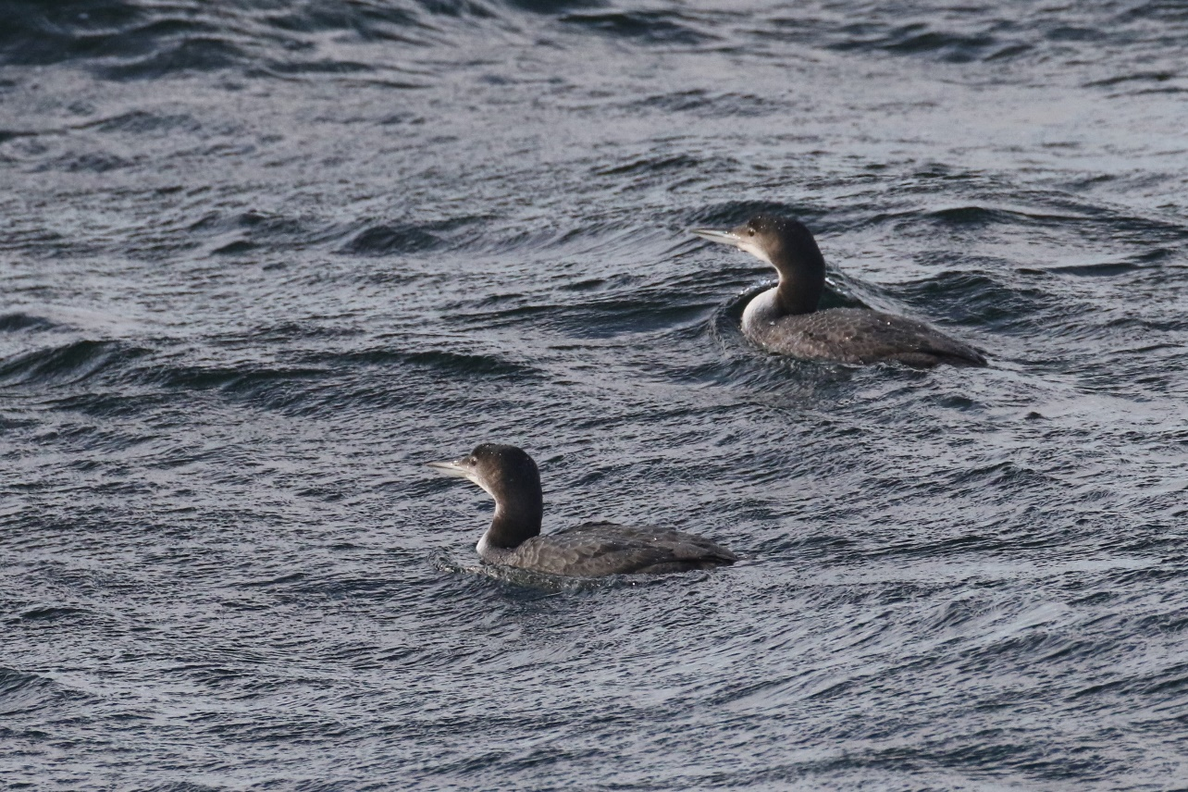

Photo – Peter Scott – Great Northern Diver

Fulmar. One flew over QF Wood on 06.06. (CIP)
Manx Shearwater. One was in RWSA on 04.09. – sadly killed by a Great Black-backed Gull.
Little Grebe. Present at the reservoirs mainly in autumn and winter. A scarce breeder. At FHP
up to three were present between 04. and 26.01. with one on 11.04. and autumn birds from 14.08. to the end of the year, peaking at seven in Dec. Breeding was confirmed at RWEg and Greet Valley GC.
Red-necked Grebe. One was at RWSA up to 12.03. and again from 04.09. to at least 25.10.
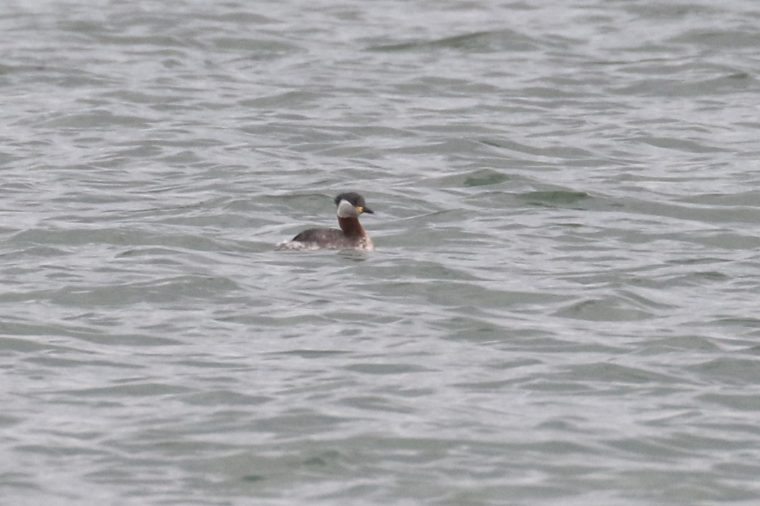

Photo – Peter Scott – Red-necked Grebe
Great Crested Grebe. Present at both reservoirs all year with peak nos.in winter. Breeding was
confirmed at both.
Slavonian Grebe. One was in RWNA up to 02.03. and one was at RW Dam between 17. And 13.10.
Black-necked Grebe. Two were at RWNA or Eg3 from 01.01. to the end of Feb. with three noted
on 02.03. and 11.03. One was at EBR on 09.08. whilst RWNA had one from 04.09.to 24.09. and one from 01.12. to 26.12.
Glossy Ibis. One was reported from EBR on 09.11.
Spoonbill. One was at RWEg4 and NA from 15.08. to 13.09. with two reported on 24.08. A juvenile
flew north over Upp on 15.09 and a single was again at RWEg1 on 10.10.
Bittern. One, possibly two were at RWEg3 on 02. and 04.03. and between 01.08.and 13.09. Two
were again reported on 06.12. and one was at EBR inflow on 12.11. When will they finally breed at RW?
Cattle Egret. This species is visiting Rutland more frequently and may eventually become as
regular as the other egret species. One was at RWEg1 on 12.05. with two at Lynd/Eg1 on 06.07. and one on 02., 03. and 18.08. At EBR one was seen on 20. and 23.05., from 05. to 17.08. and on 15.09. There may be duplication in sightings from both reservoirs.
Grey Heron. Was seen at both reservoirs throughout the year with a small breeding colony at
RWBFP. Regularly commuted along the Welland valley and three flew north at QF on 23.09. One or two were always at FHP top lake between 18.07. and 04.10., when the level of the lake was very low.
Great White Egret. The rise of this graceful species continues apace with records in all months
from RW. Nos. there increased from late summer with 24 roosting on Eg2 by 21.09. One flew over Rygate Lake, Ext Park on 02.02.and singles were also noted over Wg, Man and MThorpe. One was at EBR on 03.05. with one on 08.12., two on 10.12. and three on 13.12.
Little Egret. This colonist could be seen by any water body in the county with the largest nos.
at RW, where it is now nesting. There was an April peak of 127 there on 18.04. One or two were at EBR, FHP, Rygate Lake, Tin Pumping Station, Geest and Greet GC during the year. Six were at BGP on 26.07.
Gannet. Two juveniles flew west over BW on 01.09. and a third-year bird flew north at EBR on 05.10.
Shag. There was a large influx of birds to the reservoirs, mainly RW, in late summer with birds
present into the autumn. One in RWNA on 22.08. was the first, with arrivals from 25.08. at the Dam. The peak of 24 was from this date to 27.08 with nos decreasing slowly thereafter. There were still twelve at the Dam on 04.09. with seven on 09.09. and 16.09. and one on 29.09. We have no Oct. records but one or two were reported between 04. and 24.11. At EBR there were two on 24.08. with singles on 25. and 27.08.
Cormorant. Resident at both reservoirs with a thriving breeding colony in BFP at RW. One or two
were regular at FHP and Rygate Lake, Ext Park throughout the year with four at FHP on 22.02. Frequently seen commuting over QF. A huge count of 960 was made at RW on 01.09. (SL).
Osprey. Migrant breeder at RW and passage visitor. The first bird returned on13.03. and 26
adults finally arrived in the RW area where eight pairs fledged 19 chicks, further cementing the success of this tremendous project. Birds were regularly seen at EBR throughout the summer and, away from the reservoirs, two were mobbed by a Buzzard at HM on 24.03. Singles also flew over Stam (28.04.), Wg (12.06.) and QF (29.06.). Most had left by early Sept. (one was at EBR on 04.09.) with the last departed by mid-month.
Sparrowhawk. Well distributed in woodlands across the county with regular sightings in gardens.
Display was noted over Ext Park, WardW and QF Wood. Gardens were visited in Barrow, Oak, Stam and Pres. Prey taken included Blue Tit, Blackbird and Starling. Rural records came from Pick Drift, Teigh, Tin and BarnsW.
Marsh Harrier. One or two female/immatures were at RWEg from early Jan. to at least 29.04. There
were then records in every month from July (24.07.) to the end of the year, usually one or two but increasing from Sept. with up to five roosting in Eg3 reed bed. Elsewhere there were singles at EBR on 03.08., and10.-11.09. over MThorpe on 02.09. and at Tin in mid-Oct.

Red Kite. Our most regularly seen raptor, noted over farmland, woodlands, villages and towns
across the county. Seven were over Glas on 08.02. and twelve were seen near Pick Drift on 13.11. Birds were noted following ploughing at Stoke Dry and visiting suburban gardens to collect scraps. No confirmed breeding was reported but pairs were noted over BW, WardW and Ext Park woods throughout the spring and summer.
White-tailed Eagle. How exciting to include this magnificent bird in our annual report. The last
Rutland bird was ‘shot at but missed’ near Emp about 1900. One of the Isle-of-Wight juveniles was at RWNA on 02 to 04.04., when it was seen chasing Egyptian Geese. The same bird passed over KettQ on 19.04., en route to the Peak District. On 01.08. it flew over RWBFP.
Buzzard. Perhaps our commonest raptor with birds seen in many woodlands and hunting over
farmland. Thirteen following ploughing at Stoke DryD was the highest count but groups of up to seven birds were reported over woods in April and May. A pair fledged two young at Mor, and fledged young called in Ext Park, at Lynd and Wg Burrows in Aug.
Water Rail. Resident and breeding at RWEg/Lynd with autumn and winter records from other suitable wetland sites. Two called at FHP on 10.10.
Moorhen. A common species at all wetland sites where there is suitable cover. The peak count at
FHP was 48 on 26.09.
Coot. A breeding resident at larger water bodies with large winter populations at the reservoirs.
Nested at both reservoirs, BGP, FHP, Rygate Lake and Geest. Peak winter counts at FHP were 64 on 10.01. and 56 on 14.11.

See Also Rutland Water Wader Counts.

Stone-curlew. One was at Luff Airfield on 23.04.(TC).
Oystercatcher. One or two were along RW south shore between 03. and 28.01. Bred on the Eg
Lagoons with one seen on 19.07.. Single birds were heard over Wg on 04., 14. and 25.04. and two were at EBR on 03.05.
Avocet. Reported from RWEg between 13.03. and the end of April with a peak of eight in the
latter month. One was at EBR on 22.03. with two there on 23.04. Three late birds were at RWEg1
from 08. to 15.11.
Lapwing. A flock of 150 flew over Strett on 03.02. and there were 342 at EBR on 08.02. Approximately
200 were in Ext Park on 24.03. Display was noted from 14.03. at Ext Park, Man, RWEg (breeding
confirmed), WFL, Pick and BGP and a pair with four chicks was seen near Cott on 23.04. 92 flew
east over Ext Park on 19.09. and 21 were at EBR next day. On 17.10., 52 were in Ext Park with 269
at EBR on 18.10.
Golden Plover. Two flew over Ext Park on 04.01. 45 flew north over Pilt on 07.01 and around 200 were
at RWEg on 11.01. Just one was at EBR on 08.02. At QF there were 21 south-west on
05.10 and 13 south-west on 13.12. On 05.12. an impressive 3000 were on Eg4 and 42 flew south-
west over MThorpe on 18.12.
Grey Plover. One was at RW on 18.04. and four were at EBR on 28.11.
Ringed Plover. One was heard over RWGgorse on 16.03. There were spring records from RW
between 23. and 29.04. with ten on the latter date. Autumn birds were noted between 08.08. and 27.09. with a max. of 17 on 20.08. One was heard over MThorpe on 17.09. None were reported from EBR this year.
Little Ringed Plover. One was at RWEg4 on 21.03. with six there on 27.04. and one at EBR on
18.05. Autumn birds were at RW from 25.07. to 14.08. with eight on 10.07. Single birds were at EBR on 16. and 19.07. and 08.08.
Whimbrel. Spring birds passed through at RW between 04. and 27.04 with six on the latter date.
Four were over Luff Airfield on 18.04. with one over QF on 30.04. One flew over Prest on 17.05. The only autumn bird was one over Man on 27.07.

Curlew. This enigmatic wader occurs as a passage and winter visitor and a scarce breeder. Six
flew over RW on 03.03. and one was at EBR on 08.03. One or two were back at Cott Airfield on 25.03. and one was over Wg Fishing Lakes on 03.04. Birds were in several areas of likely breeding habitat between April and the end of June: Barrow, Ash, Cott Airfield, MM, Luff Airfield (bred) and Lang. Five over Bussack Water, on 14.06. which is adjacent to Cott Airfield may indicate successful breeding there. Migrants were heard over Wg and MThorpe between 29.06.and 18.07. with a late bird on 18.10.
Bar-tailed Godwit. One was on RWEg4 on 14.04. with four present on 29.04.
Black-tailed Godwit. Up to four were at RWEg between 21. and 27.04. Autumn birds were noted
there from 06.07. to 18.10, mainly in July and Aug., with a peak of 29 on the first date. EBR birds were reported from 03.07. to 11.08. on five dates with a max. of 13 on 10.07. Six were at RWMan Bay on 22.11. with three nearby on 03.12.
Turnstone. Nine were at RW on 24.05. and four were on Eg4 there on 30.07.
Knot. One was on RWEg3 on 06.07. One was on Eg4 on 14.08. with two present on 15. and
16.08. Fifteen flew over there on 30.08. One or two were at Eg from 06. to 20.09. and one was in RWNA/BFP between 16. and 24.12.
Ruff. None were reported until one at RWEg4 on 25.06. Two were at RWEg on 14. and 18.08.
EBR had two on 20.08. and one on 24./25.08. A poor year for the species was rescued by an amazing count of 41 at EBR on 30.12. (AM); the largest count in the county away from RW.
Curlew Sandpiper. Single juvenile birds were at RWEg on 26./27.08. and between 02. and 07.09.
Juvenille birds were at EBR on 01.09. and 20.09.
Temminck’s Stint. Single birds were at RWEg4 on 13. and 22.05.
Sanderling. One was at RW on 29.04. with four on 24.05. Autumn singles were present on 08.
and 14.08. with two on 22.08. and one again on 26.08.
Dunlin. Spring passage was between 23. and 29.04 at RW with 24 on the latter date. One was at
EBR on 18. and 20.05. Autumn birds visited EBR from 22.06. to 29.09. on at least six dates with a peak of just seven on the last date. There were RW records from 25.07. monthly to the end of the year but no double figure counts, apart from twelve which flew over on 11.12.
Little Stint. Single birds were at RWEg on 16 and 25.07. One or two were present between 01. and
10.09. on Eg1.
White-rumped Sandpiper. This rare North American wader was at RWEg1 on 14.08.
Woodcock. In the first winter period birds were reported from TunnW, Pilt, WestlandW and Wg up
to 14.03. with a max. of four in TunnW on 26.01. The first autumn birds were singles at MThorpe on 14.10. and CPW on 16.10. Between 04.11. and 27.12. there were records from Luff Airfield, TunnW, Man, MThorpe and Pick Drift, with four in TunnW on 27.12.
Jack Snipe. Singles were flushed at BGP on 08.01. and 06.03. One was at RWEg between 18-
27.10.
Snipe. A passage and winter visitor, four were at BGP on 08.01. with one or two at Wg later in the
month. Five were at BGP on 06.03. and there were three at NLuff on 20.04. with one there on 26.04. the last of the spring. One at EBR on 01.09. was our first autumn bird; single birds were flushed at QF on 11. and 16.09. and two were at LFP on 18.09. Three were at EBR on 06.12. These low totals beg the questions, are we failing to find these birds, was 2020 just a bad year or have they really declined massively? None were found at FHP for the first time in twenty years of birding there.
Common Sandpiper. Our only spring records of this passage migrant were single birds at EBR on 20.
and 30.05. One at FHP on 02.07. was the first autumn bird. There were records from RW between 10.07. and 29.08. with a max. of ten on 18.08. One was at EBR on 24.08.

Green Sandpiper. This species is a passage visitor, often found away from the reservoirs, which
may overwinter when conditions are mild. From 01.01. to 20.03. single birds were noted at RWEg/Lynd, Wg, and FHP. No spring records were received but birds were seen in every month from 08.06. when one was at EBR. Single birds were noted at EBR regularly until 29.09. At RW four were seen on 28.06. and 11 were counted on 10.09. It was a good autumn at FHP with records between 01.08. and 12.12. and five on 30.08. Migrants were heard over Man (five seen on 19.08.), MThorpe and Leigh between 31.07. and 04.09. with a late bird over MThorpe on 24.10.
Redshank. Few records, and all from RW, were received. In Jan up to five frequented the south
arm shore with one or two remaining to 21.02. Birds were present, and nesting on the Eg lagoons throughout the summer but 26 there on 06.07. were certainly migrants. Two were at RWWhit on 19.11.
Wood Sandpiper. A passage migrant in varying nos.; three were at RWEg4 on 27.04. with two still
present on 29.04. One was at EBR on 06.05. One was at EBR on 09.06. with two on 12.06. Autumn passage got underway at both reservoirs from 09.08. and extended to 17.08. at EBR and 04.09. at RW, with peak counts of three on 10.08. at EBR and 18.08. at RW
Spotted Redshank. At EBR there were two on 22.04. and one on 15.-16.08.
Greenshank. An elegant passage migrant at both reservoirs, the first birds were two at RW on 21.04.
with birds noted to 29.04. One was at EBR on 13.05. One calling over Man on 11.07. was an early autumn bird. At EBR there were two on 10.08., three on 24.08. and two next day. RW had birds from 02.08. to 13.09. with four on 14.08.
Kittiwake. Single birds were at RWEg4 on 14.03. and EBR on 03.11.
Black-headed Gull. Present throughout the year, breeding at RWEg, with large nos. of continental
birds present in winter. Around 1500 were at RW on 11.03.; 400 were at FHP on 21.08. Autumn passage was noted over MThorpe on 06.08. with 907 south-west, Wg on 30.08. with 277 south-west and Wg on 20.09 with 3050 mainly south-south-east.
Little Gull. On spring passage there were twelve at EBR on 10.04., seven there on 17.04., seven at
RWSA on 18.04. and three there on 23.04. Single Autumn birds were at RW on 29.07, 09.08. and 21.08.
Mediterranean Gull. An occasional visitor at the reservoirs, often found in the evening roosts.
Single birds were at RW on 02. and 24.01. One was on Eg4 on 21.03. and there were two on 07.04. An adult was at the Dam on 23.06. One was at Eg on 30.06.and single birds were at RWEg on 14. and 29.08.
Common Gull. A winter and passage visitor, often numerous on spring migration. There were 45 at EBR
in Feb. and 2000 gathered at RW on 14.03., when there were 250 at EBR. 60 passed over QF on 30.03. Ten were back at RW on 21.07. with no records then until 08.10, when there were 67 at EBR rising to 400 there on 28.11. 330 were near Oak on 02.11.
Great Black-backed Gull. Present at RW all year, mainly immature birds in summer. Counts at RW
included 32 on 31.01., 28 in Feb., 30 on 11.03. and 20 on 30.06. There were 30 in July, 41 on 04.08. 32 on 11.08. and 30 on 04.09. Four were at Greet GC in Feb. and one or two were regular during the day in both winter periods at EBR.
Glaucous Gull. An adult was at EBR on 07.03.
Herring Gull. A winter and passage visitor, most numerous in winter. There were 220 at RW on 31.01.
with 200 roosting in Feb. 12 were at EBR on 28.11.
Caspian Gull. A scarce visitor at the reservoirs on passage and in winter. Two adults were at
RWEg4 on 11.01. with single birds on 12. and 24.01. One was present on 10.03. and passage singles were noted on 08., 11., and 18.08.
Yellow-legged Gull. A passage visitor, most regular in summer and autumn. One was on RWEg4
on 28.06. with nos. rising to 11 on 10.07.and 17 on 28.07. with 16 on 26.08. Six were still present on 13.09. and a single bird was seen at the Dam on 15.09. and 06.10. and at Whit on 24.10.
Lesser Black-backed Gull. A regular passage visitor at the reservoirs. The only record was of twelve
in March at RW.
Sandwich Tern. Three were at RW Man Bay on 17.09. and one was at EBR on 20.09.
Little Tern. Single birds were at RW Man Bay on 04.06. and RWEg3 on 26.07.

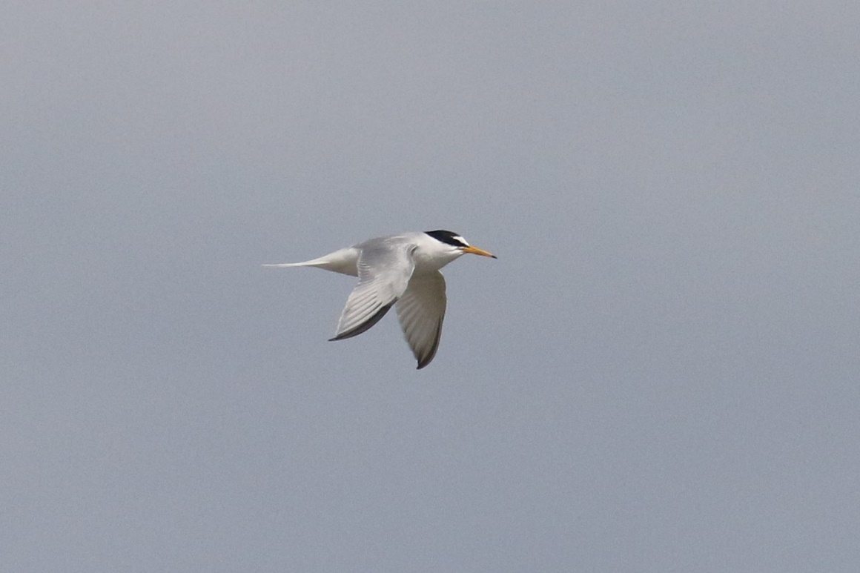

Photo – Peter Scott – Little Tern

Common Tern. A passage bird and breeder at the reservoirs. Our first record was of six in RWSA
on 19.04. (TA) with nos. at RW rising to 40 by 26.04. Migration continued into May with four over Wg on 09, two on 19 and two on 28. Eleven were at EBR on 31.05. where breeding was confirmed. Nos. at RW (where breeding was successful on the lagoons) were 101 on 10.07. and 58 on 26.08. Our last birds were two at RW Old Hall on 06.09.
Arctic Tern. A regular passage visitor at the reservoirs. Four at RWNA on 14.04. were the first birds,
with five there on 18.04. and 20 at EBR on 20.04. Two birds were there on 21.04. A juvenile at RWEg3 on 15.08. was the first returning migrant with further single birds on 17 and 25.08. A juvenile was in RWSA on 20.09. with the final two birds there on 29.09.
Black Tern. A passage visitor, now in much reduced nos. Spring migration was noted between
18.04. and 30.05. with up to three at RW on three April dates and four at EBR on the last date. All but one of the autumn records were from RW between 24.06. and 08.10. with the bulk between 09. and 29.08. with a max. of just four on 20. and 24.08. Two were at EBR on 25.08.
Feral Pigeon. Local populations are found in Oak, Upp, Stam and at Castle Cement, Kett.
Suburban birds, frequenting unenclosed solar panels, are exploiting garden feeding stations in Stam. The only count was of c.300 feeding on arable land near QF on 20.11.
Stock Dove. A well distributed resident of woodland and farmland. Rural feeding stations were
visited at Barrow and BCF in Jan and Feb. and an Oak garden was visited in April. Bred in farm buildings at BCF and in a Barn Owl nest box in Ext Park with other breeding season records from RWEg, FHP, QF and Geest.
Woodpigeon. A common species, now well entrenched in suburban areas, with a marked autumn
passage. Between 04. and 07.11. 2380 passed over the Man/Leigh area and between18.11. and 27.11. 1362 passed over MThorpe/Gun.
Collared Dove. Twenty-five roosted at Pilt on 07.01. A large flock of 73 fed on harrowed stubble near QF
on 28.09. Seven was a high garden count at Barrow on 21.10.
Cuckoo. A declining summer visitor, the first was on 08.04. over Wg with the next at WardW on
14.04. Noted at 15 sites (14 last year) with the last at QF on the early date of 29.06.
Barn Owl. An uncommon resident whose nos. fluctuate with declines following harsh winters.
Birds were reported from an encouraging 23 sites across the county from the west to the east (16 sites last year) and similar to the 22 sites in 2018. Noted at only two of our nest boxes since lockdown made monitoring and ringing of any young impossible.

Tawny Owl. A well distributed resident in woods and parkland, reports came from 13 sites in 2020
(14 in 2019). Recently fledged young were seen at Ext (13.05.), Shacklewell Hollow (May), Mor (May) and Upp (06.08.). Vocal birds were at Barrow all year and TunnW in March, April and Nov. and Leigh, where five or six were sorting out territories on 31.08.
Little Owl. This introduced species was reported from ten sites, the same number as last year,
mainly in the west of Rutland. Breeding was confirmed at Bden and near Brk and one moved into a nest box at Norm from 13.11. to the end of the year. It remains absent from former sites at BCF and EBR and its absence from the arable east of the county suggests a lack of prey or nest sites.

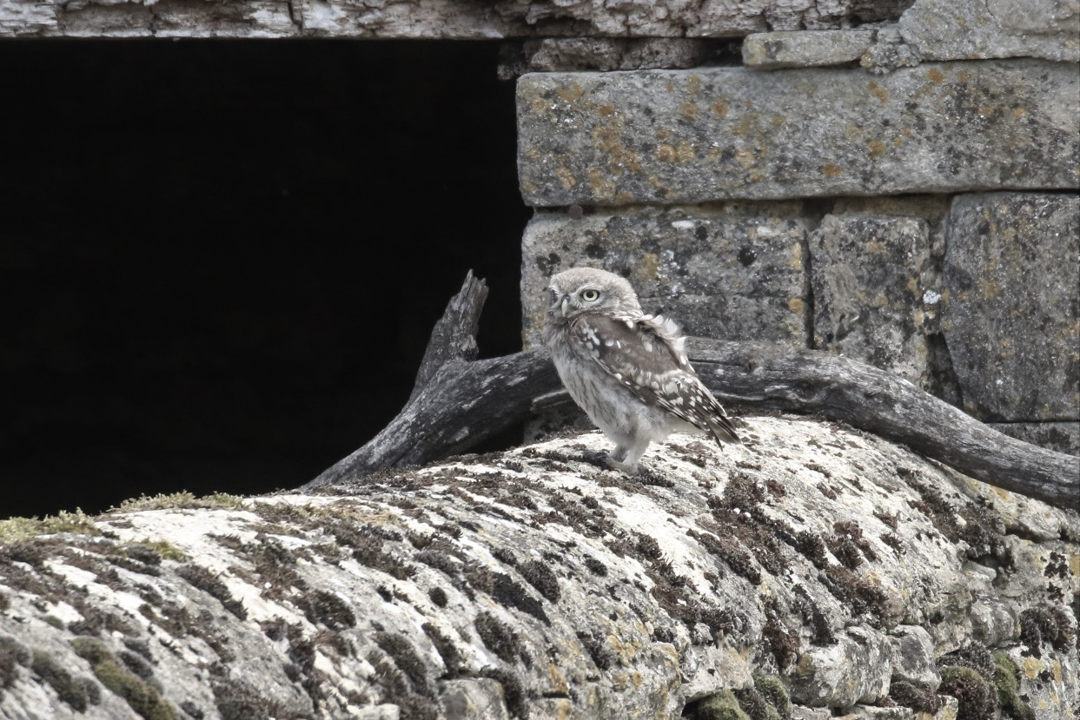

Photo – Peter Scott – Little Owl

Long-eared Owl. One was discovered in hawthorn scrub in the east of Rutland on 17.11. (TC).
Short-eared Owl. One was at Luff Airfield on 11.08. (TC).
Swift. A decreasing summer migrant. One over RW on 18.04. was the first followed by two at Man
on 27.04. Few records were received and none of feeding flocks, apart from 40 over Wg on 27.06. and 30 at Stam on 16.07. or confirmed breeding. Birds seen over Stam and Upp in May were likely to be local breeders. The last Stam birds were seen on 14.08. and the last records were on 30./31.08 over Man.
Kingfisher. A scarce resident on rivers, regularly visiting the reservoirs to fish. One was along RW
south shore on 27.01. with the next in April at Tin Pumping Station. No confirmed breeding was reported. There were then records for all months to the end of the year with birds seen at FHP, Rygate Lake, Mor, QF, LFP, Leigh, MThorpe, and Stam.
Hoopoe. One was reported/photographed at MO on 10.04.
Great Spotted Woodpecker. A well distributed resident, often seen at garden feeding stations.
Birds were noted at 14 sites, one more than last year but this species was surely under-recorded (Covid restrictions?) with drumming heard only at Barrow, BCF, QF, RWEg and WardW. Breeding was confirmed at QF, FHP and WestlandW. Gardens were visited regularly at Barrow and Oak and there was an interesting record of drumming at BCF on 04./05.11.
Green Woodpecker. Reports came from only eight sites compared to twelve last year (see note in GS
Woodpecker above). The most regular site was QF, where breeding was confirmed and birds were seen on virtually every visit. Ant hills at FHP proved attractive with frequent sightings there.
Kestrel. Following a request for all records of Kestrels, there were reports from 21 sites (ten last
year). Hunting birds were noted over roadside verges and grassland across the county. Breeding was noted at an old tree site near Teigh in July whilst young were fledged from nest boxes at Hall Farm, Ext and Norm (five ringed on 30.06.). A pair were also successful at the dovecote by Rygate Lake in Ext Park.
Merlin. With eight records, it was a good year for this moorland breeder. A male was at EBR on
02.01., one was near Tin Cottages on 08.02. and one was at RW on 11.03. Autumn birds were at MThorpe on four dates between 09. and 25.10. and one flew over QF on 19.10.
Hobby. An early bird was at RWNA on 13.04. with reports from 13 sites during the summer (ten
last year). There were frequent sightings from three areas, indicating local nesting and one pair was confirmed breeding at a traditional site. The last bird was also at RWNA on 01.10.
Peregrine. Present throughout the year and noted at twelve sites (nine last year). Regular at RWEg
in winter with two or three present in Nov. and Dec. Present at a regular breeding site but no fledged young were reported.
Golden Oriole. A singing male was tape recorded by the R.Chater at Kett on 16.06. (per TMa).
Jay. Well distributed in woodlands across the county but few records were received. Noted in Ext
Park woodlands and at RWEg with Jan. sightings from a Barrow garden and two visiting feeders near Braun, also in Jan.
Magpie. A widespread and common species where there are overgrown hedgerows and scrub,
now frequent in suburban gardens. Regular at QF where 14 were counted together on 04.08.
Jackdaw. Common at quarries and on pasture where they can forage among livestock. Farm
buildings provided nesting opportunities, as at BCF. Two Tawny Owl nest boxes were used at FHP and one at BCF. c.500 were noted near MO on 28.07.
Rook. No rookery counts were received. Remains widespread, especially where pasture and
adjacent arable land provide feeding opportunities.
Carrion Crow. Regular in suburban areas, eg Stam, where they are not persecuted. Common in
open countryside where hedgerow trees provide nest sites.
Raven. This species was well distributed across the county with records from 13 sites (14 last
year). Records came from five regular breeding sites with three young fledged at two. Seven flew over EBR on 19.07. and the largest nos. were still in the west with peaks of 20 at Leigh on 27.08. and twelve there on 10.09.
Coal Tit. Well distributed in coniferous and mixed woodland and regular at some winter bird
tables. Four or five visited TunnW feeders in both winter periods. A pair bred in a garden nest box in Upp, fledging young on the early date of 04.04.
Marsh Tit. Found mainly in deciduous woodland with records from TunnW, WestlandW, PGW,
BarnsW and HambW. Feeders were visited at TunnW, and in gardens at Wg, and Upp.
Willow Tit. A very local species, now apparently restricted to the west of the county. One was at
RWLynd feeders on 19.01. with one nearby at Ggorse on 11.03. Single birds also noted at CWBWg, WFL, MThorpe Fox Covert, Glas, Wg (singing) and LFP.
Blue Tit. A common and widespread species in woodlands and gardens. Nos. on the BCF CBC plot remained stable. Up to 15 visited TunnW feeders at a time in both winter periods.
Great Tit. Well distributed in woodlands and gardens. There were only three territories on the
BCF CBC plot – half of the 2019 total.
Skylark. Present as a breeding bird on farmland and waste ground with a marked autumn
passage. Approximately 30 were in Ext Park on 10.01. Song was noted at MThorpe from 23.03. Eight territories at BCF CBC plot were almost double last year’s total and there were c.15 territories at QF where autumn passage began on 21.09 and extended to 09.11. with a peak of 72 passing south in two hours on 05.10.
Sand Martin. First reported from RWEg on 14.03. with two in NA next day. Few records received
but both artificial ‘banks’ at Eg were well populated. Seen occasionally at FHP throughout the summer. At least five pairs bred in an old wall at Park House, Norm. Our final record was from RWEg on 25.09.
Swallow. Single birds at Barrow and Cal on 07.04. were our first records, with the next at FHP on
11.04. Nos. seemed low compared to previous years but 40 were over Wg playing fields on 27.08. There were four Oct reports with one south at MThorpe on 20.10 the latest record.
House Martin. The first report was of two at Upp on 08.04. with the next at Man on 12.04.
Regular over the ponds at QF from May to Aug. 182 were noted flying south-west at Brk on 12.09 and the last birds were three over MThorpe on 06.10.
Cetti’s Warbler. Present at RWEg throughout the year. Five were around Eg3 in Feb. and 15
were ringed in July. Song was heard at a private site in May and two fledged young were seen there on 16.07. Song was also heard on the Mill Stream by Broadeng Bridge, near Tin Pumping Station between 14.04. and 24.05.
Long-tailed Tit. Generally widespread in scrubby areas and along hedgerows and regular at some
garden feeding stations. Six were on Ryll Heath on 02.01. and one Oak garden had birds between Jan and March (max. four on 05.01.), July and Aug. (max seven on 17.08.) and from Oct. to Dec (max. three on several dates). Another Oak garden attracted eleven on 05.12. Up to seven were regular at QF in Nov. and 25 were noted near Wg on 31.12.
Yellow-browed Warbler. One was in Oak between 19-22.10.
Willow Warbler. Singing birds at QF, Bisbrooke and Wg on 06.04. were our first birds. Noted also
at Pick Drift, PGW, FHP and RWEg but nos. remained low. There were probably six territories at QF. Our last record was at QF on 07.09.
Chiffchaff. Now present throughout the year with birds wintering at sewage works and around
RW. One was at Geest STW on 17.01. and single birds were at RW south shore between 27.01. and 25.02. Song was first heard at RWNA on 07.03 and later at four other sites in March. Widespread in April. Seven held territory at BCF and at least six at QF. Regular at several sites through Sept., with Oct. records from Man, FHP and QF. Single birds were at RWLynd on 16.-17.11. and near Gun on 20.11. December records came from RWLynd on 05. and 09., and two were at RWEg on 12.12.
Sedge Warbler. There were no significant arrival or departure dates, but birds were present at
RWEg/Lynd throughout the summer. Single birds sang at EBR on 22.04. and at QF on 29.04.and 01.05.
Reed Warbler. No significant arrival or departure dates were received. Singing birds were noted
at both RW reserves, at QF (two), FHP (two) and Geest (four). Passage birds were at MThorpe on 07. and 10.08. Our final bird was at RWEg on 14.09.
Grasshopper Warbler. One held territory at FHP between 11.04. and 30.05. Four were singing at
RWEg in June and July (TA) and one was ringed at Luff Airfield on 10.09.
Blackcap. A common summer visitor in woodlands and spinneys with regular winter records in
gardens. An Oak garden had single birds, mainly female, from 25.01. to 18.03. A male was in a N.Luff garden on 05.02. and a female was regular in another Oak garden in Feb. Song was heard first at Ggorse on 21.03. and two were singing at QF on 01.04. with five eventually holding territory there. There was an increase to 14 territories (from ten last year) at BCF. A male at Man on 09.11. was the first winter record with a female on 20.11. and both sexes on 25.11. A male was in an Oak garden on 26.11. The Man birds remained throughout Dec. with other records from Oak and Wg of single birds.
Garden Warbler. A summer visitor to woodlands and spinneys, the first was heard at QF on 25.4.
A migrant was at FHP on 02.05. when three were singing in Westland Wood. One was at Wg on 10.06 and our final, early, records were from MThorpe on 04.08. and QF the next day.
Lesser Whitethroat. A warbler of dense scrub where it is often difficult to see and is identified
mainly from its song. The first record was at QF on 21.04. with one at EBR next day. Singing birds were noted at RW, Tin, Cott, Wg, Ext, CWBWg, and Barrow/MO. There were three territories at QF and two at BCF. One was at FHP on 13.09. and the last was at QF on 28.09.
Whitethroat. A widespread summer visitor of hedgerows and scrub, the first was at EBR on 10.04.
with the next at QF on 16.04. Singing birds were reported from sites across the county; four along Pick Drift on 01.05. three at Wg on 21.05., four west of Ess on 26.05. and six at Wg Burrows on 21.06. The last record was from QF on 21.09.
Goldcrest. A resident of coniferous and mixed woodland and an autumn migrant noted in Ext Park
woods, QF and at BCF.

Wren. A woodland and hedgerow resident with improved nos. At the BCF CBC plot, up from nine
to 14 territories this year.
Nuthatch. A woodland species showing evidence of expansion in Rutland. Noted at traditional
Sites: PGW, Exton Park woods, FHP and CPW. There were occasional records between 28.07. and 27.11. from QF wood, apparently a new site, and a spinney near Taylor’s Farm, south of Pick on 31.07. Garden feeders were visited at Barrow in Jan. and Feb. and at TunnW in both winter periods.
Treecreeper. An overlooked woodland species. Reported from TunnW, RWLynd, QF and FHP. Bred in a shed at Mor. and was seen in a Barrow garden.
Starling. A resident, now more commonly nesting in urban areas than woodlands. A murmuration
of several thousand birds was noted near Upp in late Jan., and Oct/Nov. saw a murmuration of c.5000 birds into the reed bed at RWEg3. On autumn passage 7636 were counted moving west over MThorpe between 13. and 31.10.
Ring Ouzel. The ‘mountain blackbird’ is a scarce passage migrant. A female was at Wg on 20.04.
and a male was at MThorpe on 11.10.
Blackbird. A common resident and a passage and winter visitor. Nos. remained stable at BCF
CBC plot. At QF there was an increase from 15 on 14.10 to 39 on 02.12. as continental migrants arrived.
Fieldfare. A common and widespread passage and winter visitor. In Jan there were large nos.
around Pilt.: 250 on 21., 350 on 24. and 200 on 25. There were no Feb. records but in March flocks of c.30 were seen at Ext., QF, Barrow, Pick and LCast. April birds were 30 at Tin on 07., 85 north-west at Wg on 16, 30 at Stoke Dry Wood on 20 with the last two over Wg on 26. The first autumn birds, 1400 west at MThorpe on 11.10, heralded a strong passage with 4004 moving through between 13. and 30.10. Some did stay with us e.g. 95 at QF on 09.11., 30 in Ext Park on 14.11 and 70 near Pick on 24.11.
Redwing. A common winter and passage visitor. Few records were received in the first winter
period. There were 40 north of Oak on 21.02. One or two at RWEg and QF in March remained into April with the last single birds at Tin on 07.04. and over Wg on 10.04. Autumn arrivals were well reported with 22 south-west at Man on 27.09. the advance guard of a spectacular passage. A total of 4300 passed west over MThorpe on 11.10. and between 12. and 31.10. a total of 3903 were counted there. Small flocks of c.20 were widespread in Nov, and Dec., feeding on haws and up to three visited gardens in Barrow and Oak on 06. and 14.12.
Song Thrush. A widespread but rather sparsely distributed resident and passage visitor – less
common in gardens but an Oak garden had records in March, May and July. Three sang in QF 31.05. and two at Glas Tunnel Bridge, Wg on 21.06.
Mistle Thrush. This fine singer, the scarcest of our resident thrushes, was noted at five sites in the
breeding season. Two sang in QF wood on 28.04. with fledged young being fed on the same day. Most records were of post-breeding family groups and flocks with ten at Norm and Wg late in the month. In Aug. 25 flew over Wg on 05. with 16 there on 08. and 15 on 13. Nineteen flew south-east there 06.09.

Spotted Flycatcher. A singing bird near Wg on 07.05. was the first arrival with subsequent records
from only nine sites (15 last year). Singing birds were heard also at EBR, QF and Man with pairs or proved breeding at Upp and Wg, where a pair fledged young at the village Hall. The decline of this species continues - how soon before we lose it completely? The last record was on 28.07.; no autumn migrants were reported.

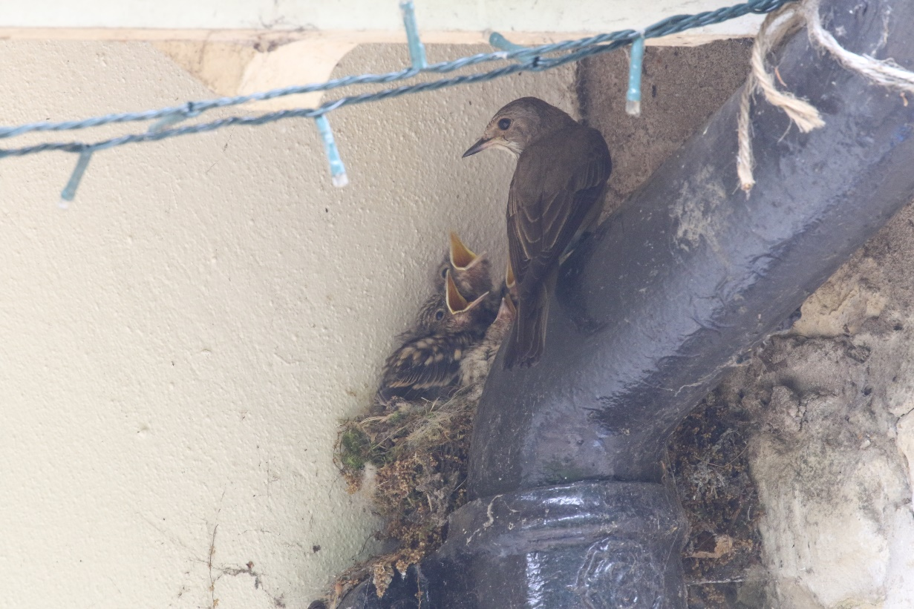

Photo – Peter Scott – Spotted Flycatcher
Robin. A common and popular species which is rarely reported. A brood of four was at Wg on
05.05. and nos. at BCF remained stable.
Nightingale. Reported between 16.04. and 25.05. from PGW with a max. of three singing on 05.
and 19.05. Single birds sang at Stock on 02.05. (KM) and Big Pits Quarry (near PGW) on 19.05. No reports were received from RWEg.
Pied Flycatcher. Single birds were at Luff Airfield on 13.08. and Man on 17.08.
Black Redstart. Female types were at RW Dam on 06.03., in an Oak garden on 03. and 05.04.
and QF on 16.04.
Redstart. Scarce passage migrant and former breeder. A male in a garden at Burl on 12.04. was
the first and a female was near Man on 15.04. For the first time since 1995 a male held territory at BCF and was present between 27.04. and 27.05. Sadly, no female was seen and breeding could not be proved. On a prolonged autumn passage birds were seen between 12.07. and 07.10. MThorpe was the most popular site with one or two found on 15 dates. One was regular for much of July at Man, a male fed on ants in a Stam garden on 20.07. and one was ringed at Luff Airfield on 07.08. (TC). One, possibly two, were at Leigh on 04.09.
Whinchat. The only spring record was a of single bird at Luff Airfield on 06.05. (TC). The first autumn
migrant was a male near Ggorse on 08.07. EBR had birds from 11.07. to 01.10. with a max. of five on 01.09. At Luff Airfield there were records from 12.08. to 02.09., when five were present. Single birds were noted at Ext Park on 06.09. and MThorpe on 13.09.

Stonechat. Passage and winter visitor which has bred (2017). In the first winter period a female
was at RWEg to at least 24.01. and one was at EBR on 22.01. A female frequented RW south shore between 15.01. and 13.03. A male was at FHP on 07.02. with a pair nearby on 21.02. An excellent autumn passage began with one at EBR on 29.08 with one or two there until 31.10. One was at LFP on 18.09. Two were in Ext Park on 26.09. with birds present to the end of the year and a max. of eight on 22.11. Two were at QF between 30.09. and 07.10. with one to 09.10. A remarkable 14 were at Luff Airfield on 01.10. (TC). A male was at MThorpe on 13.10. One or two were at RWLynd from 18.10. to at least 13.12. with one or two along south shore from 20.11. to 02.12. A pair were in the Chater valley near Man between 26. and 31.12.
Wheatear. One at Luff Airfield on 16.03. was the first with four there next day. (TC). One was
near Pick on 06.04.and a pair were at QF on 17.04. with single birds there on 20.04. and 05.05. Two at Luff Airfield on 21.07. were the first autumn birds with two on 12.08, six on 18.08. and one on 01.10. the latest record. Other autumn birds were two at Cott Airfield on 05.09. and one in Ext Park on 27.09.
House Sparrow. A common species in villages and suburbs where nos. are maintained by regular
feeding. A Stam garden population peaked at 45 in Aug.
Tree Sparrow. Now a scarce resident following a massive decline. Jan. records were of two at
Leigh, three at MThorpe and two near Pilt. Two were at RWLynd feeders on 19.01. Three were at EBR inflow on 07.03. and two visited at Oak garden on 02.04. One was at EBR again on 08.12. A depressing series of records.
Dunnock. An unobtrusive species on farmland, in woodland and in gardens (inadvertently omitted
from the 2019 annual report!). Nos. at BCF remained stable. Seventeen were at MThorpe on 30.09., with eight flying from a hedgerow and going south-west. Were they on migration?
Yellow Wagtail. A passage migrant and local breeder. One or two spring migrants were noted
from 06.04. to 18.05. over Wg, Upp and MThorpe, mainly from 02.05. Territorial birds were at EBR, Prest and Ext Park, where two pairs probably bred. Early autumn passage from 25.06. onwards was noted at Wg, RWLynd, Upp, Ext Park and RW Dam, where there were ten on 02.09. One south over MThorpe on 05.10. was our final record.
Grey Wagtail. A passage and winter visitor and scarce breeder. One was at Geest STW on
17.01. and three were along RW south shore on 08.02. One was in an Oak garden in early April and one was by the R.Gwash at Braun on 25.04. An adult fed two fledged young by the town bridge in Stam on 03.05. and one flew over Wg next day. One was at Tin Pumping Station on 17.05. One or two were regular at FHP from 04.07. to the end of Dec., with other autumn records from Rygate Lake (26.09.), RW (18.10., 10.11. and 18.11.), two Oak gardens and Braun (19.12.).
Pied Wagtail. A common resident and passage migrant. Few records but regular at RW Dam and
two pairs were at BCF for the first time since 2017. Thirty were feeding at Ext Park pig units on 10.10.
Meadow Pipit. A scarce breeder and common passage visitor with small nos. in winter. A flock of 72 flew
north-west over RWLynd on 20.03. Display flight was noted throughout the summer at Luff and Cott Airfields and QF, where three pairs probably bred. One south over Upp on 01.09. was the first autumn migrant with four at RW Dam next day. On 07.09. 19 flew south at QF in two hours whilst from that date to 14.09. 237 passed over MThorpe and Leigh. Passage continued into Oct. with 374 noted between 05. and 09. Four were at QF on 16.12. with three south on 31.12.
Tree Pipit. Scarce passage migrant, former breeder. One flew over EBR on 07.08. One was
ringed at Luff Airfield on 19.08. (TC). Four flew south at Leigh on 24.08 with three over MThorpe on 01.09. and one at leigh on 04.09.
Rock Pipit. Scarce passage visitor. One was in RWNA on 14.03. Autumn single birds were at EBR
on 05., 17. and 25.10. At RW single birds were at sites around the reservoir on 05., 09., and 17.10.

Chaffinch. A common resident, recently declined, and passage visitor. Up to 32 fed in a rural
Barrow garden in Jan. Singing birds were widely reported, with the first at BCF on 03.02., where there was a slight recovery in breeding nos. from seven territories in 2019 to ten this year. There were c.70, presumably local, birds at MThorpe on 28.08. Autumn passage was noted there between 13. and 25.10. with 521 counted on six dates. A mobile flock of c.140 were at WFL on 29.12.
Brambling. A passage and winter visitor. It was a poor year for this species with single birds widely
reported from 07.01. to the last on 02.04. Records came from Pilt, CWBWg, Geest, RWEg, RWSA, RW Fishponds Cottage, Man, Ext Park and Wg. Two were at Geest on 17.01. and two at Ext Park next day. A female at a Norm feeding station was the first autumn bird with two at QF on 07.10. the next. Two were over MThorpe on 09.10 and four flew west at QF on 12.10. One or two were noted over Wg, Leigh, Man (four on 06.11.) and Gun on several dates in Nov. and Dec.; one fed in a Wg garden on 11.11.
Hawfinch. One fed at RW Fishponds Cottage feeders on 31.10. (TA). and one was in PGW on
27.12.(AHJH).
Bullfinch. Widespread in scrubby areas and overgrown hedgerows. Records came from
RWEg/Lynd, Pick Drift, QF and TunnW.
Greenfinch. A widespread species, much reduced in nos. A regular visitor to garden feeding
stations, where 18 in an Oak garden on 03.01.was the peak count.
Linnet. A common species on farmland and scrubby areas. Some large winter flocks were
reported in both winter periods with birds frequenting plots of winter bird seed on farmland. More than 300 were near Pilt on 05.01., 300 were on Hamb Peninsula on 10.01. with 150 in Ext Park on 18.01. 350 remained at Pilt on 25.01. Sixty were near HM on 02.02. A flock of 25, local breeders, were near Half Moon Spinney on 30.06. and larger flocks assembled from Aug. with 150 at MThorpe on 28. Sept saw 100 at MThorpe on 01. and 120 near Rid on 10. A regular flock at QF throughout the autumn totalled c. 200 on 20.11. and 125 were at RWEg on10.12.
Common (Mealy) Redpoll. A scarce passage and winter visitor. One was ringed at Luff Airfield on
11.11. (TC).
Lesser Redpoll. A frequent passage and winter visitor and former breeder. Few were noted in the
First winter period with single birds over Pilt on 05. and 25.01. and 01.02. Two visited feeders in Oak and RW Fishponds Cottage gardens between 25.01. and 14.03., the last winter birds. One calling over Man on 26.07. was the first of an excellent autumn passage. A total of 45 flew over Man on 23.09. Forty-one were ringed at Luff Airfield on 01.10. (TC) and 49 flew south over MThorpe on 07.10. with 60 over Man on 21.10. Ten were at RWLynd on 15.11. and 35 were over Man. Twenty-five were at TunnW on 28.11. In Dec. c.20 fed in birches at Eg3 on 13.12 and there were ten at RW Sykes Lane next day. One visited an Oak garden between 22.-31.12. and two were at Barrow on 25.12.
Crossbill. A scarce passage visitor. There were records for all months between June and
November. Nineteen passed over Wg between 19. and 27.06 with 13 over KettQ on 22.06. Single birds were through Wg and MThorpe on four July dates with seven over RW on 13. Aug. saw up to four on eight dates over Man, MThorpe, Leigh and Wg. In Sept. three flew over Rygate Lake on 19. and single birds were over QF and MTthorpe. Oct. was a good month with 74 south or south-west over MThorpe between 06. and 26. and 14 south at RW on 09. In Nov. single birds were noted on three dates up to 09., over Leigh and Man.
Goldfinch. A common species on waste ground and regular at garden feeders. Small nos. visited
feeders throughout the year in many villages with 15 at Oak on 20.12. the max. reported. A flock of up to 80 fed on teasel at QF between early Sept and Dec.
Siskin. A regular passage and winter visitor, nos. were rather low in the first winter period. Twenty-two
were at RW Berrybut Spinney on 27.01. with 12 there on 03.02. Twelve were at RWEg on 30.01. One flew over Wg on 25.04. One south over Wg was the first autumn bird with up to five seen here throughout June and up to 30.08. (but 15 on 10.07.). Sept. and Oct. saw larger nos. with 75 south at Leigh on 10. and 72 south at Man on 23. There were more than 100 south at MThorpe on 06.10. and a similar no. next day. Thirty frequented alders at RWEg2 in Dec and there were c.15 at BCF on 25.12.

Corn Bunting. A singing male was reported near Stoke Dry on 21.05. but it could not be located
on later dates (TL).
Yellowhammer. Widespread but declining on arable farmland and areas of scrub. Around 40 were in
Ext Park on 21.03. Three or four held territory at QF. Nos. at BCF remained low with just seven territories.
Reed Bunting. A resident on farmland as well as in wetland sites. Three held territory at QF in
May with five at FHP. Made good use of winter wild bird seed plots with c.30 at Banthorpe GP in both winter periods and 20 in Ext Park in Dec.

Rutland Natural History Society

Wildfowl and Waders Counts 2020 Recorder: Terry Mitcham

Rutland Water

Date | 12.01. | 08.02. | 08.03. | 10.07. | 26.08. | 20.09. | 18.10. | 15.11. | 13.12.
Canada Goose | 609 | 336 | 276 | 931 | 530 | 651 | 605 | 324 | 535
Barnacle Goose |  |  |  |  |  |  |  |  | 2
Greylag Goose | 424 | 537 | 323 | 1121 | 482 | 828 | 680 | 884 | 613
Mute Swan | 151 | 154 | 227 | 468 | 465 | 243 | 379 | 405 | 392
Whooper Swan |  | 11
Egyptian Goose | 34 | 18 | 15 | 54 | 63 | 43 | 27 | 25 | 31
Shelduck | 13 | 26 | 24 |  | 4 | 4 | 6 | 11 | 13
Ruddy Shelduck | 2
Mandarin Duck |  |  |  | 7 | 8 | 3 | 1 | 3
Garganey |  |  |  |  | 3 | 2
Shoveler | 113 | 74 | 65 | 27 | 132 | 302 | 301 | 160 | 81
Gadwall | 214 | 411 | 225 | 1744 | 1462 | 1397 | 1531 | 805 | 666
Wigeon | 3786 | 3324 | 1809 | 5 | 18 | 1618 | 3160 | 3514 | 3131
Mallard | 360 | 314 | 250 | 842 | 1162 | 1236 | 724 | 766 | 704
Pintail | 17 | 10 | 7 |  | 1 | 78 | 171 | 122 | 149
Teal | 417 | 365 | 250 | 42 | 269 | 831 | 769 | 903 | 893
Red-crested Pochard |  |  |  |  | 2 | 2 |  | 40 | 14
Pochard | 138 | 144 | 36 | 27 | 58 | 57 | 78 | 6 | 119
Tufted Duck | 2457 | 1479 | 1621 | 1478 | 4724 | 4907 | 2455 | 2791 | 2764
Scaup | 11 | 7 | 2 |  |  |  | 1 | 2
Common Scoter | 1 |  |  |  |  |  |  | 1
Bufflehead | 1
Goldeneye | 332 | 315 | 265 |  |  | 3 | 52 | 87 | 249
Smew | 12 | 16 | 20 |  |  |  |  |  | 4
Goosander | 22 | 30 | 11 |  |  |  | 4 | 21 | 22
Great Northern Diver |  |  |  |  |  |  |  | 3 | 6
Little Grebe | 98 | 71 | 30 | 58 | 162 | 100 | 117 | 147 | 163
Red-necked Grebe | 1 | 1 | 1 |  |  | 1 | 1
Great Crested Grebe | 295 | 211 | 155 | 381 | 677 | 459 | 407 | 386 | 298
Slavonian Grebe | 1 | 1 |  |  |  |  | 1
Black-necked Grebe | 3 | 3 | 3 |  |  | 1
Spoonbill |  |  |  |  | 1
Grey Heron | 17 | 37 | 20 | 10 | 20 | 29 | 41 | 25 | 24
Great White Egret | 15 | 15 |  | 3 | 15 | 23 | 33 | 25 | 23
Little Egret | 22 | 21 | 13 | 59 | 70 | 80 | 58 | 31 | 36
Shag |  |  |  |  |  | 1 | 1
Cormorant | 232 | 295 | 206 | 368 | 723 | 1228 | 600 | 350 | 263
Water Rail | 10 | 14 | 10 | 8 | 10 | 6 |  | 2 | 8
Moorhen | 43 | 63 | 38 | 62 | 152 | 134 | 99 | 56 | 77
Coot | 3159 | 1408 | 605 | 797 | 1387 | 2256 | 2414 | 1648 | 2525
Kingfisher |  | 3 | 2 |  |  | 1 | 2
TOTAL | 9823 | 9769 | 6594 | 8792 | 12600 | 16524 | 14719 | 13543 | 13786

Eyebrook Reservoir
Date | 08.02. | 08.03. | 20.09. | 18.10.
Canada Goose | 64 | 16 | 196 | 47
Greylag Goose | 134 | 59 | 824 | 324
Mute Swan | 116 | 86 | 114 | 183
Egyptian Goose |  |  | 2
Shelduck |  | 1 | 1
Shoveler | 5 |  | 25 | 22
Gadwall | 41 | 4 | 64 | 124
Wigeon | 613 | 440 | 218 | 364
Mallard | 157 | 51 | 344 | 142
Pintail | 16 | 5 | 47 | 19
Teal | 886 | 176 | 216 | 125
Pochard | 5 | 5 | 107 | 120
Tufted Duck | 886 | 35 | 45 | 253
Goldeneye | 70 | 19 |  | 2
Goosander | 1
Little Grebe |  |  | 5 | 1
Great Crested Grebe | 43 | 17 | 109 | 85
Grey Heron | 1 |  | 3 | 2
Little Egret |  |  | 3
Cormorant | 27 | 12 | 26 | 23
Moorhen | 3 |  | 3
Coot | 19 | 1 | 480 | 888
TOTAL | 2680 | 927 | 2832 | 2373

Fort Henry Ponds and Exton Park Lake
Date | 10.01. | 07.02. | 06.03. | 11.04. | 09.05. | 06.06. | 04.07. | 20.08. | 19.09. | 17.10. | 14.11. | 12.12.
Canada Goose |  |  |  | 4 | 2 |  |  |  |  | 36
Greylag Goose | 37 | 243 | 48 | 3 | 6 | 2 |  |  |  | 1 |  | 3
Mute Swan | 13 | 14 | 18 | 14 | 7 | 9 | 7 | 12 | 12 | 13 | 12 | 13
Egyptian Goose | 2 |  |  | 1 |  |  |  |  |  | 2
Shelduck |  |  |  |  | 1
Mandarin Duck |  | 4 | 5 |  |  |  |  |  |  | 2 | 2 | 2
Shoveler |  |  |  | 4 | 2 |  | 1 |  | 40 | 38 | 18 | 9
Gadwall | 56 | 40 | 37 | 26 | 20 | 38 | 18 | 39 | 64 | 93 | 106 | 77
Wigeon | 90 | 155 | 129 |  |  |  |  |  | 1 | 13 | 30 | 58
Mallard | 100 | 109 | 59 | 40 | 49 | 66 | 96 | 122 | 102 | 140 | 166 | 133
Pintail |  |  |  |  |  |  |  |  |  | 3 | 2
Teal | 11 | 24 | 8 |  |  |  |  | 8 | 50 | 82 | 78 | 67
Red-crested Pochard |  |  |  |  |  |  |  |  |  |  | 1
Tufted Duck | 105 | 56 | 84 | 64 | 32 | 36 | 44 | 7 | 5 | 4 | 3 | 20
Goldeneye |  |  |  |  |  |  |  |  |  |  | 2
Goosander | 1 |  |  |  |  |  |  |  |  |  |  | 2
Little Grebe | 3 |  |  | 1 |  |  |  | 1 | 2 | 1 | 3 | 8
Grey Heron |  |  |  |  |  | 1 | 1 | 2 | 1
Great White Egret |  |  | 1
Little Egret | 1 | 1 | 1 |  |  |  |  |  |  | 1 |  | 1
Cormorant | 4 | 2 | 1 | 1 | 1 | 1 | 1 |  | 1 | 1 |  | 1
Moorhen | 4 | 7 | 12 | 13 | 14 | 5 | 7 | 25 | 39 | 44 | 26 | 16
Coot | 67 | 62 | 51 | 33 | 30 | 37 | 47 | 56 | 41 | 32 | 56 | 49
Total | 494 | 717 | 454 | 209 | 164 | 195 | 222 | 272 | 358 | 506 | 505 | 459

Banthorpe Gravel Pit

Date | 08.01. | 06.02. | 06.03. | N/C | 24.05. | 05.06. | 02.07. | 20.08. | 18.09. | 16.10. | 13.11. | 11.12.
Greylag Goose | 42 | 2 | 16 |  | 16 |  |  |  |  |  |  | 12
Mute Swan |  | 3 | 2 |  | 1 | 1 | 2 | 4 | 4 | 4 | 3 | 3
Mandarin Duck |  |  |  |  |  |  |  |  |  |  |  | 1
Gadwall | 2 |  | 1
Mallard | 58 | 6 | 8 |  | 7 | 1 | 2 | 28 | 12 | 13 | 40 | 68
Teal | 34 | 26 | 25 |  |  |  |  |  | 20 | 20 | 35 | 10
Tufted Duck | 1 | 2 |  |  | 2 |  |  |  |  |  | 1 | 2
Grey Heron |  | 2 |  |  |  | 1 |  | 1 | 1 | 1 |  | 1
Little Egret |  |  |  |  |  |  | 2 | 5 | 5 |  | 1
Cormorant | 1 |  |  |  |  |  |  | 1 | 3 | 3
Moorhen | 1 | 1 | 1 |  | 1 | 2 | 1 | 3 | 5 | 3 | 1 | 1
Coot |  |  | 1 |  | 5 | 7 | 4 | 1 |  | 1
Kingfisher |  |  |  |  |  |  |  |  | 1 | 1
TOTAL | 139 | 42 | 54 |  | 32 | 12 | 11 | 43 | 51 | 46 | 81 | 98

Greetham Golf Course

Date | 10.01. | 08.02. | 17.05. | 17.07. | 24.08. | 20.09. | 17.10.
Canada Goose |  |  | 2
Mute Swan | 2 |  | 2
Mandarin Duck |  |  |  |  |  |  | 1
Gadwall |  |  | 1
Mallard | 51 | 37 | 37 | 29 | 18 | 47 | 48
Tufted Duck |  |  | 2 | 1
Little Grebe | 1 |  |  | 2
Grey Heron | 1 |  |  | 1 | 1 | 1 | 1
Little Egret |  |  | 1 |  |  | 1
Cormorant | 1
Moorhen | 35 | 37 | 22 | 24 | 35 | 39 | 32
Coot | 3 | 4 | 9 | 6 | 2
TOTAL | 93 | 78 | 76 | 63 | 56 | 88 | 82

Holywell Lake

Date | 08.01 | 08.02. | 06.03. | 24.09. | 19.10. | 12.11. | 14.12.
Canada Goose | 7 | 36 | 26 | 2 | 6 | 13 | 43
Greylag Goose |  | 44 | 65 |  |  |  | 15
Mute Swan | 2 |  | 2 | 2 | 2
Mandarin Duck | 1
Gadwall | 11 | 16 | 8 |  |  | 6 | 10
Wigeon | 26 | 36 | 56 | 4 | 32 | 72 | 78
Mallard | 92 | 69 | 22 | 62 | 89 | 66 | 114
Teal | 5 | 3 | 6 | 1 |  | 12 | 16
Tufted Duck | 13 | 20 | 32 |  | 11 | 43 | 25
Little Grebe | 19 | 11 | 17 | 22 | 16 | 19 | 31
Grey Heron |  |  |  | 1 |  | 2 | 1
Little Egret | 1 | 3 | 1 | 2 | 1 | 1 | 2
Cormorant |  |  |  | 1 | 1 | 2 | 3
Moorhen | 25 | 6 | 15 | 14 | 18 | 18 | 22
Coot |  | 2 | 8 |  |  |  | 1
Kingfisher | 1 |  |  | 1 | 1
TOTAL | 203 | 236 | 258 | 112 | 177 | 254 | 361

Rutland Water Waders Counts

Date | 12.01. | 08.02. | 08.03 | 10.07. | 26.08. | 20.09. | 18.10 | 15.11. | 13.12.
Oystercatcher | 1 | 14 | 20 | 18 |  |  |  |  | 1
Avocet |  |  |  |  |  |  |  | 3
Lapwing | 823 | 1720 | 207 | 49 | 265 | 67 | 648 | 1583 | 2270
Golden Plover | 190 | 4 | 96 |  |  |  | 192 | 1766 | 9
Ringed Plover |  |  |  | 2 | 10 | 6 | 4
Little Ringed Plover |  |  |  | 8 | 5
Curlew | 9 | 9 | 10 | 8 | 6 | 6 | 8 | 10
Black-tailed Godwit |  |  |  | 6 | 8 | 8 | 7 | 3
Knot |  |  |  |  |  | 2
Ruff |  |  |  |  | 5
Curlew Sandpiper |  |  |  |  | 1
Sanderling | 1 |  |  |  | 1
Dunlin | 1 |  | 2 | 2 | 12 | 7 | 3 | 8 | 7
Jack Snipe |  |  |  |  |  |  | 1
Snipe | 1 | 8 | 3 |  | 16 | 23 | 8 | 13 | 14
Common Sandpiper |  |  |  | 4 | 9
Green Sandpiper | 1 | 3 | 3 | 8 | 23 | 9 | 9 | 4 | 5
Redshank | 4 | 4 | 6 | 1 |  |  | 3 | 2 | 6
Wood Sandpiper |  |  |  |  | 2
Greenshank |  |  |  | 1 | 4
TOTAL | 1031 | 1762 | 247 | 107 | 367 | 130 | 883 | 3392 | 2312

