Rutland Natural History Society

ANNUAL BIRD REPORT 2021 Recorder: Terry Mitcham

With fewer lockdowns this year we were able to explore the county more easily, although some early wildfowl counts could not be carried out. It was a good year for scarce and rare birds with two species – Bonaparte’s Gull and Icterine Warbler – added to the Rutland list, both at the Egleton reserve. Other interesting species included Ring-necked Duck, Black-throated Diver, Glossy Ibis, Cattle Egret, American Golden Plover and Kentish Plover.

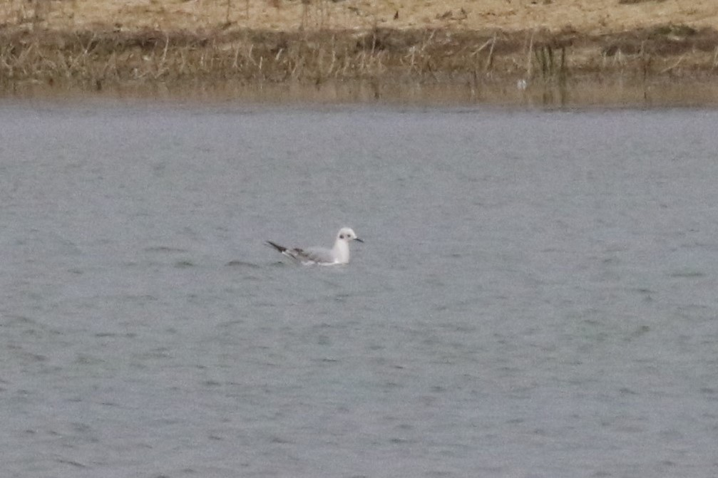
Photo Bonaparte’s Gull © Peter Scott

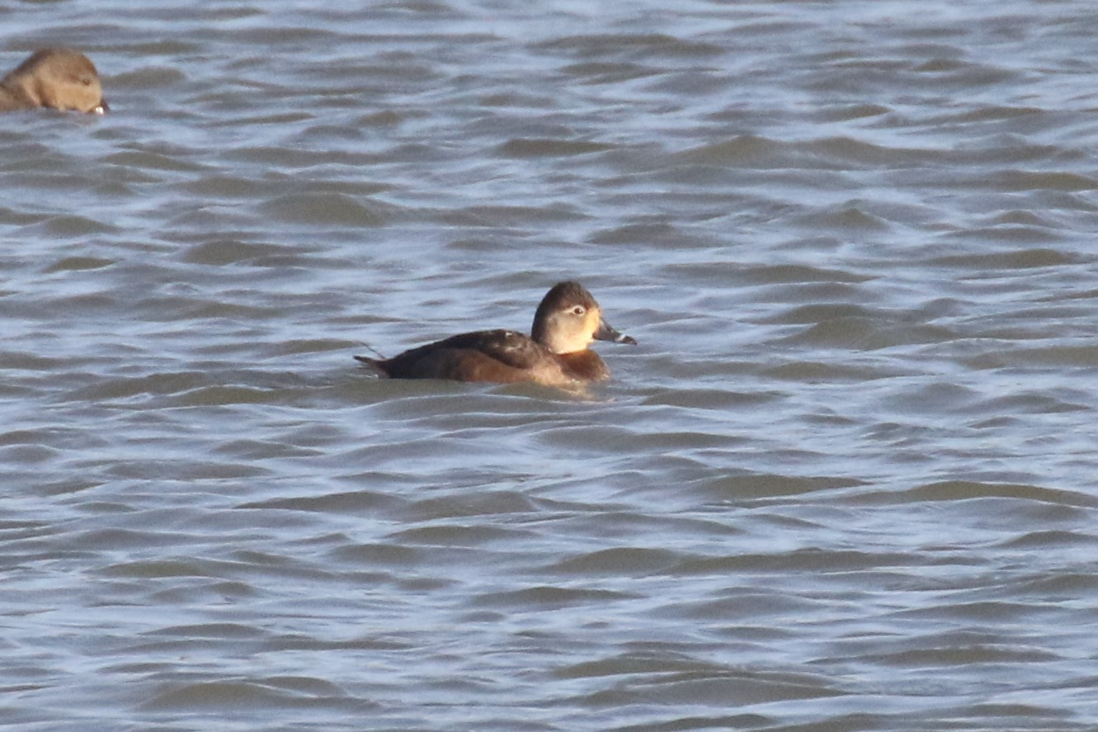
Photo Ring necked Duck © Peter Scott

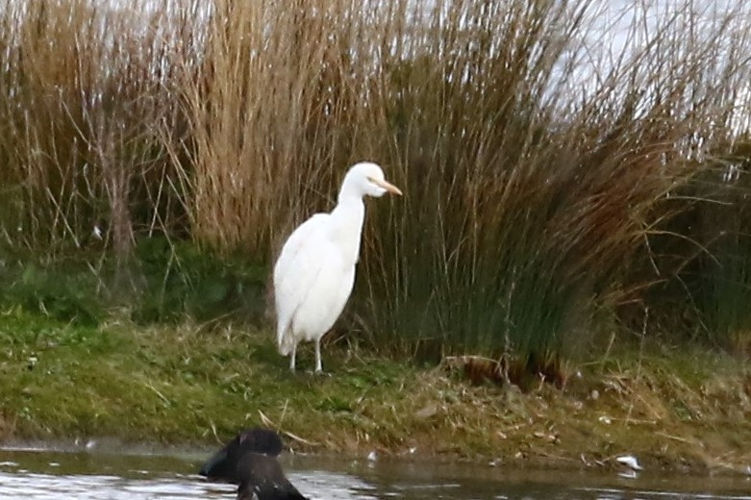
Photo Cattle Egret © Peter Scott

Wildfowl counts were received from six sites ranging from large ponds to our major reservoirs and including a wide range of species and not just at Rutland Water, with a late Garganey at Fort Henry Ponds. The Common Birds Census at Beaumont Chase Farm completed its 30th year, providing a long data set charting the ups and downs of our farmland birds, significantly the alarming decline of the Chaffinch. With the anticipated development of the Quarry Farm site in the next few years, a special effort to record its birds produced over 70 species, with 37 breeding. Bearing in mind the wealth of other wildlife on this site, it is imperative that vulnerable habitats there are protected. The possibility of a major solar development blighting a large part of the east of the county poses another threat to our wildlife, not least the wildfowl which use Banthorpe Gravel Pit.

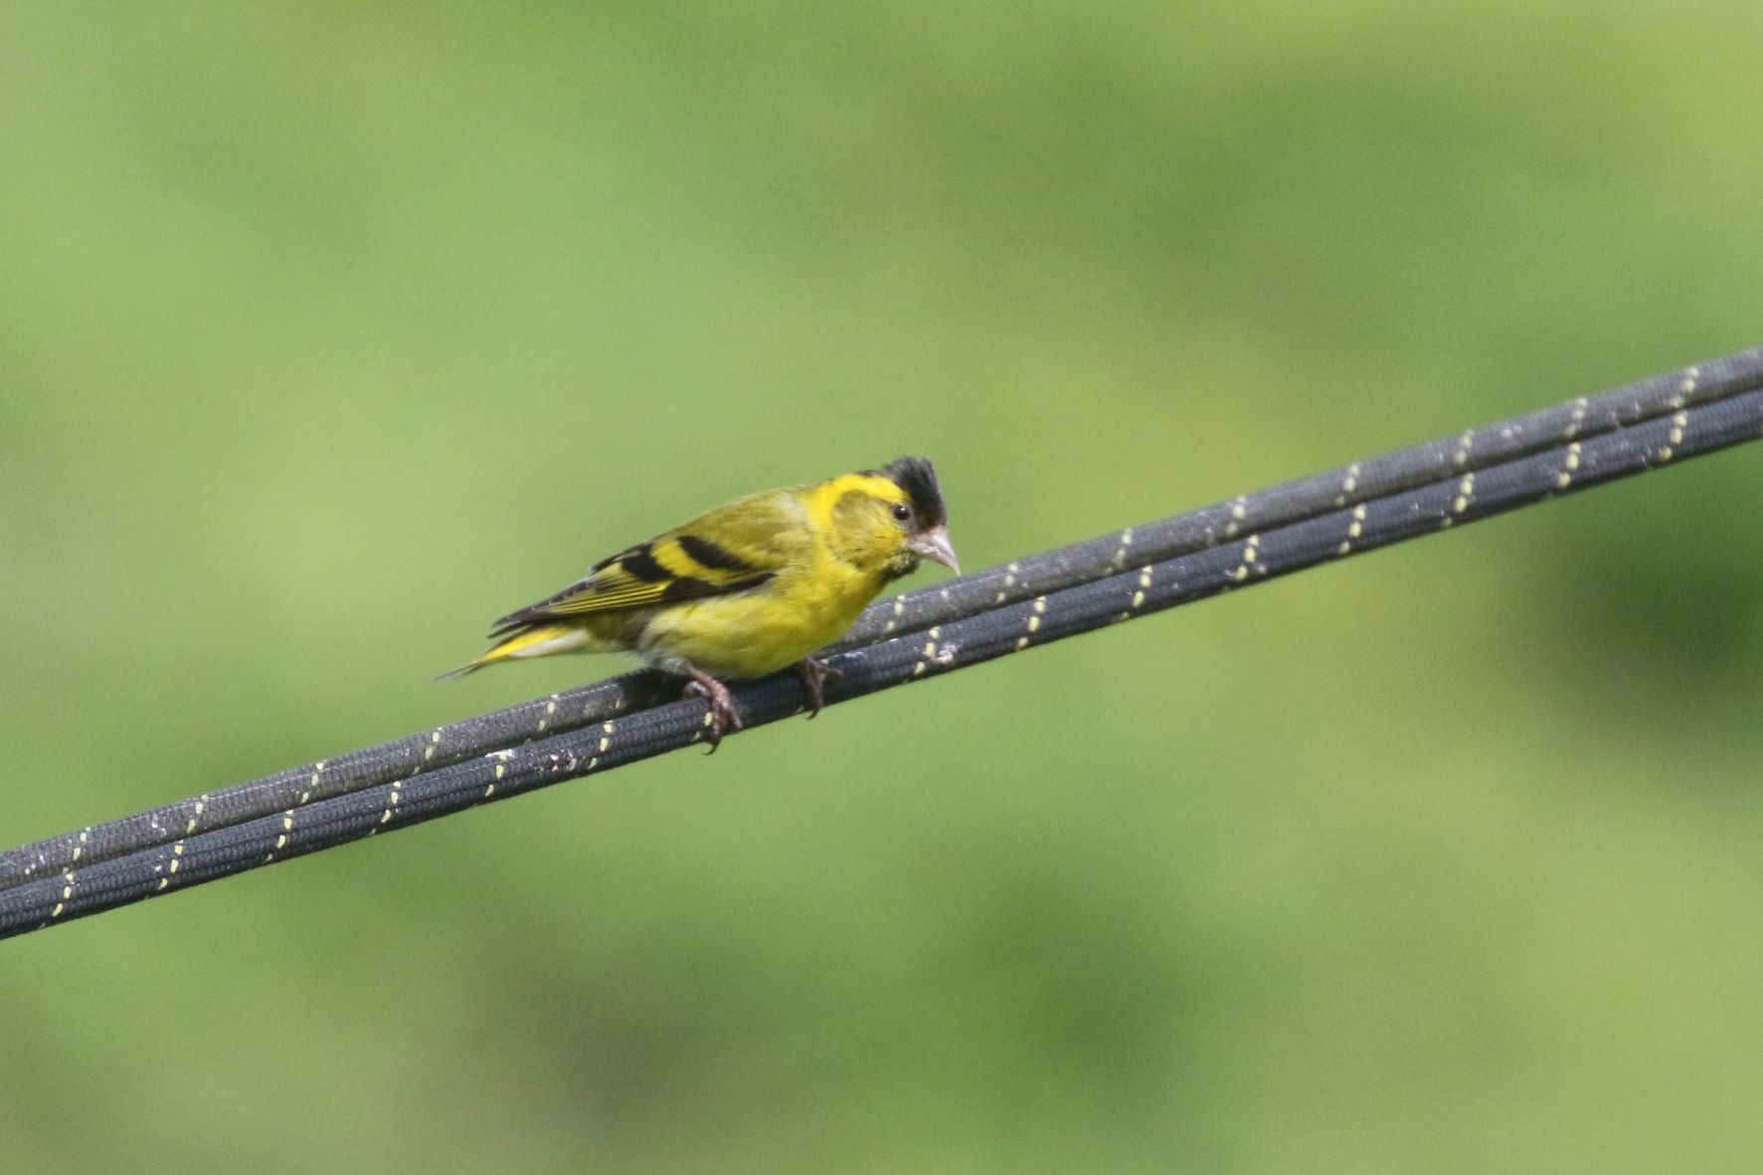

Photo Siskin © Peter Scott

Fortunately, our gardens provided respite for some species and this year there were records of Ring-necked Parakeet, Blackcap, Lesser Redpoll and Siskin. Sparrowhawks enlivened some gardens with their hunting forays and Nuthatch and Marsh Tit were also reported. Records were received from many parts of the county with the exception of the Welland valley and the north-west. It would be good to include reports from these areas in the 2022 annual report.
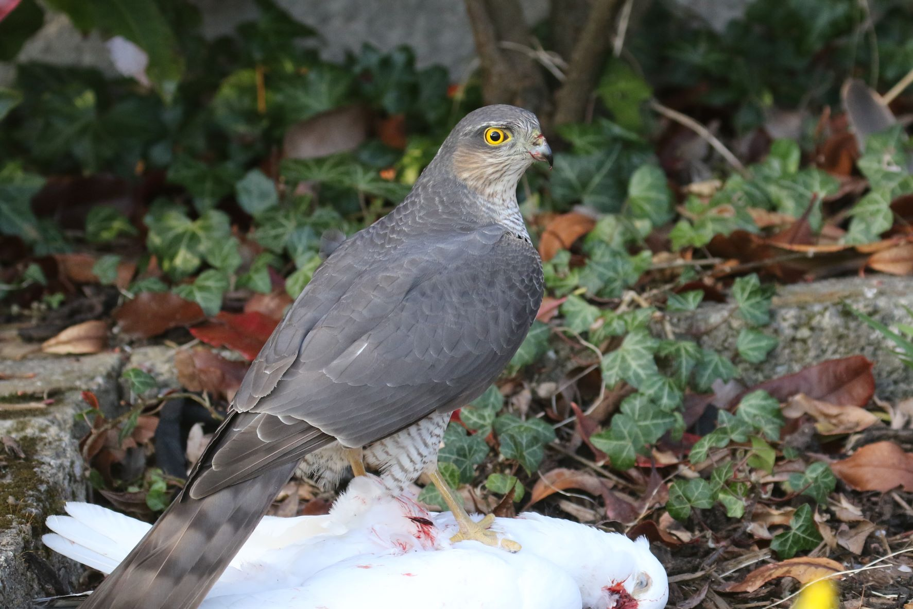

Photo Sparrowhawk © Peter Scott

Terry Mitcham (joterpat@btinternet.com)

My thanks to the following for their 2021 records: -
T.Appleton, D.& J.Ball, P.Bennett, A.J.& L.Biddle, L.Burger, T.Caldicott, A.Clarke, L.Clark, D.P.Cole, T.Collins, A.& J.Comber, C.Debney, M.Dixon, Dr.C.H.Gallimore, J.Griffin, M. & G.Griffin, J.Harris, A.H.J.Harrop, C.Hubbard, T.Land, P.Langston, A.Lawrence, LROS, S.Lister, Dr.T.Macrill, M.Markham, D.Masters, K.Mather, I.Misselbrook, T.Mitcham, B.Moore, J.W.Nourish, C.I.Park, P.Robinson, J.& J.Rodgers, RWNR, P.Scott, T.Sexton, T.Williams

Abbreviations Used
Ash –Ashwell | Luff - Luffenham
Barns – Barnsdale | Man - Manton
BGP – Banthorpe Gravel Pit | MThorpe - Martinthorpe
Bis – Bisbrooke | MM – Merry’s Meadow
BFP – Burley Fishponds | Norm - Normanton
BCF – Beaumont Chase Farm | Oak - Oakham
BW – Burley Wood | Pick - Pickworth
CPW – Clipsham Park Wood | PGW – Pickworth Great Wood
CBC – Common Birds Census | QF – Quarry Farm
Cottesmore Wood | RWEg – Rutland Water Egleton Reserve
EastW – East Wood | RWLynd – Rutland Water Lyndon Reserve
EW – Edith Weston | RWNA – Rutland Water North Arm
Emp – Empingham | RWSA – Rutland Water South Arm
Ext – Exton | Stam - Stamford
EBR Eyebrook Reservoir | SDW – Stoke Dry Wood
Geest – Geeston | Tin - Tinwell
GC – Golf Course | TunnW – Tunneley Wood
GGorse – Gibbet Gorse | Upp - Uppingham
Gt Cast – Great Casterton | WardW – Wardley Wood
Greet – Greetham | WestW - Westland Wood
Kett – Ketton | Whit - Whitwell
Lang – Langham | WFL – Wing Fishing Lakes
Leigh – Leighfield | WG - Wing
LFP – Leighfield Fishponds | Whiss - Whissendine
See Also Wildfowl Counts and Wader Counts

Brent Goose | A flock was heard over RW on 10.02. and one was at EBR between 29.03. and 04.04
Canada Goose | Regular at both reservoirs throughout the year with breeding confirmed at both sites. A pair at FHP on 13.03. was the only record there this year.
Barnacle Goose | Two were with Greylag Geese at RW(Whit) on 18.01. and 24.02. with a pair at BGP on 18.05.
Snow Goose | Seven feral/escapes were at EBR on 13.06.
Greylag Goose | Large nos. were at both reservoirs during the winter months. At FHP there were 89 on 06.02. and small nos. present to 10.07, but no breeding was confirmed. There were 184 present on 05.12. and 186 on 18.12. Breeding was confirmed at both reservoirs, at Rygate Lake in Ext Park and BGP, where there were 42 adults and c.30 goslings on 22.05. Breeding was suspected by a flooded field at Cott where there were four on 11.04. and one on 23.05.
Pink-footed Goose | One flew over RWEg on 26.03., one was at EBR on 02. and 03.04. and one was at RWEg on 05. and 18.05. In the autumn 23 flew over Whiss on 11.10. and c.120 flew over Man on 03.11. with c.130 over there next day. Three were at RWBFP on 12. and 21.12.
White-fronted Goose | One was at EBR between 04. and 06.05. and three were at RWNA on 21.12.
Mute Swan | Present at both reservoirs throughout the year with breeding confirmed at both sites. Single pairs bred at BGP, FHP, Geest and Rygate Lake in Ext Park. The latter pair lost all five of their cygnets, presumably to Fox predation and the FHP pair fledged only one of their six cygnets.
Bewick’s Swan | The only record was of a pair in RWNA between 25. and 27.12
Whooper Swan | A juv. at FHP on 09.01. relocated to RWSA where it remained to 14.03. Other records in the first winter period were five at EBR and eight flying west over Ext Park on 13.02. with two late birds in RWNA on 29.05. The first autumn bird was at EBR on 13.10. Ten were in RWNA on 20.10 with six at Lynd and 12 at EBR on 21.10. Six flew over Man on 03.11. and there were six at EBR on 05.11. with four the next day. Four were in RWNA on 23.11. In Dec ten were at EBR on 20, with three on 21. and 30. Thirty six were at RW on 21.12. – flocks of 24 and 12.
Egyptian Goose | Present and breeding at RWEg throughout the year. A pair had very small goslings by BFP on 06.04. Two were in Ext Park on 08.01., the only other record
Shelduck | One or two were at FHP between 27.02. and 20.06. with four on 26.06. There was no breeding attempt. Nos. were low at both reservoirs with no breeding reported – one was at EBR on 22.08. and there were five there on 05.12. This species seems to be in decline locally.
Ruddy Shelduck | One was at RWEg4 on 25.06. with three juvs. there on 04.08. Two were in the BFP area on 22.09. with one noted from 25.10. to at least 13.11.
Mandarin Duck | Two pairs were on flood water by the R.Welland at Geest on 31.01. and two pairs were at a Cott pond on 24.02. Up to three were noted in the Wg/Bis/Pilt area between 28.02. and 13.05. A female and five ducklings were on Rygate Lake in Ext Park on 12.06. and breeding also occurred at RWNorm, where a female was seen throughout June and five juvs. were seen on 07.07. Two were at FHP on 25.07. and 21.10.
Garganey | A pair was at RWEg1/4 from 12.04. to 23.04. with six on 21.04. A pair was at EBR on 23.04. and 02.05. and singles at RWEg from 26.05. to 06.06. One or two were at EBR from 24.07. to 20.09. and one was in RWSA on 27.09. A female at FHP on 09.10. remained to at least 28.11. Two were in RWBFP on 20.10.
Shoveler | Present in all months at FHP with a pair from 10.04. to 20.06. but breeding was not confirmed. The autumn peak was 34 on 03.10. with four present on 27.12. At RW, 365 were counted on 16.11. Two were on Rygate Lake in Ext Park on 27.12
Gadwall | Present and breeding at both reservoirs. At FHP peak winter counts were 65 on 09.01.and 86 on 12.12. Four pairs bred at FHP with broods of two, six, eight and nine, and a pair on Rygate Lake had nine ducklings on12.06.
Wigeon | Large nos. winter at both reservoirs. A flooded field at Cott had 122 on17.01. and 165 on 22.02. Winter peaks at FHP were 106 on 06.03. (last on 04.04.) and 85 on 18.12. (first on 05.09.). Rygate Lake held 30 on 13.03. and 47 on 18.12.
Mallard | Widespread on water bodies of all sizes with breeding confirmed at both reservoirs, BGP, Rygate Lake and FHP, where at least six pairs bred. Peak counts at FHP were 82 on 02.01. and 119 on 02.12.
Pintail | Present in variable nos. in winter at both reservoirs. Singles were at RWEg4 on 27.04. and 08.05. One was at FHP from 03.10. to 12.12.
Teal | Twelve were at LFP on 02.03. and four were on the flooded field at Cott on 11.04. Low water levels attracted high nos. to both reservoirs in the second winter period. Seventeen on 02.01. was the peak in the first winter period at FHP with the last on 18.04. The first autumn bird was on 07.08. with nos. peaking at 101 on 23.09.
Red-crested Pochard | Five were in RWSA on 18.01. One was at RWEg3 on 20.04. Four were at EBR on04.06. with one there on 30.08. One was in RWMan Bay on 31.10. with nos. then increasing to 36 on 20.11. Up to three were at EBR between 16. and 30.12. and one was in RWSA on 24.12.
Pochard | Pochard are now much scarcer winter visitors but still breed at RWEg where there were broods of three and seven in June. Now uncommon at FHP with singles on 13.02. and 02.05. and four on 07.06.
Ring-necked Duck | A female of this North American species was at EBR from 13.11. to 31.12
Tufted Duck | Present throughout the year at the reservoirs, with high autumn counts at RW. Peak counts at FHP were 59 on 13.02. and 40 on 18.12. Bred at RWEg but not at FHP this year. Noted irregularly at BGP and Rygate Lake
Scaup | All records in the first winter period were from RW with max. of eight on 14.02. Last noted at Eg3 on 28.04. The first autumn bird was in RWSA3 on 16.10. with four at Lynd on 06.11. and two on 09.11. Present at EBR from 20.11. to 31.12. with seven on 24.11.
Common Scoter | A passage and winter visitor in decreasing nos., one in RWNA on 07.03.was the only spring record. Two were at EBR on 17.07. with one there on 13.09. and two at RWNA on 19.01. Two were on Main Water at RW on 09.10. and six in SA3 on 22.11.
Goldeneye | A winter and passage visitor at both reservoirs with feeding flocks of 20- 50 birds regular at RW. On 17.03. 450 roosted there, and our last record was on 08.05. The first autumn bird was at RWSA on 11.08. A female was at FHP on 18.12.
Smew | A winter visitor at both reservoirs. RW had birds to at least 11.03. peaking at 13 on 20.02. with eight males. At EBR up to seven were present, with seven on 19.01. and 14.03. including five males. Last reported at EBR on 20.03. The first autumn redheads were at EBR on 22.11. and RW on 24.11. Peak counts in the second winter period were 13 at EBR, including eight males and just one at RW.
Goosander | A winter visitor to both reservoirs in decreasing nos. with occasional records from Rygate Lake. The last spring date was 09.03. on Rygate Lake where there had been singles on 09.01. and 13. 02. The first autumn birds were three at RW on 09.10. A male was on Rygate Lake on 12.12.
Red-legged Partridge | Resident on farmland with large numbers released for shooting, especially in the east of the county – few records received but noted at Exton, BCF, BGP, Mounts Lodge, Pick, EBR and Emp
Grey Partridge | Our native partridge remains scarce but widespread. Records came from Ext Park (six pairs in March), QF, Eg, Lynd Top and near Cott Airfield. Most records were of one or two but six were near Gt Cast on 16.11
Quail | Calling birds were heard near Ext between 25. and 28.05. Pres on 16.06. and QF on 09.07.
Pheasant | A species introduced for shooting and abundant in some areas and less common where this is not the case e.g., QF, where it was not seen all year. Burley and Ext Estates released large nos. as did the farm bordering EBR. A male visited a suburban Stam garden in Feb. and a female was at Greet GC on 27.07. with 20 chicks
Red-throated Diver | One was seen at RWHamb on 28.11
Black-throated Diver | One was in flight over RWNA on 03.01. and one was in RWSA between 02. and 02.12.
Great Northern Diver | One at RW in Jan., increasing to six on 01.02. and seven on 11.03. and 19.03. Nos. then declined with the last sighting on 27.04. One reappeared on 13.11. with two on 04.12. and three from 18.12. to the end of the year
Leach’s Petrel | One was reported during windy weather at RWDam on 27.11.
Little Grebe | A regular passage and winter visitor at the reservoirs and FHP and occasional at Rygate Lake, Greet GC and LFP. Ten were at the latter site on 10.08. Breeding confirmed only at RWEg.
Great Crested Grebe | Present all year and breeding at both reservoirs with peak nos. in winter.
Slavonian Grebe | One was at RWDam from 13.11. to the end of the year
Black-necked Grebe | One was at RWDam between 15. and 18.2
White Stork | A bird of unknown origin was over RWLynd on 18.04. With introduced birds now breeding successfully in Sussex, we may expect wandering individuals to become more frequent.
Glossy Ibis | One was at RWEg between 23.08. and 05.09.
Spoonbill. | This species is becoming a more regular visitor, with breeding birds well established in Norfolk and nesting at other sites in the UK. Singles were at RWNA on 21.03. RWEg5 on 22.03., RWBFP on 12.04., RWLynd on 13.07 and EBR on 10.10.
Bittern | After an increase in records in recent years, especially from the Eg3 reed bed, the only reports this year were from there on 08. and 24.09.
Cattle Egret | One was at RWBFP on 19.10. An increasing species in Britain, it is always worth checking fields of livestock for their presence.
Grey Heron | Present all year and regular at the reservoirs with a heronry at BFP. Also frequented FHP, Rygate Lake and BGP with peak nos. in autumn/winter. Four were at FHP on 08.10. and BGP on 02.12.
Great White Egret | There were records for all months except for May and Aug. RW remains the main site for this species with birds also seen at EBR, but it was also reported from Rygate Lake on 09.01., LFP on 27.02. and 02.03 (two), Geest on 08.04. and FHP (two) on 19.09. At RW there were 31 on 28.09. and 41 on 28.10.
Little Egret | Like the previous species, Little Egrets have been reported from water bodies across the county away from the reservoirs with birds at Rygate Lake, FHP, BGP, Geest, Greet GC and Tin Pumping Station. Bred at RW.
Gannet | An adult was at RW on 07.07.
Cormorant | Resident and breeding at RW with birds regular at EBR and visiting BGP, Rygate Lake and FHP, where there were records in all months and a max. of eight on 05.09. The highest RW count was 1455 on 28.09.
Osprey | Migrant breeder at RW and passage visitor. The first record was at RWNA on 16.03. with the Man pair back on 19.03. Eventually 30 adults returned and eight pairs reared 19 chicks, an impressive achievement. Regular at EBR throughout the summer with one at FHP on 17.07. and two over Pilt on 18.08. Autumn birds were at Greet GC on 10.09. and one over Wg on 12.09.
Sparrowhawk | Well distributed in woodlands with sightings from gardens at Barrow, Oak, Stam. Display was noted over TunnW, WardW and BW in March
Goshawk | A captive bred adult male was found dead at FH on 07.06. It carried a closed ring inscribed ’Goshawks of St. Just’. The body was sent to the Predatory Birds Monitoring Scheme for autopsy but no results have been received to date.
Marsh Harrier | Present at RWEg in Jan. (three on 03.01.) and between 01.and 26.03. A female was at Eg3 on 08.05. and birds were regular there from 12.07. to the end of the year with up to three noted in Sept. The only other record was over Greet GC/Ext Park on 07.11.
Hen Harrier | A male was at EBR on 01.05
Red Kite | Well distributed with sightings over woods, farmland and built up areas. One took a chicken carcase from a Stam garage roof on 01.02. A pair bred at FH with birds noted over BW, WardW, Ext Park woods and SDW in the breeding season. The peak count was 13, hunting over mown grass in Ext Park on 26.08.
White-tailed Eagle | Immature birds from the Isle of Wight reintroduction were seen at RW on 29.05. and 18.09., the latter bird having roosted overnight by BFP.
Buzzard | A commonly seen raptor with birds noted over woodland and farmland – less inclined to cross built up areas than the Red Kite. The peak count was seven over Northfields Farm on 22.03. and Ext Park on 05.09.
Water Rail | Resident and breeding at RWEg/Lynd with autumn and winter records from other suitable wetland sites. Eleven territories were estimated at RWEg in May. Singles were at EBR on 12.05., LFP on 27.02.and 05. and 18.09., and FHP on 21.10. and 14.11.
Moorhen | A common species at all wetland sites where there is suitable cover. The peak count at FHP was 44 on 11.09.
Coot | A breeding resident on larger water bodies with large winter nos. at the reservoirs. Bred at both reservoirs, BGP, FHP and Rygate Lake. The FHP peak on 23.01. was a low 43.
Oystercatcher | First seen at RWNA on 03.02. with a pair by the Sailing Club on 09. 03.. One was at EBR on 01.05. with a pair present on 08.05. Bred on the Eg lagoons.
Avocet | One was by RWNA on 26.02. with six in flight near Bars on 27.02. One was on Eg5 on 14.03. and more birds than usual settled to breed. In June there were 20 adults and 30 juvs. One was at EBR on 04.09. with three there on 30. /31.12.
Lapwing | An uncommon breeder with large nos. on passage and in winter. There were 250 by RW Sailing Club on 01.02. Breeding season records between 23.02. and 10.06. came from BGP, RWEg, Ext Park and Cott, where breeding was confirmed by seeing five young in June. Autumn flocks included 102 in Ext Park on 17.07., 283 at EBR on 22.08., 204 at EBR on 12.09. and 524 there on 10.10. On 17.10., 154 were in Ext Park.
Golden Plover | Nos. in the first winter period were relatively low, apart from c.1500 near Cott on 06.03. Other flocks were 70 near Cott on 10.01. and 57 at Glebe Farm on 09.04., the latter birds probably on passage. Passage birds at Bis between 18.04. and 07.05. peaked at 120 on 22.04., declining to ten on the last date. The first autumn bird was one over Mthorpe on 24.08. while 45 flew south there on 07.10., 14 over Wg Hill on 13.10. and c.40 over FHP on 21.11. There were 35 over Man on 05.12. and, the largest flock of this period, c.1500 was over RWNA on 16.12
American Golden Plover | One was at RWEg on15.06.
Grey Plover | There were more records this year, all from RWEg4. Singles were noted on 30.03., 24.-25.04., 08.05. and 04.08. Three were present on 22.12.
Ringed Plover | Records came from RWEg between 06.02. and 15.06. and from 21.08. to 10.10. Spring nos. were generally below ten but there were 28 on Eg4 on 19.05. No successful breeding was reported. Autumn nos. were also mostly below ten but with 13 on Eg1 on 02.09. We had one spring record from EBR of a single on 03.05. with autumn birds present between 11.08. and 17.10. and a max. of 19 on 12.09.
Little Ringed Plover | The first records were singles over RWEg on 25.03. and 29.03. with one over QF on the latter date. Up to ten were noted at RW between 13.04. and 15.06. with autumn birds on 21.08. (three) and 01.09. (two). Six were at EBR on 21.08. with smaller nos. until the last single on 12.09.
Kentish Plover | One was on RWEg4 on 21.04., the first at this site. The previous five Rutland records were all at EBR.
Whimbrel | An early bird flew over RW on 09.03. with up to six noted there from 01. to 23.04. A remarkable passage then saw birds remaining on pasture and the lagoons at Eg with ten on 24.04. increasing to 16 on 29.04 and 04.05. and double figure counts to 09.05. One on 15.05. was the last spring bird. At EBR there were singles on 10.04. and 01.05. and three on 24.04. Autumn passage was between 09.07. and 21.08., involving mostly singles over RW with five on the last date.
Curlew | Calling birds were heard at breeding sites at MM and Barrow on 26.02. and from 12.03. one was on territory at Luff Airfield with display and song was also heard at Cott Airfield and Teigh/Ash from 04.04. Three passage birds were over Wg on 24.05. Birds were present at Barrow to 08.06. Singles were over Man on 26. and 30.06. whilst at RWEg there were five on 29.06 with birds noted there to the end of the year and a max. of eight on 15.08. Two were at EBR on 12.09.
Bar-tailed Godwit | Spring passage at RW was between 16. and 27.04. with up to seven (27.04.) present. Singles were also noted at Luff Airfield and RWNorm on 16.04.
Black-tailed Godwit | Five were at RWEg5 on 31.03. with further single spring birds at Eg from 04.04. to 08.05. Six on 25.06. were the first autumn birds with records then in every month to the end of the year and a peak of 30 on 18.07. but mostly below nine in number. A colour-ringed bird on Eg4 on 11.07. had been ringed in Portugal on 11.03.21. Singles were at EBR on 15. and 24.07. with two on 03./04.09.
Turnstone | All records were from RWEg and Dam. A good spring passage saw birds on nine dates between 25.04. and 29.05. with a peak of ten on 18.05. There were autumn singles on 14.08. and 12.09.
Knot | One was at RWEg5 between 08. and 15.03. with further spring singles on 07./08.04. and 08.05. Two on Eg4 on 22.07. were the first autumn birds with one on 24.07. Six were present on 17.08. with one on 23.08. and two on 06.10. EBR had two on 21.08. and one from 06. to 11.09.
Ruff | Spring passage at RW was between 31.03. and 25.04. with records on 12 dates and a max. of three on 15. and 24.04. One was at EBR on 10.04. Autumn birds at RW were noted in every month from 03.07. to 01.10 with a max. of just four on 21.08. Up to five (03.09.) were at EBR between 24.07. and 09.10. with a late single on 22.12.
Curlew Sandpiper | Our only record was of one at EBR on 14.09
Temminck’s Stint | Singles were at RWEg4 on 08./09.05, 16.05. and 27./28.05
Sanderling | All records were from RWEg4 with one on 08.04. and the main spring passage between 04. and 22.05. with a max. of 14 on 08.05. There were single autumn birds on 14.and 21.07. and 29.08.
Dunlin | Seven were at RWManBay on 08.01. Present at RW from 01.03. to 19.03. with 16 on 09.03. Spring birds were noted between 04.04. and 25.05., usually single figures but 40 on 04.05. and 85 on 08.05. EBR had three on 01.05. and one on 07./08.05. Autumn birds at RW were noted in every month from 03.07. to the end of the year in single figure nos. apart from 25 at Lynd on 20.11. From EBR there were records on eight dates from 11.08. to 26.12.; again, single figure counts but 26 on 26.12.
Little Stint | Singles were on RWEg4 on 09.04. and 02./03.06. Autumn birds were present there from 29.08. to 19.09. with two birds on three dates. One was at EBR on 03.09.
Pectoral Sandpiper | One was at EBR from 11. to 21.09.
Woodcock | In the first winter between 02.01. and 09.03. period birds were noted at Barrow, Man, RWBerrybutts, RWBarns, TunnW, WestlandW, WG and QF with a max. of four in TunnW on 23.01. Autumn birds, between 02.11. and 27.12., were at TunnW, WestlandW, BCF, Man Pastures and EastW, where 22 were flushed (but not shot) during a Dec. shoot
Jack Snipe | One was at QF between 05./15.03. and one at RWEg3 on 12./14.12.
Snipe | A passage and winter visitor, now in low numbers. Records between 07.01. and 17.04. came from RWMan Bay, QF, Ash, FHP, BGP and EBR with the max. of six at Ash on 13.02. Autumn birds arrived from 05.09. (FHP) with others at EBR, QF, BCF and RW, where there was a max. of 19 on 12.09.
Common Sandpiper | Spring records came from RWEg and EBR with birds seen on eight dates between 18.04. and 08.05. The same sites hosted autumn birds between 03.07. and 09.10. with a peak of five at RW on 27.07.
Green Sandpiper | A passage visitor, often away from the reservoirs, which winters in mild weather. Up to five remained at RW between 02.01. and 13.04. with one over Man on 25.02. Autumn birds arrived from 15.06. at RW with records to the end of the year there and a max. of 15 on 21.08. and 12.09. At EBR it was noted from 15.07. to 09.12. with a peak of1 1 on 21.08. FHP had birds from 05.09. to 12.12. with five present on 23.09. One was a LFP on 05. /07.09. and four flew over Man on 11.11.
Redshank | A passage and winter visitor and scarce breeding bird, which seems to be declining with few records away from the monthly counts. One was at RWWhit on 18.01., one was at EBR on 03.04. and seven were in RWNA on 20.11. No breeding records were received
Wood Sandpiper | One or two were at EBR from 01.05. to 07.05. One was at RWEg1 on 27.08. and one at EBR between 17/30.10.
Spotted Redshank | Spring singles were at RWEg4 on 23.04. and 13./14.05. Autumn birds were noted on four dates between 21. and 26.08.at RW with four on the first date. One was at EBR on 30.08. and a late bird was on RWEg1 on 21.11.
Greenshank | Spring passage birds were all at RWEg between 23.04. and 10.05 with a peak of seven on 23. and 28.04. Autumn migration at EBR was from 15.07. to 17.10. with a max. of two on two dates. At RW there were records between 07.08. and 12.09. with a peak of five on 21.08.
Kittiwake | Singles were in RWNA on 03.01. and at EBR on 04.05.
Bonaparte’s Gull | A first-winter bird was at RWEg3/4 between 13. and 24.04. This is a first record for Rutland and was initially misidentified as a Little Gull.
Black-headed Gull | Present throughout the year, breeding at RWEg, with large nos. of continental birds present in winter. At RW there were 147 on 25.05. with 64 nests on Eg4. On 12.09. 903 were counted.
Little Gull | One was in RWMan Bay on 15.02. A good spring passage began with singles at EBR on 02., 17. and 20.04., six on 22.04., 12 next day and c.70 on 24.04. Eleven on 25.04. declined to one by 03.05. At RWEg birds were present between 21.04. and 10.05. with an impressive max. of c.107 on 23.04.
Mediterranean Gull | An occasional visitor at the reservoirs, often found in the evening roosts. One was on RWEg5 on 11.03. and two were at EBR on 13.04. An adult was on RWEg4 on 27.06. with one there on 10./11.07. A 1st winter bird was at EBR on 13.10. and one was in RWNA on 21.12.
Common Gull | A winter and passage visitor, often numerous on spring migration, with 550 at EBR on 02.04. Nos. declined with 21 at RW on 18.05. and seven in July. Thirty six were back at EBR on 26.09. and 2000 were at RW on 06.11.
Great Black-backed Gull | Present at RW all year with mainly immature birds in summer. The only RW counts were of 175 roosting on 03.01., 15 on 28.05. and 19 on 26.07.
Herring Gull | A winter and passage visitor, most numerous in winter. The only counts were 175 roosting on 03.01., 110 at RW on 01.02. and 14 at EBR on 27.03.
Caspian Gull | A scarce visitor at the reservoirs on passage and in winter. One was at RW on 17.and 21.07.
Yellow-legged Gull | A passage visitor, most regular in summer and autumn. Singles were at RW on 03.01., 30.04. and 14.05. Four were present on 27.06. with five on 11.07. An adult was at EBR on 22.08. and at Eg4 on 24.09. On 13.11. one was at RWDam with two there on 15.11.
Lesser Black-backed Gull | A regular passage visitor at the reservoirs. At RW there were 15 on 28.05. and 46 on 06.07.
Sandwich Tern | One was at RW on 30.03. with one also next day and there were seven on 21.08.
Little Tern | At RWEg there were two on 10., one on 12. and two on 16.06.
Roseate Tern | One was at RWEg4 on 02.05. As nos. of this rare tern increase on Coquet Island in Northumberland, we may hope for more regular records of this elegant bird
Common Tern | A passage bird and breeder at the reservoirs. First seen at EBR on 10.04. and RWSA next day. One was over Greet GC on 23.05. Bred at RWEg where there were 127 on 25.05. declining to 72 on 15.06. with 61 on 24.08. Up to ten were noted around rafts at EBR throughout the summer with breeding confirmed by at least three pairs. Two at RW on 12.09. were the last recorded.
Arctic Tern | Regular on passage at both reservoirs. Spring passage began with six at RWEg3 on 13.04., extending to 21.05. with generally low nos. but 80 on 04.05. At EBR birds were seen between 16.04. and 01.05. with 80 on 27.04. and c.30 on 29.04. An autumn juv. was at RWEg3 on 19.08.
Black Tern | A passage visitor, now in much reduced nos. Spring passage, between 23.04. and 16.05., involved singles at RW on five dates with two at EBR on 27.04. Autumn birds were seen from 13.06. with one at RWEg throughout June, July and Aug. with two between 13. and 22.08. Four were at EBR on 06.09. and the last was at RWEg3 on 19.09.
Feral Pigeon | Local populations were at Oak, Upp, Stam and Castle Cement, Kett. Suburban birds, exploiting solar roof panels, fed in Stam gardens throughout the year with c. 30 noted in one area. At Ext Park 25 fed on wild bird crops in Jan. and 200 were on stubble near QF in Oct.
Stock Dove | A well distributed resident of woodland and farmland. Two fed in an Oak garden in Jan. and it was regular at BCF garden feeders. Bred in farm buildings at BCF and Barn Owl nest boxes at Geest and Ext. There were 30 feeding on fallow land in Ext Park on 26.06. and 03.07. increased to c.150 on 10.07.
Woodpigeon | A common species on farmland and in suburban areas where mature trees provide nest sites. There was an increase in nests at BCF CBC site this year (see plot sheet). Up to 400 fed on arable land in Ext Park in Oct.
Collared Dove | Mainly a suburban species, exploiting garden feeding stations. Few records were received but up to nine visited a Stam garden in Oct.
Cuckoo | A declining summer visitor. One singing at RWEg3 on 18.04. was the first record. Noted at only 12 sites (15 last year), mainly around RW and Man/Wg. Three flew north at Man on 19.06. One at MThorpe on 28.08. was the last record. All records of this species should be submitted.
Barn Owl | An uncommon resident whose nos. fluctuate with declines following harsh winters. Records came from 18 sites (23 last year). Most records were of single birds but two were near WFL on 03.01. and near GGorse on 19.07. One was at a nest box by Oak bypass on 05.03. Dead birds were found near Kett on 31.01. and in Ext Park on 05.05., the latter having been ringed as a chick there in June 2019. Broods of three and four were ringed at RWNR, with a third pair on eggs in Aug. Four young were ringed at an Ext Park nest box on 17.08.
Tawny Owl | A well distributed resident in woods and parkland, there were records from 15 sites (13 last year). Most reports were of calling birds, with three near MThorpe on 05.02. One was at a TunnW nest box on 20.02. and broods of two and one were ringed at RWNR. Fledged young were calling at QF in May. One was in an Oak garden on 01./02.06.
Little Owl | This introduced species was noted at 14 sites (ten last year), mainly around the villages south of RW by one member, with a regular site near Lang. It would be interesting to find out whether it is being overlooked in other parts of the county or is genuinely absent – it has not returned to former regular sites at FHP or BCF. There were no confirmed breeding records.
Short-eared Owl | One was flushed along Pick Drift on 03.01. Three were at Luff Airfield throughout Jan. with six noted in March (TC). One was at RWEg on 10.08.
Nightjar | One was photographed on a garden fence in Wg on 11.09. Our other recent record was also on a garden fence, in Upp on 25.08.16.
Swift | A decreasing summer migrant. First noted at RWEg on 24.04. with two at EBR next day. Breeding season records of screaming parties were few – Oak, Emp and Stam. No counts of feeding flocks were received. The last birds were four over Stam and two over Pilt on 19.08
Kingfisher | A scarce resident on rivers, regularly visiting the reservoirs to fish. One was at FHP on three Jan. dates with birds also at RW in Jan. with one at the Dam on 03.02. Two were along the R. Chater near Wg on 12.05. and three or four were at EBR inflow on 29.07. Singles were at FHP on 10.07., BGP on 20.08. and LFP between 05./23.09. with two at RWEg on 24.09.
Great Spotted Woodpecker | A well distributed resident often seen at garden feeding stations. Noted at 11 sites, even fewer than last year’s 14. Drumming was heard between 07.01. and 21.04. at Barrow, RWBFP, Berrybut Spinney, CottW, TunnW, PickW and BCF. Garden feeders were visited at Mor, Ext, Upp and Barrow, where a family party visited in June. An optimistic bird was drumming at RWBFP on 11.12.
Green Woodpecker | Reported from eight sites, the same as last year with regular sightings at FHP, RWEg and QF.
Kestrel | Records came from 14 sites (21 last year). Six young were ringed at an Ext Park nest box on 14.06 and three fledged at another in the Park. One was found dead in a nest box at Barrow in June.
Merlin | Singles were near Lang on 18.02., Braun on 12.04. and QF on 26.04
Hobby | Our first record was on a relatively late 08.05. with records from 12 sites (13 last year). Two young fledged at a regular site in mid-Aug. and birds were at two other likely nest sites. One took a House Martin over Stam on 09.07. Three were at RWEg on 24.09. and a late bird hawked insects over Barns Lodge on 26.10.
Peregrine | Seen regularly throughout the year around RW. A pair and then just the female frequented Oak parish church, where a nesting tray had been installed, up to May and a female perched on Lang church spire on 21.02. One was at FHP on 13.03. Present at a regular breeding site but no fledged young were reported. One was seen carrying prey at RWeg1 on 27.06. A pair bred on All Saints church in Stam, fledging two young, which were ringed in June. One was at EBR on 09.10.
Ring-necked Parakeet | One flew over Oak on 20.04. One visited garden feeders in Lang between 15. And 23.05 and again on 09.06.
Jay. | Well distributed in woodlands across the county – around RW, Ext Park, WardW and PickW. There was evidence of an influx in autumn with 12 in RWNA on 28.09., seven at QF on 12.10. ten at Lynd on 18.10. and up to 20 at BCF on 02.11.
Magpie | A widespread and common species where there are overgrown hedges and scrub with birds frequent in suburban gardens. QF again provided regular record of up to 12 birds.
Jackdaw | Common at quarries, woodland and hedgerow trees with birds breeding in urban areas. Many foraged on pasture among livestock. Tidying of buildings at BCF helped to reduce nos. from 19 nests last year to 12 this year. There were no counts of winter roosts.
Rook | Rooks remain widespread, especially where pasture and adjacent arable land provide feeding opportunities. A rookery with nine nests was re-established at BCF and a new rookery was established at QF, with 20 nests on 26.03.
Carrion Crow | A widespread and common species from open country to woodland and suburban areas with nos. controlled on shooting estates.
Raven | An uncommon resident across the county. Noted at only eight sites this year but with no reports from the west of the county. Nine at FHP on 27.06. was the peak count and breeding was confirmed at three regular breeding sites with birds present at a fourth.
Waxwing | One was in Stam on 21.12.
Coal Tit | Well distributed in coniferous and mixed woodland and regular at some winter bird feeders (e.g. BCF). Up to six visited TunnW feeders in both winter periods.
Marsh Tit | Resident in RW and Ext Park woods with up to four at TunnW feeders in both winter periods. Other records came from Wg (visiting feeders in Feb.), EBR, BCF, MThorpe and WFL.
Willow Tit | A very local species noted near Man on 09.01., MThorpe on 04.02. and RWEg7 on 08. and 16.03. One was at BCF on 13.06. and singles were at LFP on 05.09. and MThorpe again on 09.09.
Blue Tit | A common and widespread species in woodlands and gardens. Nos. at BCF CBC plot declined to 13 territories (20 last year) but good nos. visited TunnW feeders with up to 20 noted in Feb.
Great Tit | A well distributed species in woodlands and gardens but less common than the previous species. Around 12 was the max. winter count at TunnW feeders. At BCF territory nos. returned to the 2019 level of six.
Bearded Tit | One was reported from RWEg on 06.03
Skylark | A breeding bird on farmland and waste ground with a marked autumn passage. There were no reports of flocks in the first winter period. Around 15 held territory at QF and at BCF territory nos. were half of last year’s eight. Over MThorpe 63 flew south on 07.10. and c.100 were on stubble there on 28.11.
Sand Martin | A regular passage migrant at the reservoirs and local breeder. Four at RW on 09.03. were the first birds. Seen occasionally at FHP throughout the summer. Bred in the artificial sites at RW but no data was received. Two or three pairs bred in a stone wall at Norm. The last record was from RWNA on 07.10.
Swallow | The first birds were at RWNA and FHP on 23. and 27.03. respectively. Well distributed by mid-April but in lower nos. than last year. Autumn records were c.140 at LFP on 07.09. with others at RW and FHP with one at QF on 18.10. Late birds were at RWBFP on 02. and 06.11.
House Martin | The first bird was at EBR on 01.04. with ten at RWBFP on 06.04. Sumer records came from QF, FHP, Ext and Wg but the only nest records were from central Oak, where three nests were still occupied on 08.09. Our last record was on the early date of 12.09. at RW.
Cetti’s Warbler | Present at RWNR throughout the year with records from new sites on 17.01. and 05.10.
Long-tailed Tit | There were garden records between Jan. and March in Oak with six at one on 10.01. A good count near RW was of 43 on 29.09.
Willow Warbler | Almost all records were of spring arrivals with the first at RWEg5 on 01.04. Other records, up to 10.04., were from Bis, Barrow and Ext. There were five territories at QF. Sept. records came from Lynd Top, Bis, LFP, and Luff Airfield, where the last bird was ringed on 26.09. (TC)
Chiffchaff | Present throughout the year with birds wintering at sewage works and around RW. One was near Man on 01.01. and birds were present at sites around RW from 01.01. with six at the tertiary treatment works on 02.01. Song was heard at NLuff, sewage treatment works on 22.02. and CottW on 28.02. March records were from Barrow, QF (up to five on territory) and RW with one singing in Oak on 25.03. One was in an Oak garden on 22./23.08. snd there were singles near Man on 03. And 08.11. Two were at RWEg on 10.12.
Sedge Warbler | Our first record was on the late date of 14.04. at RW, the key site for this species. There were no breeding season reports from any other sites. One sang at EBR on 22.08. with singles at LFP on 05. and 07.09.
Reed Warbler | An early bird was at RW on 01.04. (TS) with no other records there until 19.04. One sang in a hedge near Wg on 31.05. with QF, Geest and LFP also supporting small nos. of breeding birds. One was at LFP to 18.09. One was ringed at Luff Airfield on 26.09. and the last was at RW on 09.10.
Icterine Warbler | A singing male was in scrub by RWEg3 on 29.06. This is a first record for Rutland.
Grasshopper Warbler | A poor showing with singles singing at RWEg on 15., 19. and 25.04. being the only records. Clearly a declining species in the county.
Blackcap | A common summer visitor in woodlands with regular winter records from gardens. Up to 30.03. one or two were in two Oak gardens, one in Man, one in Upp and one in Barrow. The Man pair took ornamental crab apples in Feb. Song was first heard in Stam on 22.03., presumably from a wintering bird. From 01.04. one at Upp heralded spring arrivals and birds were widespread by mid-April. Oct birds were noted at five sites up to 26.10., when eight were ringed at Luff Airfield (TC). A pair were in an Oak garden throughout Dec. with one in a second garden on 07. and 28.12. A Man garden was visited between 11. and 22.12.
Garden Warbler | A summer visitor to woodlands and spinneys. First heard at PGW on 19.04. with other records from BW, QF and Ext Park woods. The last bird was one with a tit flock at Man on 29.08.
Lesser Whitethroat | The first report was from RWEg on 14.04. with subsequent records from Barrow, Berrybut Spinney, BCF, QF, FHP, Leigh, Bis and Man. The last birds were two ringed at Luff Airfield on 26.09. (TC).
Whitethroat | Two singing at Bis on 18.04 were our first birds. Widespread by the end of April with 11 on territory at BCF and nine at QF on 11.05. Singles were ringed at Luff Airfield on 26. and 28.09. (TC).
Goldcrest | A resident of coniferous and mixed woods and an autumn migrant. Reported from Ext Park woods, EBR Plantation and CPW. A migrant was at QF on 12.10.
Wren | A woodland and hedgerow resident. Few records received. At BCF nos. increased to16 territories this year (13 last year).
Nuthatch | A woodland species showing evidence of expansion in Rutland. Records came from traditional sites in the Ext woods, BarnsW, BW and CPW. Recorded at QF between 16.02. and 19.03. but breeding was not confirmed. A pair fed at garden feeders in Wg in Feb.
Treecreeper | An overlooked woodland species noted in Ext Park woods, at QF in March, RW woods and BW.
Starling | A resident, passage and winter visitor. Two were reported eating snow in an Oak garden on 13.02. Around 500 fed on RW golf course 09.03. Autumn passage saw 3660 flying WNW over Wg on 25.10. and 2458 W on 05.11. An urban roost of c.1000 birds was reported in Oak on 14.12.
Ring Ouzel | A scarce passage visitor, with five April records. The first was in a Barrow garden on 09. One was at RWEg1 on 24. with two near Bis on the same day; one was at EBR on 25. and one was at Norm on 27./29.
Blackbird. | A common resident and a passage and winter visitor. Twenty nine were at QF on 04.01. and 23 were around Heron Bay at RW on 23.02. Sexteen were at QF on 12.10 and up to eight were noted on passage at Man on seven dates between 06.11. and 15.11.
Fieldfare | A common and widespread passage and winter visitor. There were singles in Oak gardens on 26.01. and 07.02. There were 50 near CottW on 28.02. and 80 were at Pres on 17.03. with 100 at RWNA on 29.03. There were 60 at Norm on 14.04. with c.250 near Leigh on 30.04. Late spring records were 40 at Leigh on 01.05. with singles near Wg on 01.05. and over RWEg5 on 06.05. Autumn arrival was later than usual with 619 WNW at Man on 04.11 the first birds. There was a heavy passage between 05. and 08.11. with 8301 west over Man. Subsequent nos. were lower with reports from QF, FHP, Upp and Ext of up to 60 feeding on haws.
Redwing. | A common passage and winter visitor. 30 were near RW Sailing Club on 19.01. Cold and snowy weather in Jan. and Feb. brought birds into gardens with 16 at Oak on 02. and 06.01., four on 07.02. and ‘several’ on 12.02. Late singles were at Leigh on 30.04. and RWEg on 01.05. One over MThorpe on 08.10 was the first autumn bird with a good passage of 1604 over Wg on 13.10. Between 03. and 08.11. 6739 passed west over Man. There were 60 at QF on 19.11.
Song Thrush | A widespread but rather sparsely distributed resident and passage bird. Few records were received – two were in an Oak garden on 07.05
Mistle Thrush | Reported from only five sites – FHP, Ext, RWEg, Wg and Leigh. Post-breeding flocks were of nine at Wg on 23.07. and 16 at Leigh on 24.09.
Spotted Flycatcher | A declining summer migrant, the first was at Lyndon on 12.05. with two at Pilt next day. Noted at ten sites in the breeding season up to 09.07. (nine last year). Autumn passage, from 07.08. at EW, was well reported from eight sites with the last at Norm and Lynd Top on 12.09.
Robin | A common and popular species which is rarely reported. Nos. at BCF CBC plot were slightly down this year from 13 to ten territories.
Nightingale | One sang by RWEg1 on 19.04. with one at Eg3 on 08.05. Up to three sang at a north Rutland site between 19.04. and 28.05. Two (female and juv.) were ringed at RWEg on 29.06.
Pied Flycatcher | A male was at Greet Valley GC on 10.09
Black Redstart | Female types were at Luff Airfiled on 11.04. (TC), in an Upp garden on 15.04. and at RWDam on 30.04.
Redstart. | A scarce passage migrant and former breeder, the only spring record was at RWEg7 on 08.04. Singles were ringed at Luff Airfield on 16. and 21.07. (TC). A female was at MThorpe between 10. and 25.08. with two there on 26.08. and one to 28.08. Sept. singles, between 04. and 07. were at GGorse, MThorpe and LFP.
Whinchat. | One was at EBR from 26.04. to 30.04. with two on 29.04. Four were at RWeg1 on 30.04. Between 09. and 12.05. up to three were at Luff Airfield. Autumn birds were noted from 29.07. to 06.10. at Luff Airfield, EBR, RWEg and Cott Airfield with a max. of three at EBR on 31.08. and 01.09.
Stonechat | A passage and winter visitor which has bred. Up to four were at FHP/Ext Park from 03.01. to 20.02. One was at RWMan Bay to 25.01. with one or two near Man to 15.01. Two were near RW Heron Bay on 16.02.and one was at Leigh on 21.02. The first autumn bird was at RWMan Bay on 28.09. Subsequent records of one or two from RWEg1, RWSA, Ext Park, FHP, EBR, Luff Airfield to 21.12.
Wheatear | Spring birds were noted between 27.03. and 28.05. at Luff Airfield, RWEg, RWDam, Ext Park, EBR, MThorpe, Bis and Man with 11 at Luff Airfield on 31.03. the peak count. Autumn birds were at Luff Airfield, Cott Airfield (peak of two on 11.09.), EBR, Man, MThorpe and RWDam between 28.07. and 06.10.
House Sparrow | Common in villages and suburbs where local populations are maintained by regular feeding. No records were received.
Tree Sparrow | Still present at EBR with birds at feeders in May and Oct (six on 05.10). There were no records from the once regular site at RWLynd One was ringed at Luff Airfield on 09.12. (TC).
Dunnock | An unobtrusive species on farmland, in woodland and gardens. Rarely reported but nos. at BCF CBC plot were stable.
Yellow Wagtail | A passage migrant and local breeder. First seen at RWEg on 01.04., there was a good passage at the Dam with birds noted there to 30.04. and 34 on 10.04. Other passage birds were at Bis, EBR, Leigh and BCF to 01.05. Breeding season records, from 22.05. to 26.06. were from BGP (confirmed), Ext Park, Bis, Wg and Man. Autumn passage, from 22.08. at EBR and RW, extended to 08.10. with ten on 29.09. and one on the last date.
‘Channel Wagtail’ | One was at EBR on 01./02.05.
Blue-headed Wagtail | A male was at EBR from 13. to 27.04.
Grey Wagtail | A passage and winter visitor and scarce breeder. Singles noted up to 09.03. at Oak, FHP, Mor and Braun with two at Mor in Feb. Autumn passage began on 12.09 with one at EBR with others at FHP, Greet Valley GC (two), Man (two), Rygate Lake and WFL to 15.12.
Pied Wagtail | A common resident and passage species. Few records were received but regular along RWDam. There was just one pair on the BCF CBC plot.
White Wagtail | A regular passage migrant in spring. The continental race of the Pied Wagtail was reported between 26.02. and 28.04 at RWDam, Norm, EBR and Man. Most were singles but four were at Norm on 16.04.
Meadow Pipit | A scarce breeder and common passage visitor with small nos. in winter. Spring passage began with 11 at RWDam on 26.02. There were 30 at QF on 02.03. with song and display there on 05.03. Around 20 were at RWDam on 26.03. and c.100 were between the dam and Norm on 13.04. Song /display was noted at Ext Park, Luff Airfield and Cott Airfield between 18.04 and 30.06. There were 20 at QF on 17.09. with lower nos. regular there to the end of Nov. On 03.10. 165 flew SSE at MThorpe.
Tree Pipit | A scarce passage migrant and former breeder. One flew over RWEg7 on 17.04. One was over MThorpe on 24.08. with two on 16.09.
Water Pipit | One was along the shoreline at RWNA on 02.11.
Rock Pipit | A regular autumn migrant, scarce in spring. There was a spring record of one on RWDam on 19.03. Autumn records were from RWDam, RWNA and EBR on ten dates between 08.10. and 02.11. Five were at the dam on 15.10.
Chaffinch | A common resident species, declining, and passage migrant. There were no records of flocks in either winter period. At BCF CBC plot, nos. fell further to only four territories (ten last year). Autumn passage saw 112 flying south at MThorpe on 07. 10 and 91 over Wg on 25.10. On 02.11. 107 flew west over Gun.
Brambling | A passage and winter visitor. Most records in the first winter period were of singles between 29.01. and 28.03. (when three were in Ext Park). Gardens at Pick Drift and Oak were visited. Birds were noted at RWBerrybut/Eg, Leigh, Wg and Bis. Autumn birds were reported from 05.10. with larger nos. including 32 over Wg Hill on 13.10., 20 at RWLynd on 14.11., 12 at Luff Airfield on 15.11 (eight were ringed – TC) and c.20 near Gt Cast on 20.12.
Bullfinch | A widespread species in scrubby areas and overgrown hedgerows. Records came from TunnW, QF, RWEg/Lynd and TBr. A male visited an Oak garden on 09.01.
Greenfinch | A widespread species, much reduced in nos. with 21 the max. Count in an Oak garden in Jan. There was just one territory on the BCF CBC plot.
Linnet | A common species on arable farmland and on scrubby areas. Most records were of winter flocks on wild bird seed plots. There were 150 in Ext Park on 03.01. and 120 near FH on 23.01. Around 120 were at MThorpe on 24.08, whilst 112 flew south there on 07.10. The largest flock reported was around 120, near Gt Cast on 29.11.
Common Redpoll | A scarce passage migrant and winter visitor. One was reported from an Oak garden on 19.01.2022
Lesser Redpoll | A frequent passage migrant and winter visitor and former breeder. There were 52 in birch trees at RWEg on 02.01. One Oak garden had birds regularly from 05.01. to 23.04. with a max. of six on 09.04. Singles were noted in Wg and Oak gardens in Jan. Twelve were at WestW on 28.03. and two were over Man on 28.04. Six were over Leigh on 01.05. with 16 north over Wg on 06.05. and one there on 23.05. was the last spring bird. The only autumn record was of two in an Oak garden on 17./18.12.
Crossbill | Singles were over Leigh on 07. and RWEg7 on 14.03. and five flew west over Stam on 17.03. One was over Wg on 09.06. and one over RWGGorse on 17.07.
Goldfinch | A common species on waste ground and regular at garden feeders. In an Oak garden the peak count was15 in Jan. Roughly 100 were near MThorpe on 25.08. and 70 were at QF on 2012.
Siskin | A regular passage and winter visitor. There were 60 at RWLynd on 13.01. Garden feeders in Man, Oak and Wg attracted birds from 18.01. with one Oak garden having birds up to 25.04. peaking at ten on 19.03. Singles were over MThorpe/Wg on three May dates with one on 03.06. and one on 08.07. Around 55 over Wg on 24.10. were the first autumn birds with 48 over Man on 04. and 96 there on 10.11. There were 15 at EBR inflow on 20.11., 35 at MThorpe on 06.12., 40 over Man on 21.12.and seven by Rygate Lake on 27.12.
Snow Bunting | A male was at RWDam on 06.03.
Yellowhammer | Widespread but declining on arable farmland and areas of scrub. Nos. at BCF CBC Plot remained stable. The only winter flocks reported were 40 near Pick on 28.01. and 20 in Ext Park on 14.11.
Reed Bunting | A resident on arable farmland and wetland sites. Approximately 30 were on wild bird seed in Ext Park on 03.01. One was in song at FHP on 23.01. Two Oak gardens were visited between 15.01. and 21.02. and a male was in a Barrow garden on 06.04.

Terry Mitcham

BEAUMONT CHASE FARM, UPPINGHAM, RUTLAND
. FARMLAND CBC PLOT (1450) – 2021
Grid ref: SP845995 Plot Size: 65.4ha
Visit Dates (all mornings) A – 6th March 3hrs 21mins F – 12th May 3hrs 03mins
B – 20th March 3hrs 00mins G – 25th May 3hrs 00mins
C – 3rd April 3hrs 02mins H – 6th June 3hrs 10mins
D – 17th April 3hrs 12mins J – 13th June 3hrs 10mins
E – 1st May 3hrs 00mins K – 19th June 3hrs 20mins
Total Survey Time: 31hrs 18mins
Species Recorded (Figures in brackets refer to 2020).
Canada Goose F (-) Rook 9N (P) Starling P (F)
Shelduck F (-) Carrion Crow 1N (1N) Blackbird 16 (14)
Mallard 1 (1) Coal Tit P (1) Redwing P (-)
Red-legged Partridge 2 (2) Willow Tit P (-) Song Thrush 1 (P)
Pheasant 5 (5) Blue Tit 13 (20) Mistle Thrush P (P)
Red Kite 1 (2) Great Tit 6 (3) Spotted Flycatcher 1 (-)
Buzzard 1 (1) Skylark 4 (8) Robin 10 (13)
Feral Pigeon P (-) Swallow P (P) House Sparrow 11N/T (10N/T)
Stock Dove 9N/T (9N/T) Long-tailed Tit 1 (1) Dunnock 7 (8)
Woodpigeon 36N (28N) Chiffchaff 3 (7) Yellow Wagtail P (P)
Collared Dove P (-) Blackcap 11 (14) Pied Wagtail 1 (2)
Tawny Owl P (P) Garden Warbler 1 (1) Chaffinch 4 (10)
Great Spotted Woodpecker 1 (1) Lesser Whitethroat 2 (2) Bullfinch 1 (2)
Green Woodpecker P (1) Whitethroat 11 (14) Greenfinch 1 (3)
Jay P (P) Wren 16 (13) Linnet 3 (5)
Magpie 1 (1) Nuthatch P (P) Goldfinch 3 (2)
Jackdaw 12N (19N) Treecreeper P (P) Yellowhammer 8 (7)

No. of Species Holding Territory in 2021: 35 (35) Key - - Not Recorded
Total No. of Territories/Nests in 2021: 214 (233) P – Present
11 – No. of Territories
Terry Mitcham (01780-751268) N – No of nests
joterpat@btinternet.com F – Flying Over

Quarry Farm Birds – 2021.
The following list is based on 68 visits to the site in all months between 04.01. and 28.12. A total of 75 species was recorded under three categories.
Species Breeding or Holding Territory (37).
Grey Partridge*, Stock Dove, Woodpigeon, Collared Dove, Tawny Owl, Great Spotted Woodpecker, Green Woodpecker, Magpie, Jackdaw, Rook, Carrion Crow, Blue Tit, Great Tit, Skylark*, Long-tailed Tit, Willow Warbler, Chiffchaff, Reed Warbler, Blackcap, Garden Warbler, Lesser Whitethroat, Whitethroat, Wren, Starling*, Blackbird, Song Thrush, Mistle Thrush*, Robin, Dunnock, Meadow Pipit, Chaffinch, Bullfinch, Greenfinch* Linnet*, Goldfinch, Yellowhammer*, Reed Bunting.
Species Using the Site – Feeding or Roosting (25). Wigeon, Mallard, Teal, Quail, Grey Heron, Sparrowhawk, Red Kite, Buzzard, Moorhen, Jack Snipe, Snipe, Cuckoo*, Swift*, Kestrel, Jay, Coal Tit, Swallow, House Martin* Goldcrest, Nuthatch, Treecreeper, Fieldfare*, Redwing, House Sparrow*, Brambling.
Species Flying Over – Not Using the Site (13). Greylag Goose, Goosander, Little Egret, Cormorant, Lapwing, Golden Plover, Little Ringed Plover, Black-headed Gull, Common Gull, Great Black-backed Gull, Lesser Black-backed Gull, Feral Pigeon, Pied Wagtail.

Birds of Conservation Concern (BOCC) December 2021.
Red List Species – marked by an asterisk.
Amber List Species – printed in italics.
Terry Mitcham (joterpat@btinternet.com) (Bird Recorder, RNHS )
Wildfowl and Wader Counts 2021
Rutland Water

 | Feb.  07 | Mar.  15 | April  13 | May  25 | June  15 | July  27 | Aug.  24 | Sept.  12 | Oct.  10 | Nov.  07 | Dec.  21
Canada Goose | 502 | 116 | 104 | 131 | 899 | 1130 | 852 | 646 | 280 | 163 | 841
Greylag Goose | 222 | 247 | 211 | 252 | 1229 | 1009 | 925 | 713 | 572 | 317 | 769
Pink-footed Goose |  |  |  |  |  |  |  |  |  |  | 3
White-fronted Goose |  | 1 |  |  |  |  |  |  |  |  | 3
Mute Swan | 173 | 132 | 132 | 195 | 354 | 415 | 389 | 308 | 386 | 432 | 453
Whooper Swan |  |  |  |  |  |  |  |  |  |  | 36
Egyptian Goose | 7 | 17 | 28 | 37 | 42 | 63 | 90 | 47 | 58 | 50 | 43
Shelduck | 19 | 24 | 14 | 8 | 9 | 4 |  |  | 6 | 3 | 14
Ruddy Shelduck |  |  |  |  |  |  |  |  |  | 1
Mandarin Duck | 3 | 2 | 2 |  | 2 | 11 | 6 | 2
Shoveler | 66 | 67 | 151 | 3 | 4 | 3 | 102 | 247 | 644 | 358
Gadwall | 321 | 136 | 91 | 140 | 505 | 2030 | 1112 | 1131 | 1128 | 1285
Wigeon | 2056 | 1422 | 58 | 2 | 24 | 12 | 17 | 460 | 3478 | 4661 | 3934
Mallard | 392 | 306 | 247 | 226 | 532 | 710 | 1119 | 895 | 1232 | 989 | 787
Pintail | 36 | 2 | 1 |  |  |  | 2 | 44 | 190 | 288 | 113
Teal | 219 | 107 | 92 | 1 |  |  | 353 | 619 | 2128 | 1936 | 1121
Red-crested Pochard |  |  |  |  |  |  |  |  |  | 6 | 2
Pochard | 58 | 80 | 23 | 9 | 14 | 10 | 81 | 38 | 36 | 17 | 69
Tufted Duck | 1280 | 973 | 829 | 204 | 260 | 3069 | 3269 | 3528 | 2708 | 1828 | 973
Scaup | 9 | 1 |  |  |  |  |  |  |  | 1 | 8
Common Scoter |  |  | 2
Goldeneye | 326 | 341 | 48 | 1 | 1 |  |  |  |  | 56 | 235
Smew | 3 | 4 |  |  |  |  |  |  |  |  | 1
Goosander | 12 |  |  |  |  |  |  |  | 3 | 11 | 38
Great Northern Diver | 3 | 3 | 3 |  |  |  |  |  |  |  | 3
Little Grebe | 108 | 9 |  | 1 | 4 | 28 | 103 | 142 | 132 | 135 | 125
Great Crested Grebe | 114 | 112 | 102 | 125 | 156 | 257 | 581 | 632 | 878 | 293 | 563
Slavonian Grebe |  |  |  |  |  |  |  |  |  |  | 1
Black-necked Grebe | 1
Glossy Ibis |  |  |  |  |  |  | 1
Grey Heron | 3 | 29 | 4 | 3 | 10 | 14 | 12 | 25 | 32 | 23 | 21
Great White Egret | 3 | 2 |  |  | 1 | 7 | 11 | 16 | 39 | 29 | 12
Little Egret |  | 3 | 8 | 11 | 31 | 48 | 60 | 59 | 65 | 38 | 3
Cormorant | 141 | 142 | 142 | 167 | 149 | 266 | 844 | 986 | 1057 | 334 | 316
Water Rail |  | 12 |  | 1 |  |  | 4 | 5 | 5 | 2 | 6
Moorhen | 22 | 28 | 23 | 21 | 28 | 50 | 73 | 68 | 124 | 93 | 108
Coot | 1146 | 436 | 105 | 107 | 256 | 991 | 1277 | 1793 | 3105 | 2061 | 1776
Kingfisher |  |  | 1 |  |  |  |  |  |  |  | 3
TOTAL | 7247* | 4754 | 2420 | 1645 | 4516 | 10158 | 11283 | 12406 | 18286 | 15410 | 13212
*Plus two Barnacle Geese

Eyebrook Reservoir.

 | April  11 | May  23 | June  13 | July  25 | Aug.  22 | Sept.  12 | Oct.  10 | Nov.  07
Canada Goose | 17 | 21 | 247 | 10 | 434 | 529 | 601 | 2
Snow Goose |  |  | 7
Greylag Goose | 60 | 39 | 61 | 37 | 577 | 867 | 959 | 48
Mute Swan | 52 | 73 | 70 | 185 | 190 | 138 | 134 | 119
Shelduck | 2 | 2 |  |  |  |  | 1 | 2
Garganey |  |  |  |  | 2
Shoveler |  |  |  |  | 1 | 2 | 18 | 3
Gadwall | 5 | 2 |  | 10 | 73 | 36 | 78 | 22
Wigeon | 3 |  |  |  |  | 5 | 98 | 245
Mallard | 33 | 38 | 107 | 183 | 292 | 356 | 308 | 142
Pintail |  |  |  |  |  | 7 | 38
Teal | 21 |  |  | 2 | 22 | 226 | 168 | 167
Pochard |  |  |  |  |  |  | 118 | 75
Tufted Duck | 42 | 4 | 6 | 14 | 5 | 33 | 322 | 697
Scaup |  |  |  |  |  |  |  | 1
Goldeneye | 9 |  |  |  |  | 1 | 2 | 9
Little Grebe |  |  |  | 1 | 4 | 1 | 1 | 3
Great Crested Grebe | 87 | 35 | 46 | 100 | 82 | 55 | 70 | 36
Spoonbill |  |  |  |  |  |  | 1
Grey Heron | 1 |  |  | 2 | 1 | 8 | 5 | 4
Great White Egret |  |  |  | 1 |  | 2
Little Egret | 2 | 5 |  | 8 | 8 | 4 | 2 | 1
Cormorant | 22 | 3 | 7 | 12 | 19 | 17 | 25 | 36
Moorhen | 1 |  |  | 3 | 4 | 2 | 1 | 2
Coot | 12 | 5 | 58 | 221 | 215 | 605 | 426
TOTAL | 369 | 227 | 609 | 1689 | 1930* | 2892 | 3376 | 1614
*Plus one Egyptian Goose

Fort Henry Ponds and Exton Park.

 | Jan.  17. | Feb.  13. | Mar.  13. | April  10. | May  23. | June  12. | July  10. | Aug.  21. | Sept.  09. | Oct.  10. | Nov.  8. | Dec.  18.
Canada Goose |  |  | 2 |  |  | 1
Greylag Goose | 5 |  | 5 | 22 | 8 | 9 | 9 | 12 |  |  | 76 | 186
Mute Swan | 13 | 13 | 9 | 8 | 5 | 7 | 6 | 7 | 7 | 6 | 6 | 5
Whooper Swan |  | 8
Egyptian Goose |  | 2
Shelduck |  |  | 1 |  | 1
Mandarin Duck |  |  |  |  |  | 1 | 2 |  | 1 |  | 2
Shoveler | 9 | 4 | 1 | 3 | 2 | 1 |  | 9 | 12 | 31 | 24 | 6
Gadwall | 55 | 55 | 54 | 31 | 20 | 48 | 18 | 43 | 43 | 58 | 72 | 78
Wigeon | 64 | 108 | 119 |  |  |  |  |  | 1 | 11 | 22 | 132
Mallard | 98 | 115 | 52 | 60 | 48 | 71 | 135 | 112 | 108 | 138 | 90 | 149
Pintail |  |  |  |  |  |  |  |  |  |  | 1
Teal | 2 | 11 |  |  |  |  |  | 8 | 48 | 62 | 67 | 37
Pochard |  | 1
Tufted Duck | 54 | 60 | 44 | 27 | 34 | 27 | 20 | 2 |  |  | 10 | 42
Goosander |  | 1 |  |  |  |  |  |  |  |  |  | 1
Little Grebe | 5 |  |  |  |  |  | 1 |  |  | 3 | 4 | 8
Grey Heron | 1 | 2 |  |  |  | 1 | 1 | 3 | 2 | 5
Little Egret |  |  | 1 | 1 |  |  |  | 1
Cormorant | 3 | 3 | 1 | 1 |  | 1 |  | 1 |  | 3 | 2 | 1
Moorhen | 9 | 5 | 9 | 11 | 5 | 3 | 6 | 25 | 46 | 40 | 47 | 39
Coot | 30 | 27 | 30 | 23 | 25 | 17 | 21 | 32 | 28 | 25 | 34 | 39
Kingfisher | 1 |  |  |  |  |  | 1 |  |  |  |  | 1
TOTAL | 349 | 415 | 328 | 190 | 148 | 187 | 220 | 255 | 296 | 383 | 457 | 725*

*Plus one Goldeneye at Fort Henry Ponds on 18.12.
Banthorpe Gravel Pit.

 | Jan.  17. | Feb.  15. | Mar.  14. | Apr.  10. | May.  22. | June.  10. | July.  17. | Aug.  20. | Sept.  10. | Oct.  06. | Nov.  05. | Dec.  15.
Canada Goose |  |  | 2 |  | 2
Barnacle Goose |  |  |  |  | 2
Greylag Goose | 113 | 56 | 32 | 22 | 42 | 47 | 2 |  |  | 38 | 6 | 62
Mute Swan | 6 | 3 | 2 | 2 | 2 | 2 | 2 | 3 | 3 | 3 | 3 | 3
Shoveler |  |  | 1
Gadwall |  |  | 2
Wigeon | 2 | 2 | 1
Mallard | 60 | 44 | 11 | 17 | 16 | 10 | 1 | 1 | 25 | 68 | 49 | 99
Teal | 24 | 48 | 1 | 7 |  |  |  |  | 9 | 5 | 13 | 19
Tufted Duck | 2 | 5 | 12 | 2 |  |  |  |  |  |  | 1 | 2
Grey Heron |  | 1 | 1 |  |  |  |  |  | 2 | 2 |  | 1
Little Egret |  |  |  |  |  | 1 |  |  |  | 2 | 2
Cormorant |  | 1 |  | 1 |  |  |  |  |  |  |  | 1
Moorhen | 3 | 5 | 4 | 1 | 1 | 2 | 1 | 3 | 3 | 2 | 2
Coot |  | 2 | 4 | 8 | 4 | 4 | 1 |  |  |  | 1
Kingfisher |  |  |  |  |  |  |  | 1 |  | 1
TOTAL | 210 | 167 | 73 | 60 | 69 | 66 | 7 | 8 | 42 | 121 | 75 | 187

Greetham Golf Course.

 | April  04 | May  23 | June  12 | July  24 | Sept.  10 | Oct.  10 | Nov.  07
Greylag Goose |  | 2
Mute Swan | 2 | 2 | 2 | 2 | 4 | 4 | 3
Gadwall | 2 | 2
Mallard | 30 | 16 | 35 | 23 | 41 | 55 | 36
Little Grebe |  |  |  | 1
Grey Heron |  |  | 1 |  | 2 | 1 | 1
Little Egret |  |  | 1
Cormorant |  | 1 |  |  | 2 | 1 | 1
Moorhen | 9 | 8 | 10 | 34 | 43 | 29 | 39
Coot | 2 | 2 | 4 | 2 | 3
TOTAL | 45 | 33 | 53 | 62 | 95 | 90 | 80

Holywell Lake.

 | March  14 | April  16 | Sept.  13 | Oct.  06 | Nov.  08 | Dec.  20
Canada Goose | 27 | 9 | 101 | 33 | 43 | 12
Greylag Goose | 10 | 10 | 123 |  | 54
Mute Swan | 3 | 2 |  | 2 |  | 2
Shoveler |  |  |  |  |  | 3
Gadwall | 16 | 7 | 3 | 8 | 16 | 22
Wigeon | 106 |  |  |  |  | 24
Mallard | 24 | 25 | 88 | 28 | 59 | 103
Teal | 4 | 2 | 8 | 6 | 9 | 4
Tufted Duck | 18 | 20 | 4 | 16 | 38 | 26
Little Grebe |  | 6 | 14 | 22 | 15 | 10
Grey Heron |  | 1 | 2 |  | 1
Little Egret |  |  | 1 | 4 | 1
Moorhen | 18 | 10 | 31 | 21 | 26 | 22
Coot | 3 | 6
Kingfisher |  |  |  |  | 1 | 2
TOTAL | 229 | 98 | 375 | 141 | 167 | 230

Rutland Water – Wader Counts.

 | Feb.  07 | Mar.  15 | Apr.  13 | May  25 | June  15 | July  27 | Aug.  24 | Sept.  12 | Oct.  10 | Nov.  07 | Dec.  21
Oystercatcher | 2 | 34 | 21 | 33 | 21 | 19 | 2 |  |  |  | 1
Avocet |  | 1 | 14 | 20 | 22 | 7 | 1
Lapwing | 94 | 21 | 26 | 25 | 48 | 392 | 408 | 237 | 524 | 385 | 1964
Golden Plover | 4 | 120 | 18 |  |  |  |  |  |  | 1 | 850
American Golden Plover |  |  |  |  | 1
Ringed Plover |  |  | 3 | 6 | 3 |  | 5 |  | 3
Little Ringed Plover |  |  | 6 | 6 | 10 |  | 4
Whimbrel |  |  | 1
Curlew | 9 | 6 | 3 |  |  | 5 | 8 | 3 | 3 |  | 2
Black-tailed Godwit |  |  |  |  |  | 15 | 7 | 8 | 3 | 2 | 2
Turnstone |  |  |  |  |  |  |  | 1
Ruff |  |  |  |  |  |  | 5 | 3
Dunlin | 6 |  | 4 | 1 |  |  | 3 |  |  | 26 | 56
Snipe |  | 3 | 3 |  |  |  | 7 | 19 | 4 | 5 | 9
Common Sandpiper |  |  |  |  |  | 5 | 1 | 2 | 1
Green Sandpiper |  | 5 | 2 |  | 2 | 1 | 9 | 15 | 1 | 3 | 6
Redshank | 5 | 6 | 16 |  | 3 |  |  |  |  | 10 | 16
Spotted Redshank |  |  |  |  |  |  | 1
Greenshank |  |  |  |  |  |  | 5 | 4
TOTAL | 120 | 216 | 117 | 91 | 110 | 444 | 466 | 292 | 539 | 432 | 2906

