Rutland Natural History Society
BOTANY ANNUAL REPORT 2020 Recorder: John Rodgers
What a strange year we all experienced in 2020. Restrictions because of the Covid-19 pandemic meant that many of the areas usually visited were closed during the spring and therefore the number of records of bluebells, primroses and cowslips, for example, were almost non-existent. The last time the countryside was closed was in 2001, the year of Foot and Mouth Disease. After Easter we were released from lockdown and records started to flow so that by the end of the year we had received some 1800 records of 475 species from 22 faithful recorders. These included colleagues from Leicester who completed records for some less-surveyed tetrads, especially highlighted by the work done during the year for the BSBI Atlas.
The first flowers recorded in January were the usual early birds; Daisy Bellis perennis, Dandelion Taraxacum agg, Groundsel Senecio vulgaris, Shepherd’s-purse Capsella bursa-pastoris, and White Dead-nettle Lamium album, exactly the same plants that have been recorded in the 2021 New Year Plant Hunt, run by BSBI. The Winter Heliotrope Petasites fragrans by Oakham Canal was in bloom as it has been for at least the last 20 years. Winter Aconites Eranthis hyemalis appeared in Uppingham by10 January and Snowdrops Galanthus nivalis in a similar location by the 25th. Primroses Primula vulgaris were seen in Ketton Quarry on 22 January but the next record was not until 25 February in Ashwell. Cowslips Primula veris were not recorded until 9 April on one of the verges of Oakham bypass. Along Barnsdale Avenue, between the trees, were swaths of Woodruff Galium odoratum, mixed with the occasional Sanicle Sanicula europaea. These do not seem to have been recorded there before, but they were probably not new merely overlooked despite their bright white. Green-winged Orchids Orchis morio were in Merry’s Meadows as usual, first seen on 21April; Early-purple Orchids Orchis mascula at Pickworth by 16 April and Common Spotted-orchids Dactylorhiza fuchsii in Ketton Quarry on the 23rd. Pyramidal Orchids Anacamptis pyramidalis were reported from fewer sites than in previous years, probably the result of fewer people going out and about.

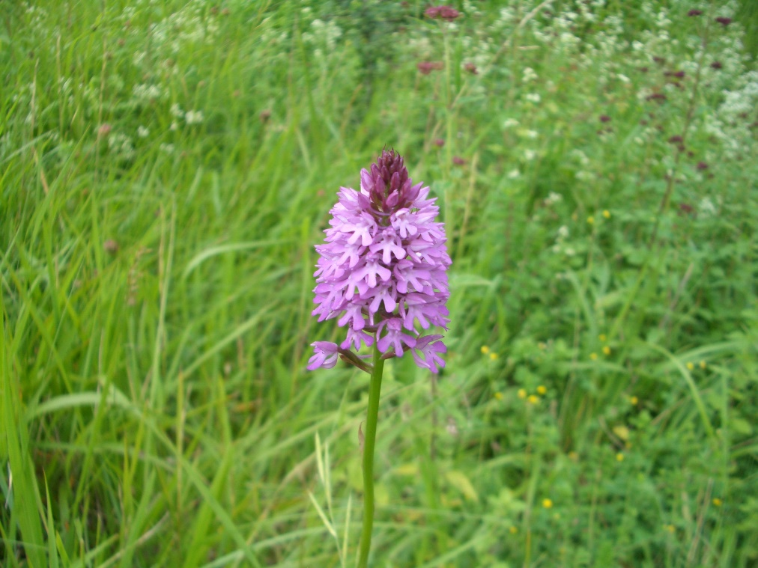
Photo – Pyramidal Orchid – Peter Scott
There were no “botany” outings in 2020, but a chance remark about the plants on a new verge turned into a survey which we hope to repeat each year. The road between Ketton and Empingham has been diverted, to enable expansion of the quarry, and the unseeded verges of the new piece of road are being naturally populated. A number of members met Geoffrey Hall the VC55 Botany Recorder and we found a total of 89 species including some relatively rare plants. Dwarf Spurge Euphorbia exigua and Night-flowering Catchfly Silene noctiflora are both on the Vulnerable list in the England Red book. Other uncommon plants found included Hare’s-foot Clover Trifolium arvense, Bugloss Anchusa arvensis and Musk or Nodding Thistle Carduus nutans. We hope that Rutland County Council will be able to ensure that these verges are left alone so we are able to see how they develop.

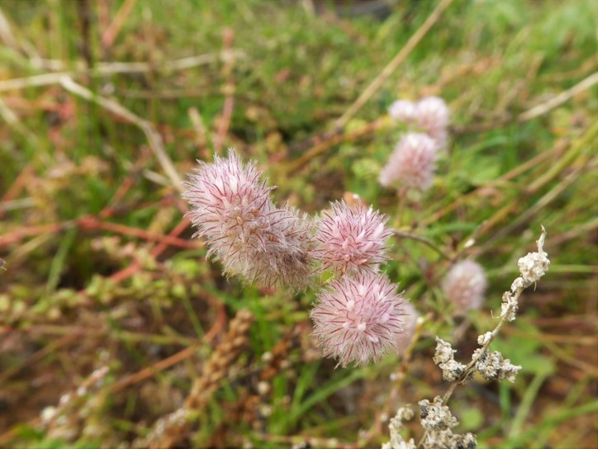
Photo – Hare’s-foot Clover – Carolyn Baxter
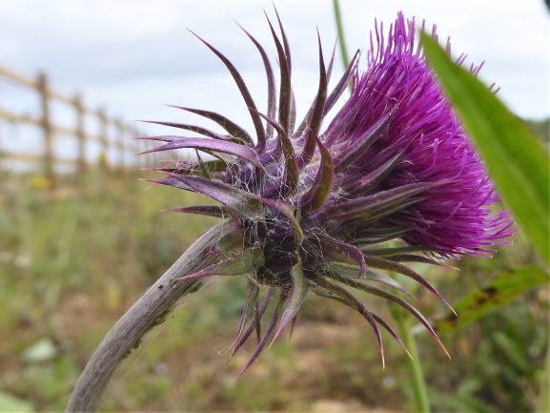
Photo – Musk or Nodding Thistle – Carolyn Baxter

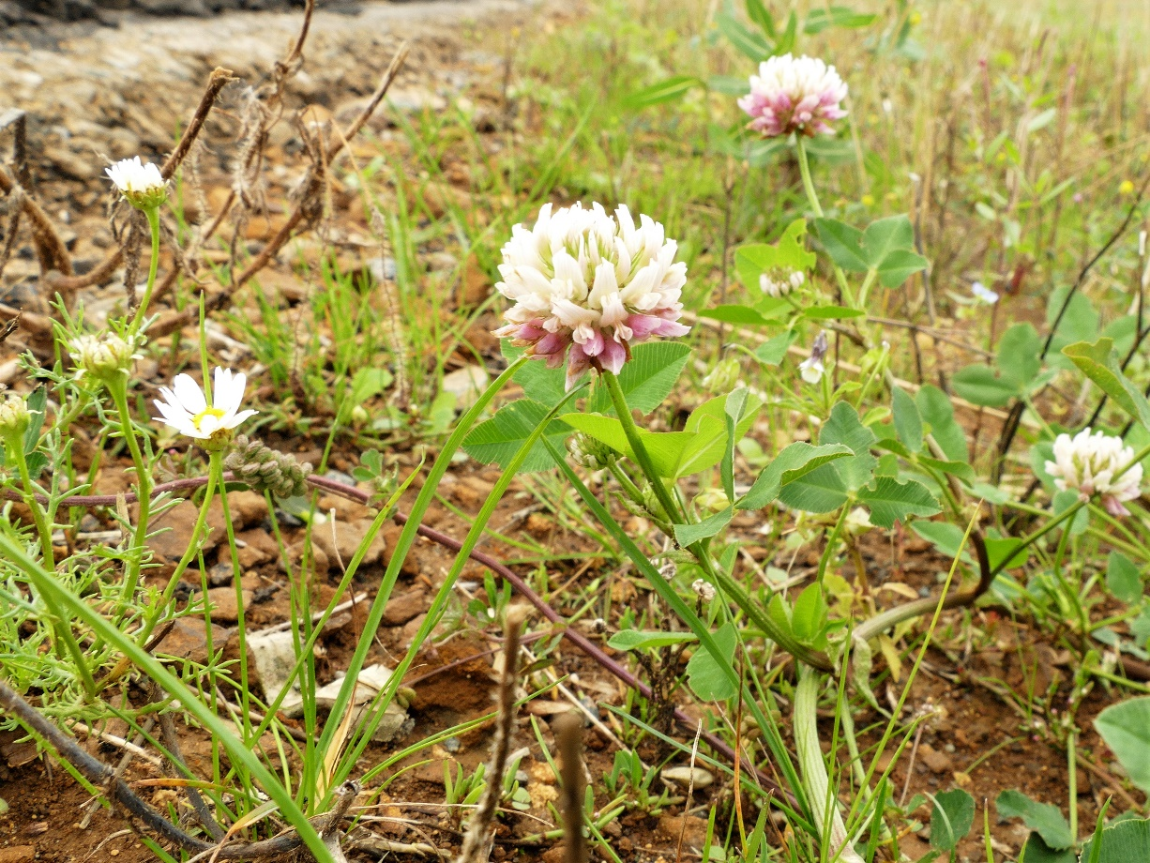
Photo – Alsike Clover – Carolyn Baxter

Thank you to all those who sent in records in 2020. Despite the restrictions that seem to go on for ever, please continue to look around you and tell us what you see. It is important to maintain recording for the evidence it provides, as we all try and maintain biodiversity and protect the environment.

Recorders were: Duncan and Jane Ball, Carolyn Baxter, Anthony and Linda Biddle, Tim Caldicott, Linda Clark, Martin Grimes, Jenny Harris, Neil Harris, Geoffrey Hall, Helen Ikin, Roy Lemmon, Terry Mitcham, Dave Needham, Joe Norrish, Russel Parry, Phil Rudkin, Donnie Smalley, Jayne Walker, Steve Woodward.

