Rutland Natural History Society

BOTANY ANNUAL REPORT, 2022 Recorder John Rodgers

This was a year without Covid-19 restrictions to prevent outings, but the weather stepped in instead. A period of drought and then heat frizzled everything up, which made it difficult to find flowering plants. Even so there were 800 records submitted of 282 species by 15 people. There were several organised surveys. The first was to join the Botanical Society of Britain and Ireland (BSBI) New Year Plant Hunt. A total of 28 species were found by 8 recorders, much the same as in 2021. As spring developed the usual flowers were found, but strangely the first record of Cowslip (Primula veris) was not until 21 April; the first Primrose (Primula vulgaris) having been seen on 2 January and Lesser Celandine (Ficaria veris) by the middle of February.

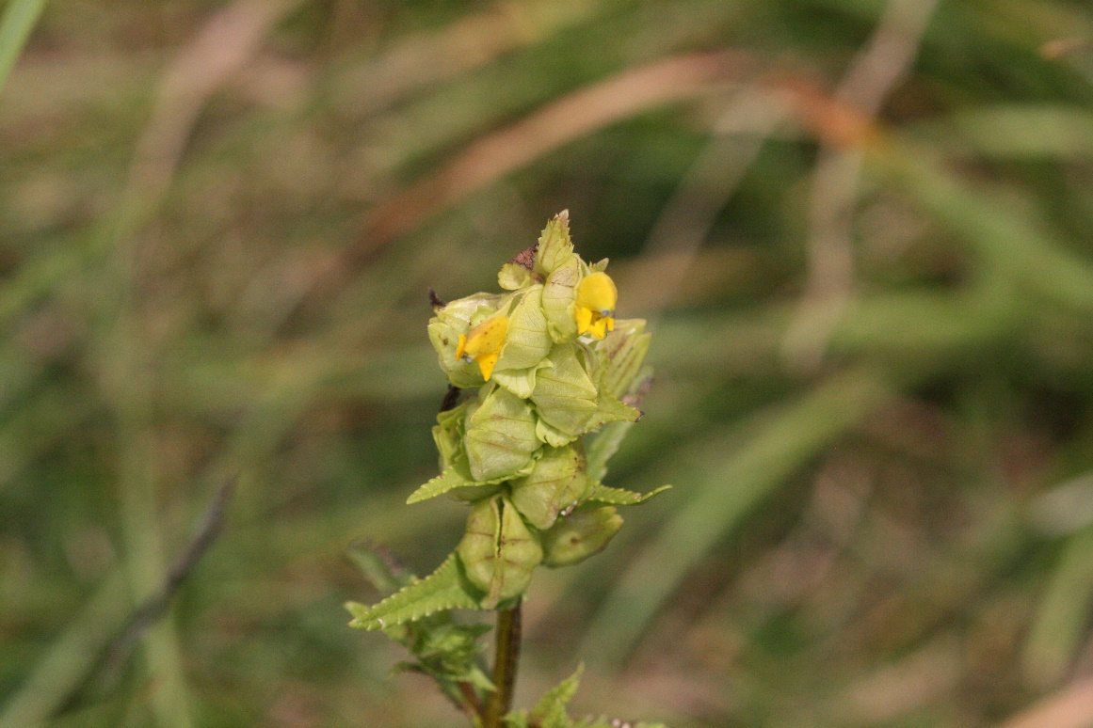

Photo: Yellow-rattle © Peter Scott

Later, recorders performed two surveys of Anglian Water Wing Treatment Works at the request of that organisation’s ecologist, Steve Rose. The land there is being managed for wildlife diversity. In April we found Field Madder (Sherardia arvensis), Parsley-piert (Aphanes arvensis) and Early Forget-me-not (Myosotis ramosissima), and Yellow-rattle (Rhinanthus minor) that Steve had planted from seed collected from a nature reserve, to try and reduce the vigour of the growth of grass. In July we found Pyramidal Orchid (Anacamptis pyramidalis) and Stone Parsley (Sison amomum) which is uncommon. We hope to be able to repeat this survey in future years.

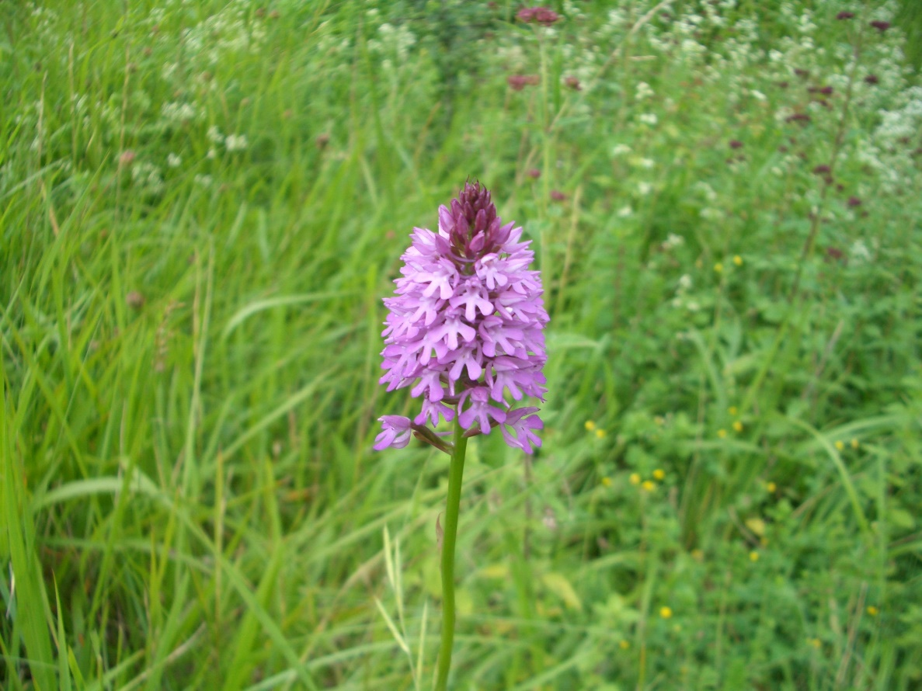

Photo: Pyramidal Orchid © Peter Scott

Recorders were also involved in a survey of Hebe's Wood, a privately owned woodland near Braunston-in-Rutland, at the suggestion of the owner, again with the intention of repeating the work in future years. Prize plants included Heath Spotted-orchid (Dactylorhiza maculate) and Southern Marsh-orchid (Dactylorhiza praetermissa). It is a very interesting area and deserves much more detailed investigation than this first visit. Other work included a visit to Panter's Orchard between Ketton and Empingham and one to Oakham Canal. The visit to Panter’s Orchard revealed Rat’s-tail Fescue (Vulpia myuros), an uncommon grass. At Oakham Canal Water-plantain (Alisma plantago-aquatica) and Narrow-leaved Water-plantain (Alisma lanceolatum) were growing amongst the water lilies; Common Hemp-nettle (Galeopsis tetrahit) and Skullcap (Scutellaria galerliculata) were also recorded.

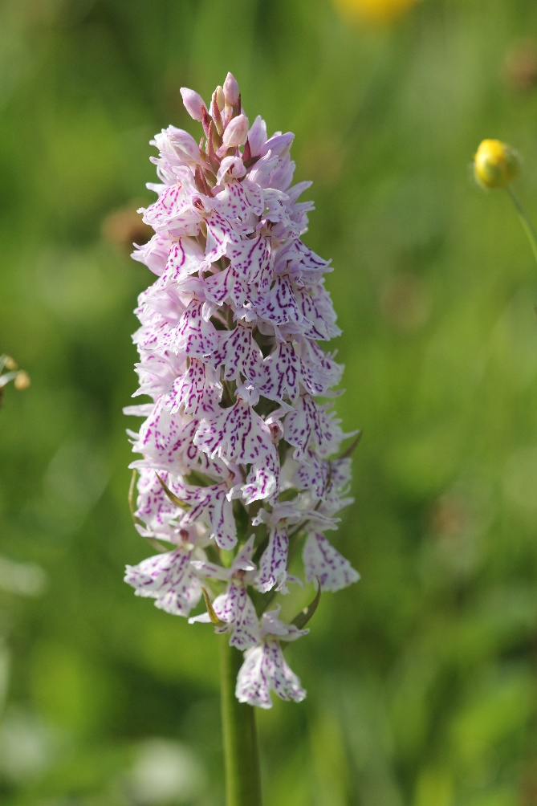

Photo: Heath Spotted-orchid © Peter Scott

Hebe’s Wood and Panter’s Orchard were both new sites for the Society.

In early September, several plants of Vervain (Verbena officinalis) were found beside the path leading down to Teal Hide, close to the visitor centre at Lyndon Hill Nature Reserve, Rutland Water. According to the BSBI map, the plant is not common, with only one site in Rutland (Lyndon) and one site in Leicestershire, at Market Bosworth.

As always, we must thank Linda and Anthony Biddle. Carolyn Baxter, Duncan and Jane Ball, Linda Clark, Tim Caldicott, Martin Grimes, Jenny Harris, Roy Lemmon, Marian Markham, Dave Needham and Donnie Smalley, together with our colleagues from Leicester, Geoffrey Hall, Helen Ikin, and Steve Woodward, for all the records received.

Plant names follow those in Jeeves, M. (2011). The Flora of Leicestershire and Rutland: Checklist and Rare Plant Register. LRWT.

