Rutland Natural History Society

BOTANY REPORT 2021 Recorder: John Rodgers

During 2021, Covid-19 restrictions, though not severe as in 2020, were still sufficient to restrict the number of outings during the year. Despite this there were 1210 records of 374 species submitted by the usual 20 faithful recorders.

The main event of the season was the Bioblitz at Clipsham Yew Tree Avenue in May. This was a very successful event enjoyed by all who came. A number of different sallies were made, including surveying for plants. More than 50 species were identified including Toothwort (Latheria squamaria) which only occurs in a few places in Rutland and Betony (Betonica officialis).

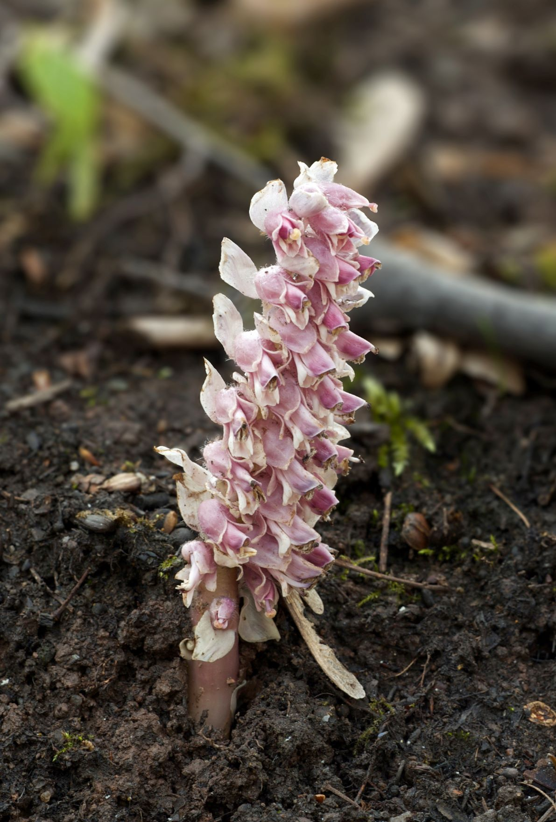

Photo Toothwort (Latheria squamaria) © Carolyn Baxter

The New Year Plant Hunt, organised by the Botanical Society of Britain and Ireland (BSBI), occupied several recorders at the beginning of the year. Unfortunately, Covid regulations prevented the organisation of a group outing but even so 10 members went out in small groups to discover 30 plants in flower. Later in the year some of us were able to join in surveys organised by colleagues from Leicester, including an opportunity to go out onto parts of the nature reserve at Egleton. This followed a request from one of the wardens to survey the plant life on the shores of the newer lagoons.

The first records of a number of flowers fitted the usual pattern, although Lesser Celandine (Ficaria verna) was found in flower on 2 January, rather earlier than in other years. Primrose was reported at the end of February closely followed by Snowdrop (Galanthus nivalis). Cowslip (Primula veris) wasn’t recorded until the beginning of May, just after the first record of Common Spotted Orchid (Dachtylorhyza fuchsii) and Green-winged Orchid (Orchis morio) at Merry’s Meadows. These dates were much later than last year but this may only be a reflection of who was looking where. There seems to be a tendency for flowers to bloom earlier than in the past, but a report in Plantlife stated that many plants flowered later in 2021. Amongst the more uncommon flowers was Butterbur (Petasites hybridus) off the Oakham bypass, Greater Bird’s-foot-trefoil (Lotus pedunculatus) in Clipsham Park Wood and Seaton Meadows, and Lesser Sea-spurry (Spergularia marina) at the Tinwell Road-A1 junction. The lagoon banks at Egleton Nature Reserve yielded masses of Gypsywort (Lycopus europaeus), Trifid Bur-marigold (Bidens tripartita), Nodding Bur-marigold (Bidens cernua), Water Mint (Mentha aquatica), and masses of the pernicious New Zealand Pygmyweed (Crassula helmsii) which is a great threat to aquatic flora and fauna. Several specimens of the rare Mudwort (Limosella aquatica) were also found.

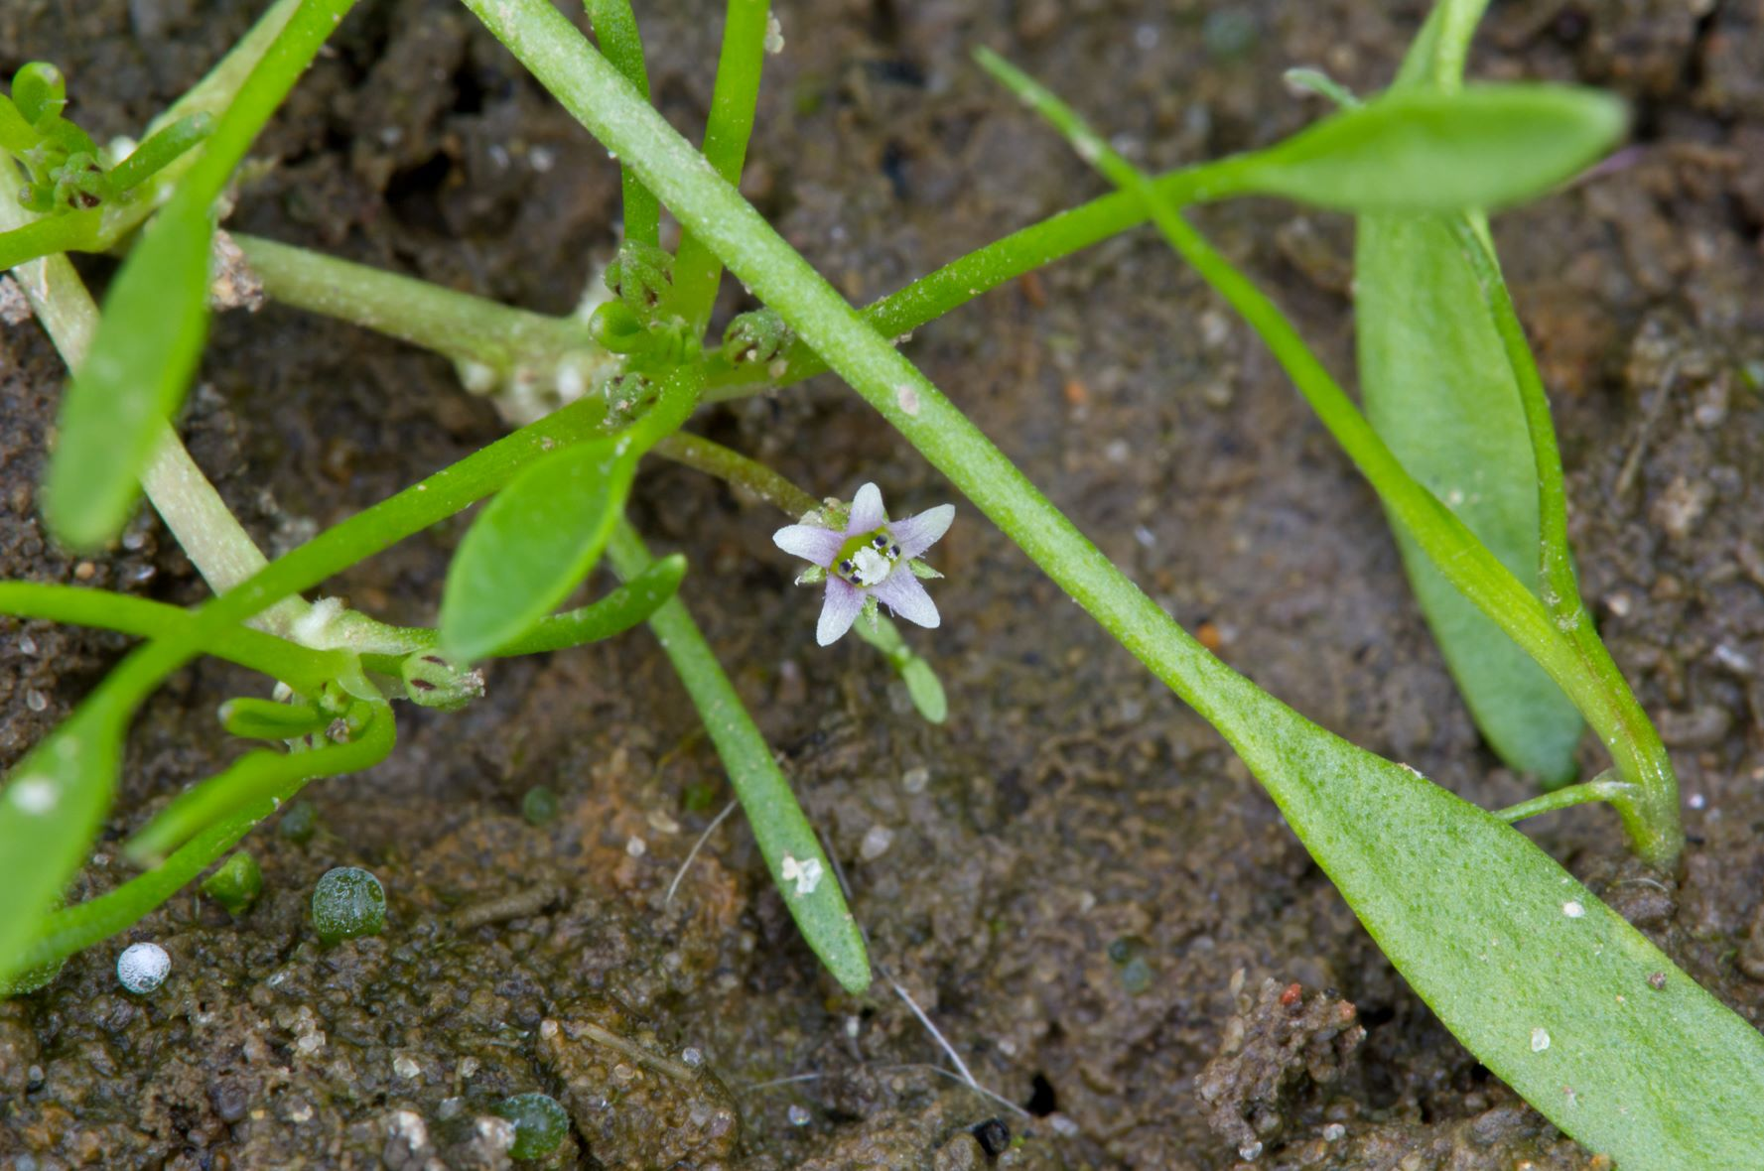

Photo Mudwort (Limosella aquatica) © Carolyn Baxter

Let us hope that 2022 will not be as blighted with restrictions as the past two years and that the Society will be able to organise some guided botanical outings and encourage new and especially younger members to develop an interest in botany, We, and all animal species, are entirely dependent on plant life and so we must learn to preserve it. One of the first steps must be to be able to recognise what is growing all around us. This also means that we must record what we see, so please send in records.

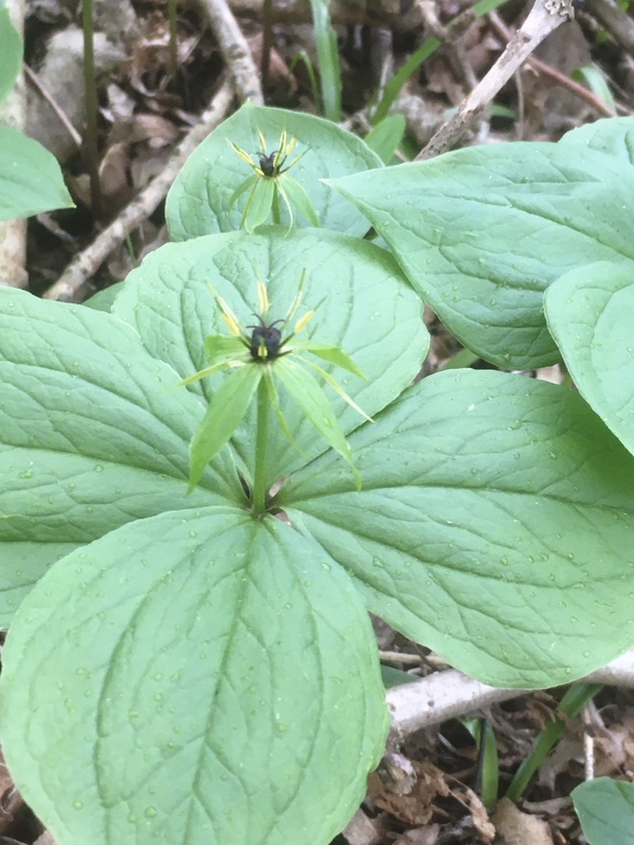

Photo Herb-Paris (Paris quadrifolia) © John Rodgers

Thank you to all those who have done that this year: Duncan and Jane Ball, Carolyn Baxter, Anthony and Linda Biddle, Tim Caldicott, Linda Clark, Martin Grimes, Geoffrey Hall, Jenny Harris, Helen Ikin, Roy Lemmon, Terry Mitcham, David Needham, Russel Parry, John Rodgers, Phil Rudkin, Donnie Smalley, Jayne Walker, Steve Woodward.

