Rutland Natural History Society

FUNGI 2020 Joint Recorders: Carolyn Baxter and Linda Clark

Fungi recording in 2020 began in October due to the absence of a Recorder.

In total 68 species were recorded as being positively identified. Many fungi were reported but we were unable to positively identify these due to lack of experience and the pandemic which prevented us from consulting experts face to face. The records that we were unable to verify have been kept for later and it is hoped that, when identified, these will be added to the 2020 list.
The number of species recorded has been boosted by the records sent in by Roy Lemmon who is our resident expert on Mildews, Rusts and Smuts which fall into the Mycological Kingdom.

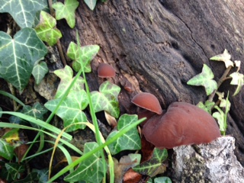

Photo – Jelly Ear – Linda Clark

The most common fungi recorded were Jelly Ear, Auricularia auricula - judae and a rust Puccinia Glechomatis both being found at five different locations. Turkey Tail, Trametes versicolour, Candlesnuff Fungus, Xylaria hypoxylon and King Alfred’s Cakes, Daldinia concentrica were frequently seen.

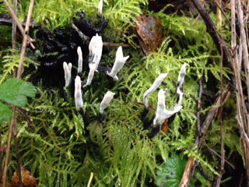

Photo – Candlesnuff – Linda Clark
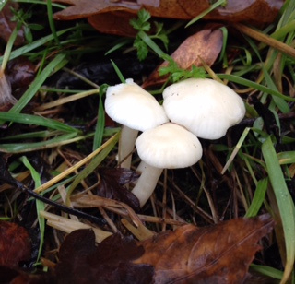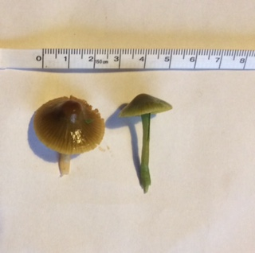

Photo – Snowy Waxcap – Linda Clark Photo – Meadow Waxcap – Linda Clark

Waxcaps (Hygrocybe spp) tend to grow on unimproved grassland especially where it is grazed or cut. Snowy Waxcaps, Hygrocybe virginia were reported being present on private land in Barrowden, from a verge in Wing and from Walk Farm Plantation. Meadow, Hygrocybe pratensis and Parrot, Hygrocybe psittacona waxcaps were both reported from a large grassy area in Wing which had not been fertilised or treated for ten years. Pipe Club Macrotyphula fistulosa, a small delicate fungus, was spotted in a private wood in Wing; a great find and not often seen.

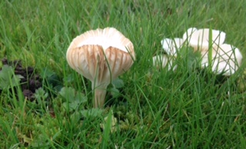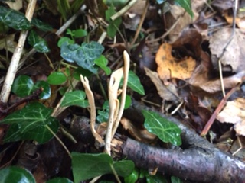

Photo – Parrot Waxcap – Linda Clark Photo – Pipe Club – Linda Clark

FUNGI SPECIES LIST 2020

SCIENTIFIC NAME | SPECIES | GRID REF
Agaricus campestris. | Field Mushroom | SK924112 | Exton Village
Agaricus xanthodermus | Yellow Stainer | SP860992 | Beside Leighfield primary school Uppingham
Aleutian aurantia | Orange peel Fungus | SK889025 | Wing to Glaston Road.
Ampulloclitocybe clavipes | Club foot fungus | SP835994 SP834993 | Wardley Woods
Armillaria mellea | Honey Fungus | SK891031 | Wing
Auricularia auricula- judae | Jelly Ear | SK966020 SK909068 SP863994 SP834993 SK905070 | Hambleton Wood. Uppingham Arboretum.
Blumaria Graminis (anamorph) | Ascomycetes. Powdery Mildew | SK945082 | Hereward Way Empingham
Bolbitius titubans | Yellow Fieldcap | SK905070 SK899028 | Hambleton. Wing.
Chlorophyllum rhacodes | Shaggy Parasol | TF009132 SK892028 | Ryhall Heath. Wing private wood
Coprinellus micraceus | Glistening inkcap | SK89250316 | Wing
Coprinopsis atramentaria | Common inkcap | SP860991 | Uppingham School
Coprinus comatus | Shaggy inkcap | SP862994 SK892028 | Uppingham Arboretum. Wing
Crepidotus variabilis | Variable oysterling | SP866991 SK892028 | Uppingham. Wing Private Wood.
Cymadothea trifolii | Ascomycetes | SK992131 | Pickworth, Bridleway to Christians Lodge
Dacrymyces stillatus | Basidiomycete | SK995110 | Mounts Lodge Bridleway Pickworth
Daldinia concentrica | King Alfreds Cakes | SK905070 SP835994 SK892028 | Hambleton Wood Wardley Woods. Wing
Diatrype disciformis | Beech bark spot | SK905070 | Hambleton Wood
Erysipelas heraclei | Ascomycetes. Powdery Mildew | SK992131 | Pickworth, Bridleway to Christians Lodge
Erysipelas tortillas | Ascomycetes. Powdery Mildew | SK992131 SK945082 | Pickworth, Bridleway to Christians Lodge
Erysipelas urticaria | Ascomycetes. Powdery mildew | SK968024 | Barrowden Road, Ketton
Exidia glandulosa | Black witches butter | SK904026 | Pilton small wood.
Exidia nucleata | Crystal Brain Fungus | SK892028 | Wing Private Wood
Ganoderma sp | Large bracket | SP862994 | Uppingham Arboretum
Geastrum triplex | Earthstar | SK904026 SK943002 | Wing Pilton small wood.
Golovinomyces artemisiae | Ascomycetes. Powdery Mildew | SK968024 | Barrowden Road, Ketton
Golovinomyces cichoracearum | Ascomycetes. Powdery Mildew | SK992131 | Pickworth, Bridleway to Christians Lodge
Golovinomyces sordidus | Ascomycetes. Powdery Mildew | SK992131 | Pickworth, Bridleway to Christians Lodge
Hygrocybe pratensis | Meadow Waxcap | SK890031 | Wing
Hygrocybe psittacona | Parrot Waxcap | SK890031 | Wing
Hygrocybe virginia | Snowy Waxcap | SK887026 Barrowden on private ground. TF015124. | Wing. Barrowden. Walk Farm Plantation
Hyphodontia sambuci (Hyhodermataceae) | Elder whitewash | SK892028 | Wing Private Wood
Hypoxlon fragiforme | Beech woodwort | SP862994 | Uppingham Arboretum
Junghuhnia nitida | Crust fungus | SP834993 | Wardley Woods
Lactarius deliciosus | Saffron Milkcap | SK899028 | Wing
Lycoperdon perlatum | Common puffball | SK832051 | Priors Coppice
Macrotyphula fistulosa | Pipe Club | SK892028 | Wing Private Wood
Melampsora caprearum | Basidiomycetes - Rust | SK992131 | Pickworth, Bridleway to Christians Lodge
Melampsora euphorbiae | Basidiomycetes. Rust. | SK995110 | Pickworth Mounts Lodge Bridleway
Microbotryum lichinidis-dioicae | Basidiomycetes - smut like fungus | SK995110 | Pickworth Mounts Lodge Bridleway
Mycena galericulata | Common Bonnet | SK832049 | Priors Coppice
Nectria cinabarina | Coral Spot | SK892029 SK905070 | Wing. Hambleton Wood.
Nederysiphe galeopsidis (A) | Ascomycetes. Powdery Mildew | SK945082 SK995110 SK968024 | Hereward Way, Empingham. Barrowden Road, Ketton Pickworth Mounts Lodge Bridleway
Parasola plicatilis | Pleated Inkcap | TF015124 | Walk Farm Plantation
Paxillus involutus | Brown Rollrim | SK890029 | Wing
Phragmidium Bulbosum | Basidiomycetes - Rust | SK992131 SK945082 SK995110 SK968024 | Barrowden Road, Ketton. Pickworth, Bridleway to Christians Lodge Pickworth Mounts Lodge Bridleway
Phragmidium microdtum | Basidiomycetes Rust. | SK968024 | Barrowden Road, Ketton
Phragmidium mucronatum | Basidiomycetes. Rust. | SK995110 | Pickworth Mounts Lodge Bridleway
Phragmidium violaceum | Basidiomycetes Rust. | SK968024 SK995110 | Barrowden Road, Ketton
Phyllactinia guttata (H) | Ascomycetes. Powdery Mildew | SK945082 | Hereward Way, Empingham.
Podosphaera fugax | Ascomycetes. Powdery Mildew | SK992131 | Pickworth, Bridleway to Christians Lodge
Puccinia distincta | Basidiomycetes - Rust | SK945082 | Hereward Way, Empingham. Barrowden Road, Ketton
Puccinia glechomatis | Basidiomycetes Rust. | SK968024 SK992131 SK945082 SK995110 SK971108 | Hereward Way, Empingham. Barrowden Road, Ketton, Pickworth, Bridleway to Christians Lodge Pickworth Mounts Lodge Bridleway
Puccinia lapsanae | Basidiomycetes. Rust. | SK995110 | Pickworth Mounts Lodge Bridleway
Puccinia malvacearum | Basidiomycetes Rust. | SK968024 SK995110 SK945082 | Hereward Way, Empingham. Barrowden Road, Ketton Pickworth Mounts Lodge Bridleway
Puccinia punctata | Basidiomycetes. Rust. | SK995110 | Pickworth Mounts Lodge Bridleway
Puccinia tanaceti | Basidiomycetes Rust. | SK968024 SK995110 | Barrowden Road, Ketton
Puccinia variabilis | Basidiomycetes. Rust. | SK995110 SK992131 | Pickworth, Bridleway to Christians Lodge
Puccinia vincae | Basidiomycetes - Rust | SK945082 | Hereward Way, Empingham.
Pucciniastrum agrimoniae | Basidiomycetes. Rust. | SK995110 | Pickworth Mounts Lodge Bridleway
Rhytisma acerinum | Discomycete. Tar Spot. | SK945082 | Hereward Way, Empingham.
Russula betularum | Birch Brittlegill | SK899028 | Wing
Scleroderma citrinum | Common Earthball | SK894029 | Wing Playing field
Stereum hirsutum | Hairy Curtain Crust | SK909068 SK905070 | Hambleton Wood
Trametes versicolor | Turkey Tail | SK966020 | Fox Covert Barrowden Road Ketton
Tranzschelia pruni-spinosae | Basidiomycetes Rust. | SK968024 | Barrowden Road, Ketton
Tremella mesenterica | Yellow Brain Fungus | SK892029. SK95171863. | Wing. Morkery Wood
Tricholomopsis rutilans | Plums and Custard | SK892028 | Wing Private Wood
Xylaria hypoxylon | Candlesnuff Fungus / Stag’s Horn | SK905070 SP835994 SP834993 SK995110 SK889025 | Hambleton Wood.Wardley Woods Pickworth Mounts Lodge Bridleway. Wing Pickworth Mounts Lodge Bridleway

