Rutland Natural History Society

Annual Report: Fungi 2022 Recorders: Linda Clark, Carolyn Baxter

Records from members were sparse this year, and from only twelve people. Most of the reports I received were from just three individuals. Forty six Rutland locations were involved, many of them from Rutland Water Nature Reserve, both at Egleton and Lyndon.

Rutland experienced drought conditions until the end of September, after which precipitation and dews brought out fungal fruiting bodies. A total of one hundred and fifty three species were recorded for the year 2022. Many could not be identified to species level, particularly those belonging to the families of Mycenae and Psathyrella.

Of particular note were a couple of species found by Tim Sexton, Monitoring and Species Recorder for Leicestershire and Rutland Wildlife Trust, at Rutland Water. Tim discovered Marasmius limosis on reed stems; prior to this, only thirty nine records of this species had been accepted in the UK. Tim went on to find numerous examples of this fungus in Rutland Water reedbeds and it is likely that this species has been under recorded. A new species for Rutland and Leicestershire was found in Cherry Wood, Rutland Water: Psathyrella typhae, of which there were only seven records on the Biodiversity Network and twelve in the Kew Database.

Snowy Waxcaps, Hygrocybe virginia were especially abundant this year, found in areas of unimproved grassland. Brown Roll Rims, Paxillus involutus were numerous in the autumn and were seen in many locations.

Semi free morels, Morchella semilibera, were found at the far end of the summer track at Rutland Water Egleton.

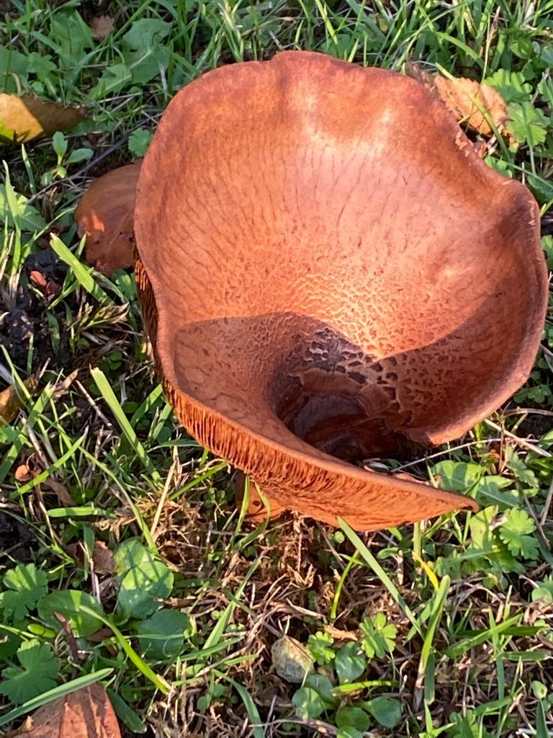
Photo - Brown Roll Rim © Linda Clark

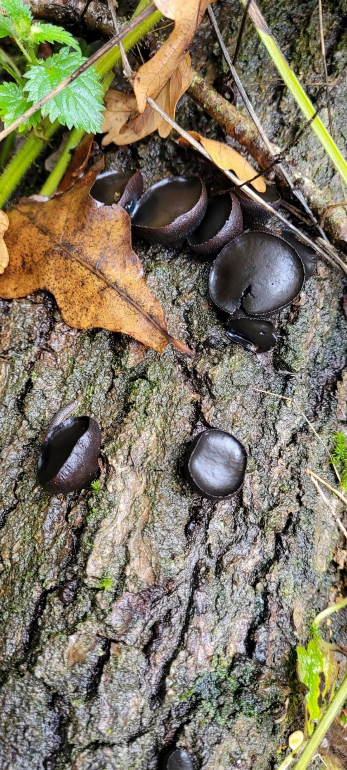
Photo - Black Bulger © Linda Clark

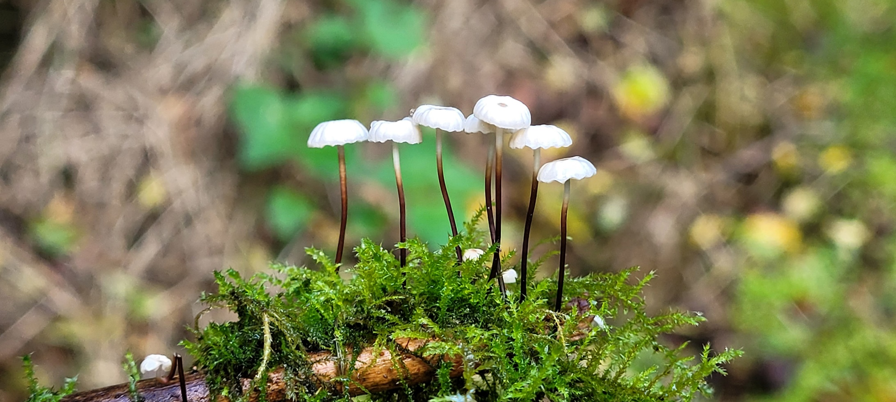
Photo - Collared Parachute © Linda Clark

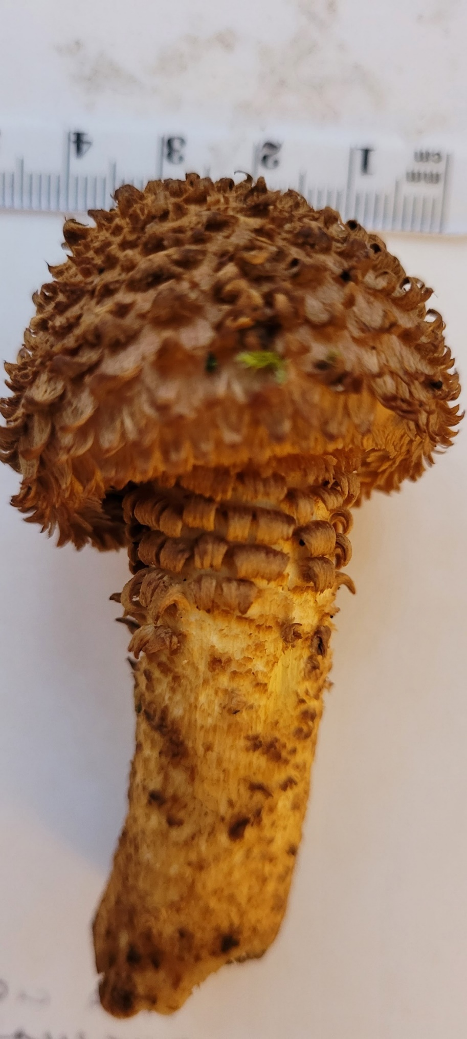
Photo – Scalycap © Linda Clark

