Rutland Natural History Society

ANNUAL REPORT: GLOW WORMS, 2022 Recorder: Linda Clark

After two years of very little Glow Worm hunting and recording I am pleased to report that Glow Worms are still to be found in Rutland albeit in small numbers.

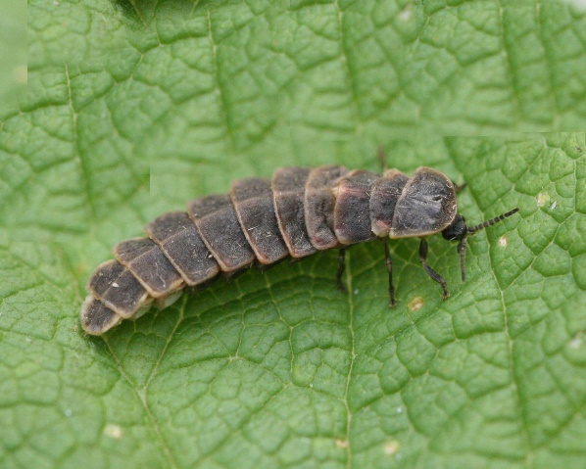

Photo © Peter Scott
Three sights were searched: Ketton, Essendine and Barrowden.
I was contacted by one of the National Glow Worm Recorders about a record of one glow seen on Station Road, Ketton by the railway line. I was unable to access the area when I visited on 5 July, as work was being done on the line that night, and I had not managed to do a recce during daylight. Historically there has been a population in the area and it is planned to investigate this next year.
Ketton Quarry NR was surveyed on four occasions and glows were found in three different areas on three occasions. The areas in which they were found were in the field near the car park (two found on 20 June), on the track leading from the car park to the Dell on 23 June, and in the Dell and the Fire Pit area on 30 June. The night of 30 June showed a total of eight glowing females and on the night of 15 July there were six in the area next to the car park.
Barrowden has protected verges along Back Road and Luffenham Road. Glow Worms have been monitored there for some years by Linda Worrel, latterly by local resident Ron Fraser and this year by Valerie Fraser who reported seven glows on Back Road on 28 June (SK945003). On Luffenham Road on 23 June (SK947005) one was found in long grass towards the back of the verge and one was found on the opposite verge, near the village sign, very near the road edge in short grass where the grass had been mown. A further two were found on Back Road, Barrowden on 30 June (SK945003); both these glows were found low down in the long grass at the hedge base.
Essendine verges along the Pickworth Road were checked on 10 July. One of these verges is signed as a protected verge. A total of six glowing females was spotted, most of these being in the longer vegetation (TF04241289). Only one glow was found on the signed verge, two being found on the opposite verge and the other three were found on the two verges nearer the village end (TF043127).
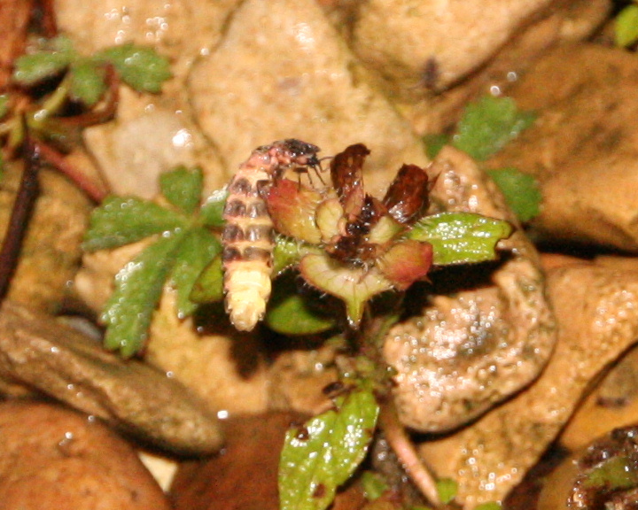

Photo © Peter Scott

Unfortunately verges in both Essendine and Luffenham Road, Barrowden (on the right-hand side going out of the village towards the A47) had been mown in strips along the road edge. The verges, if they are managed correctly for Glow Worms, should not be mown between the end of May and the end of August. This has been a perennial problem when it comes to verge management and is ongoing. Rutland County Council have requested advice from the RNHS about cutting regimes to best manage the verges with Glow Worms in mind. Advice has been given.

My Thanks to C. Baxter. V. Fraser, D. Needham and J. Harris.
Linda Clark August 2022

