Rutland Natural History Society

ANNUAL REPORT: GLOW WORMS, 2024 Authors C Baxter T Sexton

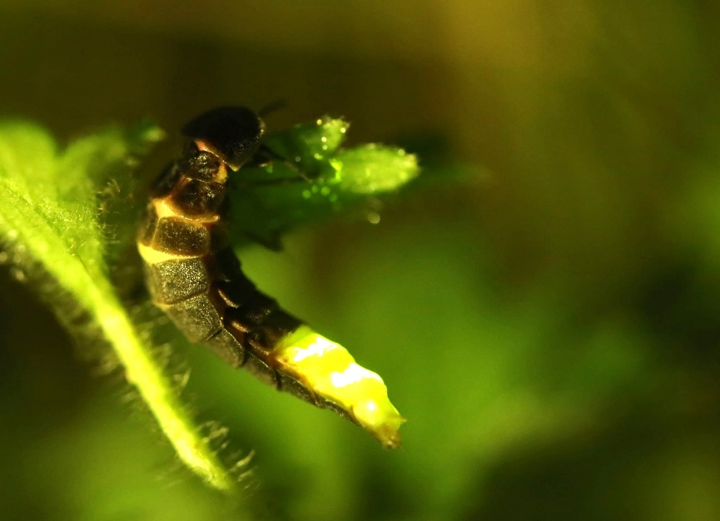
Female glow worm Burley 2024
Once a common sight in the UK, glow-worms are declining nationally because of habitat loss, degradation, light pollution and pesticide use. In some parts of the country, glow-worm numbers have plunged by up to three-quarters since 2001. In addition to this, many of the remaining sites where they are found are becoming geographically isolated with dwindling populations. The females, being wingless, do not move far and therefore isolated populations are further at risk of becoming unviable over time.
Rutland has historically supported several large colonies of glow-worms, with most records coming from the limestone soils in the east of the county. Records date back to the Second World War, with stories of glow-worms ‘lighting up’ verges in the absence of streetlamps. Systematic recording of glow-worms in the county began in the early 1990s through the work of Linda Worral and Rutland Natural History Society.
There was renewed interest in glow-worm recording locally in 2023, following the announcement that Leicestershire and Rutland Wildlife Trust were seeking funding for a project to enhance priority grassland habitats in the county and aid the recovery of glow-worm populations. In summer of that year, a citizen science project helped to map glow-worm populations across Leicestershire and Rutland – confirming continued activity on many of the historic sites, but also identifying two previously unknown populations in Leicestershire.
There are five main glow-worm colonies in Rutland: Burley Wood, Ketton Quarry, Barrowden Verges, Essendine Verges and Pickworth Woods. Other records have come from South Luffenham Level Crossing, Clipsham Old Quarry, Tixover, Geeston, North Luffenham Quarry, Luffenham Heath Golf Course and Braunston. In recent years, only a handful of surveys have been carried out on the key sites each year (Ketton Quarry, Essendine and Barrowden).

In 2024 RNHS collaborated with Leicestershire and Rutland Wildlife Trust (LRWT) to carry out a detailed survey of glow-worms in Rutland. It may be because the sites were investigated continuously over the glow-worm breeding period by more volunteers, or that 2024 was a particularly good “glowing” year, but the results for every site covered except Bloody Oaks (Nil), exceded recent recording years. Tim Sexton and volunteers surveyed Burley Woods weekly from the first week in June until the second week in August, (ten weeks) while RNHS volunteers and Sarah Bedford (LRWT) surveyed other known sites in the County for most weeks over a period of eight weeks from the beginning of June to the end of July.
The weather for the first part of the survey in early June was cool with winds coming mainly from the northeast, making night-time temperatures low for the time of year, possibly delaying the start of the season. There was a distinct lack of night-flying insects in the first week with the first Barrowden investigation on 5 June resulting in no glows at all, but the night was particularly cold. However, by 20 June, the daytime temperatures had picked up to around 25 degrees with plenty of sunshine to the end of the month. The weather changed back again at the beginning of July with winds and rain affecting temperatures once more but became much more settled by the end of the month and into August.
In all, 465 glow worms were recorded across the five sites. The greatest number of glowing females recorded in one night was at Ketton Quarry where 35 were recorded on the 11th July, this was closely followed by Burley Wood on the 3rd July when 28 females were recorded along with 3 males. The peak period of activity was the first week of July with 108 glowing females recorded across all sites. Totals from each of the surveyed sites (along with maxima) are shown in the table below.

Site Name | Total glow-worms recorded during survey period | Maxima (most recorded on one night)
Burley Wood | 158 | 32
Ketton Quarry | 142 | 35
Barrowden | 94 | 27
Essendine Verges | 46 | 15
Pickworth Woods | 25 | 12

Bloody Oaks Quarry was surveyed in 2024. However, after several visits no glow worms were found. A record of a glowing female was reported from Armley Wood at Rutland Water by an angler. No further details were given, this will be followed up by a survey on both sides of the Hambleton Peninsula in 2025. Systematic surveys of the five key sites in Rutland by volunteer recorders from RNHs will also continue in 2025.

Chart and map of the Burley wood survey.
Date | Female glows | Male glows | Larvae glows | Weather
05/06/24 | 2 | 0 | 0 | 10 Overcast
13/06/24 | 3 | 0 | 0 | 12 Overcast
18/06/24 | 9 | 7 | 0 | 12.5 Overcast
24/06/24 | 9 | 9 | 0 | 11 Clear
29/06/24 | 25 | 7 | 0 | 14 Clear
09/07/24 | 28 | 3 | 0 | 16 Lt. cloud. Clear ltr.
12/07/24 | 5 | 0 | 0 | 11 Overcast. Lt rain
18/07/24 | 16 | 7 | 1 | 18 scattered cloud. Nr full moon.
25/07/24 | 5 | 2 | 5 | 19 Overcast. Lt cloud.

