Rutland Natural History Society

INSECT ANNUAL REPORT 2020 Recorder: Jayne Walker

Introduction
I would like to thank all the RNHS members and also non-members that have submitted insect records. This year has been a challenge to us all in many ways, and having the chance to connect with nature and to get to know ‘local patches’ in greater depth, I feel sure has helped us through numerous lockdowns.

At the start of 2020 I stepped into the role that Jill Chiverton expertly held for many years and it has been a huge learning curve. However, being challenged has been a positive experience and I have come to appreciate how fascinating the lives of insects are, the abundance of different species, evolutionary adaptations that allow them to inhabit niche environments and most of all the huge contribution they make to our planet biodiversity and wellbeing.

Records
A total of 166 records were received in 2020 and these are broken down by group and species month by month. Where no records have been received for species groups a ‘nil’ return has not been included in the report below e.g. Zygentoma – Silverfish.

Where identification of an insect has required further research; these have been referred to Naturespot, Natural History Museum, and pers.com to entomologists.

Records have been submitted from Society members by email, some with photographs attached to corroborate identification, using the recorders’ spreadsheet available on the RNHS website and paper records through the post.

A full list of records can be found in Tables 1 to 8: in the main body of the report and a list of contributors and thanks can be found at the end of the report.

A copy of these records will be forwarded to the County Recorder.

Species Summary

Odonata - Dragonflies and Damselflies

A total of 39 records were received for Dragonflies and Damselflies between the months of May and September; overall 14 species were recorded at various sites across the County, with the majority of records coming from the Oakham Canal (National Grid Reference (NGR)) SK865110 and Ketton Quarry (NGR) SK980060. The majority of records from Ketton Quarry were gathered in August, when the Society held its first outdoor meeting following the lifting of Covid-19 restrictions. Details of the Odonata records are provided in Table 1, below.

Oakham Canal proved to be an excellent location for spotting dragonfly and damselfly, with beautiful species such as Blue-tailed Damselfly Ischnura elegans, Red-eyed Damselfly Erythromma najas and Emperor Dragonfly Anax imperator recorded.
Willow Emerald Damselfly Chalcolestes viridis was recorded at Eyebrook Reservoir (NGR) SP844970 which is a rare immigrant and was first recorded at this location in 2019. Three singletons were seen in August at (NGR) SP844 970, which is an excellent record for VC55.

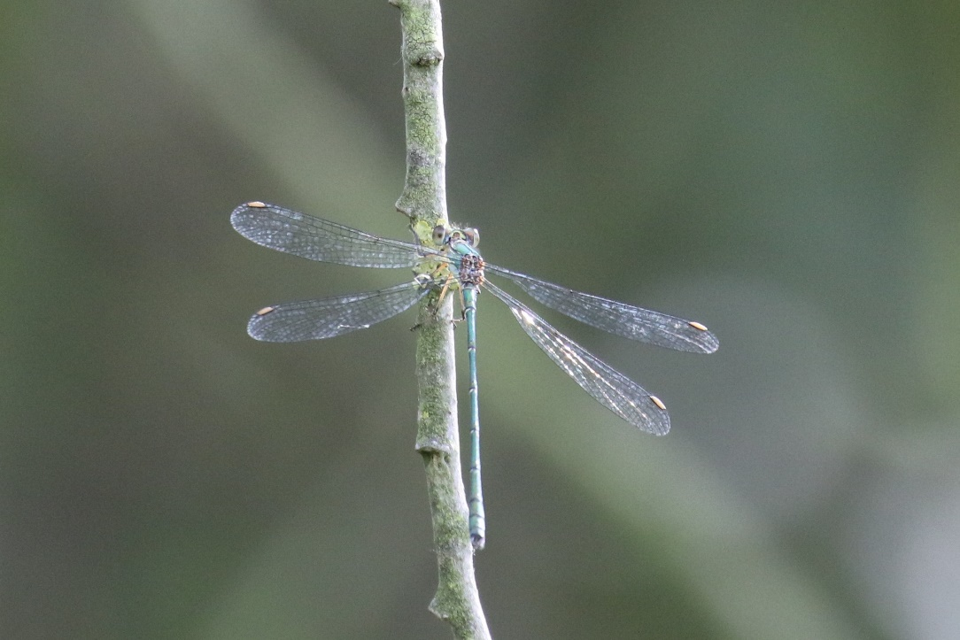

Photo – Peter Scott – Willow Emerald

The White-Legged Damselfly Platycnemis pennipes was recorded in Wing in June at three locations with the majority of records coming from the Wing railway bridge area (NGR) SK 88780249. This species is shown to be at the northern edge of its distribution range in Rutland, and Naturespot records it as ‘still infrequent in VC55…but may well be increasing in frequency’. However, this data may now be a little out of date. This damselfly was the subject of an investigation launched by the British Dragonfly Society in 2020; in order to collect data from under-recorded areas and use this to inform future conservation measures for this species.
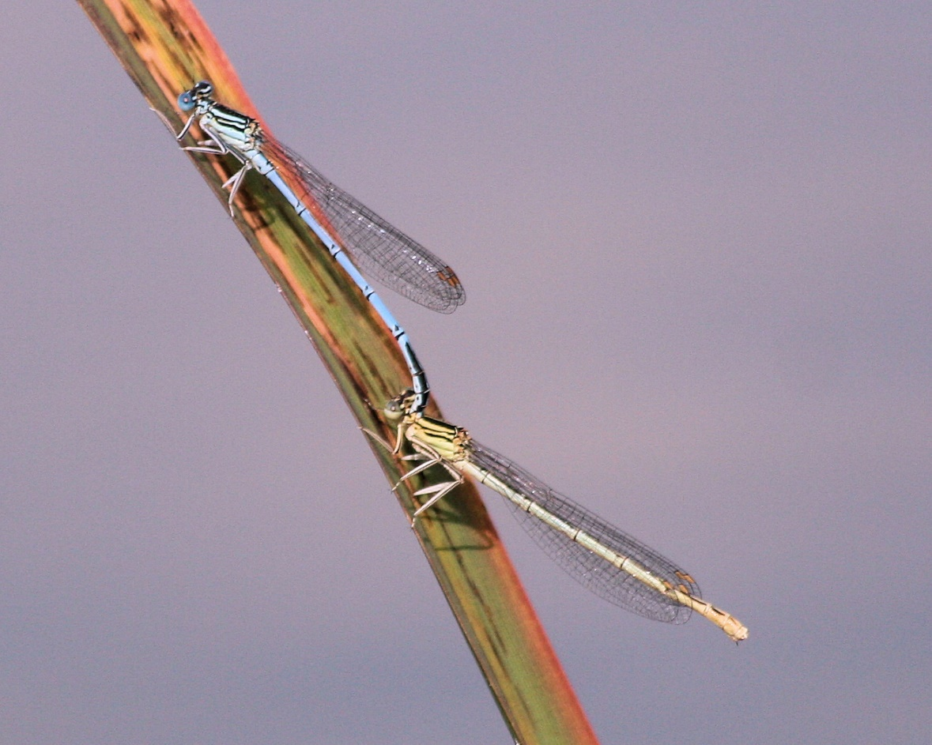

Photo – Peter Scott - White-legged Damselfly

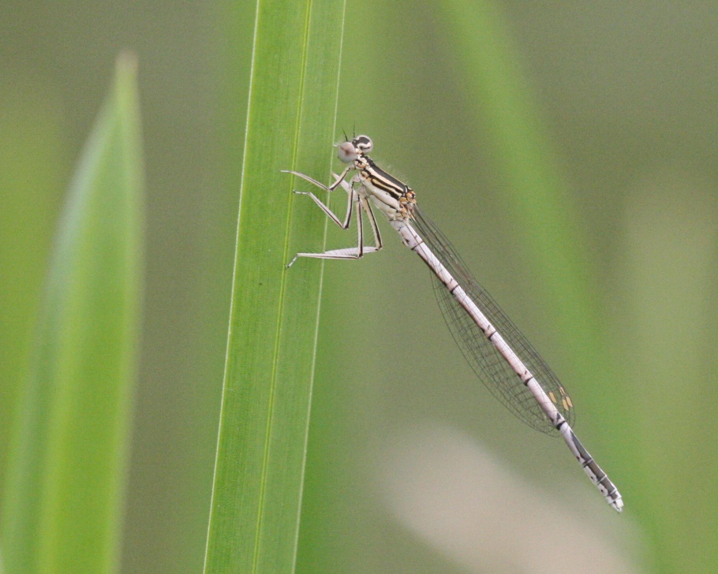

Photo – Peter Scott – White-legged Damselfly

Table 1: Odonata Records

Odonata - Dragonflies and Damselflies
May
Azure Damselfly | Coenagrion puella | Oakham Canal | General | SK865110 | Numerous
Large Red Damselfly | Pyrrhosoma nymphula | Oakham Canal | General | SK865110 | 1
Banded Demoiselle | Calopteryx splendens | Oakham Canal | General | SK865110 | 1
Red-Eyed Damselfly | Erythromma najas | Oakham Canal | General | SK865110 | Numerous
Blue-Tailed Damselfly | Ischnura elegans | Oakham Canal | General | SK865110 | 4
Broad-Bodied chaser | Libellula depressa | Quarry Farm, Stamford | Reedbed Pond | TF014084 | 2
Broad-Bodied chaser | Libellula depressa | High Moor Spinney | Plantation understorey. | SK930005 | 1
Broad-Bodied chaser | Libellula depressa | Stamford | Garden |  | 1
June
Large Red Damselfly | Pyrrhosoma nymphula | Wing | Garden | SK8902903011 | 1
White-Legged Damselfly | Platycnemis pennipes | Wing | Wing allotment | SK88910288 | 1
White-Legged Damselfly | Platycnemis pennipes | Wing | Wing railway bridge area | SK88780249 | 2
White-Legged Damselfly | Platycnemis pennipes | Wing | Wing railway bridge area | SK88780249 | 2
White-Legged Damselfly | Platycnemis pennipes | Wing | Wing railway bridge area | SK88780249 | 2
July |  |  |  | SK88780249
Broad-Bodied Chaser (Male) | Libellula depressa | Rutland Water | West end of the north arm. |  | 1
Blue-Tailed Damselfly | Ischnura elegans | Rutland Water | West end of the north arm. |  | 1
Blue-Tailed Damselfly | Ischnura elegans | Oakham Canal |  | SK865110 | Many
Brown Hawker | Aeshna grandis | Ketton Quarry |  | SK980060 | 1
Migrant Hawker | Aeshna mixta | Ketton Quarry |  | SK980060 | 2
Ruddy Darter | Sympetrum sanguineum | Ketton Quarry |  | SK980060 | 1
Red-Eyed Damselfly | Erythromma najas | Oakham Canal |  | SK864106 | Several
Blue-Tailed Damselfly | Ischnura elegans | Oakham Canal |  | SK864106 | Numerous
Emperor Dragonfly | Anax imperator | Oakham Canal |  | SK864106 | 1
Brown Hawker | Aeshna grandis | Oakham Canal |  | SK864106 | 3
Black-Tailed Skimmer | Orthetrum cancellatum | Rutland Garden Centre |  | SK048894 | 1
August
Blue-Tailed Damselfly | Ischnura elegans | Oakham Canal |  | SK864106 | Numerous
Brown Hawker | Aeshna grandis | Ketton Quarry |  | SK980060 | 1
Ruddy Darter | Sympetrum sanguineum | Ketton Quarry |  | SK980060 | 1
Ruddy Darter | Sympetrum sanguineum | Oakham Canal |  | SK864106 | 2
Ruddy Darter | Sympetrum sanguineum | Oakham Canal |  | SK864106 | 4
Ruddy Darter | Sympetrum sanguineum | Horn Mill |  | SK951117 | 5
Emperor Dragonfly | Anax imperator | Oakham Canal |  | SK864106 | 1
Emperor Dragonfly | Anax imperator | Oakham Canal |  | SK864106 | 1
Brown Hawker | Aeshna grandis | Oakham Canal |  | SK864106 | 2
Brown Hawker | Aeshna grandis | Oakham Canal |  | SK864106 | 4
Migrant Hawker | Aeshna mixta | Ketton Quarry |  | SK980060 | 1
Common Blue damselfly | Enallagma cyathigerum | Ketton Quarry |  | SK980060 | 1
Common Blue damselfly | Enallagma cyathigerum | Oakham Canal |  | SK864106 | 1
Willow Emerald Damselfly | Chalcolestes viridis | Eyebrook |  | SP844970 | 3
September
Common Darter | Sympetrum striolatum | Ketton Quarry |  | SK980060 | 30+

Dermaptera - Earwigs

A single record of an earwig was received for April and this is shown in Table 2.

Table 2: Dermaptera Records

Dermaptera - Earwigs
April
Earwig sp |  | Wing | Allotment | SK 890 003 | 1

Arachnida - spiders

There are ~660 species of spiders in the UK and the optimal time for looking for them is between summer and autumn when they reach their peak. There is a smaller peak in spring and early summer. Some species of spiders can live up to eight years in the UK.
Seven records have been submitted for arachnids between the months of May and September, which record six different species of spider.
A wolf spider Lycosidae sp. was recorded in a garden in Wing in May. This species carries their babies on their back and look after them
Two records of False Widow Spider Steatoda nobilis were record in Rutland homes this year. Photographs of these two individuals were sent to the Natural History Museum for identification and were identified from the shape, colouration (shiny dark reddish-brown abdomen), pedipalps and abdominal markings.

Table 3: Arachnida Records

Arachnida - spiders
May
Wolf Spider | Lycosidae sp. | Wing | Garden | SK8340906676 | 1
June
House Spider | Tegenaria domestica | Wing | House | SK8902903011 | 1
Spider | Agraecina striata | Wing | Garden | SK8902903011 | 1
Spider | Araniella opisthographa | wing | Garden | SK8902903011 | 1
August
Hunting Spider | Salticus scenicus | Wing | Allotment | SK88090290 | 1
False Widow Spider (male) | Steatoda nobilis | Wing | House | SK8902903011 | 1
September
False Widow Spider (female) | Steatoda nobilis | Exton | Cupboard | SK12781099 | 1

Hemiptera – Bugs

A total of 17 records were received, which represents the sightings of nine different bug species, for the period between January and August. The most common of these was the Green Shieldbug Palomena prasina which was almost, but not exclusively, recorded in gardens.

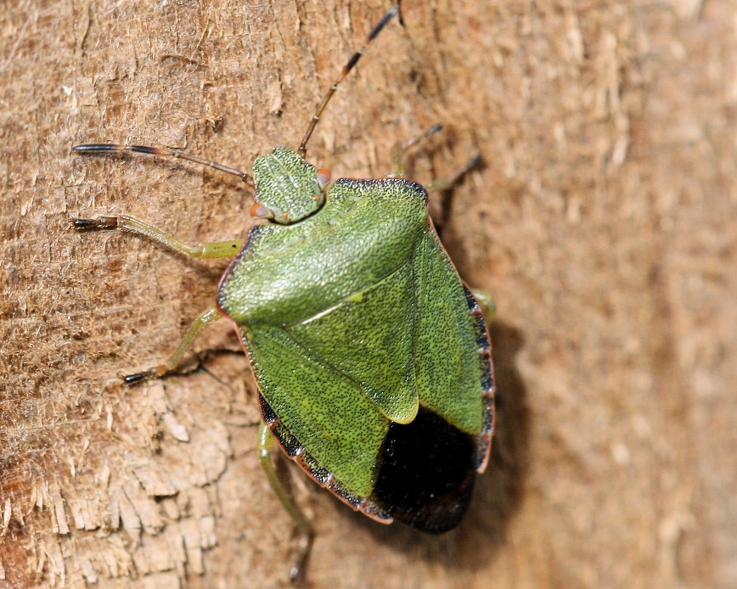

Photo – Peter Scott – Green Shield Bug

Hairy Shieldbug Dolycoris baccarum was recorded in May and June, and is widespread and common within VC55, as are Forest or Red-legged Shieldbug Pentatoma rufipes, and Bronze Shieldbug Troilus luridus.

Tortoise Bug Eurygaster cf testudinaria singletons were recorded at two locations within Rutland, one of which was an instar. These feed in grassland between May and August, reaching the adult stage from July onwards. Naturespot indicates that the ‘status in Leicester and Rutland’ is previously ‘uncommon’ but is expanding northwards from its previous range in the south of England.

An Assassin Bug Reduvius personatus was found in a moth trap. This is rare in Leicestershire and Rutland and has been recorded mostly in southern and central England.

A Common Water Boatman Corixa punctata was recorded in a garden pond in Wing. These
swim right side up near the bottom of water bodies, which distinguishes them from backswimmers Notonectidae, which can be found in similar aquatic habitats.

Table 3: Hemiptera Records

Hemiptera - Bugs
January
Forest or Red-Legged Shieldbug | Pentatoma rufipes | Oakham | Kitchen floor. | SK865089 | 1
April
Green Shieldbug | Palomena prasina | Exton | Garden | SK12781099 | 1
Green Shieldbug | Palomena prasina | Oakham | Garden | SK856081 | 3
May
Assassin Bug | Reduvius personatus | Exton | Moth Trap | SK12781099 | 1
Hairy Shieldbug | Dolycoris baccarum | Wing | Garden | SK8340906676 | 1
Green Shieldbug | Palomena prasina | Wing | Garden | SK8340906676 | 1
June
Hairy Shieldbug | Dolycoris baccarum | Wing | Garden | SK8902903011 | 1
Green Shieldbug | Palomena prasina | Wing | Garden | SK8902903011 | 1
Bronze Shieldbug | Troilus luridus | Wing | Garden | SK8902903011 | 1
Rhopalid Bug | Corizus hyoscyami | Wing | Geranium head | SK8902903011 | 1
Rhopalid Bug | Corizus hyoscyami | Exton | On foliage | SK12781099 | 2
Common Water Boatman | Corixa punctata | Wing | Garden pond. | SK8902903011 | 1
July
Tortoise Beetle Instar | Eurygaster cf testudinaria | Ketton Quarry | On grasses | SK972056 | 1
August
Dock Bug Instar | Coreus marginatus | Caldecott | Meadow Farm | SK866935 | 2
Green Shieldbug | Palomena prasina | Ketton Quarry |  | SK980060 | 1
Forest or Red-Legged Shieldbug | Pentatoma rufipes | Exton |  | SK12781099 | 1
Tortoise Shieldbug | Eurygaster cf testudinaria | Exton |  | SK12781099 | 1

Coleoptera - Beetles

The earliest fossil beetle records date to the Lower Permian ~297 MA ago, and it is thought that they co-evolved with the flowering plants and were the first pollinators.

Currently, there are ~400K species of beetles worldwide, which is roughly a quarter of all known animals on our planet with 4072 known species in the UK representing 103 different families; so, there are plenty of potential species out there in Rutland to record.

Photographs from RNHS members have proved extremely useful in the identification of beetle species, which also show how diverse they are; for example, ladybirds, which exhibit a wide range of colour variation and patination.

A total of 30 records which represents 22 species were identified between January and September.

The most common species recorded over this period was Soldier Beetle Rhagonycha limbata, recorded at a number of locations within VC55.

Greater Thorn-tipped Longhorn Beetle, Pogonocherus hispidulus, Rufous-shouldered Longhorn Beetle Anaglyptus mysticus and Rhinoceros Beetle Sinodendron cylindricum were recorded in Exton when fallen wood was cleared from arable fields.

Swollen-thighed Beetle Oedemera nobilis was recorded at a number of locations within VC55, with garden pests such as the Broad-bean Beetle Bruchus rufimanus and Lily Beetle Lilioceris lilii recorded in several Exton gardens.

In July a Wasp Nest or Wedge Beetle Metoecus paradoxus was recorded in Wing, which is the only beetle of the Ripiphoridae Family found in the UK. Despite being widespread, they are not common in Britain and are seldom seen. According to Naturespot, the VC55 Status in Leicestershire and Rutland, states that ‘there were only seven records for this species up to March 2015’.
The Tawny Longhorn Beetle Paracorymbia fulva was recorded at Bloody Oaks Quarry; it is a Nationally Scarce beetle found in woodland where larvae develop in decaying wood. This is stated as ‘rare’ in Leicestershire and Rutland with the UK status as ‘uncommon nationally’.
A striking red and black coloured member of this group is the Carrion or Burying Beetle Nicrophorus investigator which belongs to the Sexton beetle family. These are one of the few insects that show bi-parental care. They prepare an animal carcass by stripping it of fur or feathers, bury it, coat it in mucus and prepare a depression within the top of the carcass in which to lay the eggs. Once they hatch, they are fed by their parents.

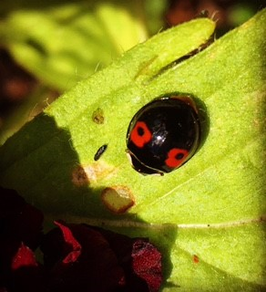

Photo - Jayne Walker – Harlequin Ladybird
Table 4: Coleoptera Records

Coleoptera - Beetles
January
Harlequin Ladybird | Harmonia axyridis | Manton | Back yard |  | 1
7-Spot Ladybird | Coccinella septempunctata | Wing | Allotment |  | 1
March
22-Spot Ladybird | Psyllobora 22-punctata | Manton | Back yard |  | 1
Harlequin Ladybird | Harmonia axyridis | Manton | Back yard |  | 1
April
Greater Thorn-Tipped Longhorn Beetle | Pogonocherus hispidulus | Exton | Log pile in garden | SK12781099 | 1
Rufous-Shouldered Longhorn Beetle | Anaglyptus mysticus | Exton | Log pile in garden | SK12781099 | 1
Rhinoceros Beetle | Sinodendron cylindricum | Exton | Log pile in garden | SK12781099 | 1
Harlequin Ladybird | Harmonia axyridis | Wing | Allotment | SK 8900030 | 1
May
Larder Beetle | Dermestes lardarius | Wing | Home | SK 83409 06676 | 1
Soldier Beetle | Rhagonycha limbata | Wing | Garden | SK 83409 06676 | 1
Broad-Bean Beetle | Bruchus rufimanus | Wing | Garden | SK 83409 06676 | 1
Cardinal Beetle | Pyrochroa serraticornis | Priors Coppice | Throughout reserve | SK831051 | several
Cockchafer | Melolontha melolontha | Exton | Moth Trap | SK12781099 | 5
Wasp Beetle | Clytus arietis | Exton | Log pile in the garden | SK12781099 | 1
Soldier Beetle | Cantharis pellucida | The Seek |  | SK839070 | several
Swollen-Thighed Beetle | Oedemera nobilis | The Seek |  | SK839070 | 1
Soldier Beetle | Cantharis rustica | Rutland Water Golf Club | Foliage | SK91030549 | 1
Lily Beetle | Lilioceris lilii | Exton | Lily plants in garden | SK12781099 | 6
June
Lesser Stag Beetle | Dorcus parallelipipedus | Wing | Garden | SK8902903011 | 1
Soldier Beetle | Cantharis livida | Rutland Water, Old Hall | Grassland adjacent to water’s edge. | SK90110705 | 1
Soldier Beetle | Cantharis rustica | Rutland Water, Old Hall | Grassland adjacent to waters edge. | SK90110705 | 1
Leaf Beetle | Cryptocephalus aureolus | Exton | Flowers | SK12781099 | 1
Lesser Stag Beetle | Dorcus parallelipipedus | Exton | Alive in a spider’s web. | SK12781099 | 1
Tanbark Borer | Phymatodes testaceus | Exton | Log pile in the garden | SK12781099 | 1
Swollen-Thighed Beetle | Oedemera nobilis | Wing | Garden | SK8902903011 | 1
July
Tawny Longhorn Beetle | Paracorymbia fulva | Bloody Oaks Quarry | Nationally scarce | SK970108 | 1
Carrion or Burying Beetle | Nicrophorus investigator | Exton | Garden | SK12781099 | 1
August
Wasp Nest or Wedge Beetle | Metoecus paradoxus | Wing | House | SK8902903011 | 1
Nut Weevil | Curculio nucum | Stamford garden | From tree in garden | TF193077 | 1 larva
September
Ladybird Larvae | Coccinellidae sp | Wing | Garden | SK8902903011 | 1

Diptera - Flies

A total of 31 records were received between March and October, of which 23 species were recorded. The Bee Fly Bombylius major was the earliest record and these delightful little insects could be seen flying about, making the most of the early spring sunshine and spring flowers.

Into late spring and early summer, colourful Drone Flies were recorded. Eristalis pertinax and E. tenax were recorded at three locations in the Rutland area. Apologies to those who know this already, but they are named ‘Drone’ due to their resemblance to female honeybees.

In August a singleton Verrall's Wasp Hoverfly Chrysotoxum verralli was recorded in Wing (NGR) SK88910288. There are eight British species of Chrysotoxum which are noted as “large and very smart wasp mimics” This species occurs mainly in the south-east of England, with Rutland being on the edge of its range, based on data from the Hoverfly Recording Schemes as of May 2011. However, Naturespot has records of this species in VC55 since 2011 and it is considered that future surveys are needed to confirm the status of this insect within the VC.

The larval stages of Agromyzid flies, such as the Holly Leaf Miner Phytomyza ilicis, P. ranunculi, whose larvae mine the leaves of the Buttercup family, and P. chaerophylli whose larvae favour Umbellifers, such as Cow Parsley Anthriscus sylvestris, were recorded mid-autumn and are very unrecorded within the VC.

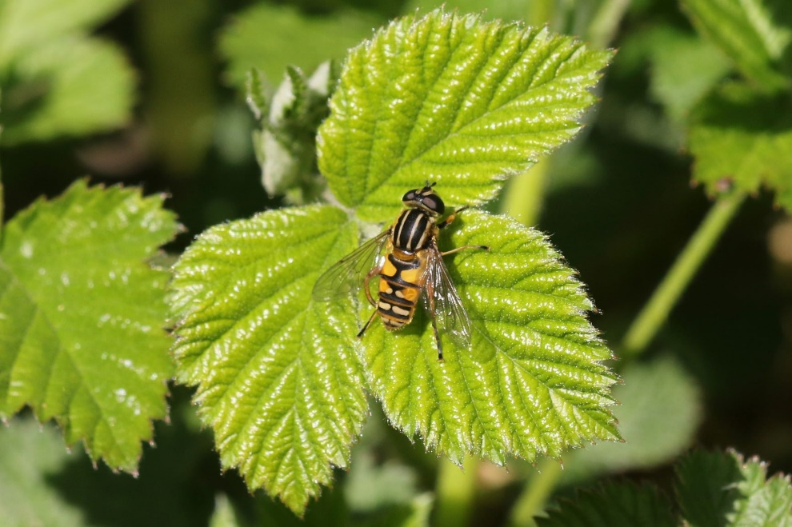

Photo – Peter Scott – Helophilus pendulus

Table 5: Diptera Records

Diptera - Flies
March
Bee Fly | Bombylius major | Oakham | Conservatory | SK865089 | 1
Bee Fly | Bombylius major | Ketton Quarry | West Glade | SK972056 | several
Bee Fly | Bombylius major | Ketton Quarry |  | SK980060 | 1
April
Migrant Hoverfly | Eupeodes corollae | N/A | N/A | N/A | N/A
Yellow Dung-fly | Scathophaga stercoraria | Brooke Hill Wood/Gorse field Wood Oakham |  | SK850077 | Loads
 | Helophilus pendulus | The Seek |  | SK839070 | >6
 | Epistrophe eligans | 12 Tees Close, Oakham | Back garden | SK856081 | unsure
 | Tephritis neesii | Exton | Garden on an oxe-eye daisy | SK12781099 | 1
Drone Fly | Eristalis tenax | wing | Garden Top Street | SK8902903011
May
 | Tipula vernalis | Exton | Garden | SK12781099 | Many
Drone Fly | Eristalis tenax | Exton | Garden pollinating flowers | SK12781099 | Many
Hoverfly | Helophilus pendulus | Oakham Canal | General | SK865110 | ?
Tapered Drone Fly | Eristalis pertinax | Wing | Garden | SK8340906676 | 1
June
Crimson Belted Hoverfly | Brachypalpoides lentus | Wing | Garden | SK8902903011 | 1
 | Helophilus pendulus | Wing | Garden | SK8902903011 | 1
Tachinid Fly | Exorista sp. (larvarum?) | Rutland Water, Old Hall | Grassland adjacent to water’s edge. | SK90110705 | 1
Black Snipefly | Chrysopilus cristatus | Rutland Water, Old Hall | Grassland adjacent to water’s edge. | SK90110705 | 1
Batman hoverfly | Myathropa florea | Exton | On foliage | SK12781099 | 1
Hoverfly sp | Lejogaster metallina | Wing | Wing allotment | SK88910288 | 1
Verrall's Wasp Hoverfly | Chrysotoxum verralli | Wing | Wing allotment | SK88910288 | 1
Stripe-Winged Dronefly | Eristalis horticola | Wing | Wing allotment | SK88910288 | 1
July
Sphaerophoria scripta | Sphaerophoria scripta | Exton | Garden | SK12781099 | 1
August
The Footballer' | Helophilus pendulus | Eyebrook |  | SP844970 | 1
Marmalade Fly' | Episyrphus balteatus | Ketton Quarry |  | SK980060 | many
Dark-Edged Bee Fly | Bombylius major | Ketton Quarry |  | SK980060 | 1
October
Diptera | Phytomyza pastinacae/spondylli agg | N/A |  | N/A | 1
Diptera | Phytomyza chaerophylli | N/A |  | N/A | 1
- | Calycomyza artemisiae | N/A |  | N/A | 1
Tephritidae | Acidia cognata | N/A |  | N/A
- | Phytomyza ranunculi | N/A |  | N/A | 1
- | Phytomyza ilicis agg | N/A |  | N/A

Mecoptera – Scorpionflies

There was a single record for Scorpion Fly.

Table 6: Mecoptera Records

Mecoptera - Scorpionflies
June
Scorpion Fly | Panorpa communis | Exton | On foliage | SK12781099 | 1

Trichoptera – Caddisflies

A singleton of the species, Stenophylax permistus was recorded in a garden in Wing, (NGR) SK8340906676. A further Caddisfly Limnephilus sp. was found in a light trap (NGR) SK12781099; however, from the photograph, it could not be identified to species level.

Table 7: Trichoptera Records

April
 | Stenophylax permistus | Wing | Garden | SK8340906676 | 1
 | Limnephilus sp. | Exton | Moth Trap | SK12781099 | 1

Hymenoptera - Ants, Wasps, Bees & Relatives

Hymenoptera is the largest order of insects in Britain and Ireland with 7760 known species.

A total of 36 records were received between January and November, which represented 21 species. Over thirty percent of these records were attributed to two species, the Buff-tailed Bumblebee Bombus terrestris and the recent UK colonist Tree Bumblebee Bombus hypnorum. Many other species of bee were recorded within gardens and other habitats, making the most of the abundant flora that can found in VC55.

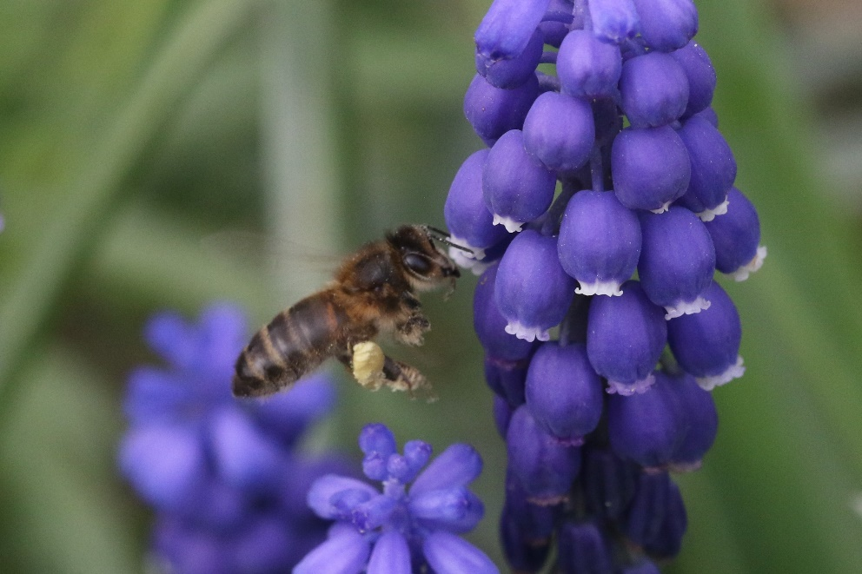

Photo – Peter Scott – Honey Bee

Other species recorded include the Common Wasp Vespula vulgaris, which is a less fussy pollinators than bees. Wasps in general are under-appreciated and play a hugely important ecological role within the environment. They are active predators and control the number of pest species such as greenfly. On-going research has shown that by transferring pollen as they go about visiting a variety of flowers to drink nectar, they are also extremely valuable pollinators.

Several species of Ichneumon Wasps have been recorded during the summer months. These parasitoid wasps are known to live in a variety of habitat and can be found on flowers, such as Umbellifers, and areas where dead wood can be found. These wasps have a variety of larval hosts within the insect kingdom.

The species recorded by RNHS members are as follows:
- Ichneumon stramentor which parasitises the Large Yellow Underwing Noctua pronuba and Setaceous Hebrew Caterpillar Xestia c-nigrum moth larvae;
- Ichneumon suspiciosus was received; this species favours laying its eggs into Swift Moth Korscheltellus lupulina caterpillars;
- Diphyus quadripunctorius favours the Geometridae and Noctuidae moth families as hosts for their larvae; and
- Ophion obscuratus which is a frequently attracted to light and parasitises Noctuid moth larvae.
.
Table 8: Hymenoptera Records

Hymenoptera - Ants, Wasps, Bees & Relatives
January
Common Wasp | Vespula vulgaris | Manton | House | SK88000465 | 1
March
Buff-Tailed Bumblebee | Bombus terrestris | Ketton Quarry |  | SK980060 | 4
Red-Tailed Bumblebee | Bombus lapidarius | Wing | Wing allotment |  | 1
Buff-Tailed Bumblebee | Bombus terrestris | Manton | Back yard | SK88000465 | 1
Buff-Tailed Bumblebee | Bombus terrestris | Rutland water | Gibbet Gorse |  | 7
April
Ichneumonidae | Ichneumon stramentor | Exton | Garden | SK12781099
European Honey Bee | Apis mellifera | Oakham | Garden | SK856081 | 1
European Honey Bee | Apis mellifera | Exton | Garden | SK12781099 | 1
Ashy Mining Bee | Andrena cineraria | Wing | Garden Top Street | SK89029030 | 1
Red-Tailed Bumblebee | Bombus lapidarius | wing | Garden Top Street | SK8902903011 | 1
Buff-Tailed Bumblebee | Bombus terrestris | Wing | Garden Top Street | SK8902903011 | 1
Ashy Mining Bee | Andrena cineraria | Exton | Path through arable fields. | SK93361055 | 1
May
Tree Bumblebee | Bombus hypnorum | Manton | 25 St Marys Road, front garden |  | 1
Hairy-Footed Flower bee | Anthophora plumipes | Wing | Garden | SK8340906676
June
Vestal Cuckoo Bee | Bombus vestalis | Wing | Garden | SK8902903011 | 2
Wool-Carder Bee | Anthidium manicatum | Exton | Garden | SK12781099 | 1
Sawfly | Tenthredo notha | Exton | Garden | SK12781099 | 1
Patchwork Leaf-Cutter Bee | Megachile centuncularis | 10 Beech Road, Oakham | Garden
Tree Bumblebee | Bombus hypnorum | Manton | Garden | SK88000465 | 1
Tree Bumblebee | Bombus hypnorum | Manton | Garden | SK88000465 | 1
Tree Bumblebee | Bombus hypnorum | Wing | Wing railway bridge area | SK88780249 | 1
Tree Bumblebee | Bombus hypnorum | Wing | Wing railway bridge area | SK88780249 | 1
Tree Bumblebee | Bombus hypnorum | Wing | Wing allotment | SK88910288 | 1
Ant Sp | Formica fusca | Wing | Wing railway bridge area | SK887 0249 | 1
July
Ichneumonidae | Ichneumon suspiciosus | Exton | Garden | SK12781099 | 1
Ichneumonidae | Diphyus quadripunctorius | Pickworth | Pickworth Great Wood |  | 1
Big-headed Digger Wasp | Ectemnuis cephalotes | Rutland Water, Tim Appleton’s |  | SK888088353 | 1
August
Ichneumonidae | Ichneumon suspiciosus | Langham | Church |  | 1
Ichneumonidae | Ophion obscuratus | Wing | Garden | SK8902903011 | 1
European Honey Bee | Apis mellifera | Ketton Quarry |  | SK980060 | many
Buff-Tailed Bumblebee | Bombus terrestris | Ketton Quarry |  | SK980060 | 1
Common Carder Bee | Bombus pascuorum | Ketton Quarry |  | SK980060 | 1
Common Carder Bee | Bombus pascuorum | Exton |  | SK12781099 | 2
October
Elm Zig-Zag Sawfly | Aproceros leucopoda | N/A |  | N/A | 1
 | Fenella nigrita | N/A |  | N/A | 1
November
 | Pimpla rufipes | Oakham |  | SK865089 | 1

Contributors

I would like to thank the following members, (in no particular order) who have submitted records in 2020 and for their help with identification: Tim Caldicott, Dave Needham, Carolyn Baxter, Charles Gallimore, Roy Lemmon, Peter Scott, Phil Rudkin, Tricia Marston, Linda Clarke, Marion Markham, Richard Brown, Linda and Anthony Biddle and Martin Grimes.
I would also like to thank my friend and former colleague Stuart Robinson Mem.R.E.S., for his invaluable advice and support with the insect identification, which was much appreciated.
In addition, I would also like to thank my dear friend, John Wadham, retired Environment Agency water scientist and current President of the Rutland Water Fly Fishers, for his help on aquatic invertebrates.
Please accept my apologies if I have unintentionally missed anyone.

Jayne Walker
Insect Recorder

www.naturespot.org.uk
Natural History Museum, Identification and Advisory Service.
www.british-dragonflies.org.uk. Brochard. C., The White-legged Damselfly Investigation. On the search for a mysterious river damsel. 2019.
Britain’s Hoverflies, A Field Guide (2nd Edition). Ball, s. and Morris, R. 2015.
Britain’s Hoverflies, A Field Guide (2nd Edition). Ball, s. and Morris, R. 2015.

