Rutland Natural History Society

ANNUAL REPORT: INSECTS Recorder: Jayne Walker

I would like to thank all the RNHS members and also all the non-members that have submitted insect records. As I write this report we are finally out of lockdown and able to explore further afield once more.

However, monitoring local patches has its value as the changes in invertebrate population distribution and abundance can help inform how this group is responding to the on-going challenges attributed to climate change.

Records
A total of 350 records representing 178 species was received in 2021 compared to 166 total records in 2020 due to lockdown; these are broken down by Group and species and month of record. Where no records have been received for species groups a ‘nil’ return has not been included in the report below e.g. Zygentoma – Silverfish.

Where identification of an insect has required further research; these have been referred to Naturespot, Royal Entomological Society (RES) and pers.com to entomologists.

Records have been submitted from Society members by email, some with photographs attached to collaborate identification, using the recorders spreadsheet available on the RNHS website and paper records through the post.

A full list of records can be found in Tables 1 to 11: in the main body of the report and a list of contributors and thanks can be found at the end of the report.

A copy of these records will be forwarded to the County Recorders.

Species Summary

Collembola – Springtails

A total of four records was received for Springtails, which were recorded during the RNHS Bioblitz that took place on the 22nd May. These were found in the leaf litter collected from the site at various locations within the woodland fringe and were identified off site. Pogonognathellus longicornis (c.6mm) is a noted woodland species and is a fairly large size compared to other woodland species, apart from its size another key identification feature is its abdominal hairs. Orchesella villosa (c.4 mm) key identification feature is the fact that it is ‘hairy’.

Table 1. Collembola Records

May
Orchesella villosa | Clipsham Great Park | Yew Tree Avenue | SK 978 168 | 1
Pogonognathellus longicornis | Clipsham Great Park | Yew Tree Avenue | SK 978 168 | 1
Dicyrtoma fusca | Clipsham Great Park | Yew Tree Avenue | SK 978 168 | 1
Orchesella cincta | Clipsham Great Park | Yew Tree Avenue | SK 978 168 | 1

Ephemeroptera - Mayflies

Two records were noted for Mayflies, which are detailed below in Table 2.

Table 2. Ephemeroptera Records

March
Pond Olive | Cloeon dipterum | Exton | Vicars Close | SK 1278 1099 | 1
May
Mayfly | Ephemera danica | Exton | Vicars Close | SK 1278 1099 | 1

Odonata - Dragonflies and Damselflies

A total of 37 records was received for Dragonflies and Damselflies between the months of April and September; overall 15 species were recorded at various sites across the County. Details of the Odonata records are provided in Table 3, below.

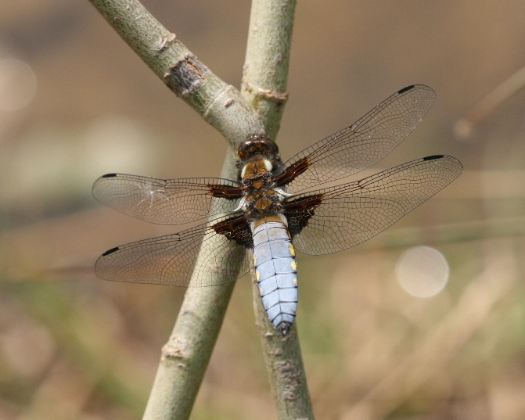

Photo – Broad Bodied Chaser © Peter Scott

Locations which provided the majority of the records for dragonfly and damselfly, included Leighfield Fishponds, (NGR) SK 8314 0374, Ketton Quarry (NGR) SK 980 060, Thorpe-by-Water NGR SP 891 960 and around Rutland Water (see Table 3 below for more details).

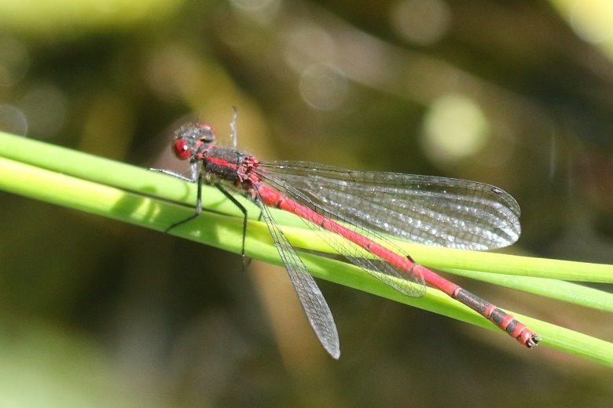
Photo – Large Red Damselfly © Peter Scott

It is very pleasing to note that the Willow Emerald Damselfly Chalcolestes viridis (formerly Lestes viridis), has again been recorded in 2021. This is a rare immigrant and was first recorded at Eyebrook Reservoir in 2019, with records in 2020 at the same location. In addition, it was also record in Uppingham at (NGR) SP 858 993). Again, these are excellent records for VC55.

Leighfield Fishponds and Thorpe-by-Water proved to good locations to see Emerald, Lestes sponsa, White-legged Platycnemis pennipes and Red-eyed Damselfly, Erythromma najas along with Banded Demoiselle Calopteryx splendens.

Table 3: Odonata Records

April
Large Red Damselfly | Pyrrhosoma nymphula | Ketton Quarry |  | SK 980 060 | 2
May
Brown Hawker | Aeshna grandis | Ketton Quarry |  | SK 980 060 | 1
Common Blue Damselfly | Enallagma cyathigerum | Ketton Quarry |  | SK 980 060 | 30+
June
Emperor Dragonfly | Anax imperator | Exton | Back fields | SK 9304 1098 | 1
Broad-bodied Chaser | Libellula depressa | Ketton Quarry |  | SK 980 060 | 1
Common Darter | Sympetrum striolatum | Ketton Quarry |  | SK 980 060 | 1
Banded Demoiselle | Calopteryx splendens | Thorpe-by- water. | Next to the Welland | SP 891 960 | Many
Banded Demoiselle | Calopteryx splendens | Thorpe-by- water. | Next to the Welland | SP 891 960 | Lots flying around.
White-legged damselfly | Platycnemis pennipes | Thorpe-by- water. | Next to the Welland | SP 891 960 | 1
White-legged Damselfly | Platycnemis pennipes | Thorpe-by- water. | Next to the Welland | SP 891 960 | A few
Broad-bodied Chaser | Libellula depressa | Wing Allotment. | On my plot. | SK 8891 0288 | 1 female
Broad-bodied Chaser | Libellula depressa | Wing Allotment. | On my plot. | SK 8891 0288 | 1 female
White-legged Damselfly | Platycnemis pennipes | Leighfield Fishponds. | West of Leigh Lodge. | SK 8281 0410 | 1 female
White-legged Damselfly | Platycnemis pennipes | Leighfield Fishponds. | West of Leigh Lodge. | SK 8281 0410 | 1 male
White-legged Damselfly | Platycnemis pennipes | Gunthorpe area. |  | SK 8778 0563 | 2 females
Emperor Dragonfly | Anax imperator | Exton | Back fields. | SK 9304 1098 | 1
July
Emperor Dragonfly | Anax imperator | Ketton Quarry |  | SK 980 060 | 1
Brown Hawker | Aeshna grandis | Ketton Quarry |  | SK 980 060 | 1
Common Darter | Sympetrum striolatum | Ketton Quarry |  | SK 980 060 | 6
Migrant Hawker | Aeshna mixta | Wing | Wing Hill Allotment. | SK 8891 0288 | 1
Migrant Hawker | Aeshna mixta | Near Rutland Water | East edge of Gibbet Gorse (Butterfly Meadow) | SK 9022 0586 | 1
Emperor | Anax imperator | Wing | Wing Hill Allotment. | SK 8891 0288 | 1
Emperor | Anax imperator | Near Rutland Water. | Butterfly Meadow. | SK 9032 0591 | 1
Emerald Damselfly | Lestes sponsa | Near Rutland Water. | East edge of Gibbet Gorse (Butterfly Meadow). | SK 9022 0586 | 1
White-legged Damselfly | Platycnemis pennipes | Near Rutland Water. | Butterfly Meadow. | SK 9032 0591 | 1
Ruddy Darter | Sympetrum sanguineum | Near Rutland Water. | Butterfly Meadow. | SK 9032 0591 | 1
Black-tailed Skimmer | Orthetrum cancellatum | Rutland Water | Cycle track Lagoon 5 and Lagoon 7. | SK 8781 0634 | 8
Brown Hawker | Aeshna grandis | Wing | Wing Hill Allotment. | SK 8891 0288 | 1
Black-tailed Skimmer | Orthetrum cancellatum | Near Rutland Water. | Butterfly Meadow. | SK 9032 0591 | 3
August
Broad-bodied Chaser | Libellula depressa | Wing | Wing Hill Allotment. | SK 8891 0288 | 1
September
White-legged Damselfly | Platycnemis pennipes | Caldecott | River Welland. | SP881 938 | 1 but could have been more.
Willow Emerald Damselfly | Chalcolestes viridis | Uppingham | On wall at home. | SP 858 993 | 1
Emerald Damselfly | Lestes sponsa | Leighfield | Leighfield Fishponds. | SK 8314 0374 | 3
Emerald Damselfly | Lestes sponsa | Leighfield | Leighfield Fishponds. | SK 8314 0374 | 2
Red-eyed Damselfly | Erythromma najas | Leighfield | Leighfield Fishponds. | SK 8314 0374 | 1
Red-eyed Damselfly | Erythromma najas | Leighfield | Leighfield Fishponds. | SK 8314 0374 | 1
Willow Emerald Damselfly | Chalcolestes viridis | Eyebrook Reservoir | By the bridge. | SP 84430 97074 | 1

Arachnida - spiders

Ten records have been submitted for Arachnids between the months of April and September, which overall record ten different species of spider.
Most of the records received were obtained from the Bioblitz which was undertaken in May at Clipsham Great Park. Other records were from Exton and Uppingham, with several Zebra Spiders of various sizes being observed.
Spiders inhabit a vast range of habitats, and it would be wonderful if we got more records for this group.
Table 4: Arachnida Records

April
A Wolf Spider | Alopecosa pulverulenta | Merry's Meadow |  | SK 937 157 | Many
May
Nursery Web Spider | Pisaura mirabilis | Clipsham Great Park | Yew Tree Avenue | SK 978 168 | 1
An Orb Weaver | Metellina sp. (pres. mengei) | Clipsham Great Park | Yew Tree Avenue | SK 978 168 | 1
A Sac Spider | Clubiona pallidula | Clipsham Great Park | Yew Tree Avenue | SK 978 168 | 1
Buzzing Spider | Anyphaena accentua | Clipsham Great Park | Yew Tree Avenue | SK 978 168 | 1
A Crab Spider | Philodromus dispar | Clipsham Great Park | Yew Tree Avenue | SK 978 168 | 1
A Money Spider | Neriene (Linyphia) montana | Clipsham Great Park | Yew Tree Avenue | SK 978 168 | 1
A Slender Crab Spider | Tibellus oblongus | Clipsham Great Park | Yew Tree Avenue | SK 978 168 | 1
June
House Spider | Eratigena duellica | Exton | Vicars Close | SK 1278 1098 | 2
September
Garden Spider | Araneus diadematus | Uppingham | Gypsy Lane | SP 859 991 | 1
Zebra Spider | Salticus spp | Uppingham | Home greenhouse | SP 858 993 | Several of varying sizes.

Pseudoscorpiones

One record of Pseudoscopiones was received, which was identified from leaf litter collected during the Clipsham Great Park Bioblitz. As shown in Table 5. below, eight individuals were found.

Table 5. Pseudoscorpiones Records

May
Common Chthonid | Chthonius ischnocheles | Clipsham Great Park | Yew Tree Avenue | SK 978 168 | 8

Hemiptera – Bugs

A total of 42 records was received, which represents the sightings of 22 different Hemiptera species, for the period between February and October. The most common record was the Green Shieldbug Palomena prasine; however, the Woundwort Shieldbug Eysarcoris venustissimus was the most numerous. Although the name suggests that it feeds exclusively on Hedge Woundwort Stachys sylvatica, it will also feed on White Deadnettle Lamium album and Black Horehound Ballota nigra.

During the Bioblitz at Clipsham Great Park, the Scarab Shieldbug Thyreocoris scarabaeoides was recorded. This is an excellent record as it is a ‘Nationally Scarce’ species.

Dock Bug Coreus marginatus was recorded at a couple of locations within the area and these are ‘Leatherbugs or Squash Bugs’. Again, as the name suggests, Dock Bug tends to favour Dock Rumex sp. although they can be seen on other vegetation including bramble Rubus fruiticosus Agg..

Some of the most attractive bugs (in my humble opinion) to be recorded in 2021 include the Blue Shieldbug Zicrona caerulea, Red and Black Froghopper Cercopis vulnerata, Corizus hyoscyami and Crucifer Shieldbug Eurydema oleracea. The Blue Shieldbug can be found in damp grasslands along with a variety of habitats; they are voracious predators and have a liking for metallic blue Leaf beetles Altica sp

Another bug of note was the Denticulate leatherbug, Coriomerus denticulatus which was recorded in a garden in Exton, SK 1278 1098. This was identified from the conspicuous bristles on its pronotum.

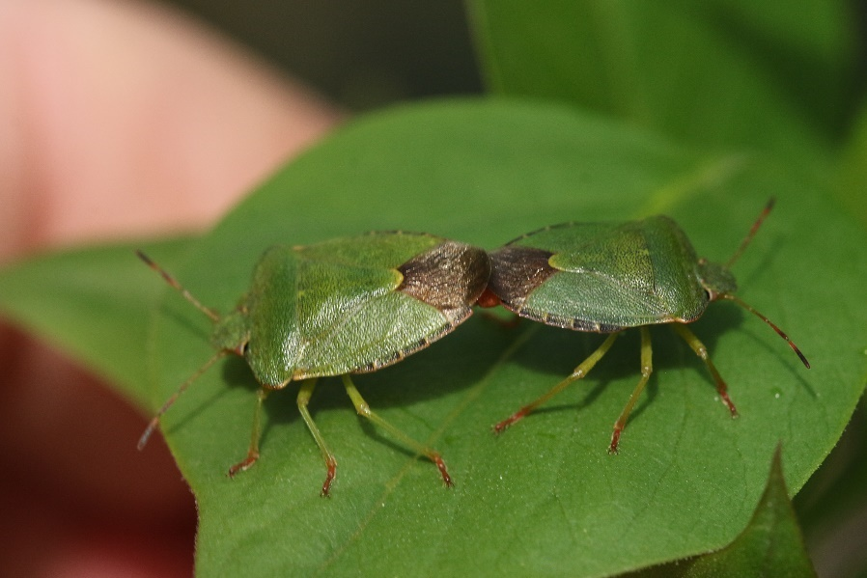

Photo – Green Shield Bug © Peter Scott

Table 6: Hemiptera Records

February
Common Green Shieldbug | Palomena prasina | Manton | St Marys Road | SK 8800 0465 | 1
Blue Shieldbug | Zicrona caerulea | Wing | Wing Allotment | SK 8891 0288 | 4
March
Common Green Shieldbug | Palomena prasina | Exton | Vicars Close | SK 1278 1098 | 1
Pied Shieldbug | Tritomegas bicolor | Wing | Wing Allotment | SK 8891 0288 | 1
April
Common Green Shieldbug | Palomena prasina | Exton | Vicars Close | SK 1278 1098 | 1
Common Green Shieldbug | Palomena prasina | Exton | Vicars Close | SK 1278 1098 | 1
Woundwort Shieldbug | Eysarcoris venustissimus | Wing | Wing Allotment | SK 8891 0288 | 1
Common Green Shieldbug | Palomena prasina | Wing | Wing Allotment | SK 8891 0288 | 1
Dock Bug | Coreus marginatus | Martinsthorpe | Fox Covert Area | SK 8684 0428 | 1
May
Dock Bug | Coreus marginatus | Exton | Vicars Close | SK 1278 1098 | 1
Red and Black Froghopper | Cercopis vulnerata | Pickworth Great Wood |  | SK 985 148 | 1
Parent Bug | Elasmucha grisea | Clipsham Great Park | Yew Tree Avenue | SK 978 168 | 1
Common Green Shieldbug | Palomena prasina | Clipsham Great Park | Yew Tree Avenue | SK 978 168 | 1
Scarab Shieldbug | Thyreocoris scarabaeoides | Clipsham Great Park | Yew Tree Avenue | SK 978 168 | 1
Birch Catkin Bug | Kleidocerys resedae | Clipsham Great Park | Yew Tree Avenue | SK 978 168 | 1
Woundwort Shieldbug | Eysarcoris venustissimus | Wing Area | Wing Hill Allotment | SK 8891 0288 | 20+
Sloe Bug/Hairy Shieldbug | Dolycoris baccarum | Wing Area | Wing Plantation | SK 9057 0264 | 6
Nettle Ground Bug | Heterogaster urticae | Wing Area | Wing Hill Allotment | SK 8891 0288 | 1
A Rhopalid Bug | Rhopalus subrufus | Wing Area | Wing Plantation | SK 9057 0264 | 2
Red and Black Froghopper | Cercopis vulnerata | Clipsham Great Park | Yew Tree Avenue | SK 978 168 | 2
An Elongate Grass Bug | Megaloceroea recticornis | Clipsham Great Park | Yew Tree Avenue | SK 978 168 | 2
Sloe Bug/Hairy Shieldbug | Dolycoris baccarum | Clipsham Great Park | Yew Tree Avenue | SK 978 168 | 2
June
Common Green Shieldbug | Palomena prasina | Exton | Vicars Close | SK 1278 1098 | 2
Hairy Shieldbug | Dolycoris baccarum | Exton | Vicars Close | SK 1278 1098 | 1
Brassica Bug/Crucifer Shieldbug | Eurydema oleracea | Chater Valley, Manton Area. | Near River Chater. | SK 8677 0381 | 1
Woundwort Shieldbug | Eysarcoris venustissimus | Wing Allotment | On my plot. | SK 8891 0288 | 30+
Nettle Ground Bug | Heterogaster urticae | Wing Allotment | On my plot. | SK 8891 0288 | 1
Red-legged Shieldbug | Pentatoma rufipes | Wing Allotment | On my plot. | SK 8891 0288 | 1 final instar
Caspid Bug | Liocoris tripustulatus | Uppingham | Gypsy Lane. | SP 859 991 | 1
Hawthorn Shieldbug | Acanthosoma haemorrhoidale | Oakham | Barmstedt Drive | SK 8609 2852 | 1
Common Green Caspid | Lygocoris pabulinus | Wing | Garden | SK 893 001 | 1
July |  |  | Garden
Blue Shieldbug | Zicrona caerulea | Wing | Wing Hill Allotment | SK 8891 0288 | 1
Common Froghopper | Philaenus spumarius | Rutland Water | Green Bank | SK 8907 5635 | 1
Meadow Plant Bug | Leptopterna dolabrata | Rutland Water | Green Bank | SK 8907 5635 | 6
Lucerne Bug | Adelphocoris lineolatus | Rutland Water | Green Bank | SK 8907 5635 | 1
Common Green Caspid | Lygocoris pabulinus | Rutland Water | Green Bank | SK 8907 5635 | 1
August
A Rhopalid Bug | Corizus hyoscyami | Wing | Wing Hill Allotment | SK 8891 0288 | 1
September
Brassica Bug/Crucifer Shieldbug | Eurydema oleracea | Wing Hill Allotment | On my plot. | SK 8891 0288 | 1
Hairy shieldbug | Dolycoris baccarum | Wardley Woods | Sweethedges Farm End | SP 837 993 | 1
Dock Bug | Coreus marginatus | Exton | Vicars Close | SK 1278 1098 | 1
October
Hawthorn Shieldbug | Acanthosoma haemorrhoidale | Wing Area | NW of the village. | SK 8882 0321 | 1
November
Birch Shieldbug | Elasmostethus interstinctus | Manton | My back yard. | SK 8801 0463 | 1

Neuroptera - Lacewings and Ant - lions

Two records for Lacewings were received.

Table 7. Neuroptera - Lacewings and Ant - lions

April
Lacewing sp. | Chrysopidae sp | Priors Coppice | Woodland Walk | SK 831 051 | 1
Lacewing sp. | Chrysopidae sp | Exton | Vicars Close | SK 1278 1098 | 1

Coleoptera - Beetles

Currently, there are ~400K of beetles worldwide, which is roughly a quarter of all known animals on our planet with 4072 known species in the UK representing 103 different families.
Photographs from RNHS members have proved extremely useful in the identification of beetle species, so please keep them coming in.

A total of 77 records were submitted, which represents 50 species identified between January and December, with the earliest records being attributed to Ladybird species.

The most common species recorded over this period was the Ladybird, with 18 of the 76 records, followed by the Burying or Sexton Beetles. The second most numerous records were the Cockchafer Beetle Melolontha melolontha and Garden Chafer Phyllopertha horticola. The Cockchafers usually appear at the end of April with the females burying eggs 10-20cm within the soil. The grubs feed on plant roots and it can take three to five years until they eventually pupate; the cockchafers appear in a cycle of every three to four years. The Garden Chafer has a similar lifecycle to the cockchafer. The burying beetle, Nicrophorus vespillo was recorded at Wing Hill Allotment. This species ranges in size from 12 to 22mm and has very colourful and distinctive markings; they are often attracted to light and can be found in moth traps

A single record of the Green Tiger Beetle Cicindela campestris was received in April, this sighting was at Bloody Oaks Quarry (SK 970 103). According to Naturespot, the VC55 status is recorded as ‘very local and uncommon’ in many areas of Leicestershire and Rutland. Adults are active in early summer and prefer sunny areas and are voracious predators of other invertebrates.

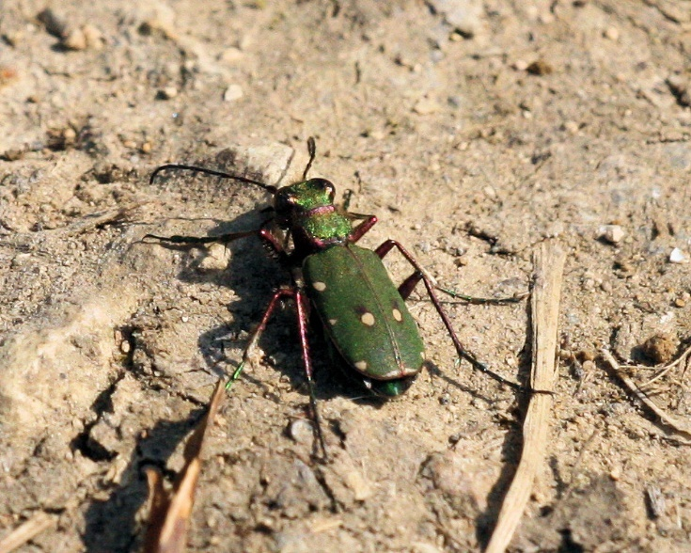

Photo – Green Tiger Beetle © Peter Scott

The Longhorn group of beetles was also well represented within the records received throughout the summer with Rufous-shouldered Longhorn Beetle Anaglyptus mysticus, Variable Longhorn Beetle Stenocorus meridianus, Black-spotted Longhorn Beetle Rhagium mordax, Black-Striped Longhorn Beetle Stenurella melanura and Red Longhorn Beetle Stictoleptura rubra being recorded. The latter was spotted on a rotting log in Clipsham Great Park, SK 9702 1706. In addition, a single female was recorded in Exton. This is noted as ‘rare in Leicestershire and Rutland’ with very few records for VC55.

The weevil Acalles ptinoides was recorded at the Bioblitz, this is a Nationally ‘notable b’ status insect.

Table 8: Coleoptera Records

January
7-spot Ladybird | Coccinella septempunctata | Oakham | Barmstedt Drive | SK 8609 2852 | 1
February
22-spot Ladybird | Psyllobora 22-punctata | Wing | Wing Allotment | SK 8891 0288 | 1
Harlequin Ladybird | Harmonia axyridis | Manton | St Marys Road | SK 8800 0465 | 1
March
Pine Ladybird | Exochomus 4-pustulatus | Manton | St Marys Road | SK 8800 0465 | 1
22-spot Ladybird | Psyllobora 22-punctata | Wing | Wing Allotment | SK 8891 0288 | 2
April
Vine Weevil | Otiorhynchus sulcatus | Exton | Vicars Close | SK 1278 1098 | 1
Ground Beetle | Pterostichus madidus | Exton, Disused Sewage Works | Empingham Road | SK 9310 2257 | 1
Lesser Striped Flea Beetle | Phyllotreta undulata | Rutland Water | Old Hall Bay | SK 9011 0705 | 1
Dung Beetle | Onthophagus coenobita | Rutland Water | Old Hall Bay | SK 9011 0705 | 1
Mint Leaf Beetle | Chrysolina herbacea | Rutland Water | Old Hall Bay | SK 9011 0705 | 1
A Leaf Beetle | Chrysolina brunsvicensis | Rutland Water | Old Hall Bay | SK 9011 0705 | 1
Green Tiger Beetle | Cicindela campestris | Bloody Oaks Quarry | On south-facing bank, on north side of reserve, on stones and bare ground, near entrance to reserve. | SK 970 103 | 2
False Blister Beetle | Oedemera lurida | Exton | Vicars Close | SK 1278 1098 | 1
Red-Headed Cardinal Beetle | Pyrochroa serraticornis | Wardley Woods |  | SP 835 994 | 1
May
False Blister Beetle | Ischnomera cyanea | Exton | Vicars Close | SK 1278 1098 | 1
A Weevil (mallow weevil?) | Aspidapion radiolus | Exton | Vicars Close | SK 1278 1098 | 1
A Weevil | Polydrusus cervinus | Exton | Vicars Close | SK 1278 1098 | 1
A Rove Beetle | Philonthus decorus | Exton | Vicars Close | SK 1278 1098 | 1
Copper Greenclock | Poecilus cupreus | Exton | Vicars Close | SK 1278 1098 | 1
A Soldier Beetle | Malthodes minimus | Clipsham Great Park | Yew Tree Avenue | SK 978 168 | 1
7 -Spot Ladybird | Coccinella septempunctata | Clipsham Great Park | Yew Tree Avenue | SK 978 168 | 1
Red-headed Cardinal Beetle | Pyrochroa serraticornis | Clipsham Great Park | Yew Tree Avenue | SK 978 168 | 1
A weevil | Archarius pyrrhoceras | Clipsham Great Park | Yew Tree Avenue | SK 978 168 | 1
A weevil | Betulapion simile | Clipsham Great Park | Yew Tree Avenue | SK 978 168 | 1
A weevil | Acalles ptinoides | Clipsham Great Park | Yew Tree Avenue | SK 978 168 | 1
A weevil | Cionus hortulanus | Clipsham Great Park | Yew Tree Avenue | SK 978 168 | 1
A weevil | Cionus tuberculosus | Clipsham Great Park | Yew Tree Avenue | SK 978 168 | 1
A weevil | Cionus alauda | Clipsham Great Park | Yew Tree Avenue | SK 978 168 | 1
A weevil | Polydrusus pterygomalis | Clipsham Great Park | Yew Tree Avenue | SK 978 168 | 1
A weevil | Curculio venosus | Clipsham Great Park | Yew Tree Avenue | SK 978 168 | 1
10-spot Ladybird | Adalia 10-punctata | Wing Area | Wing Hill Allotment | SK 8891 0288 | 1
Thistle Tortoise Beetle | Cassida rubiginosa | Wing Area | Wing Hill Allotment | SK 8891 0288 | 1
A rove beetle | Tachyporus solutus | Manton Area | Fox Covert | SK 8685 0428 | 1
Common Springtail-stalker | Notiophilus biguttatus | Manton Area | Fox Covert | SK 8685 0428 | 1
Red-headed Cardinal Beetle | Pyrochroa serraticornis | Rutland Water | Carrots Creek | SK 9207 0835 | 1
A weevil | Polydrusus pterygomalis | Exton | Vicars Close | SK 1278 1098 | 1
Cockchafer Beetle | Melolontha melolontha | Exton | Vicars Close | SK 1278 1098 | 18
Cockchafer Beetle | Melolontha melolontha | Exton | Vicars Close | SK 1278 1098 | 15
June
Rufous-shouldered Longhorn Beetle | Anaglyptus mysticus | Exton | Vicars Close | SK 1278 1098 | 1
A Soldier Beetle | Cantharis rustica | Exton | Vicars Close | SK 1278 1098 | 1
Cockchafer Beetle | Melolontha melolontha | Exton | Vicars Close | SK 1278 1098 | 15
Black Sexton Beetle | Nicrophorus humator | Exton | Vicars Close | SK 1278 1098 | 1
Rufous-shouldered Longhorn Beetle | Anaglyptus mysticus | Manton Area | Lyndon Road | SK 8907 0476 | 1
Cockchafer Beetle | Melolontha melolontha | Wing Allotment | On my plot. | SK 8891 0288 | 1
Black-spotted Longhorn Beetle | Rhagium mordax | Chater Valley, Manton Area. | Near River Chater. | SK 8677 0381 | 1
Variable Longhorn Beetle | Stenocorus meridianus | Chater Valley, Manton Area. | Near Fox Covert | SK 8687 0444 | 1
Variable Longhorn Beetle | Stenocorus meridianus | Wing Allotment | On my plot. | SK 8891 0288 | 1
A Soldier beetle | Cantharis nigricans | Uppingham | Gypsy lane | SP 859 991 | 2
24-spot Ladybird | Subcoccinella 24-punctata | Rutland Water | Between Gibbets gorse and Berrybut spinneys. | SK 9034 0597 | 6
10-spot ladybird | Adalia 10-punctata | Wing Allotment | On my plot. | SK 8891 0288 | 1
Garden Chafer | Phyllopertha horticola | Exton | Vicars Close | SK 1278 1098 | 2
A Soldier beetle | Cantharis nigricans | Exton | Vicars Close | SK 1278 1098 | 2
Garden Chafer | Phyllopertha horticola | Exton | Vicars Close | SK 1278 1098 | 1
Red-headed Cardinal Beetle | Pyrochroa serraticornis | Lyndon Nature Reserve |  | SK 8905 2053 | 1
July
Lesser Stag Beetle | Dorcus parallelipipedus | Oakham | Back of 13 Peterborough Drive. | SK 865 089 | 1
Black-Striped Longhorn Beetle | Stenurella melanura | Near Rutland Water | Butterfly Meadow | SK 9032 0591 | 1
Garden Chafer | Phyllopertha horticola | Exton | Vicars Close | SK 1278 1098 | 1
Black Sexton Beetle | Nicrophorus humator | Exton | Vicars Close | SK 1278 1098 | 1
Flea Beetle | Sphaeroderma testaceum | Rutland Water | Green Bank | SK 8907 5635 | 1
Common Red Soldier Beetle | Rhagonycha fulva | Rutland Water | Green Bank | SK 8907 5635 | 1
7 -Spot Ladybird | Coccinella septempunctata | Mounts Lodge |  | SK 995 110 | 1
7 -Spot Ladybird | Coccinella septempunctata | A1/A6121 | Southbound intersect. | TF 012 066 | 1
Harlequin Ladybird | Harmonia axyridis | George Henry Wood |  | SK 955 162 | 6
Red Longhorn Beetle | Stictoleptura rubra | Exton | Vicars Close | SK 1278 1098 | 1
August
22-spot Ladybird | Psyllobora 22-punctata | Wing | Wing Hill allotment | SK 8891 0288 | 20+
Devil's Coach Horse | Ocypus olens | Martinsthorpe | Ploughed field in Gwash valley. | SK 8597 0508 | 1
Common Burying Beetle | Nicrophorus vespillo | Wing | Wing Hill allotment | SK 8891 0288 | 1
Red Longhorn Beetle | Stictoleptura rubra | Clipsham Great Park | On a rotting log in the wood. | SK 9702 1706 | 1
September
22-spot Ladybird | Psyllobora vigintiduopunctata | Uppingham | Gypsy lane | SP 859 991 | 1
Burying Beetle | Nicrophorus investigator | Exton | Vicars Close | SK 1278 1098 | 1
Burying Beetle | Nicrophorus vespilloides | Exton | Vicars Close | SK 1278 1098 | 1
Acorn Weevil | Curculio glandium | Exton | Vicars Close | SK 1278 1098 | 1
November
Harlequin Ladybird | Harmonia axyridis | Manton | My back yard | SK 8801 0463 | 4
Harlequin Ladybird | Harmonia axyridis | Manton | My back yard | SK 8801 0463 | 12
Harlequin Ladybird | Harmonia axyridis | Manton | My back yard | SK 8801 0463 | 6
December
7 -Spot Ladybird | Coccinella septempunctata | Exton | Vicars Close | SK 1278 1098 | 6
Harlequin Ladybird | Harmonia axyridis | Exton | Vicars Close | SK 1278 1098 | 4

Diptera - Flies

A total of 81 records was received between February and December compared to 31 in 2020, of which 48 species were recorded. The earliest record was attributed to a specimen of the Common Drone Fly, Eristalis tenax which was recorded in February (this species overwinters as an adult), followed by the Dark-edged Bee Fly Bombylius major. Although these species resemble bees, they only have a single pair of functional wings, compared to bees which have two pairs. A similar species which is currently expanding its range is the Dotted Bee Fly B. discolor, which favours limestone grasslands. This is identified by the dotted wing pattern as its name suggests, so keep an eye open for it.

Records were also submitted for the Flesh Fly Sarcophaga carnaria, Fever Fly Dilophus febrilis and the Blow Fly Cynomya mortuorum. These unpleasant sounding flies are very interesting; however the Flesh Fly differ from most flies as they do not lay their eggs but are ovoviviparous and lay hatched or hatching maggots into carrion. The Fever Fly is very similar to the St Mark’s Fly but is distinguished from this species by the fact that it isn’t as ‘hairy’. The larvae of this species live underground and can possibly cause damage to plant roots. These are fairly common in this region. The Blow Fly lays its eggs on carrion, however, the adults feed on pollen. They are noted as being ‘scattered but widespread record in Britain’, although it appears to be uncommon in the Leicestershire and Rutland region, this is likely due to a lack of formal records.

There was a wealth of hoverflies recorded within Rutland, such as the Tapered Drone Fly Eristalis pertinax, the Chequered Hoverfly Melanostoma scalare and the White-footed Hoverfly Platycheirus albimanus. Hoverflies can be seen in a number of habitats, including gardens. Many of the hoverfly species provide a valuable service to gardeners by eating aphids and acting as important pollinators: generally, they gather nectar and pollen from flowers where this is easy to reach, which is required for egg formation.

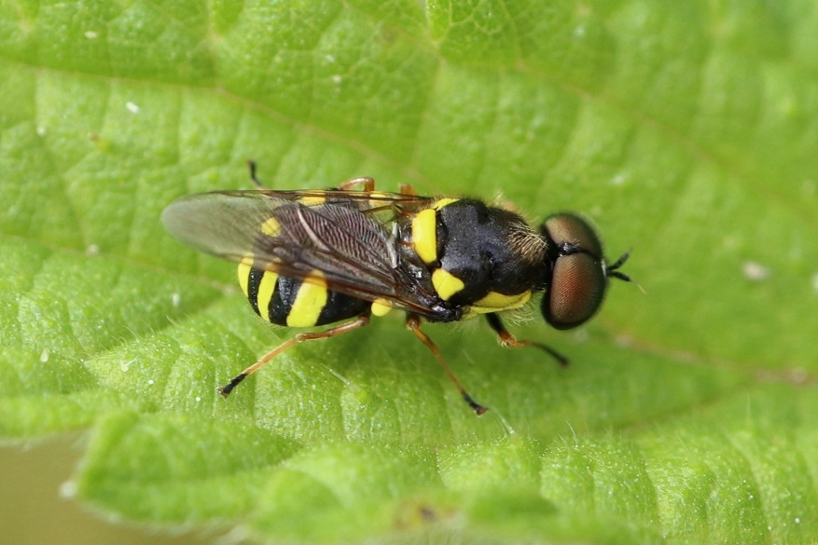

Photo – Four-barred Major © Tim Caldicott

Table 9: Diptera Records

February
Common Dronefly | Eristalis tenax | Manton | St Marys Road | SK 8800 0465 | 1
March
Dark-edged Bee Fly | Bombylius major | Ketton Quarry |  | SK 980 060 | 6
Dark-edged Bee Fly | Bombylius major | Exton | Pollinating plants in the garden. | SK 1278 1098 | 3
April
Dark-edged Bee Fly | Bombylius major | Ketton Quarry | The Dell | SK 979 052 | 1
Dark-edged Bee Fly | Bombylius major | Rutland Water | Old Hall Bay | SK 9011 0705 | Many
Yellow Dung Fly | Scathophaga stercoraria | Rutland Water | Old Hall Bay | SK 9011 0705 | 100 +
Bee Fly | Bombylius major | Clipsham Great Park | Yew Tree Avenue | SK 978 168 | 6
Thick-legged Hoverfly | Syritta pipiens | Wing | Wing Allotment | SK 8891 0288 | 1
Meadow Field Syrph | Eupeodes latifasciatus | Martinsthorpe | Fox Covert Area | SK 8684 0428 | 1
Tapered Drone Fly | Eristalis pertinax | Martinsthorpe | Fox Covert Area | SK 8684 0428 | 1
The Footballer | Helophilus pendulus | Martinsthorpe | Fox Covert Area | SK 8684 0428 | 1
Common Spotted Field Syrph | Eupeodes luniger | Martinsthorpe | Fox Covert Area | SK 8684 0428 | 1
Chequered Hoverfly | Melanostoma scalare | Martinsthorpe | Fox Covert Area | SK 8684 0428 | 2
Humming Syrphus / Common banded hoverfly | Syrphus ribesii | Martinsthorpe | Fox Covert Area | SK 8684 0428 | 2
Common Drone Fly | Eristalis tenax | Martinsthorpe | Fox Covert Area | SK 8684 0428 | 4
White-footed Hoverfly | Platycheirus albimanus | Martinsthorpe | Fox Covert Area | SK 8684 0428 | 2
St Mark's Fly | Bibio marci | Wardley woods |  | SP 835 994 | 1
Sawfly | Dolerus sp. | Wardley woods |  | SP 835 994 | 1
May
Common Spotted Field Syrph | Eupeodes luniger | Exton | Vicars Close | SK 1278 1098 | 1
Tapered Drone Fly | Eristalis pertinax | Exton | Vicars Close | SK 1278 1098 | 1
Cranefly | Tipula vernalis | Exton | Vicars Close | SK 1278 1098 | 1
Tapered Drone Fly | Eristalis pertinax | Exton | Vicars Close | SK 1278 1098 | 2
St Mark's Fly | Bibio marci | Clipsham Great Park | Yew Tree Avenue | SK 978 168 | 1
Ensign Fly | Sepsis sp. | Clipsham Great Park | Yew Tree Avenue | SK 978 168 | 1
Houseleek Blacklet | Cheilosia caerulescens | Manton area | Fox covert | SK 8685 0428 | 1
Orange-belted leafwalker | Xylota segnis | Manton area | Fox covert | SK 8685 0428 | 1
Stripe-faced Dronefly | Eristalis nemorum | Wing area | Wing Hill allotment | SK 8891 0288 | 1
Common Pipiza | Pipiza noctiluca | Wing area | Wing Hill allotment | SK 8891 0288 | 1
Thick-legged Hoverfly | Syritta pipiens | Wing area | Wing Hill allotment | SK 8891 0288 | 1
St Mark's Fly | Bibio marci | Clipsham Great Park | Yew Tree Avenue | SK 978 168 | 1
Fever Fly | Dilophus febrilis | Rutland Water | Carrots Creek | SK 9207 0835 | 1
Stripe-faced Dronefly | Eristalis nemorum | Exton | Vicars Close | SK 1278 1098 | 1
Stripe-faced Dronefly | Eristalis nemorum | Exton | Vicars Close | SK 1278 1098 | 1
Flesh Fly | Sarcophaga carnaria | Rutland Water | Carrots Creek | SK 9207 0835 | 1
Narcissus Fly | Merodon equestris | Exton | Vicars Close | SK 1278 1098 | 2
June
Broad Centurian Fly | Chloromyia formosa | Exton | Vicars Close | SK 1278 1098 | 1
Hoverfly | Leucozona lucorum | Uppingham | Gypsy Lane | SP 859 991 | 1
Yellow dung fly | Scathophaga stercoraria | Uppingham | Gypsy Lane | SP 859 991 | several
Tapered Drone Fly | Eristalis pertinax | Exton | Vicars Close | SK 1278 1098 | 1
Broad Centurian Fly | Chloromyia formosa | Uppingham | Gypsy Lane | SP 859 991 | 1
Dagger fly | Empis livida | Thorpe By Water | Next to the Welland | SP 891 960 | 2
Narcissus Bulb Fly | Merodon equestris | Wing allotment | On my plot. | SK 8891 0288 | 1
Pied Hoverfly | Scaeva pyrastri | Wing allotment | On my plot. | SK 8891 0288 | 1
A hoverfly | Parhelophilus frutetorum | Leighfield Fishponds | West of Leigh Lodge | SK 8281 0410 | 6
Superb Ant-hill Hoverfly | Xanthogramma pedissequum | Leighfield Fishponds | West of Leigh Lodge | SK 8281 0410 | 2
Shiny-backed Malengyna | Melangyna umbellatarum | Chater valley Manton area | Near River Chater | SK 8677 0381 | 1
Spotted Meliscaeva | Meliscaeva auricollis | Chater valley Manton area | Near River Chater | SK 8677 0381 | 1
Golden-tailed Leafwalker | Xylota sylvarum | Chater valley Manton area | Near River Chater | SK 8677 0381 | 1
July
Small Spotty-eyed Dronefly | Eristalinus sepulchralis | Wing | Wing Hill Allotment | SK 8891 0288 | 1
Wasp Plumehorn | Volucella inanis | Wing | Wing Hill Allotment | SK 8891 0288 | 1
Wasp Plumehorn | Volucella inanis | Wing | Wing Hill Allotment | SK 8891 0288 | 4
Wasp Plumehorn | Volucella inanis | Near Rutland Water | East edge of Gibbet Gorse (Butterfly Meadow) | SK 9022 0586 | 2
Wasp Plumehorn | Volucella inanis | Manton | St Marys Road | SK 8801 0463 | 1
Verrall’s Spearhorn | Chrysotoxum verralli | Wing | Wing Hill Allotment | SK 8891 0288 | 1
Verrall’s Spearhorn | Chrysotoxum verralli | Near Rutland Water | Butterfly Meadow | SK 9032 0591 | 5
Large Tiger Hoverfly | Helophilus trivittatus | Near Rutland Water | Butterfly Meadow | SK 9032 0591 | 1
Four-barred Major | Oxycera rara | Wing | Wing Hill Allotment | SK 8891 0288 | 1
Orange-belted Plumehorn | Volucella inflata | Near Rutland Water | East edge of Gibbet Gorse (Butterfly Meadow) | SK 9022 0586 | 1
Ferruginous Bee-grabber | Sicus ferrugineus | Near Rutland Water | Butterfly Meadow | SK 9032 0591 | 1
Small Spotty-eyed Dronefly | Eristalinus sepulchralis | Near Rutland Water | Butterfly Meadow | SK 9032 0591 | 1
Blow Fly | Cynomya mortuorum | Bloody Oaks Quarry |  | SK 970 103 | 1
August
Marsh Tiger Hoverfly | Helophilus hybridus | Rutland Water | Near the shoreline NE of Gibbet Gorse. | SK 9020 0602 | 1
Wasp Plumehorn | Volucella inanis | Gibbet Gorse Meadow | On western edge | SK 9022 0586 | 1
Verrall’s Spearhorn | Chrysotoxum verralli | Gibbet Gorse Meadow | On western edge | SK 9022 0586 | 1
Wasp Plumehorn | Volucella inanis | Wing | Wing Hill Allotment | SK 8891 0288 | 1
Superb Ant-hill Hoverfly | Xanthogramma pedissequum | Wing | Wing Hill Allotment | SK 8891 0288 | 1
Shiny-backed Melangyna | Melangyna umbellatarum | Wing | Wing Hill Allotment | SK 8891 0288 | 1
Common Copperback | Ferdinandea cuprea | Wing | Wing Hill Allotment | SK 8891 0288 | 1
Stripe-backed Fleckwing | Dasysyrphus albostriatus | Wing | Wing Hill Allotment | SK 8891 0288 | 1
A hoverfly | Platycheirus rosarum | Wing | Wing Hill Allotment | SK 8891 0288 | 1
September
Face Fly | Musca autumnalis | Wardley woods | Wardley Village end of woods | SP840 999 | 1
Mini-tiger Hoverfly | Parhelophilus frutetorum | Leighfield | Leighfield Fishponds | SK 8314 0374 | 1
Marsh Tiger Hoverfly | Helophilus hybridus | Leighfield | Leighfield Fishponds | SK 8314 0374 | 1
Wasp Plumehorn | Volucella inanis | Manton | My back yard | SK 8801 0463 | 1
Wasp Plumehorn | Volucella inanis | Manton | My back yard | SK 8801 0463 | 1
Superb Ant-hill Hoverfly | Xanthogramma pedissequum | Wing Hill Allotment | My plot. | SK 8891 0288 | 1
Wasp Plumehorn | Volucella inanis | Manton | My back yard | SK 8801 0463 | 1
Grey-backed Snout | Rhingia rostrata | Manton | My back yard | SK 8801 0463 | 1
Twin-spot Centurion | Sargus bipunctatus | Exton | Vicars Close | SK 1278 1098 | 1
Hornet Plumehorn | Volucella zonaria | Oakham | Woodland View | SK 866 091 | 2
December
House Fly | Musca domestica | Exton | Vicars Close | SK 1278 1098 | 11

Mecoptera – Scorpionflies

A single record for Scorpion Flies was recorded, details of which are shown below.

Table 10: Mecoptera Records

June
Common Scorpion Fly | Panorpa communis | Lyndon Nature Reserve |  | SK 8905 2053 | 1

Hymenoptera - Ants, Wasps, Bees & Relatives

A total of 93 records was received between January and December, which represented 25 species. The earliest record was a queen Buff-tailed Bumblebee Bombus terrestris which was received at the beginning of February, with a Common Wasp Vespula vulgaris recorded in the very warm period we had in late December.

There were four mining bee species recorded this year, with the Tawny Mining Bee Andrena fulva being the most received. This bee is the known host for Panzer’s Nomad Bee Nomada panzeri and the Broad-banded Nomad Bee N. signata. Other mining bee species recorded includes the Hawthorn Mining Bee Andrena chrysosceles, which can be seen in open woodland amongst other habitats; the Ashy Mining Bee Andrena cineraria which is a host for Lathbury’s Nomad Bee N. lathburiana; and Grey Patched Mining Bee Andrena nitida, which is a host for Gooden’s Nomad Bee N. goodeniana.

Of the 92 records received in 2021, 37% were for bumblebees, which were well represented within the Rutland area within a variety of habitats, with the Buff-tailed Bumblebee and Tree Bumblebee Bombus hypnorum being the most widely recorded.

In addition, there were records for Common Wasp Vespula vulgaris, Hornet Vespa crabro and Tree Wasp Dolichovespula sylvestris. Although the name of this latter species suggests that it builds it nests in trees; it also nests in bushes and underground and it can be very aggressive!
A record for the Five-spotted Club Horned Wasp Sapyga quinquepunctata was received, which is noted as ‘an occasional record for VC55’. This is a kleptoparasite (i.e. steals resources gathered) of bees of the genus Osmia.
Records were received for Ichneumon Wasps, including Ichneumon deliratorius which lays its eggs in Noctuid moth pupae and I. Stramentor which also lays its eggs in moth pupae.

Table 11: Hymenoptera Records

Buff-tailed Bumblebee | Bombus terrestris | Oakham | Woodland View | SK 866 091 | 1
Buff-tailed Bumblebee | Bombus terrestris | Exton | Vicars Close | SK 1278 1099 | 3
Honeybee | Apis mellifera | Exton | Vicars Close | SK 1278 1099 | 3
Buff-tailed Bumblebee | Bombus terrestris | Manton | St Marys Road | SK 8800 0465 | 1
Honeybee | Apis mellifera | Ketton Quarry |  | SK 980 060 | 4
Buff-tailed Bumblebee | Bombus terrestris | Manton | St Marys Road | SK 8800 0465 | 1
Buff-tailed Bumblebee | Bombus terrestris | Oakham | Woodland View | SK 866 091 | 1
March
Buff-tailed Bumblebee | Bombus terrestris | Wing | Wing allotment | SK 8891 0288 | 1
Common Wasp | Vespula vulgaris | Wing | Wing allotment | SK 8891 0288 | 1
Honeybee | Apis mellifera | Manton | St Marys Road | SK 8800 0465 | 1
Honeybee | Apis mellifera | Manton | St Marys Road | SK 8800 0465 | 1
Buff-tailed Bumblebee | Bombus terrestris | Manton | St Marys Road | SK 8800 0465 | 1
Garden Bumblebee | Bombus hortorum | Manton | St Marys Road | SK 8800 0465 | 1
Common Wasp | Vespula vulgaris | Manton | St Marys Road | SK 8800 0465 | 1
Early Bumblebee | Bombus pratorum | Exton | Vicars Close | SK 1278 1099 | 5
Honeybee | Apis mellifera | Wing | Garden | SK 8902 0303 | 1
Tawny Mining Bee | Andrena fulva | Wing | Garden | SK 893 001 | 1
April
Red-tailed Bumblebee | Bombus lapidarius | Priors Coppice | Woodland walk | SK 831 051 | many
Grey-patched Mining Bee | Andrena nitida | Old Hall Bay | Rutland Water | SK 9011 0705 | 1
Tawny Mining Bee | Andrena fulva | Martinsthorpe | Fox covert area | SK 8684 0428 | 3
Buff-tailed Bumblebee | Bombus terrestris | Ketton Quarry | The Dell | SK 979 052 | 1
Buff-tailed Bumblebee | Bombus terrestris | Burley Woods |  | SK 892 098 | Several
Common Carder Bee | Bombus pascuorum | Burley Woods |  | SK 892 098 | Nest
Honeybee | Apis mellifera | Burley Woods |  | SK 892 098 | 1
Buff-tailed Bumblebee | Bombus terrestris | Exton | Vicars Close | SK 1278 1098 | 1
Hairy-footed Flower Bee | Anthophora plumipes | Exton | Garden | SK 1278 1098 | 1
A parasitic wasp | Ichneumon stramentor | Exton | Garden | SK 1278 1098 | 1
A parasitic wasp | Ichneumon stramentor | Exton | Garden | SK 1278 1098 | 1
Hawthorn Mining Bee | Andrena chrysosceles | Yew Tree Avenue | Clipsham | SK 978 168 | 1
Buff-tailed Bumblebee | Bombus terrestris | Yew Tree Avenue | Clipsham | SK 978 168 | 1
White-tailed Bumblebee | Bombus lucorum | Yew Tree Avenue | Clipsham | SK 978 168 | 1
White-tailed Bumblebee | Bombus lucorum | Priors coppice |  | SK 832 052 | 1
Common Carder Bee | Bombus pascuorum | Priors coppice |  | SK 832 052 | 1
Buff-tailed Bumblebee | Bombus terrestris | Priors coppice |  | SK 832 052 | 1
Red-tailed bumblebee | Bombus lapidarius | Stretton Wood |  | SK 951 169 | 1
Buff-tailed Bumblebee | Bombus terrestris | Martinsthorpe | Fox covert area | SK 8684 0428 | 3
Tawny Mining Bee | Andrena fulva | Martinsthorpe | Fox covert area | SK 8684 0428 | 2
Common Carder Bee | Bombus pascuorum | Priors Coppice |  | SK 832 052 | 1
Buff-tailed Bumblebee | Bombus terrestris | Priors Coppice |  | SK 832 052 | 1
Red-tailed bumblebee | Bombus lapidarius | Martinsthorpe | Fox covert area | SK 8684 0428 | 1
White-tailed Bumblebee | Bombus lucorum | Wardley woods |  | SP 835 994 | 1
Honeybee | Apis mellifera |  |  |  | 1
May |  |  |  |  | 1
Common Carder Bee | Bombus pascuorum | Essendine | Verge 5, Pickworth Road | TF 042 129 | 1
Common Carder Bee | Bombus pascuorum | Clipsham Park | Avenue | SK 9753 1676 | 1
Common Carder Bee | Bombus pascuorum | Clipsham Park | Avenue | SK 9753 1676 | 1
Red-tailed bumblebee | Bombus lapidarius | Clipsham Park | Avenue | SK 9753 1676 | 1
White-tailed Bumblebee | Bombus lucorum | Exton | Vicars Close | SK 1278 1098 | 1
Tawny Mining Bee | Andrena fulva | Exton | Vicars Close | SK 1278 1098 | 1
Red-tailed bumblebee | Bombus lapidarius | Exton | Back fields | SK 9304 1098 | 1
Red Mason Bee | Osmia rufa | Bloody Oaks Quarry |  | SK 97 11 | 1
Buff-tailed Bumblebee | Bombus terrestris | Manton | My front garden | SK 8800 0465 | 1
Buff-tailed Bumblebee | Bombus terrestris | Pickworth |  | SK 990 138
Tree Bumblebee | Bombus hypnorum | Manton | My front garden. | SK 8800 0465 | 1
Tree Bumblebee | Bombus hypnorum | Manton | My front garden. | SK 8800 0465 | 1
Hornet | Vespa crabro | Burley wood | NE edge |  | 1
A parasitic wasp | Ophion obscuratus | Exton | Vicars Close | SK 1278 1098 | 1
Common Wasp | Vespula vulgaris | Exton | Vicars Close | SK 1278 1098 | 3
Common Wasp | Vespula vulgaris | Exton | Vicars Close | SK 1278 1098 | 1
Five-spotted Club Horned Wasp | Sapyga quinquepunctata | Exton | Vicars Close | SK 1278 1098 | 1
Flavous Nomad Bee | Nomada flava | Exton | Barnsdale Gardens | SK 9110 2793 | 1
Ashy Mining Bee | Andrena cineraria | Exton | Back fields | SK 9304 1098 | 1
June |  |  |  |  | 1
Common Wasp | Vespula vulgaris | Exton | Vicars Close | SK 1278 1098 | 2
A parasitic wasp | Ichneumon deliratorius | Exton | Vicars Close | SK 1278 1098 | 1
Tree Bumblebee | Bombus hypnorum | Leighfield fishponds | West of Leigh Lodge | SK 8281 0410 | 1
European Wool-carder Bee | Anthidium manicatum | Wing allotment | On my plot. | SK 8891 0288 | 1
Hornet | Vespa crabro | Manton village | In my back garden. | SK 8801 0463 | 1
Common Wasp | Vespula vulgaris | Exton | Vicars Close | SK 1278 1098 | 2
Digger Wasp | Crossocerus quadrimaculatus | Exton | Vicars Close | SK 1278 1098 | 1
July
Tree Wasp | Dolichovespula sylvestris | Near Rutland Water | East edge of Gibbet Gorse (Butterfly Meadow) | SK 9022 0586 | 1
Tree Wasp | Dolichovespula sylvestris | Near Rutland Water | East edge of Gibbet Gorse (Butterfly Meadow) | SK 9022 0586 | 1
Tree Bumblebee | Bombus hypnorum | Manton | St Marys Road | SK 8801 0463 | 1
European Wool-carder Bee | Anthidium manicatum | Wing | Wing Hill Allotment | SK 8891 0288 | 1
European Wool-carder Bee | Anthidium manicatum | Wing | Wing Hill Allotment | SK 8891 0288 | 2
European Wool-carder Bee | Anthidium manicatum | Near Rutland Water | East edge of Gibbet Gorse (Butterfly Meadow) | SK 9022 0586 | 1
A parasitic wasp | Pimpla turionellae | Exton | Back fields | SK 9304 1098 | 1
Red-tailed bumblebee | Bombus lapidarius | Essendine | Verge 5, Pickworth Road | TF 042 129 | 2
Common Carder Bee | Bombus pascuorum | A1/A6121 | Southbound intersect. | TF 012 066 | Several
August
Buff-tailed Bumblebee | Bombus terrestris | Bloody Oaks Quarry | In the quarry. | SK970 108 | 1
Common Furrow-Bee | Lasioglossum calceatum | Wing | Wing Hill Allotment | SK 8891 0288 | 1
Hornet | Vespa crabro | Lyndon | On road north of village. | SK 9026 0472 | 1
Tree Bumblebee | Bombus hypnorum | Manton | On the road south of the pub., |  | 1
September
Tree Bumblebee | Bombus hypnorum | Wing Hill Allotment | My plot. | SK 8891 0288 | 1
Tree Bumblebee | Bombus hypnorum | Manton | My back yard. | SK 8801 0463 | 1
Honeybee | Apis mellifera | Wing Hill Allotment | My plot. | SK 8891 0288 | 16
Tree Bumblebee | Bombus hypnorum | Manton | My back yard. | SK 8801 0463 | 1
Tree Bumblebee | Bombus hypnorum | Manton | My back yard. | SK 8801 0463 | 1
The Black Slip wasp | Pimpla rufipes | Exton | Vicars Close | SK 1278 1098 | 1
October
Grey Mining Bee | Andrena cineraria | Manton village | My back yard. | SK 8801 0463 | 1
Tree Bumblebee | Bombus hypnorum | Manton village | My back yard. | SK 8801 0463 | 1
Common Carder Bee | Bombus pascuorum | Exton | Vicars Close | SK 1278 1098 | 3
Buff-tailed Bumblebee | Bombus terrestris | Exton | Vicars Close | SK 1278 1098 | 2
November
Honeybee | Apis mellifera | Manton | My back yard. | SK 8801 0463 | 1
December
Common Wasp | Vespula vulgaris | Exton | Vicars Close | SK 1278 1098 | 2

Contributors
I would like to thank the following members, (in no particular order) who have submitted records in 2021 and for their help with identification: Tim Caldicott, Dave Needham, Carolyn Baxter, Dr. Charles Gallimore, Roy Lemmon, Peter Scott, Phil Rudkin, Linda and Anthony Biddle, Jenny Harris, Laura Hackett, Diana Masters, Dave Cotter, Ian Day, Linda Clark, Martin Grimes and all the members that attended RNHS outdoor meetings; where records were attributed to the group and not individual names. All records are much appreciated, so please keep sending them in.
I would also like to thank my friend and former colleague Stuart Robinson for his invaluable advice and support with the insect identification, which was much appreciated.
In addition, I would also like to thank Tim Sexton, Species and Recording Officer, Leicestershire and Rutland Wildlife Trust (LRWT) for his help with the Bioblitz identifications and Ray Morris, Leicestershire and Rutland Entomological Society (LRES).
Please accept my apologies if I have unintentionally missed anyone.

Jayne Walker
Insect Recorder

www.naturespot.org.uk
Professor Jim Hardie, Director of Science, RES.
P.D Brock, A Comprehensive Guide to Insects of Britain and Ireland. 2019
P.D Brock, A Comprehensive Guide to Insects of Britain and Ireland. 2019.
P.D Brock, A Comprehensive Guide to Insects of Britain and Ireland. 2019.
P.D Brock, A Comprehensive Guide to Insects of Britain and Ireland. 2019
www.naturespot.org.uk
www.Naturespot.org.uk
www.Naturespot.org.uk

