Rutland Natural History Society

INSECT REPORT 2022 Recorder: Jayne Walker

Introduction

I would like to thank all the RNHS members and all the non-members that have submitted insect records.

As the weather in 2022 showed, with extreme heat and heavy rainfall events, unseasonal temperature ranges and drought, recording invertebrates and the changes in their distribution and abundance takes on greater significance. Therefore, all the records submitted by the RNHS helped inform how invertebrates were responding to the on-going challenges attributed to climate change.

As with 2021 BioBlitz’s carried out by RNHS contributed to the 2022 records, with successful visits to Wing Water Treatment Works and a joint meeting with the Leicestershire and Rutland Entomological Society at Panter’s Orchard.

Records

A total of 361 records was received in 2022 compared to 350 total records in 2021 and in the report below these are broken down by Group, Species and month of record. Where no records have been received for species groups a ‘nil’ return has not been included in the report below e.g. Zygentoma – Silverfish.

The 361 records represented 208 species, with a further four records not identified beyond genus level. These four included a Nototonectid Hemipteran (backswimmer), a Chrysoperlid Neuropteran (green lacewing), a Megalopteran fly (alderfly), and a Chironomid (midges and mosquitoes) fly.

The records included ten species with a Conservation Status (Any designated status, such as Red Data listing, or Species of Principal Importance under the NERC Act.). These included two records of the NERC S41 Priority Species – the Ruderal Bumblebee Bombus ruderatus

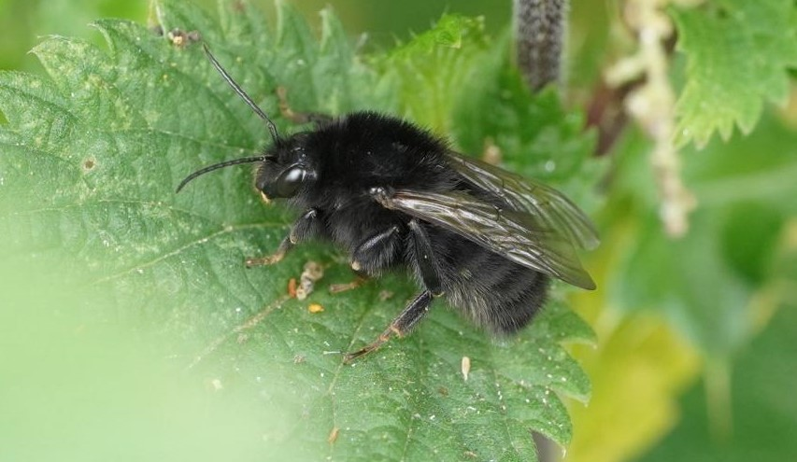

Photo - Ruderal Bumblebee © Tim Caldicott
Where identification of an insect required further research, these were referred to Naturespot and pers.com to RHNS members and non-member entomologists.

Records were submitted from Society members by email, some with photographs attached to collaborate identification; using the recorders’ spreadsheet available on the RNHS website; and by paper records through the post.

A full list of records can be found in Tables 1 to 10 in the main body of the report and a list of contributors and thanks can be found at the end of the report. A copy of these records will be forwarded to the County Recorders.

Species Summary

Ephemeroptera - Mayflies

Two records were noted for Mayflies, which are detailed below in Table 1.

Table 1. Ephemeroptera

May
 | Ephemera vulgata | Leighfield | Leighfield Fishponds | SK 8314 0374 | 1
August
Pond Olive | Cloeon dipterum | Exton | Vicars Close | SK 1278 1098 | 2

Odonata - Dragonflies and Damselflies

A total of 41 records was received for Dragonflies and Damselflies between the months of May and October; overall 18 species were recorded at various sites across the County. It was noted that a Scarce Chaser was recorded at Leighfield Fishponds in June; this is an IUCN Near Threatened (NT) species.
Details of the Odonata records are provided in Table 2, below.

Table 2. Odonata

May
Four spotted Chaser | Libellula quadrimaculata | Ketton Quarry |  | SK 980 060 | 3
Black-tailed Skimmer | Orthetrum cancellatum | Near Rutland Water | Gibbet Gorse Meadows | SK 9023 0575 | 1
Azure Damselfly | Coenagrion puella | Leighfield | Leighfield Fishponds | SK 8314 0374 | 18
Four-spotted Chaser | Libellula quadrimaculata | Leighfield | Leighfield Fishponds | SK 8314 0374 | 2
Red-eyed Damselfly | Erythromma najas | Wing Hill Allotment | My plot. | SK 8891 0288 | 1
Red-eyed Damselfly | Erythromma najas | Leighfield | Leighfield Fishponds | SK 8314 0374 | 2
Blue-tailed Damselfly | Ischnura elegans | Leighfield | Leighfield Fishponds | SK 8314 0374 | 1
Broad-bodied Chaser | Libellula depressa | Wing Hill Allotment | My plot. | SK 8891 0288 | 1
Azure Damselfly | Coenagrion puella | Leighfield | Leighfield Fishponds | SK 8314 0374 | 1
White-legged Damselfly | Platycnemis pennipes | Wing Hill Allotment | My plot. | SK 8891 0288 | 1
Four-spotted Chaser | Libellula quadrimaculata | Near Rutland Water | Gibbet Gorse Meadows | SK 9023 0575 | 1
Hairy Dragonfly | Brachytron pratense | Rutland Water | Lagoon 3 | SK 8907 1676 | 1
Azure Damselfly | Coenagrion puella | Wing | Water Treatment Works | SK 890 846 | 2
June
Southern Hawker | Aeshna cyanea | Wing | Wing Hill Allotment | SK 8891 0288 | 1
Emperor Dragonfly | Anax imperator | Leighfield | Leighfield Fishponds | SK 8314 0374 | 2
Four-spotted Chaser | Libellula quadrimaculata | Leighfield | Leighfield Fishponds | SK 8314 0374 | 5
Emperor Dragonfly | Anax imperator | Leighfield | West Leighfield | SK 8281 0410 | 1
Scarce Chaser | Libellula fulva | Leighfield | Leighfield Fishponds | SK 8314 0374 | 1
Emerald Damselfly | Lestes sponsa | Near Rutland Water | Gibbet Gorse Meadows | SK 9023 0575 | 1
Four-spotted Chaser | Libellula quadrimaculata | Near Rutland Water | Gibbet Gorse Meadows | SK 9023 0575 | 1
Ruddy Darter | Sympetrum sanguineum | Near Rutland Water | Gibbet Gorse Meadows | SK 9023 0575 | 1
July
Brown Hawker | Aeshna grandis | Near Rutland Water | Gibbet Gorse Meadows | SK 9023 0575 | 1
Azure Damselfly | Coenagrion puella | Ketton Quarry |  | SK 980 060 | 8
Common Blue Damselfly | Enallagma cyathigerum | Ketton Quarry |  | SK 980 060 | 6
Black-tailed Skimmer | Orthetrum cancellatum | Ketton Quarry |  | SK 980 060 | 1
Four-spotted Chaser | Libellula quadrimaculata | Ketton Quarry |  | SK 980 060 | 1
Brown Hawker | Aeshna grandis | Ketton Quarry |  | SK 980 060 | 2
Emperor Dragonfly | Anax imperator | Ridlington |  | SK 851 027 | 1
August
Common Darter | Sympetrum striolatum | Bloody Oaks Quarry |  | SK 97 11 | 1
Migrant Hawker | Aeshna mixta | Wing | Wing Hill Allotment | SK 8891 0288 | 1
Red-veined Darter | Sympetrum fonscolombii | Oakham | Barmstedt Drive | SK 8609 2852 | 1
Southern Hawker | Aeshna cyanea | Oakham | Barmstedt Drive | SK 8609 2852 | 1
Southern Hawker | Aeshna cyanea | Oakham | Barmstedt Drive | SK 8609 2852 | 1
Brown Hawker | Aeshna grandis | Ketton Quarry |  | SK 980 060 | 1
Southern Hawker | Aeshna cyanea | Ketton Quarry |  | SK 980 060 | 1
Azure Damselfly | Coenagrion puella | Ketton Quarry |  | SK 980 060 | 1
Common Blue Damselfly | Enallagma cyathigerum | Ketton Quarry |  | SK 980 060 | 1
October
Southern Hawker | Aeshna cyanea | Wing | Wing Hill Allotment | SK 8891 0288 | 1
Common Darter | Sympetrum striolatum | Rutland Water, Lagoon 5 | Cycle Track | SK 8781 0634 | 3
Migrant Hawker | Aeshna mixta | Manton | Priory Road |  | 1
Migrant Hawker | Aeshna mixta | Rutland Water | Lyndon Reserve |  | 2

Arachnida - spiders

Seven records were submitted for Arachnids between the months of April and August, which overall recorded seven different species of spider. Details of the Arachnid records are provided in Table 3, below. The majority of records received were obtained from the Bioblitz that was undertaken at Wing Waste Water Treatment Works.

Spiders inhabit a vast range of habitats, and it would be wonderful if we got more records for this group.

Table 3. Arachnida

April
Red Spider Mite | Tetranychus urticae | Wing | Water Treatment Works | SK 890 846 | 3
 | Xysticus cristatus | Wing | Water Treatment Works | SK 890 846 | 2
Common False Widow Spider | Steatoda bipunctata | Exton | Vicars Close | SK 12781098 | 1
May
House Spider | Tegenaria domestica | Exton | Vicars Close | SK 1278 1098 | 1
Labyrinth Spider | Agelena labyrinthica | Rutland Water | Lagoon 3 | SK 8907 1676 | 50+
June
Nursery Web Spider | Pisaura mirabilis | Wing |  | SK 890 026
August
 | Araneus diadematus | Wardley Wood | Along the path amongst plants and scrub | SP 835 995 | 1

Hemiptera – Bugs

A total of 42 records was received, which represents the sightings of 34 different Hemiptera species, for the period between March and October. Details of the Hemiptera records are provided in Table 4, below.

Table 4. Hemiptera

March
Common Green Shieldbug | Palomena prasina | Wing | Wing Hill Allotment | SK 8891 0288 | 1
April
Common Green Shieldbug | Palomena prasina | Oakham | Tees Close Garden | SK 856 081 | 2
Common Green Shieldbug | Palomena prasina | Wing | Water Treatment Works | SK 890 846 | 1
Pied Shieldbug | Tritomegas bicolor | Near Manton | Manton Junction Area | SK 8863 0362 | 4
Pied Shieldbug | Tritomegas bicolor | Near Manton | Manton Junction Area | SK 8863 0362 | 6
May
Pied Shieldbug | Tritomegas bicolor | Leighfield | Holygate Road | SK 8095 0320 | 2
Pied Shieldbug | Tritomegas bicolor | Wing | Wing Hill Allotment | SK 8891 0288 | 1
Sloe Bug/Hairy Shieldbug | Dolycoris baccarum | Leighfield | Holygate Road | SK 8095 0320 | 1
Blue Shieldbug | Zicrona caerulea | Wing | Wing Hill Allotment | SK 8891 0288 | 1
 | Rhopalus subrufus | Manton | St Mary’s Road | SK 8800 0465 | 1
Four-spotted Oak Bug | Dryophilocoris flavoquadrimaculatus | Near Rutland Water | Gibbet Gorse Meadows | SK 9023 0575 | 2
Striped Oak Bug | Rhabdomiris striatellus | Leighfield | Leighfield Fishponds | SK 8314 0374 | 5
Common Nettle Bug | Liocoris tripustulatus | Wing | Wing Hill Allotment | SK 8891 0288 | 1
Fine Streaked Bugkin | Miris striatus | Near Rutland Water | Gibbet Gorse Meadows | SK 9023 0575 | 1
Red-and-black Froghopper | Cercopis vulnerata | Near Rutland Water | Gibbet Gorse Meadows | SK 9023 0575 | 25
Dock Bug | Coreus marginatus | Wing | Water Treatment Works | SK 890 846 | 2
Nettle Groundbug | Heterogaster urticae | Wing | Water Treatment Works | SK 890 846 | 1
Hairy Sheildbug | Dolycoris baccarum | Wing | Water Treatment Works | SK 890 846 | 1
 | Notonecidae sp | Rutland Water | Lagoon 3 | SK 8907 1676 | 50+
 | Notonecta maculata | Rutland Water | Lagoon 3 | SK 8907 1676 | 10+
 | Corixa punctata | Rutland Water | Lagoon 3 | SK 8907 1676 | 10+
June
Red-legged Shieldbug | Pentatoma rufipes | Near Rutland Water | Gibbet Gorse Meadows | SK 9023 0575 | 1
Spiked Shieldbug | Picromerus bidens | Near Rutland Water | Gibbet Gorse Meadows | SK 9023 0575 | 20
Meadow Plant Bug | Leptopterna dolabrata | Near Rutland Water | Gibbet Gorse Meadows | SK 9023 0575 | 1
Common Flower Bug | Anthocoris nemorum | Near Rutland Water | Gibbet Gorse Meadows | SK 9023 0575 | 1
Miridae sp | Cyllecoris histrionius | Near Rutland Water | Gibbet Gorse Meadows | SK 9023 0575 | 1
Miridae sp | Capsus ater | Near Rutland Water | Gibbet Gorse Meadows | SK 9023 0575 | 1
Miridae sp | Grypocoris stysi | Near Rutland Water | Gibbet Gorse Meadows | SK 9023 0575 | 1
Miridae sp | Deraeocoris flavilinea | Wing | Wing Hill Allotment | SK 8891 0288 | 1
 | Apolygus spinolae | Leighfield | Leighfield Fishponds | SK 8314 0374 | 1
Meadow Plant Bug | Leptopterna dolabrata | Braunston | Hebe's Wood | SK831 059 | 1
July
Common Green Shieldbug | Palomena prasina | Wing | Water Treatment Works | SK 8974 0270 | 2
Potato Capsid | Closterotomus norwegicus | Wing | Water Treatment Works | SK 8974 0270 | 4
 | Megaloceroea recticornis | Wing | Water Treatment Works | SK 8974 0270 | 1
Spiked Shieldbug | Picromerus bidens | Near Rutland Water | Gibbet Gorse Meadows | SK 9023 0575 | 1
August
Cinnamon Bug | Corizus hyoscyami | Wing | Wing Hill Allotment | SK 8891 0288 | 1
 | Plagiognathus arbustorum | Wing | Wing Hill Allotment | SK 8891 0288 | 1
Hairy Shieldbug | Dolycoris baccarum | Ketton Quarry |  | SK 980 060
September
Tortoise Shieldbug | Eurygaster testudinaria | Near Rutland Water | Gibbet Gorse Meadows | SK 9023 0575 | 1
Box Bug | Gonocerus acuteangulatus | Manton | St Mary’s Road | SK 8800 0465 | 1
October
Blue Shieldbug | Zicrona caerulea | Wing | Wing Hill Allotment | SK 8891 0288 | 3
November
Hawthorn Shieldbug | Acanthosoma haemorrhoidale | Manton | St Mary’s Road | SK 8800 0465 | 1

Neuroptera - Lacewings and Ant - lions

Two records for Lacewings were received and the details shown below in Table 5.

Table 5. Neuroptera

May
Lacewing sp | Chrysopa perla | Wing | Wing Hill Allotment | SK 8891 0288 | 1
Lacewing sp | Chrysopidae sp. | Wing | Water Treatment Works | SK 890 846 | 1

Megaloptera - Alderflies

Three records for Alderfly were received (May and June) and the details shown below in Table 6.

Table 6. Megaloptera

May
Alderfly | Sialis lutaria | Rutland Water | Whitwell Creek | SK 9208 6600 | 1
Alderfly Larvae | Sialidae sp | Rutland Water | Lagoon 3 | SK 8907 1676 | 10+
Alder fly | Sialis lutaria | Leighfield | Leighfield Fishponds | SK 8314 0374 | 1

Coleoptera – Beetles

A total of 85 records were submitted, which represented 60 species identified between February and August, with the earliest records being attributed to Ladybird species. A single Dendroxena quadrimaculata was recorded at Gibbet Gorse Meadows and is a Nationally Notable B Species (Taxa which do not fall within the Red Data Book (RDB) but are generally ‘uncommon’ in Great Britain). The Nationally Scarce Tillus elongatus was recorded in Wing in June. Details of the Coleoptera records are provided in Table 7, below.

Table 7. Coleoptera

February
7-Spot Ladybird | Coccinella 7-punctata | Manton Village |  | SK 8801 0463 | 1
Harlequin Ladybird | Harmonia axyridis | Manton Village |  | SK 8801 0463 | 1
22-spot Ladybird | Psyllobora 22-punctata | Manton Village |  | SK 8801 0463 | 1
March
7-spot Ladybird | Coccinella 7-punctata | Oakham | Barmstedt Drive | SK 8609 2852 | 2
Rove Beetle | Tachyporus hypnorum | Exton | Vicars Close | SK 1278 1098 | 1
Pine Ladybird | Exochomus 4-pustulatus | Manton | St Mary’s Road | SK 8800 0465 | 1
Harlequin Ladybird | Harmonia axyridis | Manton | St Mary’s Road | SK 8800 0465 | 3
April
Green Tiger Beetle | Cicindela campestris | Ketton Quarry |  | SK 980 060 | 10+
 | Harpalus affinis | Ketton Quarry |  | SK 980 060 | 1
Whirligig Beetle | Gyrinus substriatus | Ketton Quarry |  | SK 980 060 | 30+
Harlequin Ladybird | Harmonia axyridis | Wing | Water Treatment Works | SK 890 846 | 1
14-spot ladybird | Propylea 14-punctata | Manton | St Mary’s Rd | SK 8801 0463 | 1
Gorse Weevil | Exapion ulicis | Near Rutland Water | Gibbet Gorse Meadows | SK 9006 0558 | 1
Common Sun Beetle | Amara aenea | Wing | Water Treatment Works | SK 890 846 | 1
Click Beetle | Athous haemorrhoidalis | Wing | Water Treatment Works | SK 890 846 | 1
Black Clock | Pterostichus madidus | Wing | Water Treatment Works | SK 890 846 | 7
 | Badister bullatus | Wing | Water Treatment Works | SK 890 846 | 1
Strawberry Seed Beetle | Harpalus rufipes | Wing | Water Treatment Works | SK 890 846 | 2
7-spot Ladybird | Coccinella 7-punctata | Wing | Water Treatment Works | SK 890 846 | 5
14-spot Ladybird | Propylea 14-punctata | Wing | Water Treatment Works | SK 890 846 | 1
10-spot Ladybird | Adalia decempunctata | Wing | Water Treatment Works | SK 890 846 | 1
Harlequin Ladybird | Harmonia axyridis | Wing | Water Treatment Works | SK 890 846 | 2
May
Green Tiger Beetle | Cicindela campestris | Ketton Quarry |  | SK 980 060 | 8
Wasp Beetle | Clytus arietis | Wing | Wing Hill Allotment | SK 8891 0288 | 1
Cream-spot ladybird | Calvia 14-guttata | Wing | Wing Hill Allotment | SK 8891 0288 | 1
16-spot Ladybird | Tytthaspis 16-punctata | Leighfield | Leighfield Fishponds | SK 8314 0374 | 1
Lesser Stag Beetle | Dorcus parallelipipedus | Wing Hill Allotment | My plot. | SK 8891 0288 | 1
Variable Longhorn Beetle | Stenocorus meridianus | Leighfield | Holygate Road | SK 8095 0320 | 1
Golden-bloomed Grey Longhorn Beetle | Agapanthia villosoviridescens | Near Rutland Water | Gibbet Gorse Meadows | SK 9023 0575 | 1
Rufous-shouldered Longhorn Beetle | Anaglyptus mysticus | Near Rutland Water | Gibbet Gorse Meadows | SK 9023 0575 | 1
Harlequin ladybird | Harmonia axyridis | Leighfield | Leighfield Fishponds | SK 8314 0374 | 27
 | Cantharis decipiens | Leighfield | Leighfield Fishponds | SK 8314 0374 | 1
 | Cantharis figurata | Near Rutland Water | Gibbet Gorse Meadows | SK 9023 0575 | 1
 | Cantharis nigricans | Near Rutland Water | Gibbet Gorse Meadows | SK 9023 0575 | 1
 | Cantharis rufa | Leighfield | Leighfield Fishponds | SK 8314 0374 | 1
 | Cantharis rustica | Leighfield | Leighfield Fishponds | SK 8314 0374 | 1
 | Cantharis livida | Wing Hill Allotment | My plot. | SK 8891 0288 | 1
 | Cantharis lateralis | Leighfield | Leighfield Fishponds | SK 8314 0374 | 1
 | Athous haemorrhoidalis | Leighfield | Holygate Road | SK 8095 0320 | 1
 | Dendroxena quadrimaculata | Near Rutland Water | Gibbet Gorse Meadows | SK 9023 0575 | 1
 | Grammoptera ruficornis | Wing | Wing Hill Allotment | SK 8891 0288 | 2
 | Rhagonycha limbata | Near Rutland Water | Gibbet Gorse Meadows | SK 9023 0575 | 1
Tortoise Beetle | Cassida vibex | Rutland Water | Lagoon 3 | SK 8907 1676 | 1
Green Tortoise Beetle | Cassida viridis | Rutland Water | Lagoon 3 | SK 8907 1676 | 1
Green Dock Beetle | Gastrophysa viridula | Rutland Water | Lagoon 3 | SK 8907 1676 | 1
Harlequin Ladybird | Harmonia axyridis | Wing | Water Treatment Works | SK 890 846 | 5
14-spot ladybird | Propylea 14-punctata | Wing | Water Treatment Works | SK 890 846 | 1
Thick-thighed Flower Beetle | Oedemera nobilis | Wing | Water Treatment Works | SK 890 846 | 5
Fairy-ring Longhorn Beetle | Pseudovadonia livida | Wing | Water Treatment Works | SK 890 846 | 1
 | Cantharis nigricans | Wing | Water Treatment Works | SK 890 846 | 3
 | Cordylepherus viridis | Wing | Water Treatment Works | SK 890 846 | 3
Tabacco-coloured Longhorn Beetle | Alosterna tabacicolor | Wing | Water Treatment Works | SK 890 846 | 1
Common Malachite Beetle | Malachius bipustulatus | Wing | Water Treatment Works | SK 890 846 | 1
Rustic Sailor Beetle | Cantharis rustica | Wing | Water Treatment Works | SK 890 846 | 1
22-spot Ladybird | Psyllobora 22-punctata | Wing | Water Treatment Works | SK 890 846 | 3
Rustic Sailor Beetle | Cantharis rustica | Barrowden | Redhill Farmhouse, Redland Close | Not provided. | 1
False Ladybird | Endomychus coccineus | Rutland Water |  | SK 8806 0613 | 1
June
Cream-spot ladybird | Calvia 14-guttata | Exton | Vicars Close | SK 1278 1098 | 1
 | Rhagonycha testacea | Near Rutland Water | Gibbet Gorse Meadows | SK 9023 0575 | 1
Thistle Tortoise Beetle | Cassida rubiginosa | Near Rutland Water | Gibbet Gorse Meadows | SK 9023 0575 | 1
Tortoise Beetle | Cassida vibex | Near Rutland Water | Gibbet Gorse Meadows | SK 9023 0575 | 1
Black-striped Longhorn Beetle | Stenurella melanura | Near Rutland Water | Gibbet Gorse Meadows | SK 9023 0575 | 1
Black-and-yellow Longhorn Beetle | Rutpela maculata | Near Rutland Water | Gibbet Gorse Meadows | SK 9023 0575 | 1
Beetle | Cantharis nigra | Leighfield | Leighfield Fishponds | SK 8314 0374 | 1
24-spot Ladybird | Subcoccinella 24-punctata | Leighfield | Leighfield Fishponds | SK 8314 0374 | 1
 | Cantharis cryptica | Leighfield | Leighfield Fishponds | SK 8314 0374 | 1
Fairy-ring Longhorn Beetle | Pseudovadonia livida | Leighfield | Leighfield Fishponds | SK 8314 0374 | 1
 | Lagria hirta | Martinsthorpe | Near Fox Covert |  | 1
Larch Ladybird | Aphidecta obliterata | Leighfield | Leighfield Fishponds | SK 8314 0374 | 1
 | Cantharis rustica | Exton | Vicars Close | SK 1278 1098 | 1
Hairy Rove Beetle | Creophilus maxillosus | Exton | Vicars Close | SK 1278 1098 | 1
Clay-coloured Weevil | Otiorhynchus singularis | Exton | Vicars Close | SK 1278 1098 | 1
Cockchafer | Melolontha melolontha | Exton | Vicars Close | SK 1278 1098 | 1
 | Tillus elongatus | Wing |  | SK 890 026 | 1
Harlequin Ladybird | Harmonia axyridis | Oakham | Tees Close | SK 856 081 | 1+
Harlequin Ladybird pupa | Harmonia axyridis | Oakham | Barmstedt Drive | SK 8609 2852 | 1
Swollen-thighed Beetle | Oedemera nobilis | Braunston | Hebe's Wood | SK 831 059 | !+
Green Nettle Weevil | Phyllobius pomaceus | Braunston | Hebe's Wood | SK 831 059 | 1
Golden-bloomed Grey Longhorn Beetle | Agapanthia villosoviridescens | Ridlington |  | SK 851 027 | 1
July
14-spot ladybird | Propylea 14-punctata | Exton | Vicars Close | SK 1278 1098 | 1
Fairy-ring Longhorn Beetle | Pseudovadonia livida | Near Rutland Water | Gibbet Gorse Meadow | SK 9023 0575 | 1
August
22-spot ladybird | Psyllobora 22-punctata | Wing | Wing Hill Allotment | SK 8891 0288 | 7
Devils Coach Horse Beetle | Staphylinus olens | Oakham | Barmstedt Drive | SK 8609 2852 | 1
Click Beetle | Athous haemorrhoidalis | Ketton Quarry |  | SK 980 060 | 1
7-spot Ladybird | Coccinella 7-punctata | Ketton Quarry |  | SK 980 060 | 1

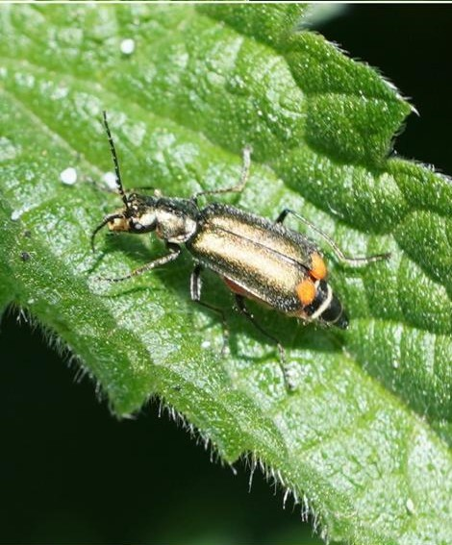

Photo – Cordylepherus viridis © Tim Caldicott

Diptera - Flies

A total of 94 records was received between February and November. The earliest record was attributed to a specimen of the Common Drone Fly, Eristalis tenax, which was recorded in February (this species overwinters as an adult), followed by the Dark-edged Bee Fly Bombylius major. It was noted last year that there was the potential for the Dotted Bee Fly B. discolor, (a similar species to the Darked-edged Bee Fly) which favours limestone grasslands to be found in the County; however, no records have been submitted to the RNHS so far. The Long-palped Cranefly, Ctenophora pectinicornis was recorded at Exton in May and is a Nationally Notable Species. The Nationally Scarce Callicera aurata was recorded at Gibbet Gorse Meadows in June along with a Pale Giant Horsefly, Tabanus bovinus at Wing in June. The latter is an IUCN Endangered (EN), Nationally Rare (NR) species. This was an interesting record for Rutland as they are usually restricted to acid and peat sedge habitats.

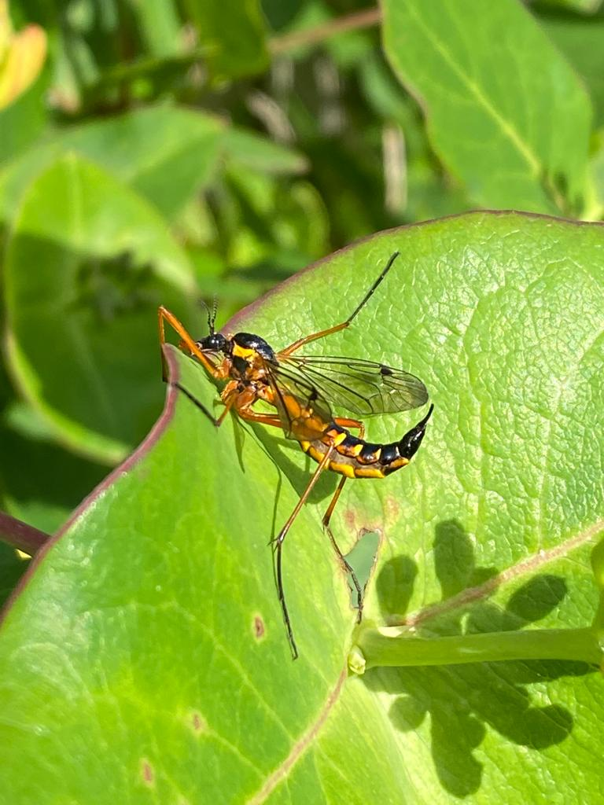

Photo - Long Palped Cranefly © Jayne Walker

Details of the Diptera records are provided in Table 8, below.

Table 8. Diptera

February
Drone Fly | Eristalis tenax | Exton | Vicars Close | SK 1278 1098 | 10+
March
Dark-edged Bee Fly | Bombylius major | Exton | Vicars Close | SK 1278 1098 | 1
Dark-edged Bee Fly | Bombylius major | Lyndon Nature Reserve | On edge of the path (Lesser Celandines, Ficaria verna) | SK 8905 0853 | 10+
Dark-edged Bee Fly | Bombylius major | Ketton Quarry |  | SK 980 060 | 20+
April
Hoverfly | Eupeodes luniger | Exton | Vicars Close | SK 1278 1098 | 1
Dark-edged Bee Fly | Bombylius major | Exton | Vicars Close | SK 1278 1098 | 1
Dark-Edged Bee Fly | Bombylius major | Ketton Quarry |  | SK 980 060 | 20+
Thick-legged Hoverfly | Syritta pipiens | Manton | St Mary’s Road | SK 8801 0463 | 1
 | Eupeodes luniger | Near Manton | Manton Junction Area | SK 8863 0362 | 1
 | Epistrophe eligans | Near Rutland Water | Gibbet Gorse Meadows | SK 9006 0558 | 10
St Mark’s Fly | Bibio marci | Wing | Water Treatment Works | SK 890 846 | 10
Thick-legged Hoverfly | Syritta pipiens | Wing | Water Treatment Works | SK 890 846 | 1
Chequered Hoverfly | Melanostoma scalare | Wing | Water Treatment Works | SK 890 846 | 1
May
Long-palped Cranefly | Ctenophora pectinicornis | Exton | Vicars Close | SK 1278 1098 | 1
Hoverfly | Criorhina berberina var. oxyacantha | Exton | Vicars Close | SK 1278 1098 | 1
Hoverfly | Eristalis pertinax | Exton | Vicars Close | SK 1278 1098 | 1
Dark-edged Bee Fly | Bombylius major | Ketton Quarry |  | SK 980 060 | 10+
 | Platycheirus peltatus | Wing Hill Allotment | My plot. | SK 8891 0288 | 1
 | Eristalis intricarius | Leighfield | Leighfield Fishponds | SK 8314 0374 | 1
Migrant Hoverfly | Eupeodes corollae | Leighfield | Holygate Road | SK 8095 0320 | 1
 | Eupeodes latifasciatus | Leighfield | Leighfield Fishponds | SK 8314 0374 | 1
 | Leucozona lucorum | Leighfield | Leighfield Fishponds | SK 8314 0374 | 1
Scorpion Fly | Panorpa communis | Wing Hill Allotment | My plot. | SK 8891 0288 | 1
Pied Hoverfly | Scaeva pyrastri | Near Rutland Water | Gibbet Gorse Meadows | SK 9023 0575 | 1
 | Cheilosia albitarsis | Leighfield | Holygate Road | SK 8095 0320 | 1
 | Parhelophilus frutetorum | Leighfield | Leighfield Fishponds | SK 8314 0374 | 1
 | Eristalis nemorum | Wing Hill Allotment | My plot. | SK 8891 0288 | 1
 | Pipiza noctiluca | Wing Hill Allotment | My plot. | SK 8891 0288 | 1
Saw Fly | Dolerus picipes | Wing Hill Allotment | My plot. | SK 8891 0288 | 1
Saw Fly | Aglaostigma fulvipes | Leighfield | Holygate Road | SK 8095 0320 | 1
Long Hoverfly | Sphaerophoria scripta | Leighfield | Holygate Road | SK 8095 0320 | 1
German Scorpion Fly | Panorpa germanica | Leighfield | Holygate Road | SK 8095 0320 | 1
 | Volucella bombylans | Wing Hill Allotment | My plot. | SK 8891 0288 | 1
 | Platycheirus rosarum | Leighfield | Leighfield Fishponds | SK 8314 0374 | 1
 | Volucella pellucens | Near Rutland Water | Gibbet Gorse Meadows | SK 9023 0575 | 1
 | Tenthredopsis litterata | Wing Hill Allotment | My plot. | SK 8891 0288 | 1
 | Tenthredo mesomela | Wing Hill Allotment | My plot. | SK 8891 0288 | 2
Superb Ant-hill Hoverfly | Xanthogramma pedissequum | Wing hill Allotment | My plot | SK 8891 0288 | 1
 | Dasysyrphus albostriatus | Near Rutland Water | Gibbet Gorse Meadows | SK 9023 0575 | 1
 | Xylota segnis | Near Rutland Water | Gibbet Gorse Meadows | SK 9023 0575 | 12
 | Criorhina floccosa | Wing Hill Allotment | My plot. | SK 8891 0288 | 1
 | Cheilosia caerulescens | Leighfield | Leighfield Northern Track | SK 8258 0509 | 1
Drone Fly | Eristalis tenax | Wing | Water Treatment Works | SK 890 846 | 1
 | Tenthredo maculata | Wing | Water Treatment Works | SK 890 846 | 1
 | Volucella pellucens | Exton | Vicars Close | SK 1278 1098 | 1
 | Criorhina berberina | Exton | Vicars Close | SK 1278 1098 | 1
 | Myathropa florea | Wing | Water Treatment Works | SK 890 846 | 1
 | Xanthogramma pedissequum | Wing | Water Treatment Works | SK 890 846 | 2
Marmalade Hoverfly | Episyrphus balteatus | Wing | Water Treatment Works | SK 890 846 | 2
 | Xylota segnis | Wing | Water Treatment Works | SK 890 846 | 2
 | Volucella bombylans | Wing | Water Treatment Works | SK 890 846 | 1
 | Cheilosia caerulescens | Leighfield | Leighfield Northern Track | SK 8258 0509 | 1
 | Eristalis tenax | Wing | Water Treatment Works | SK 890 846 | 1
June
Large Alder Sawfly | Cimbex connatus | Near Rutland Water | Gibbet Gorse Meadows | SK 9023 0575 | 1
Large Rose Sawfly | Arge pagana | Exton | Vicars Close | SK 1278 1098 | 1
Sawfly | Tenthredo mesomela | Fineshade Wood |  | Not provided. | 1
Marmalade Hoverfly | Episyrphus balteatus | Near Rutland Water | Gibbet Gorse Meadows | SK 9023 0575 | 77
Migrant Hoverfly | Eupeodes corollae | Near Rutland Water | Gibbet Gorse Meadows | SK 9023 0575 | 28
 | Melangyna labiatarum | Near Rutland Water | Gibbet Gorse Meadows | SK 9023 0575 | 1
 | Syrphus vitripennis | Near Rutland Water | Gibbet Gorse Meadows | SK 9023 0575 | 1
 | Chrysotoxum bicinctum | Near Rutland Water | Gibbet Gorse Meadows | SK 9023 0575 | 1
 | Volucella bombylans | Near Rutland Water | Gibbet Gorse Meadows | SK 9023 0575 | 30
 | Chrysotoxum festivum | Near Rutland Water | Gibbet Gorse Meadows | SK 9023 0575 | 1
 | Chrysotoxum verralli | Near Rutland Water | Gibbet Gorse Meadows | SK 9023 0575 | 2
 | Callicera aurata | Near Rutland Water | Gibbet Gorse Meadows | SK 9023 0575 | 1
 | Anasimyia contracta | Leighfield | Leighfield Fishponds | SK 8314 0374 | 1
 | Ferdinandea cuprea | Leighfield | West Leighfield | SK 8097 0333 | 1
 | Anasimyia lineata | Leighfield | Leighfield Fishponds | SK 8314 0374 | 1
Pale Giant Horsefly | Tabanus bovinus | Wing | Wing Hill Allotment | SK 8891 0288 | 1
St Mark’s Fly | Bibio marci | Wing |  | SK 890 026 | 1
 | Eristalis nemorum | Wing |  | SK 890 026 | 1
Hoverfly | Dasysyrphus venustus | Braunston | Hebe's Wood | SK 831 059 | 1
Hoverfly | Episyrphus balteatus | Braunston | Hebe's Wood | SK 831 059 | 1
Scorpion Fly | Panorpa communis | Braunston | Hebe's Wood | SK 831 059 | 1
July
Marmalade Hoverfly | Episyrphus balteatus | Wing | Water Treatment Works | SK 8974 0270 | 10
Chequered Hoverfly | Melanostoma scalare | Wing | Water Treatment Works | SK 8974 0270 | 1
Pied Hoverfly | Scaeva pyrastri | Wing | Water Treatment Works | SK 8974 0270 | 1
 | Melangyna umbellatarum | Wing | Wing Hill Allotment | SK 8891 0288 | 1
 | Helophilus trivittatus | Near Rutland water | Gibbet Gorse Meadows | SK 9023 0575 | 1
 | Volucella inanis | Near Rutland water | Gibbet Gorse Meadows | SK 9023 0575 | 1
Yellow Dung Fly | Scathophaga stercoraria | Wing | Water Treatment Works | SK 8974 0270 | 1
August
Non-Biting Midge | Chironomidae spp | Exton | Vicars Close | SK 1278 1098 | 3
 | Ferdinandea cuprea | Wing | Wing Hill Allotment | SK 8891 0288 | 1
 | Chrysotoxum verralli | Wing | Wing Hill Allotment | SK 8891 0288 | 1
 | Chrysotoxum verralli | Near Rutland water | Gibbet Gorse Meadows | SK 9023 0575 | 1
 | Volucella inanis | Near Rutland water | Gibbet Gorse Meadows | SK 9023 0575 | 2
 | Volucella inanis | Near Rutland water | Gibbet Gorse Meadows | SK 9023 0575 | 3
 | Sphaerophoria scripta | Ketton Quarry |  | SK 980 060
Hoverfly | Volucella inanis | Wardley Wood | Along the path amongst plants and scrub. | SP 835 995 | 1
September
 | Volucella zonaria | Manton | St Mary’s Road | SK 8801 0463 | 1
The Footballer | Helophilus pendulus | Wardley Wood | Along the path amongst plants and scrub. | SP 835 995 | 1
Hoverfly | Eupeodes latifasciatus | Eyebrook, Stockerston | Path overlooking Reservoir. | SP 849 980 | 1
Hoverfly (Common copperback) | Ferdinandea cuprea | Priors Coppice | In shrubbery. | SK 831 050 | 1
November
Marmalade Hoverfly | Episyrphus balteatus | Manton Pasture Fields | Field hedge SW of Tufted duck hide. | SK 8863 0527 | 1

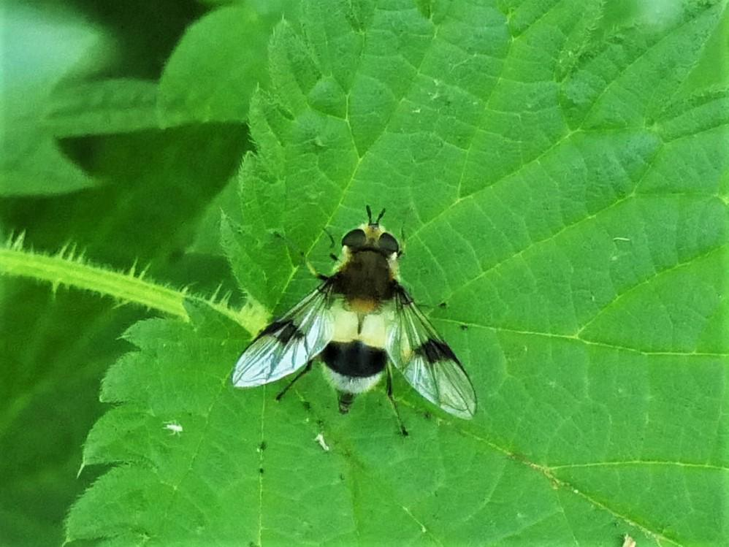

Photo - Leucozona lucorum © Jayne Walker

Trichoptera– Caddisflies

Two records for caddisflies were received, details of which are shown below.

Table 9. Trichoptera

June
 | Limnephilus lunatus | Martinsthorpe | Near Fox Covert | SK 8683 0417 | 1
September
Brown Sedge | Anabolia nervosa | Exton | Vicars Close | SK 1278 1098 | 1

Hymenoptera - Ants, Wasps, Bees & Relatives

A total of 83 records were received between January and December, which represented 25 species. The earliest record was a Honey Bee, Apis mellifera which was received in January, with records also received for November. Osmia bicolor has been recorded at Ketton Quarry and this is a Notable B Species. In addition, the Yellow-shouldered Nomad Bee, Nomada ferruginata recorded at Rutland Water, Lagoon 3 is a Red Data Book 1 Species and the Median Wasp, Dolichovespula media recorded at Gibbet Gorse Meadows is a Notable A Species.

It should be noted that records for the Saxon Wasp, Dolichovespula saxonica which is a RDB K – (Insufficiently Known Taxa in Great Britain that are suspected but not definitely known to belong to any of the other RDB categories, because of lack of information) has been recorded at Gibbet Gorse Meadow. The Ruderal Bumblebee, Bombus ruderatus recorded at Wing and Gibbet Gorse Meadows, which is a Notable B and NERC S41 Priority Species, has declined significantly in the UK and is one of our rarest species. Details of Hymenoptera are shown below in Table 10.

Table 10: Hymenoptera

January
Honey Bee | Apis mellifera | Leighfield | Leighfield Fishponds | SK 8291 0403 | 1
Honey Bee | Apis mellifera | Exton | Vicars Close | SK 1278 1098 | 1
February
Buff-tailed Bumblebee | Bombus terrestris | Manton | Priory Road | SK 8801 0344 | 1
Buff-tailed Bumblebee | Bombus terrestris | Wing Allotment | Near my plot. | SK 8891 0288 | 1
Garden Bumblebee | Bombus hortorum | Manton | My back yard. | SK 8801 0463 | 1
Common Wasp | Vespula vulgaris | Manton | My back yard. | SK 8801 0463 | 1
Honey Bee | Apis mellifera | Exton | Vicars Close | SK 1278 1098 | 1
Honey Bee | Apis mellifera | Exton | Vicars Close | SK 1278 1098 | 3
 | Ophion obscuratus | Rutland Water | Lodge window. | SK 9305 0267 | 1
March
Honey Bee | Apis mellifera | Exton | Vicars Close | SK 1278 1098 | Many
Buff-tailed Bumblebee | Bombus terrestris | Exton | Vicars Close | SK 1278 1098 | 1
Hairy-footed Flower Bee | Anthophora plumipes | Exton | Vicars Close | SK 1278 1098 | 1
Common Carder Bee | Bombus pascuorum | Exton | Vicars Close | SK 1278 1098 | 1
Early Bumblebee | Bombus pratorum | Exton | Vicars Close | SK 1278 1098 | 1
Buff-tailed Bumblebee | Bombus terrestris | Exton | Vicars Close | SK 1278 1098 | 1
Large Red-tailed Bumblebee | Bombus lapidarius | Lydon Nature Reserve | Close to Osprey Hide | SK 8805 7236 | 2
 | Ichneumon stramentor | Exton | Vicars Close | SK 1278 1098 | 1
Buff-tailed Bumblebee | Bombus terrestris | Ketton Quarry |  | SK 980 060 | 2
Common Carder Bee | Bombus pascuorum | Ketton Quarry |  | SK 980 060 | 1
Honey Bee | Apis mellifera | Near Rutland water | Gibbet Gorse Meadows | SK 9016 0565 | 23+
Buff-tailed Bumblebee | Bombus terrestris | Rutland Water | Golf Course Bay | SK 9149 0575 | 9
Common Carder Bee | Bombus pascuorum | Manton | St Mary’s Road | SK 8800 0465 | 1
Tree Bumblebee | Bombus hypnorum | Ridlington | Nest box in garden. | SK 851 027 | 1
Early Bumblebee | Bombus pratorum |  | Verge 8 Tollthorpe End | TF 016 108 | 1
Early Bumblebee | Bombus pratorum | Ridlington | Garden | SK 851 027 | 1
April
Tawny Mining Bee | Andrena fulva | Exton | Vicars Close | SK 1278 1098 | 1
Red Mason Bee | Osmia bicornis | Exton | Vicars Close | SK 1278 1098 | 1
Hairy-footed Flower Bee | Anthophora plumipes | Exton | Vicars Close | SK 1278 1098 | 1
Common Carder Bee | Bombus pascuorum | Ketton Quarry |  | SK 980 060 | 2
 | Osmia bicolor | Ketton Quarry |  | SK 980 060 | 2
White-tailed Bumblebee | Bombus lucorum | Ketton Quarry |  | SK 980 060 | 1
Two-coloured Mason Bee | Osmia bicornis | Wing | Water Treatment Works | SK 890 846
Small Black Ants | Lasius niger | Ketton Quarry |  | SK 980 060 | 1
Red Ants | Myrmica scabrinodis | Ketton Quarry |  | SK 980 060 | 1
Tree Bumblebee | Bombus hypnorum | Near Manton | Manton Junction Area | SK 8863 0362 | 1
Common Carder Bee | Bombus pascuorum | Wing | Water Treatment Works | SK 890 846 | 2
Buff-tailed Bumblebee | Bombus terrestris | Wing | Water Treatment Works | SK 890 846 | 6
Common Wasp | Vespula vulgaris | Wing | Water Treatment Works | SK 890 846 | 3
White-tailed Bumblebee | Bombus lucorum | Wing | Water Treatment Works | SK 890 846 | 1
May
Ashy Mining Bee | Andrena cineraria | Exton | Vicars Close | SK 1278 1098 | 1
Red-tailed Bumblebee | Bombus lapidarius | Ketton Quarry |  | SK 980 060 | 1
Two-coloured Mason Bee | Osmia bicolor | Ketton Quarry |  | SK 980 060 | 2
Hornet | Vespa crabro | Manton | St Mary’s Road | SK 8800 0465 | 1
Wall Mason Wasp | Ancistrocerus parietum | Leighfield | Leighfield Fishponds | SK 8314 0374 | 1
Mourning Bee | Melecta albifrons | Wing Hill Allotment | My plot. | SK 8891 0288 | 1
Common Red Ant | Myrmica rubra | Near Rutland Water | Gibbet Gorse Meadows | SK 9023 0575 | 1
Tree Bumblebee | Bombus hypnorum | Near Rutland Water | Gibbet Gorse Meadows | SK 9023 0575 | 1
Hairy-footed Flower Bee | Anthophora plumipes | Wing | Water Treatment Works | SK 890 846 | 1
Red-tailed Bumblebee | Bombus lapidarius | Wing | Water Treatment Works | SK 890 846 | 2
Common Carder Bee | Bombus pascuorum | Wing | Water Treatment Works | SK 890 846 | 5
Early Bumblebee | Bombus pratorum | Wing | Water Treatment Works | SK 890 846 | 5
Garden Bumblebee | Bombus hortorum | Wing | Water Treatment Works | SK 890 846 | 2
Panzers Nomad Bee | Nomada panzeri | Wing | Water Treatment Works | SK 890 846 | 2
Yellow-shouldered Nomad Bee | Nomada ferruginata | Rutland Water | Lagoon 3 | SK 8907 1676 | 10+
June
Median Wasp | Dolichovespula media | Near Rutland Water | Gibbet Gorse Meadows | SK 9023 0575 | 1
Tree Wasp | Dolichovespula sylvestris | Leighfield | Leighfield fishponds | SK 8314 0374 | 1
July
Hairy-footed Flower Bee | Anthophora plumipes | Wing | Water Treatment Works | SK 8974 0270 | 3
Hornet | Vespa crabro | Barrow |  |  | 2
Common Carder Bee | Bombus pascuorum | Wing | Water Treatment Works | SK 8974 0270 | 3
Red-tailed Bumblebee | Bombus lapidarius | Wing | Water Treatment Works | SK 8974 0270 | 3
Garden Bumblebee | Bombus hortorum | Wing | Water Treatment Works | SK 8974 0270 | 4
Forest Cuckoo Bee | Bombus sylvestris | Wing | Water Treatment Works | SK 8974 0270 | 1
Common Black Ant | Lasius niger | Wing | Water Treatment Works | SK 8974 0270 | 30
Red Ant | Myrmica rubra | Wing | Water Treatment Works | SK 8974 0270 | 2
Saxon Wasp | Dolichovespula saxonica | Near Rutland water | Gibbet Gorse Meadows | SK 9023 0575 | 1
White-tailed Bumblebee | Bombus lucorum | Ketton Quarry |  | SK 980 060 | 3
Common Carder Bee | Bombus pascuorum | Ketton Quarry |  | SK 980 060 | 1
Common Mouring Bee | Melecta albifrons | Ketton Quarry |  | SK 980 060 | 1
Common Wasp | Vespula vulgaris | Wing | Water Treatment Works | SK 8974 0270 | 6
Ruderal Bumblebee | Bombus ruderatus | Near Rutland water | Gibbet Gorse Meadows | SK 9023 0575 | 1
Ruderal Bumblebee | Bombus ruderatus | Wing | Wing Hill Allotment | SK 8891 0288 | 1
Forest-Cuckoo Bee | Bombus sylvestris | Wing | Water Treatment Works | SK 8974 0270 | 1
August
Big-headed Digger Wasp | Ectemnius cephalotes | Wing | Wing Hill Allotment | SK 8891 0288 | 1
Common Carder Bee | Bombus pascuorum | Ketton Quarry |  | SK 980 060 | ?
Hairy-footed Flower Bee | Anthophora plumipes | Ketton Quarry |  | SK 980 060 | 1
Forest-Cuckoo Bee | Bombus sylvestris | Ketton Quarry |  | SK 980 060 | 3
Red-tailed Bumblebee | Bombus lapidarius | Ketton Quarry |  | SK 980 060 | 1
Common Carder Bee | Bombus pascuorum | Ketton Quarry |  | SK 980 060 | 1
Honey Bee | Apis mellifera | Ketton Quarry |  | SK 980 060 | 1
November
Common Wasp | Vespula vulgaris | Manton | St Mary’s Road | SK 8801 0463 | 2
Garden Bumblebee | Bombus hortorum | Manton | St Mary’s Road | SK 8801 0463 | 1
Honey Bee | Apis mellifera | Manton | St Mary’s Road | SK 8801 0463 | 2
Buff-tailed Bumble Bee | Bombus terrestris | Manton Pasture Fields. | Field hedge SW of Tufted Duck hide. | SK 8863 0527 | 1

Contributors
I would like to thank the following members, (in no particular order) who have submitted records in 2022 and for their help with identification: Tim Caldicott, Dave Needham, Carolyn Baxter, Roy Lemmon, Peter Scott, Linda and Anthony Biddle, Gill Chiverton, Matthew Rumbelow, John and Jacky Morrell, Luke Nelson, Tim Sexton, Jenny Harris, Diana Masters, Jane and Duncan Ball, Linda Clark, Martin Grimes and all the members that attended RNHS outdoor meetings; here records were attributed to the group and not attributed to named individuals. All records are much appreciated, so please keep sending them in.
I would also like to thank my friend and former colleague Stuart Robinson, Consultant Entomologist for his invaluable advice and support with the insect identification, which was much appreciated.
In addition, I would also like to thank Tim Sexton, Species and Recording Officer, Leicestershire and Rutland Wildlife Trust (LRWT) for his help with the Bioblitz identifications and Ray Morris, Leicestershire and Rutland Entomological Society (LRES).
Please accept my apologies if I have unintentionally missed anyone.

Jayne Walker
Insect Recorder

