Rutland Natural History Society

MOTH ANNUAL REPORT 2020 Recorder: Paul Bennett

This was a difficult year as Covid-19 restrictions meant that no recording in the wider countryside could be done until early summer and none after the middle of October. If there was one benefit to be obtained from this it was that home confinement offered more time for garden trapping and most national records for the year may have come from that source; in fact, moth recorders may have been at an advantage compared to other wildlife recorders in that respect.

Although some nights were productive, 2020 was not an exceptional year in terms of the number and range of species encountered. This could possibly be attributed to the prolonged warm and dry spring weather, which resulted in many foodplants dying off before the emergence of the larvae that rely on them. Although this is not an unfamiliar tale in recent years, normally it has been the later summer period which has given the greater problem. Another consequence of very dry conditions was that moths could disperse more widely than usual making local recording less reliable as a breeding indicator, although this tendency is less marked in micro moths. Regular recording at a site over a period of years can balance out this effect. Nevertheless, it has to be remembered that moth trapping for all its advantages can be hit and miss as a method of recording. One area of improvement on 2019 was the more settled autumn weather which enabled traps to be put out until the middle of October. Immigrant or partial migrant moth numbers were lower than usual.

With the extra time available, our three regular sites were trapped throughout the summer more frequently than usual, with Bloody Oaks and Shacklewell Spinney utilised as much as the long-standing site at Lyndon Nature Reserve. Particular use was made of Shacklewell as it gave an opportunity to trap there at a time when the site would normally have been closed due to use by summer holiday groups. The relocation of the trap there to a sheltered area produced better results as did the purchase of a motorcycle battery which enabled the trap to run for up to two hours longer, helping to continue recording effectively well beyond the summer solstice.

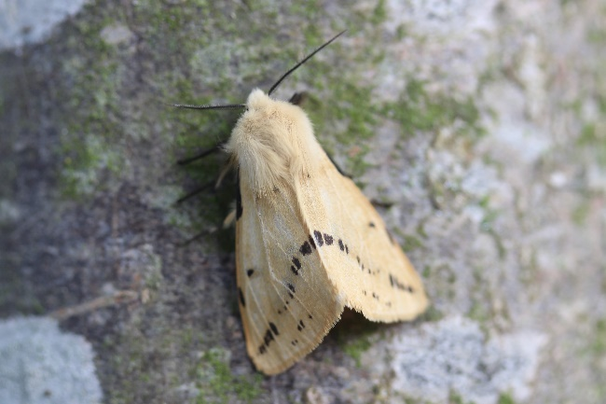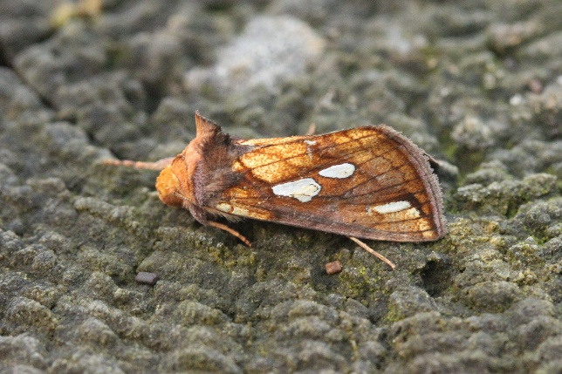

Photo – Buff Ermine – Brian Webster Photo – Gold Spot – Brian Webster

A note on records:
As recording was severely affected by the pandemic a comprehensive list of site records has not been provided for the year. The reason for this was that the normal flight times for many species fell either wholly or partly within the period when we were unable to record and therefore would not be a true reflection of their abundance; examples of these include Hawk-moths, Ermines, Carpets, Waves, Pugs and Prominents. It is also worth mentioning that many moths in recent years have started to produce second or third broods so a period of at least six months recording is now necessary in normal years to give reliable records of what moths regularly appear on sites.

The moths listed were those that were either the most recorded macro and micro moths, first records for a site, interesting records or key moth indicators; all of which may in any case be more digestible to casual readers than large lists. A full list of species and totals for the year from any site can be obtained from the VC55 (Leicestershire and Rutland) county recorder, Adrian Russell. Thanks are given to those members who sent in mainly day-flying moth records and for those I have given a comprehensive list.

Bloody Oaks Nature Reserve

This site was first trapped on 30 June with the last trap put out on 22 October. The trap was set out in a different spot from its open position in previous years to a more sheltered one closer to adjoining woodland. This paid dividends with higher counts, although with this woodland area being outside the reserve, many of the moths caught would have been from there and not from the calcareous grassland with scrub that is the main feature of the reserve. However, the conifer trees at the southern end produced species that are not normally seen at other sites. The other beneficial change from last year was the use of a new battery which enabled the bulb to last for up to eight hours each night.

Recorder effort - 7 nights, 87 species in total (64 macro 23 micro)

Highest nightly count- 180 moths of 54 species on 5 August
Highest yearly totals- Large Yellow Underwing 67
Setaceous Hebrew Character 24
Highest micro moth counts- Blastobasis adustella 7
Pyrausta aurata 6
Common Plume 5
Other notable records- Pale Eggar 4
Grey Pine Carpet 3
Feathered Gothic 2
Pine Hawk-moth 1
Square-spotted Clay 1 ( Nationally
Scarce B species)

Shacklewell Spinney

This was the first year that we had both the time and the opportunity to regularly record this site with recording commencing on 18 May and finishing on 20 September. The spinney is situated in a slight valley and the battery trap was set out in an area of short grass closely surrounded by deciduous woodland on all sides, with a small stream at the valley bottom. This is a combination of habitats which always has potential for moth activity. Footman moths were recorded in good numbers: Tree-lichen Beauty was a first record for the site as it was for many areas in VC55 and Square-spotted Clay is now a regular if occasional moth seen in traps in mid-summer. Micro moths were also seen in relatively high numbers which increased the length of recording time.

Recorder effort- 9 nights, 123 species (94 macro, 23 micro)
Highest nightly count- 168 moths of 56 species on 16 July
Highest yearly totals- Setaceous Hebrew Character 66
Common Wainscot 29
Common Footman 24
Highest micro-moth counts- Chrysoteuchia culmella 29
Agriphila tristella 9
Mother of Pearl 9
Other notable records- Least Carpet 3
Square-spotted Clay 3 (Nationally
Scarce B)
Tree-lichen Beauty 2

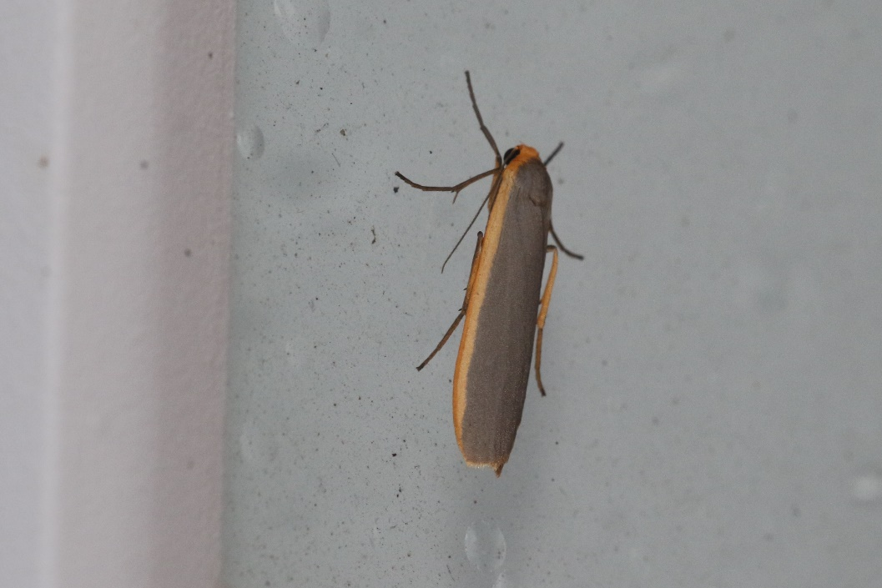

Photo – Common Footman – Peter Scott

Lyndon Nature Reserve

The first trap of the year was run briefly on 7 March 2020 and yielded just four moth species. Because of the introduction of Covid-19 lockdown restrictions soon afterwards there were no more sessions until 12 July, further sessions then being carried out regularly until mid-October. A combination of bad weather and further restrictions meant that there were no further sessions in autumn, which in some years can be surprisingly productive. The overall consequence was that many early-season moths were either recorded in smaller numbers than usual or went unrecorded. This meant that records for the year were incomplete.

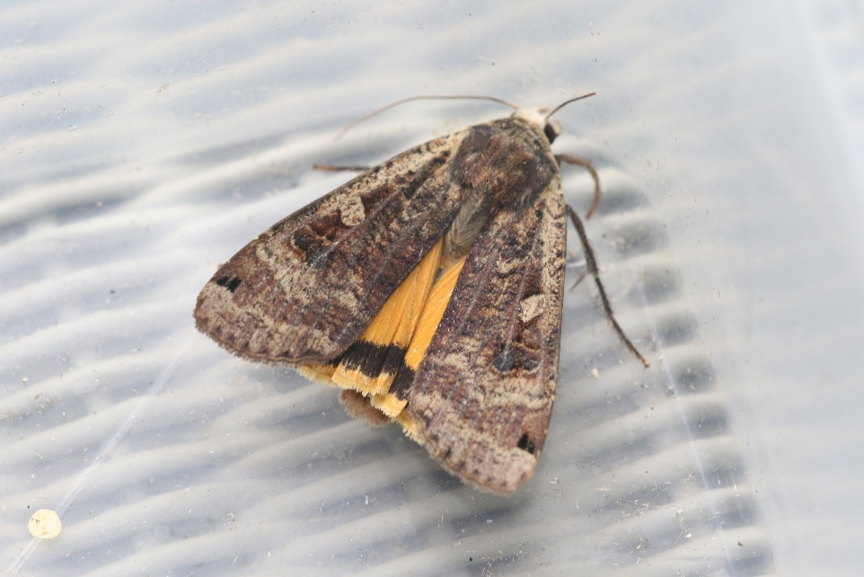

Photo – Large Yellow Underwing – Peter Scott

Humid nights in late July and early August were productive, with totals of over 60 species being recorded from two traps, but otherwise this was a slightly below average year for numbers although the range of species held up well. Numbers of common species such as Large Yellow Underwing and Setaceous Hebrew Character were much lower than usual with no individual counts in a trap of any species exceeding 50. As is becoming regular now footman moth numbers were good with Scarce Footman being the most commonly recorded (more so this year than Common Footman) although Buff Footman, which the recently published Atlas of Larger Moths shows as increasing in abundance in Britain and Ireland by 84,589% since 1970, was only seen individually on four occasions! The earlier occurring Orange Footman was also recorded for the first time since 2017. All footman moths are specialist feeders on lichens so while their drab appearance causes them to slip under the radar, they are key indicators of air quality. The most significant Lyndon appearance in this respect however was a first record of the Tree-lichen Beauty in the woodland trap on 7 August, one of seven macro moths recorded for the first time at the site. First recorded in VC55 in 2018, this was a moth being recorded in a variety of locations in 2019 and its occurrence has probably become even more frequent in 2020 with at least four sites in Rutland recording them. Its movement in an increasingly northerly and westerly direction makes it an indicator of climate change as well as air quality so its future numbers will be of interest to local recorders. It should also be mentioned that both Square-spotted Clay and Least Carpet were recorded regularly during the year and appear to be establishing themselves in the county,

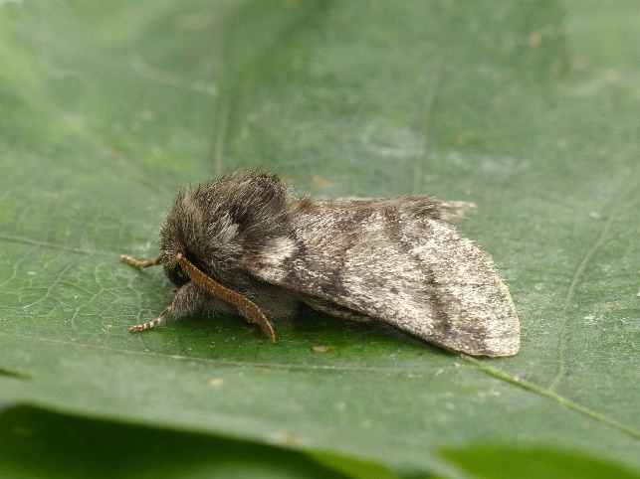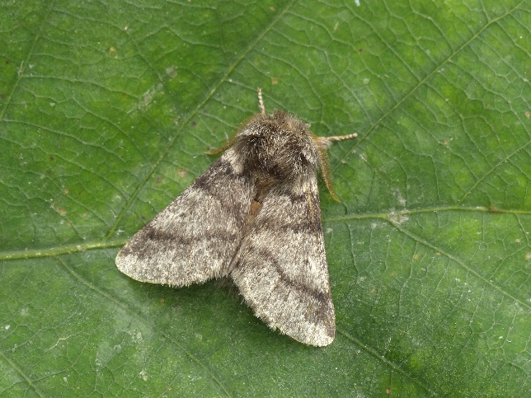

Photo – Oak Processionary Moth – Adrian Russell

The other major highlight of the year was a first VC55 record for the Oak Processionary Moth on 30 July. This moth is classed as both an immigrant and a naturalised adventive (accidentally introduced as an egg) and as a serious pest within the EU and can be occasionally encountered in swarms in the southern half of England. It probably appeared as part of an influx from the continent over the previous few days as apparently a number were recorded in Northamptonshire on the same night. Its deserved pest status stems from its larval behaviour, with large plagues of them feeding mainly on deciduous oak trees, potentially killing them while its hairs, which are easily shed, can cause severe and sometimes permanent skin irritation. One record should therefore be sufficient and from my experience of seeing it in the Spanish Pyrenees as a moth strongly attracted to light traps there is reason to believe that is the case in this instance. Another moth of interest and in the same trap on that night was Waved Black which is a moth of local D status - rare or rarely recorded in the county. The other first macro records were March Moth, Slender Pug, Antler Moth and Latticed Heath, the latter being unusual both as a rarer second brood moth and as it is more usually seen as a day-flyer in the spring.

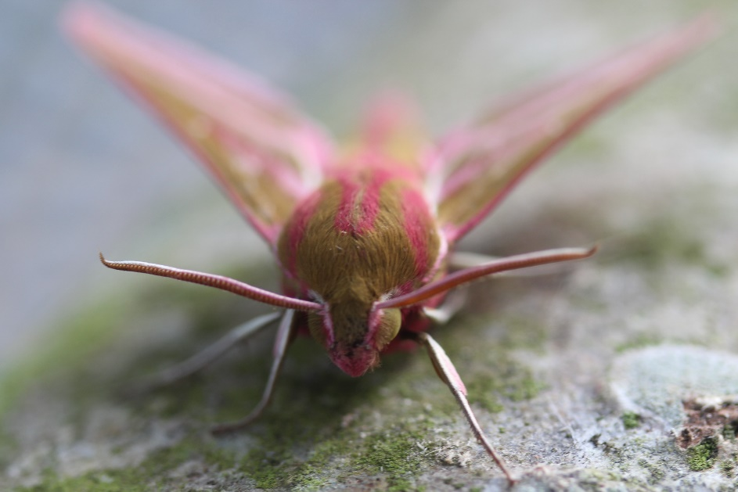

Photo – Elephant Hawk-moth – Brian Webster

As mentioned previously and in my recorder notes many moths went unrecorded in 2020, including most Hawk-moths although mention should be made of 9 Poplar Hawk-moths recorded during the year, whose flight season is usually longer than others of this group. Generally, immigrant moth numbers, especially Silver Y’s, were low this year.

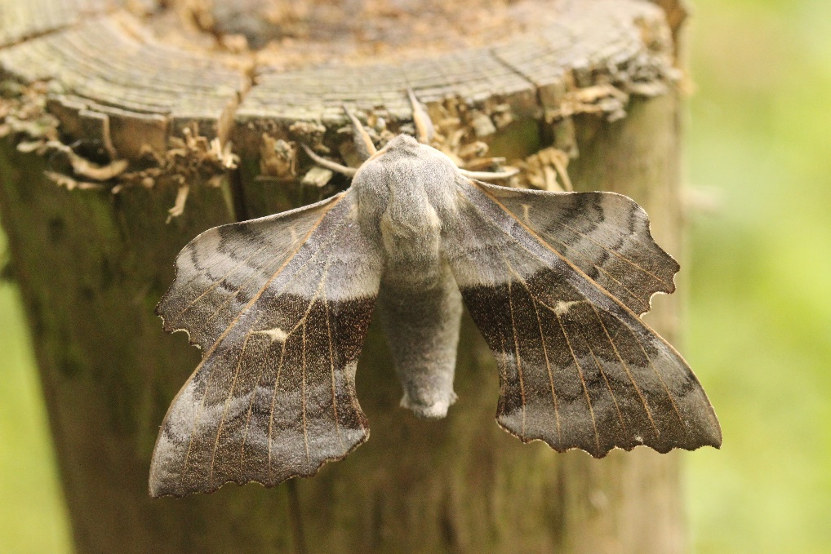

Photo – Poplar Hawk-moth – Brian Webster

Hopefully 2021 will be a better year both for moth recording at Lyndon and in every other respect.

SPECIES | LOCATION | GRID REF | NUMBERS | DATE | COMMENTS
MACRO MOTHS
Orange Underwing | Pickworth Wood | 985148SK | 1 | 16th April
Angle Shades | Oakham |  | 1 | 1st May
Common Carpet | Bloody Oaks | 975110SK | 1 | 5th May
Common Heath | Ketton Quarry | 978054SK | 6 | 14th May
Burnet Companion | Bloody Oaks | 975110SK | 5 | 26th May
Mother Shipton | Bloody Oaks | 975110SK | 1 | 26th May
Mullein | Wing Allotment |  | 1 | 27th May | caterpillar
Cinnabar | Wing Allotment |  | 1 | 28th May
6-Spot Burnet | Cottesmore | 903137SK | 1 | 28th May
Silver-ground Carpet | Barrow | 893150SK | 1 | 29th May
6-Spot Burnet | Ketton Quarry | 978054SK | 1 | 29th May | f flava
Chimney Sweeper | Merry's Meadows | 933157SK | 150 | 3rd June
Yellow Shell | Barrow | 893150SK | 1 | 8th June
Cinnabar | Barrow | 893150SK | 1 | 9th June
Hornet Moth | Ketton | 980055SK | 2 | 9th June
Chimney Sweeper | Empingham |  | 1 | 14th June
6-Spot Burnet | Empingham |  | 1 | 14th June
Garden Carpet | Wing Allotment |  | 1 | 16th June
Chimney Sweeper | Barrow | 893150SK | 1 | 16th June
Large Yellow Underwing | Wing |  | 1 | 23rd June
Mullein | Uppingham |  | 1 | 24thJune | caterpillar
Flame Shoulder | Barrow | 893150SK | 1 | 28th June
Scarlet Tiger | Manton |  | 1 | 29th June
Hummingbird Hawk-moth | Barrow | 893150SK | 1 | 30th June
Vapourer | Pickworth Wood | 985148SK | 1 | 12th July
Scarlet Tiger | Market Overton | 885164SK | 1 | 13th July
Elephant Hawk-moth | Wing Allotment |  | 1 | 29th July | Caterpillar
Silver Y | Manton |  | 1 | 22nd August
Hummingbird Hawk-moth | Manton |  | 1 | 23rd August
Silver Y | Bloody Oaks | 975110SK | 1 | 1st September
Large Yellow Underwing | Oakham |  | 1 | 2nd September
MICRO MOTHS
Light Brown Apple Moth | Oakham |  | 1 | 24th April
Pammene aurana | Wing Allotment |  | 1 | 26th May
Beautiful Plume | Oakham |  | 1 | 20th June
Diamond-back Moth | Manton |  | 1 | 20th June
Diamond-back Moth | Wing Allotment |  | 1 | 22nd June
Nettle-tap | RW Egleton | 878067SK | 1 | 12th October
Ruby Tiger | Hambleton | 922067SK | 1 | 17th November | Caterpillar
Red Underwing | Uppingham |  | 1 | 14th November | Dead when submitted

