Rutland Natural History Society

ANNUAL REPORT: MOTHS Recorder: Paul Bennett

Surveying started late this year with Covid restrictions and unsuitable overnight weather effectively preventing trapping at Lyndon until early June, making this the second year running where, following on from the lockdown spring of 2020, early season moths went more or less unrecorded. The cold spring conditions may also have been a prime reason why moth numbers were lower than in recent years with larvae struggling to find enough food.
After ten years of recording at Lyndon new moths for the site are hard to come by, with the majority of new species being micro moths and leaf miners, although a first record of Clifden Nonpareil was undoubtedly the year’s highlight. Numbers of this beautiful moth seem to be on the rise and more appearances of it are something to look forward to in the years ahead. The total list of species recorded at Lyndon now stands at over 400. Other moths worthy of note were White-point and Gem, the former recorded at a number of sites in Rutland while the latter was recorded in Shacklewell Spinney as part of an influx brought on by continental wind drift in early June. Square-spotted Clay and Least Carpet were again recorded in small but regular numbers at all sites, so can now be assumed to be breeding in the county. Other species are likely to arrive from southern and western areas in future years and gradually become established in the county, while species breeding here at the southern extremities of their range may soon be lost. It will also be interesting to see how moths respond in future years to the planting of extra trees and hedgerows in our county which is already beginning as part of nature’s recovery programme.
Bloody Oaks and Shacklewell Spinney were again utilised although only three sessions were possible at Shacklewell as the site was regularly used by groups in the summer vacation. A new site was added this year, by the consent of the owner, with the garden of a house situated by the entrance to Clipsham Park Wood being trapped on two occasions and it is hoped that this site can be used again next year. Another feature of the year was a moth bio-blitz held at the northern end of Egleton reserve at the end of July. In total 184 species were recorded in the areas around lagoons 3 and 4 of the reserve and provisional arrangements have been made to record the southern end and the whole of Lyndon reserve in this way during 2022.
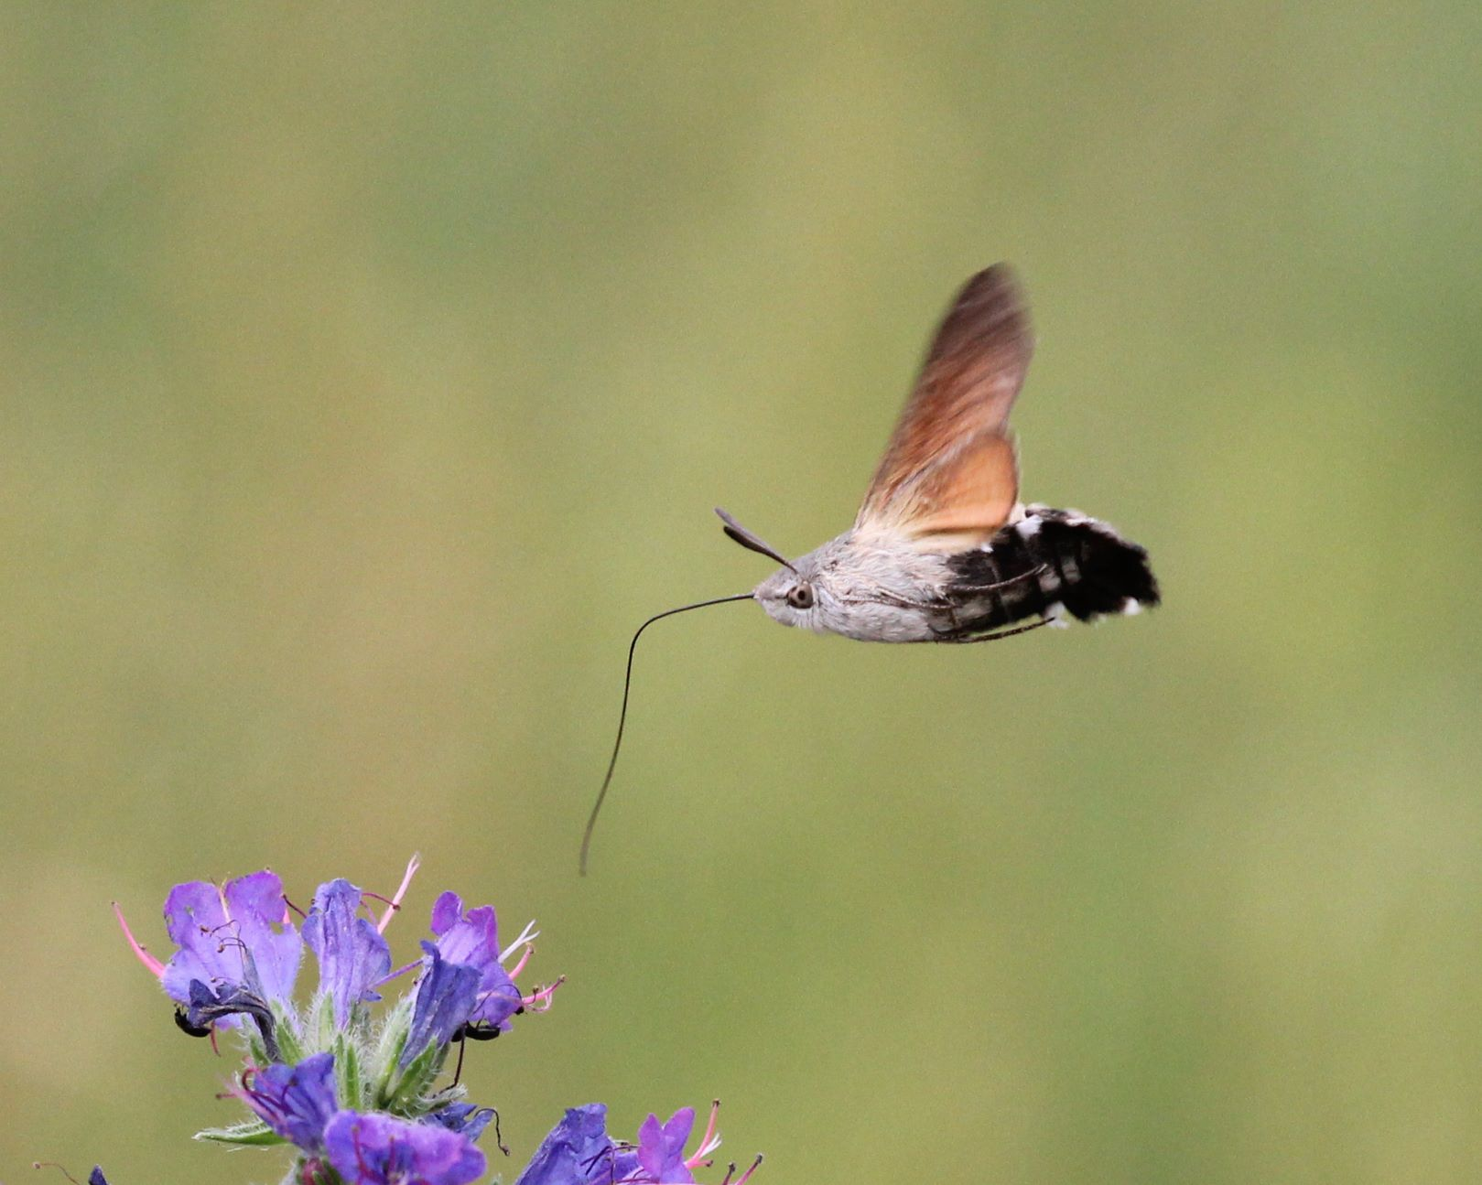
Garden traps were run by members in Oakham, Exton and Uppingham and a number of casual records were received, with the sightings of an Orange Underwing at Lyndon in April and a Hummingbird Hawk-moth in November being notable. The latter species was also regularly seen on the wing in Manton in October.
The Recorder would like to thank everyone who submitted records during 2021.

ANNUAL REPORT OF MOTHS TRAPPED AT BLOODY OAKS, 2021 | 6/10 | 6/30 | 7/21 | 8/10 | 10/8 | TOTAL
TRAP USED 20W BATTERY OPERATED MV
RECORDER: PAUL BENNETT
MAP REF 973108SK
MACRO MOTHS
Common Swift | 3 |  |  |  |  | 3
Lackey | 1 |  | 4 |  |  | 5
Drinker |  |  | 1 |  |  | 1
Poplar Hawk-moth | 1 |  |  |  |  | 1
Privet Hawk-moth |  | 2 |  |  |  | 2
Pine Hawk-moth |  |  | 2 |  |  | 2
Elephant Hawk-moth |  | 1 |  |  |  | 1
Least Carpet |  |  | 1 | 1 |  | 2
Single-dotted Wave |  |  |  | 1 |  | 1
Small Fan-footed Wave |  |  | 1 |  |  | 1
Riband Wave |  | 1 | 2 | 7 |  | 10
Blood-vein |  | 1 | 3 |  |  | 4
Shaded Broad-bar |  |  | 9 | 4 |  | 13
Red Twin-spot Carpet |  |  |  | 2 |  | 2
Silver-ground Carpet |  | 1 |  |  |  | 1
Common Carpet |  | 1 |  | 2 |  | 3
July Highflyer |  |  |  | 1 |  | 1
Spruce Carpet |  |  |  |  | 2 | 2
Grey Pine Carpet |  |  |  |  | 11 | 11
Purple Bar |  |  | 1 |  |  | 1
Barred Straw |  | 1 |  |  |  | 1
Red-green Carpet |  |  |  |  | 2 | 2
Common Marbled Carpet | 1 |  |  |  |  | 1
Green Carpet | 8 | 1 |  |  |  | 9
November Moth agg |  |  |  |  | 1 | 1
Double-striped Pug |  |  | 1 |  |  | 1
V-Pug |  |  | 1 |  |  | 1
Maple Pug |  |  |  | 1 |  | 1
Brindled Pug |  | 1 |  |  |  | 1
Lime-speck Pug |  |  |  | 5 |  | 5
Common Pug | 4 |  |  |  |  | 4
Mottled Pug | 1 |  |  |  |  | 1
Grey Pug |  |  |  | 1 |  | 1
Scorched Carpet |  |  | 2 | 2 |  | 4
Tawny-barred Angle |  |  |  | 2 |  | 2
Latticed Heath | 1 |  |  | 1 |  | 2
Scorched Wing | 1 |  |  |  |  | 1
Brimstone Moth |  |  |  | 1 |  | 1
Scalloped Oak |  |  | 2 |  |  | 2
Willow Beauty |  |  | 3 | 3 |  | 6
Mottled Beauty |  | 1 |  |  |  | 1
Engrailed |  |  | 1 |  |  | 1
Clouded Silver |  |  | 1 |  |  | 1
Buff-tip |  |  | 1 |  |  | 1
Straw Dot |  |  | 1 | 3 |  | 4
Black Arches |  |  |  | 4 |  | 4
Brown-tail |  |  | 1 |  |  | 1
Yellow-tail |  |  | 3 | 1 |  | 4
Pale Tussock | 1 |  |  |  |  | 1
White Ermine | 2 |  |  |  |  | 2
Ruby Tiger |  |  | 1 | 5 |  | 6
Cinnabar |  |  | 1 |  |  | 1
Muslin Footman |  |  | 4 |  |  | 4
Buff Footman |  |  | 2 |  |  | 2
Dingy Footman |  |  | 7 | 8 |  | 15
Common Footman |  |  | 2 | 1 |  | 3
Scarce Footman |  |  | 12 | 9 |  | 21
Small Fan-foot | 1 |  |  |  |  | 1
Spectacle | 1 |  |  |  |  | 1
Silver Y | 1 |  |  |  | 1 | 2
Plain Golden Y |  | 1 |  |  |  | 1
Knot Grass | 1 |  |  | 1 |  | 2
Coronet | 1 | 2 |  |  |  | 3
Copper Underwing sp |  |  |  | 3 |  | 3
Mouse Moth |  |  |  | 2 |  | 2
Green-brindled Crescent |  |  |  |  | 2 | 2
Mottled Rustic |  |  | 13 |  |  | 13
Rustic/Uncertain agg |  | 2 | 3 |  |  | 5
Treble Lines | 11 | 1 |  |  |  | 12
Brown Rustic | 7 | 7 |  |  |  | 14
Straw Underwing |  |  |  | 2 |  | 2
Dusky Sallow |  |  | 1 | 4 |  | 5
Flounced Rustic |  |  |  | 3 |  | 3
Large Nutmeg | 5 |  |  |  |  | 5
Dark Arches |  | 1 |  |  |  | 1
Common Rustic agg |  |  | 1 | 3 |  | 4
Middle-barred Minor |  | 1 |  |  |  | 1
Barred Sallow |  |  |  |  | 2 | 2
Beaded Chestnut |  |  |  |  | 2 | 2
Dun-bar |  |  | 1 | 6 |  | 7
Brown-line Bright-eye |  |  | 2 |  |  | 2
Pale-shouldered Brocade | 1 |  |  |  |  | 1
Common Wainscot | 1 | 3 | 10 | 2 |  | 16
Clay | 1 |  | 1 |  |  | 2
Shoulder-striped Wainscot | 1 |  |  |  |  | 1
Heart and Club | 1 |  |  |  |  | 1
Ingrailed Clay | 1 |  |  |  |  | 1
Flame Shoulder |  |  |  | 3 |  | 3
Large Yellow Underwing |  |  |  | 16 |  | 16
Broad-bordered Yellow Underwing |  |  |  | 1 |  | 1
Lesser Yellow Underwing |  |  | 1 |  |  | 1
Lesser Broad-bordered Yellow Underwing |  |  |  | 2 |  | 2
Square-spotted Clay |  |  |  | 1 |  | 1
Square-spot Rustic |  |  | 2 | 1 |  | 3
Setaceous Hebrew Character | 2 |  |  | 5 | 1 | 8
Short-cloaked Moth |  |  | 3 |  |  | 3
MICRO MOTHS
Bird-cherry Ermine |  |  | 1 |  |  | 1
Carcina quercana |  |  |  | 1 |  | 1
Ethmia dodecea |  | 2 | 1 |  |  | 3
Blastobasis adustella |  |  |  | 2 |  | 2
Agapeta hamana |  |  |  | 1 |  | 1
Agapeta zoegana |  | 1 | 1 |  |  | 2
Acleris forsskaleana |  |  | 2 | 3 |  | 5
Bramble Shoot Moth |  |  | 1 |  |  | 1
Eucosma cana |  |  | 1 |  |  | 1
Bud Moth |  |  |  | 1 |  | 1
Chrysoteuchia culmella |  |  | 2 |  |  | 2
Agriphila straminella |  |  |  | 1 |  | 1
Agriphila tristella |  |  |  | 2 |  | 2
Water Veneer | 1 |  | 6 | 2 |  | 9
Scoparia pyralella | 2 |  | 1 |  |  | 3
Eudonia lacustrata |  |  | 1 |  |  | 1
Ringed China-mark |  |  | 4 |  |  | 4
Garden Pebble |  |  |  | 1 |  | 1
Pyrausta aurata |  |  |  | 2 |  | 2
Pyrausta purpuralis |  |  |  | 1 |  | 1
Sitochroa verticalis |  |  | 1 |  |  | 1
Anania coronata |  |  | 1 |  |  | 1
Mother of Pearl |  |  | 1 | 7 |  | 8
Endotricha flammealis |  |  | 1 | 1 |  | 2
Acrobasis suavella |  |  | 1 |  |  | 1
Acrobasis advenella |  |  | 1 | 1 |  | 2
Brown Plume |  | 1 |  |  |  | 1
Common Plume |  |  | 2 |  |  | 2
Ermine agg |  |  |  | 4 |  | 4

