Rutland Natural History Society
MOTHS: ANNUAL REPORT, 2022 Recorder: Paul Bennett
During 2022, a quiet spring period preceded a warm summer with plenty of opportunities for trapping until late October. However, with many food plants prematurely dying off during hot, dry periods, this may result in reduced numbers in 2023, particularly with micro moths that are more reliant on flowers and shrubs for their life cycle.
More moths were added to the site list around Lyndon Centre which now stands at 291 macro moths and 135 micro moths recorded there since 2012. Fourteen traps were run from the meadow attracting 158 macro and 40 micros with 88 macros and 19 micros from the ten that were run from the adjoining wooded area. The new macros were Red Chestnut, Pale Pinion, Green Silver-lines, Oak Hook-tip and Dark Chestnut with the only surprise being that these species have gone unrecorded until now, being relatively common. Maple Prominent and Pearly Underwing were recorded for the first time in several years. Four species, Least Carpet, White-point, Tree-lichen Beauty and Square-spotted Clay, once very rare in the county are now firmly established, with the latter species even being recorded in double figures in one session in August. Ten new micro moths were identified on site. On 20 August a successful bio-blitz took place, mainly around Lyndon reserve, but also in Cherry Wood and Lax Hill. A total of 3081 moths of 158 species was found including six migrants, eight species of wainscot moth and nine moths that were new to Rutland Water.
Bloody Oaks was trapped on four occasions in summer with 98 species identified in total, and Shacklewell Spinney on three occasions with 87 species identified. It was hoped to run a trap at both Clipsham Wood and Wing Water Treatment Works but these proved difficult to arrange at a suitable time. It should be possible to include Clipsham on our agenda next year.
The one area of concern, not just in our county but nationwide, is the decline in numbers especially of some of our most common moths. The range of species remains fairly constant and in some species the distribution levels are increasing but overall abundance is decreasing, sometimes by a large percentage. The three most recorded moths at Lyndon were Common Wainscot, Large Yellow Underwing and Setaceous Hebrew Character with year counts of 77, 66 and 64 respectively. The highest count for a single species on one night was 42 Setaceous Hebrew Character on 20 August. This contrasted with century counts of these and other species in previous years.
Migrant numbers were varied with Diamond-back Moth and Silver Y reported in low numbers, with the latter species unrecorded in traps at Lyndon for the first time, unlike its close cousin and resident Plain Golden Y. On the other hand, Pearly Underwing, Bordered Straw and Rusty-dot Pearl all appeared while Hummingbird Hawk-moth enjoyed a bumper year with reports received from several sites.
Finally, I would like to thank all members of the Society who sent me their records.

MACRO MOTHS
Pale Pinion | Lithophane socia | RW Lynd | Meadow | SK894055 | 1 | 27/03/22
Red Chestnut | Cerastis rubricosa | RW Lynd | Meadow | SK894055 | 3 | 27/03/22
Vapourer | Orgyia antiqua | RWGgorse |  | SK902057 | 1 | 19/05/22
Meal Moth | Pyralis farinalis | Oak | house wall | SK856081 | 1 | 12/06/22
Green Silver-lines | Pseudoips prasinana | Ext | Garden | SK127109 | 1 | 17/06/22
Scarlet Tiger | Callimorpha dominula | Emp | house | SK953087 | 1 | 26/06/22
Four-dotted Footman | Cybosia mesomella | BOQ | Meadow | SK970108 | 1 | 03/07/22
Buff Arches | Habrosyne pyritoides | RWLynd | Meadow | SK894055 | 16 | 10/07/22
Maple Prominent | Ptilodon cucullina | RWLynd | Meadow | SK894055 | 1 | 10/07/22
Coronet | Craniophora ligustri | ShkwS | Lawn | SK975073 | 26 | 11/07/22
Blackneck | Lygephila pastinum | BOQ | Meadow | SK970108 | 1 | 13/07/22
Black Arches | Lymantria monacha | BOQ | Meadow | SK970108 | 5 | 31/07/22
Pale Eggar | Trichiura crataegi | BOQ | Meadow | SK970108 | 2 | 31/07/22
August Thorn | Ennomos quercinaria | Ext | Garden | SK127109 | 1 | 01/08/22
Pearly Underwing | Peridroma saucia | Ext | Garden | SK127109 | 1 | 01/08/22
Flounced Rustic | Luperina testacea | RWLynd | Meadow | SK894055 | 20 | 10/08/22
Dusky Thorn | Ennomos fuscantaria | RWLynd | Meadow | SK894055 | 18 | 20/08/22
Red Underwing | Catocala nupta | Man | wall |  | 1 | 30/08/22
Oak Hook-tip | Watsonalla binaria | RWLynd | Meadow | SK894055 | 1 | 31/08/22
Feathered Thorn | Colotois pennaria | Oak | Garden | SK840708 | 1 | 27/10/22
Merveille du Jour | Griposia aprilina | Oak | Garden | SK840708 | 1 | 27/10/22
White-point | Mythimna albipuncta | RWLynd | Meadow | SK894055 | 1 | 30/10/22
Hummingbird Hawk-moth | Macroglossum stellatarum | Man | Garden |  | 1 | 07/11/22 | 7 other locations in 2022
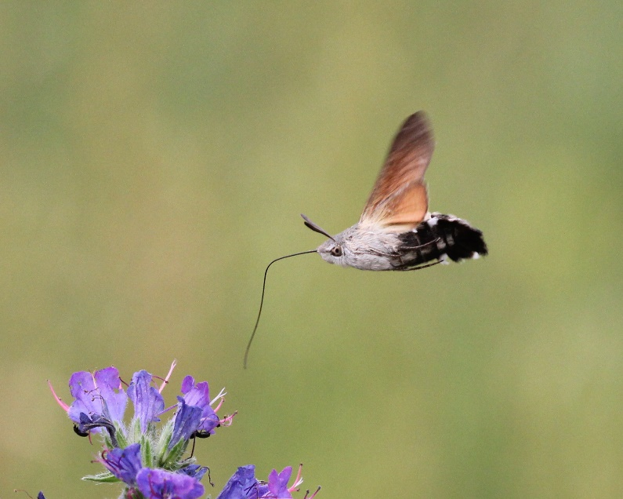
Photo Hummingbird Hawk-moth © Peter Scott

