Rutland Natural History Society

ORTHOPTERA ANNUAL REPORT 2022 Recorder: Phil Rudkin

Rutland Orthopterans had a reasonable season in 2022. As always, the May reports consisted of sightings of nymphs, with photographs sent in by Tim Caldicott and Carolyn Baxter.
First stridulating was heard from a Common Green Grasshopper, on 16 June, at Leighfield. A large colony of Roesel’s Bush Crickets was very early this year, with adults stridulating in a rough field adjacent to Ketton Quarry on 22 June. Research going back to 2018 showed no Roesel’s Bush Crickets have previously been heard so early in Rutland.

The RNHS were invited to survey the wildlife in the private grounds of the Wing Water Treatment Works on 21 July. The Society’s wildlife recorders and guests, (Steve Woodward and Helen Ikin), from Loughborough Naturalists Society, scoured the mixed habitats for any wildlife and botanical species. Anglian Water staff, at the end of the survey, provided an excellent lunch.

The Rutland Water surveys were carried out at Egleton reserve on 16 August, followed by the Lyndon reserve on 19 August, and finally back at the Egleton reserve on 1 September.

Although Rutland had no new orthopteran species in 2022, we did have some interesting reports from new sites. There were exciting appearances of two more Southern Oak Bush Crickets, following on from the first for Rutland in Empingham on 24 October 2019.
Another private woodland was Hebe’s Wood, where the owners asked The Society for a full survey, which we duly carried out on 9 June.

The new sites and habitats in the 2022 season are listed below:

Rutland Water, Egleton reserve: Cherry Wood
Gibbet Gorse Meadow
Ketton Quarry, Panter’s Wood
Hebe’s Wood
Ryhall playing fields

Regular sites: The Wing Village Allotments as usual were well covered by Linda Clark and Tim Caldicott. Other sites visited included: Ketton Quarry. Verge 7, Great Casterton, Quarry Farm and Bloody Oaks Quarry reserve SSSI.

Species list: The normal procedure for this Annual Report is to list any new sites and unusual happenings.

Bush Crickets

Southern Oak Bush Cricket Meconema meridionale
One male, found on a car windscreen, in a member’s garage, Oakham, was only the second to be found in Rutland. This was a new site: 28 August, SK864098. Photograph supplied.
One female, observed by a member on a friend’s coat, at the western edge of Hambleton Wood, was the third record for Rutland at another new site: SK906069, 16 October. Photograph supplied.

Dark Bush Cricket Pholidoptera grisoaptera
Fifty plus early instar nymphs were recorded on the summer trail, Rutland Water Egleton reserve, 2 May 2022. Regular site, one nymph, in a grass verge, Barrowden, new site: SP946006 on 13 May. Six stridulating males were recorded in a bramble patch at the top end of the footpath, Panter’s Wood, new site: SK966053 on 8 September.

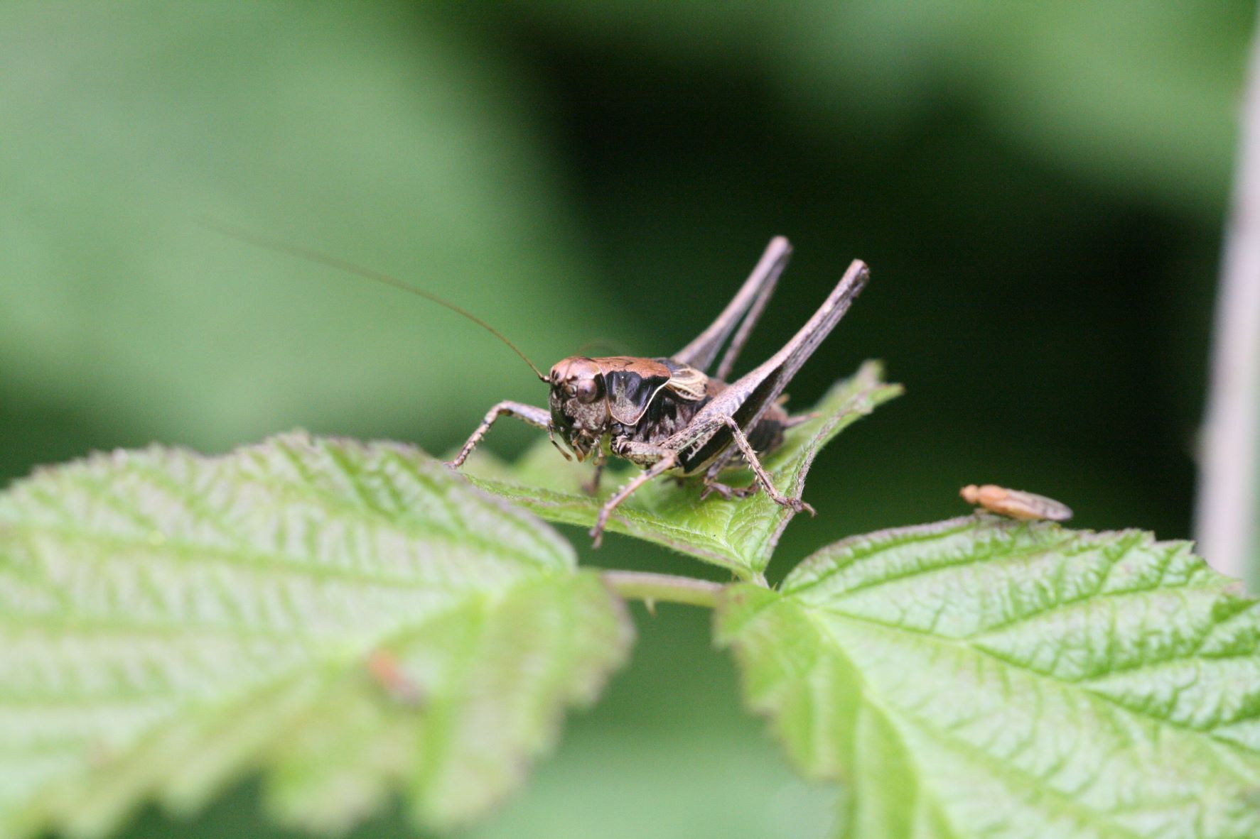

Photo - Dark Bush Cricket © Peter Scott

Roesel’sBush Cricket Roeseliana roeselii,
Five nymphs were observed at a new site in Gibbet Gorse Meadow on 7 June, at SK902057. There was a very early record of six-plus stridulating males in tall meadow grass adjacent to Ketton Quarry, SK978052 on 22 June.
There was a large colony in a small patch of tall grasses at Wing Water Treatment Works, Wing, SK897028 on 21 July.
Another new site contained large colonies on grass paths between trees in Cherry Wood, Rutland Water Egleton reserve, behind the Volunteer Training Centre, at SK886082 on 16 August. Large colonies were located in Gibbet Gorse Meadow, a new site for the species at
SK902059, on 19 August. Large colonies of stridulating males were in lush roadside verges at the entrance to Panter’s Wood, a new site, SK966053 on 8 September.

Long-winged Conehead Conocephalus fuscus
Large colonies of stridulating males were recorded on grass paths between trees at Cherry Wood, Rutland Water Egleton reserve, a new site: SK886082, 16 August.
Large colonies were located in the lush grasses of Gibbet Gorse Meadow, a new site at SK902059, on 19 August.
A large colony of stridulating males was recorded in lush grasses between a tree plantation and roadside at Panter’s Wood. New site, SK966053, 8 September.

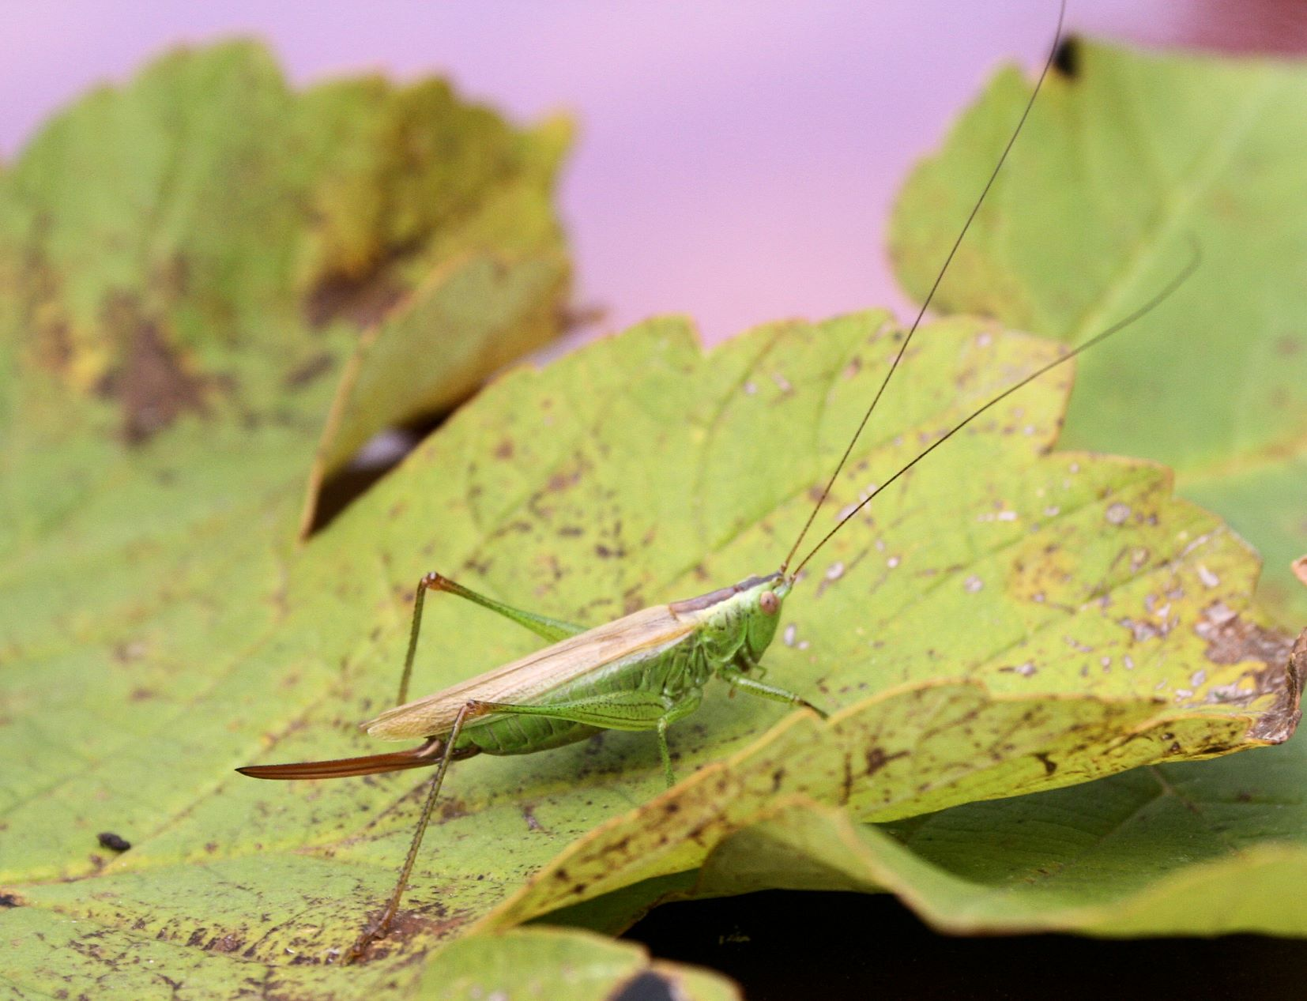

Photo - Long-winged Conehead © Peter Scott

Speckled Bush Cricket Leptophyes punctatissima
High numbers were heard in the trees and bushes of Cherry Wood, Rutland Water Egleton reserve. New site, SK886082, 16 August.
Very large colonies, everywhere, in trees and shrubs, outside the entrance to Panter’s Wood, a new site at SK966053, 16 August.
Ten plus stridulating males were heard in trees surrounding Ryhall Playing Fields, a new site for the species, TF037105, on 18 September.

Groundhoppers

Slender Groundhopper Tetrix subulata
Four nymphs were located in Gibbet Gorse Meadow, a new site for the species, SK900056, 30 April.
One adult was found in an open area at Gibbet Gorse Meadow, a new site, SK902057 on 7 September.

Grasshoppers

Common Green Grasshopper Omocestus viridulus
Five stridulating males were in lush meadows at Leighfield on 16 June. Although this is a regular site, it is important to record a declining species.

Field Grasshopper Chorthippus brunneus
One bedraggled adult was found in an open area at the outside edge of Panter’s Wood, a new site for the species at SK966053, on 8 September.

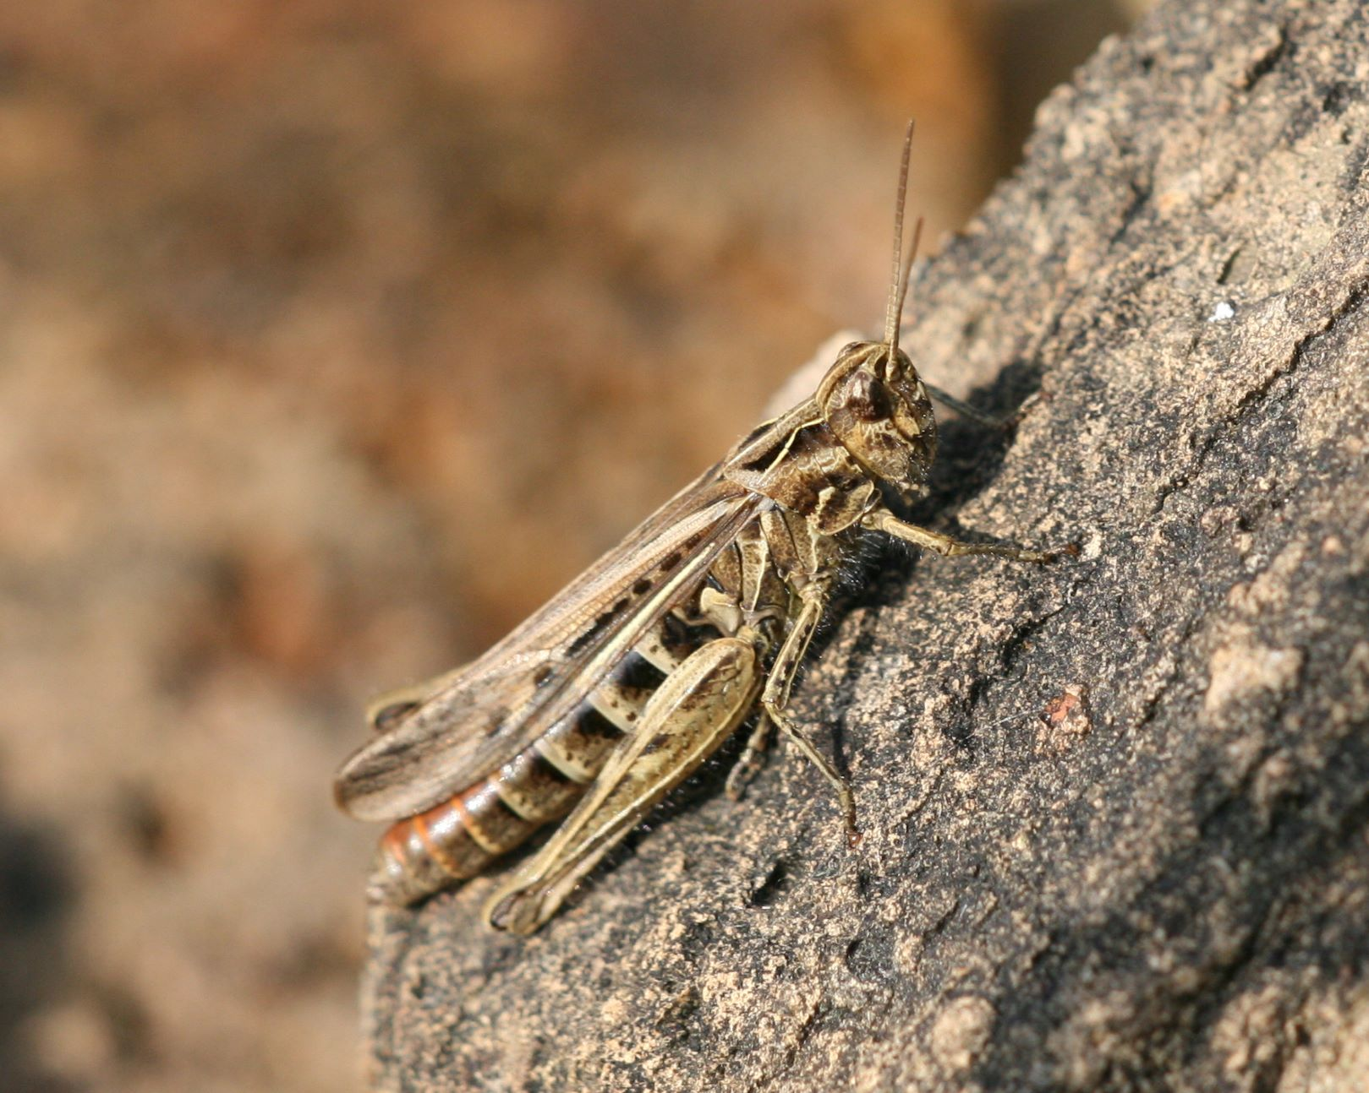

Photo - Field Grasshopper © Peter Scott

Meadow Grasshopper Chorthippus parallelus
One poor specimen, observed at the edge of Panters Wood, was at a new site for this species, at SK966053 on 8 September.

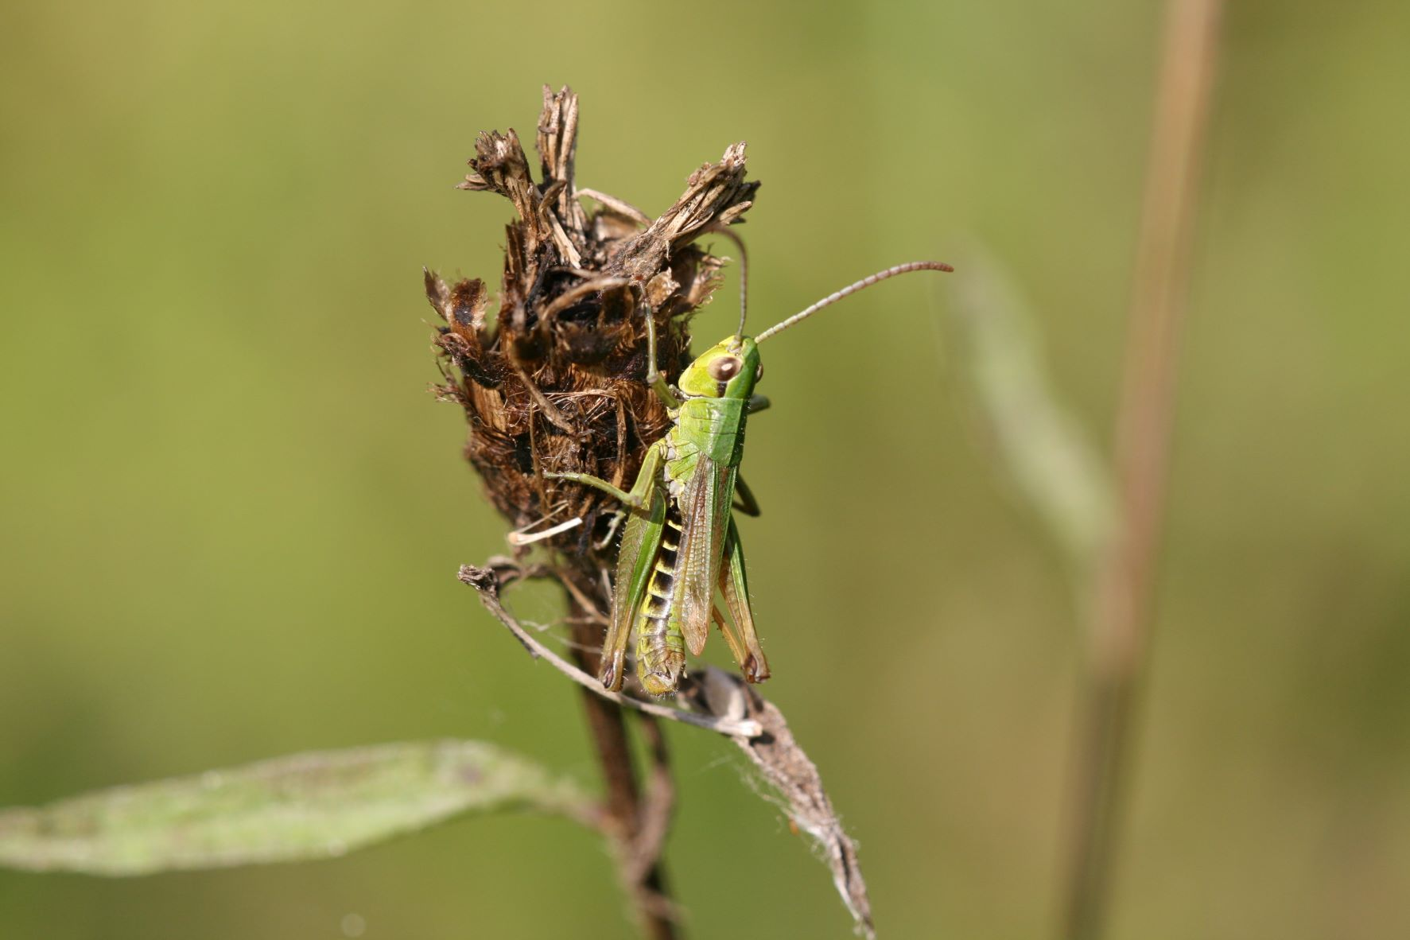

Photo - Meadow Grasshopper © Peter Scott

Many thanks to my reporters for their records and photographs during season 2022:
Carolyn Baxter, Tim Caldicott, Linda Clark, Diana Masters, Tessa Mitchell, David Needham,
Phil Rudkin, Tim Sexton.

Compiled by: Phil Rudkin, 10. Brooke Avenue, Stamford. PE9 2RU
Email: phil.rudkin@talktalk.net
Tel: 01780 762998

