Rutland Natural History Society
ORTHOPTERA ANNUAL REPORT, 2023 Recorder: Philip Rudkin

Compiled by: Phil Rudkin. 10, Brooke Avenue, Stamford, PE9 2RU.
Telephone: 01780 762998
Email: phil.rudkin@talktalk.net

In May 2023, there was little to report, as usual during this time of year. However, stalwarts of the Society (Tim Caldicott and Tim Sexton), managed to find a few species. The June/July period picked up steadily, despite the inclement weather conditions, with decent varied locations covered, for example: Manton village, Rutland Water, Lyndon Nature Reserve, Ketton Quarry, Wing Village Allotments, and Panter’s Orchard, adjacent to Ketton Quarry.

August and September was the busiest time of the season with David Needham and myself covering a large area of Rutland Water and Egleton Nature Reserve, which we missed in 2022. In September 2023, a new Rutland site was visited: two rough meadows containing the Leicestershire and Rutland Wildlife Trust (LRWT) sheep, next to Aldgate, Ketton.

SPECIES LISTS

Bush Crickets

Oak Bush Cricket Meconema thalassinum

One male, found in a member’s bedroom, Braunston, 18 August 2023, was a new site: SK832066.
One adult, found in a member’s back yard, St. Mary’s Road, Manton, 26 June 2023. Regular site.

Dark Bush Cricket Pholidoptera griseoaptera

Early instar nymphs were found in, Cherry Wood, Egleton Reserve, Anglia Bird Watching Centre summer garden, and the Summer Trail, near Grebe Hide, 15 May 2023.
Two Males found in rough herbage behind the Volunteer Training Centre (VTC), 23 August 2023. SK885082.
Small colony of six stridulating males, in the hedge of the LRWT Stable Field, Ketton, 6 September 2023, which was a new site at SK983042 .
Ten-plus stridulating males, recorded in rough pasture hedgerow, Verge 7, Great Casterton, 16 September 2023. New site: SK999106.

Roesel’s Bush Cricket Roeselina roeselii

A large colony of stridulating males, recorded in rich meadow grasses on the farm track, Lyndon Reserve, Rutland Water, 26 June 2023. Regular site.
Large colonies of stridulating male found in all parts of Ketton Quarry, 24 July 2023, regular sites.
The first Rutland Water survey took place at the Egleton Reserve, on 8 August 2023.
The second Rutland Water survey was on 23 August 2023, from the area behind Lagoon 4.
Large colonies were heard in all areas of regular sites (see Fieldfare issues during 2023).
Wing Burrows survey was on 19 August 2023. All the regular sites were full of this bush cricket, with the exception of a new site, in the Wing village playing fields, SK895028, where massive numbers were located!
Large colonies were present in very rough pasture, in the LRWT Priory Field, in Aldgate, Ketton, which was a new site: 6 September 2023, SK983042. A further new site with masses of stridulating males, was an area of lush grass verges, on Ingthorpe Road, Great Casterton, 16 September 2023, SK995077.
Other regular sites visited were: Verge 7, Great Casterton, and Lyndon Lane, Wing.

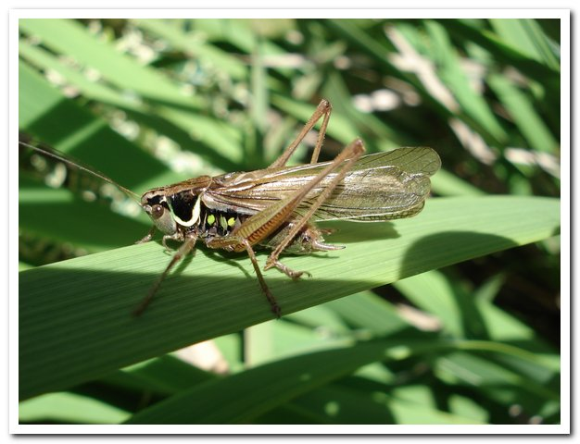
Photo Roesel’s Bush Cricket © Phil Rudkin

Long-winged Conehead Conochephalus fuscus

Many early instar nymphs were found in the Wing Village Allotments, on the regular site, 2 July 2023.
On the Wing Burrows survey, on 19 August 2023, large number of stridulating males were found in an uncut area of Wing playing fields, a new site: SK895028.
More new habitat sightings involved a large colony of stridulating males, in a very rough meadow, at the LRWT Stable Field: SK983042 and in the nearby LRWT Priory Field. SK983041. Both records were on 6 September 2023. Forty-plus males were heard in lush grass verges on Ingthorpe Road, Great Casterton, SK995077, 16 September 2023.
There were healthy numbers in the Rutland Water surveys, in Egleton and behind the VTC.

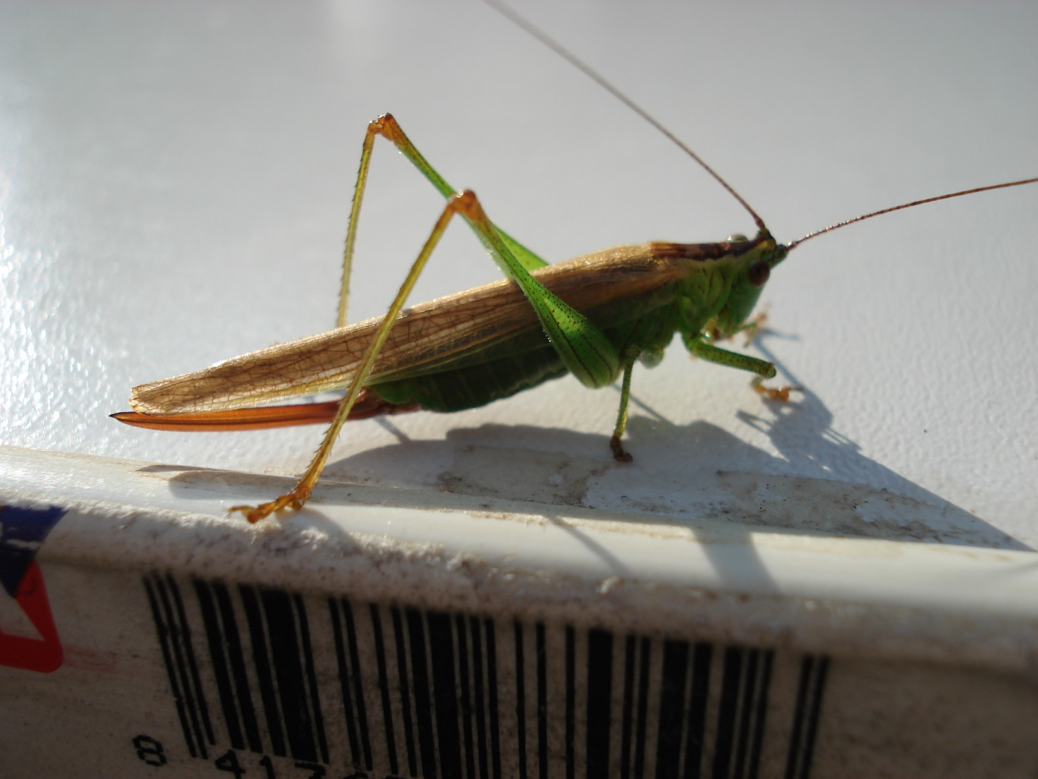

Photo Male Long-winged Conehead © Phil Rudkin
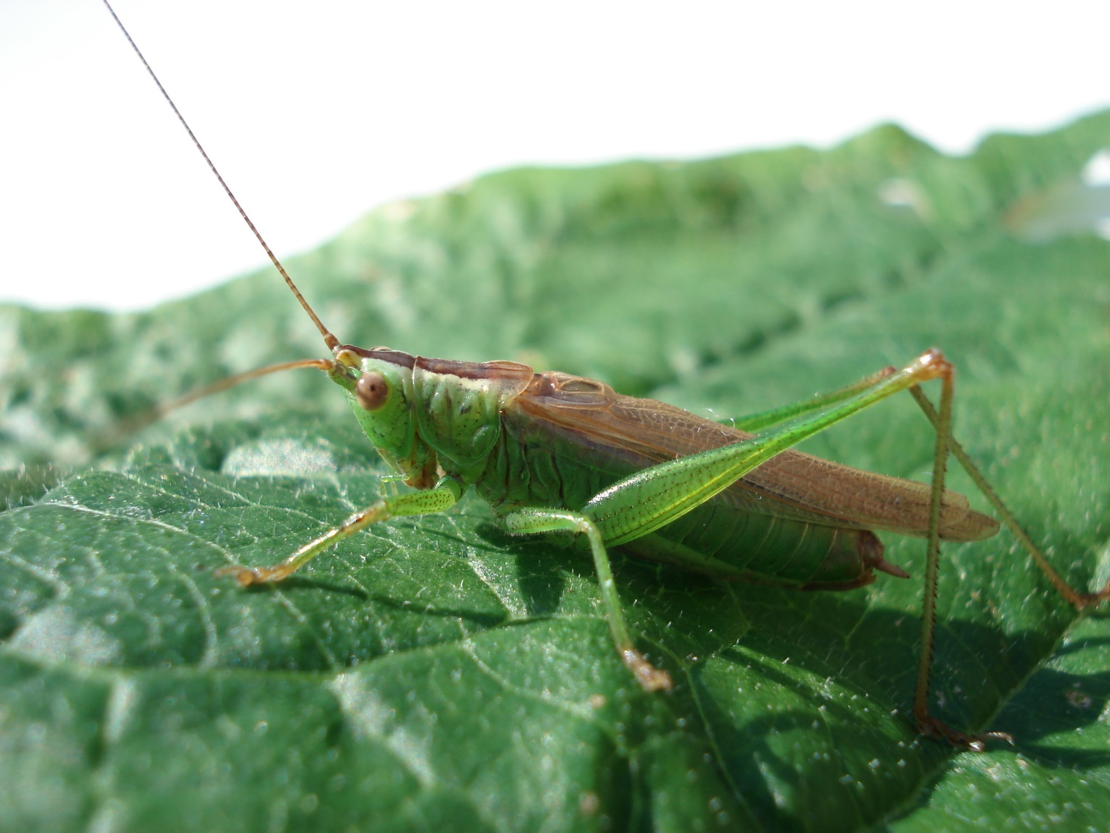

Photo Female Long-winged Conehead © Phil Rudkin

Speckled Bush Cricket Leptophyes punctatissima

One nymph, located in a lane near Pilton, 11 June 2023 was at a new site: SK914028.
Six, early instar nymphs, in neglected old orchard, Panter’s Orchard, next to Ketton Quarry, a
regular site: 27 June 2023. SK966053.
One female, found in a member’s kitchen, Braunston, 14 August 2023, was at a new site: SK832066.
Both of the LRWT sheep fields had large colonies of stridulating males in each field. These were new sites: Stable Field, SK983042, and Priory Field, SK963041, in Ketton.
Regular sites visited were Wing Village Allotments, Holygate road track, Leighfield.

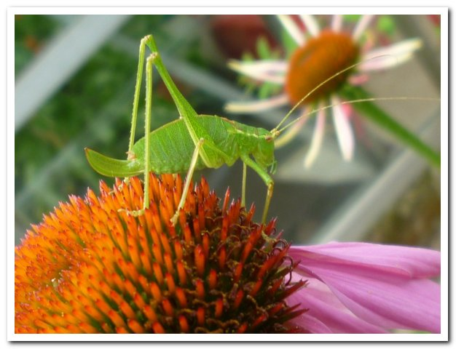
Photo Speckled Bush Cricket © Phil Rudkin

Groundhoppers

Slender groundhopper Tetrix subulata

One, observed near a ditch, on bare earth, on a footpath at Gunthorpe, 5 August 2023,
a new site: SK877056. Other regular sites visited had early instar nymphs, at Wing Village Allotments and in the Gwash valley at Martinthorpe on 20 May 2023.

Grasshoppers

Common Green Grasshopper Omocestus viridulus

Three stridulating males were located in Leighfield lush fields, 7 July 2023. This is a regular site of this declining species: SK825051.
There were two welcome reports of this species, at a late time for the grasshoppers, so no stridulating was heard: One observed in a grass verge, Holygate road track, Leighfield, 3 August 2023, new site: SK809032.
One was caught and identified in rough sheep pasture at LRWT Priory Field, Aldgate, Ketton. New site: SK983043.

Field Grasshopper Chorthippus brunneus

Four adults were caught and identified in a grass verge, outside Panter’s Wood, Ketton. Regular site, SK966053, 17 June 2023. One adult, in the Wing Village Allotments, was at a new site for the species: 27 June 2023, SK889028.

Meadow Grasshopper Chorthippus parallelus

The most common Grasshopper: a late instar nymph was recorded in a meadow at Eye Brook Reservoir, 9 July 2023, new site: SP853978. On the first Rutland Water survey at Egleton Reserve, 8 August 2023, a welcome late large colony of stridulating males was heard in the lush grasses outside the rear of Tern Hide, a new site: SK884066.
One female, observed on a wooden fence, in Lyddington Churchyard, 20 August 2023 at a new site,
SP876970. The second Rutland Water Egleton Survey, on 23 August 2023, revealed circa 25 stridulating males in lush grasses, on the high bank behind the VTC, a new site: SK885082.
Six stridulating males in rough sheep pasture, in the LRWT field at Aldgate, Ketton, a new site: SK983041, 6 September 2023.
Regular sites visited: Holygate road track, Leighfield, Wing Village Allotments.

Lesser Marsh Grasshopper Chorthippus albomarginatus

One late instar nymph and one adult recorded in meadow, Eye Brooke Reservoir, 12 July 2023, new site: SP859937.
Two, observed in grass verge, Holygate Road track, Leighfield, 3 August 2023, a new site: SK809032.
Four adults observed in rough sheep pasture, the LRWT Priory Field, Aldgate, Ketton, 6 September 2023, new site: SK983041.
Finally, one regular site visited: Wing Village Allotments where one adult and three nymphs were observed, 11 July 2023.

Thank you to my reporters for their welcome sightings in Rutland Orthoptera; and for their photographs.

Carolyn Baxter, Tim Caldicott, Tessa Mitchell, Tricia Marston, David Needham, Phil Rudkin, Tim Sexton.

Phil Rudkin,
1 April 2024

