Rutland Natural History Society

ORTHOPTERA REPORT 2021 Recorder: Philip Rudkin

Once again, the Covid 19 virus was still with us during 2021, but later in the year things were a little more relaxed than in 2020. However, I was not available for a big spell in 2021 and did not get going until the end of August. Tim Caldicott started the ball rolling, with an early report in March, of a Slender Groundhopper in the Wing village allotments. From that date, a sprinkling of reports came to me from regular sites, up to 28 September.

I would like to give special mention to the ever-dependable Tim Caldicott, and to the new Species and Recording Officer at Rutland Water, Tim Sexton. Tim carried out the only orthopteran survey for the Egleton reserve, in 2021. Many thanks to my reporters for their contributions of records and their splendid photographs: Carolyn Baxter, Tim Caldicott, Linda Clark, Marian Markham, Phil Rudkin, Tim Sexton and Sophie Widdowson.

Species List
My normal procedure for the Annual Report is to list any new sites, and for unusual happenings. However, due to small numbers in season 2021, some exceptions have been noted.

Bush Crickets

Dark Bush Cricket Pholidoptera griseoaptera
Early nymphs were observed with 25 plus in shrubbery, Stretton Woods, on 14 July, SK956170. Stridulating males: 14 in Bramble patches on Protected Verge 7, Great Casterton, 17 September, TF999101.

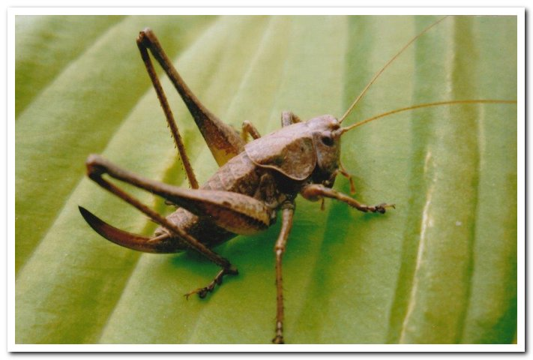

Photo Female Dark Bush Cricket © Phil Rudkin

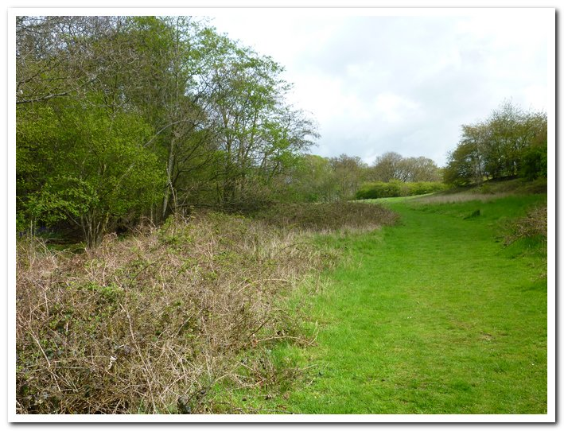
Photo Barnsdale Woods, at the bottom, of the main entrance; note the big Bramble patch on the left of the image! that is the habitat of the Dark Bush Cricket. they love that tangle. © Phil Rudkin

Roesel’s Bush Cricket Roeseliana roeselii
Early instar nymph, one found in the ride of Fox Covert, Manton, 31 May,
SK868042. Stridulating males, four heard in grass verges, Lyndon Village Lane,
31 August, SK909040.

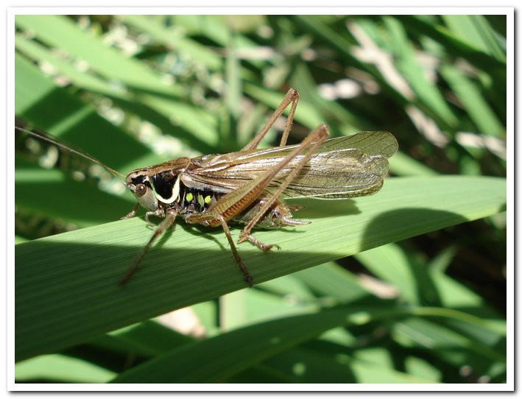

Photo Male Roesel’s Bush Cricket Macropterous form © Phil Rudkin

Long-winged Conehead Conocephalus fuscus
Nymphs observed in Butterfly Meadow, Gibbet Gorse, Lyndon Nature Reserve, Rutland Water, 6 July, SK903059. Adult stridulating males, four located in the Wing Village Allotments, 29 August, SK889028.

Short-winged Conehead Conocephalus dorsalis
As expected, there were no sightings outside the Rutland Water complex. However, Tim Sexton photographed an adult female (macropterous form) in wet vegetation adjacent to Fran’s Pond, Egleton reserve, 9 September, SK882067.

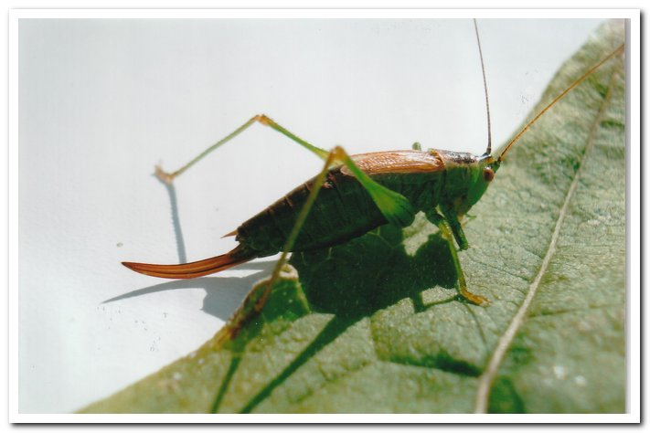

Photo Female Short-winged Conehead © Phil Rudkin

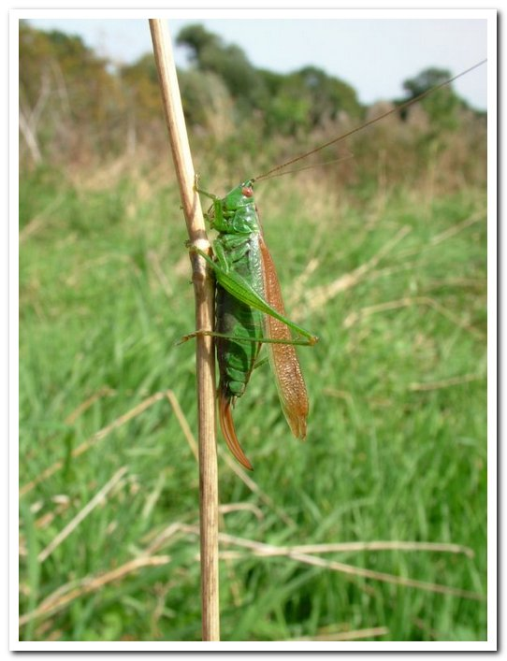

Photo Female Short-winged Conehead Macropterous form © Phil Rudkin

Speckled Bush Cricket Leptophyes punctatissima
An adult was observed in shrubs, Baulk Road, Bisbrooke, 26 June, SK881010.
A male was observed on cornflower, Bridge Street, Langham. 24 August, SK843011. Stridulating males, seven, in hedgerow trees, Lyndon Village Lane, 31 August, SK909040. Stridulating males, eight, in front garden hedges on Middle Street, Wing, 31 August, SK890029. There was a very large colony, circa 80, in a tree-lined avenue, Tinwell, 24 September, SK997069.

Groundhoppers

Slender Groundhopper Tetrix subulata
One adult was observed in Wing Village Allotments, 29 March, SK889028.
Another one was recorded in the Allotments, on 4 October.

Common Groundhopper Tetrix undulata
Adult observed on stones, one, in Wing Village Allotments, 6 September,
31 July. SK889028.

Grasshoppers

Common Green Grasshopper Omocestus viridulus
In July, this species featured in Butterfly Meadow, Gibbet Gorse, Lyndon Nature Reserve, with ten stridulating males located in this rich habitat. SK903059

Field Grasshopper Chorthippus brunneus
The Wing Village Allotments had the usual sightings in July and August, and one adult was photographed in the Bloody Oaks, SSSI reserve, on 15 August, all regular habitats!

Meadow Grasshopper Chorthippus parallelus
There was only one new site for this season, with 14 stridulating males, and one late instar nymph, in the rides of Wardley Wood, Uppingham, on 13 September, SK842002.
Regular sites visited for this widespread and common grasshopper were Bloody Oaks SSSI reserve, Stretton Wood, Wing Village Allotments, and the Protected Verge 7, Great Casterton. Populations at these sites were strong!

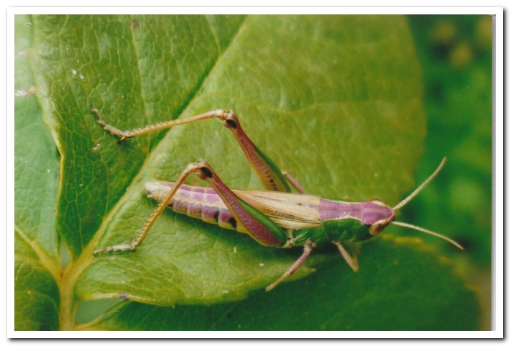

Photo Meadow Grasshopper (Purple variety) ©Phil Rudkin

Lesser Marsh Grasshopper Chorthippus albomarginatus
Only one new site was recorded in 2021: two females, found in the long-grass meadow area of Langham churchyard, 24 September, SK844112. Regular sites visited for this widespread, common grasshopper were Leigh Lodge, Leighfield Fishponds, and Wing Village Allotments.

Rutland Water Nature Reserve

Only one survey was carried out on the Rutland Water Nature Reserve at Egleton reserve, carried out by Tim Sexton between 2 June and 28 September. The species covered were Oak Bush Cricket, Roesel’s Bush Cricket, Long-winged Conehead, Short-winged Conehead, Speckled Bush Cricket, Slender Groundhopper, Common groundhopper, Meadow Grasshopper, Lesser Marsh Grasshopper. I am very grateful to Tim, for sparing time from his busy workload to produce his spreadsheet results.

