Lincolnshire Dormouse Group, a scientific journey.
Sunday 21st October 2018 Chambers Farm Wood, Forestry Commission.
Conditions: Perfect! Warm, clear sky, sunny, calm and dry.
The Hazel Dormouse, Muscardinus avellanarius
I receive Roger Parsons Lincolnshire Web Site weekly: LNU Wildnews Bulletin, and reading the groups section, I found a very important organisation. The Lincs Dormouse Group, who meet at Chambers Farm Wood: April to October, to carry out box checks.
I have a very good naturalist friend, who has asked me for months, about fixing him up with a group, which could take him to observe a Dormouse in the wild.
I contacted the Dormouse officials, and I will take the story from there:

On Sunday morning, 21st October 2018, Philip Langston drove from Oakham, in Rutland, and arrived at my home in Stamford, Lincolnshire, at 7.30am. to pick me up. It was a lovely morning, and the forecast looked good for the day. After a journey of 86 miles (with a few diversions) we duly arrived at the Chambers Farm Wood car park at 9.15am. The Lincs Dormouse group had already assembled outside their office (a shed!) and were deep in conversation; organising the strategy, for their final survey of the 2018 season. They resume survey activities in April 2019!

We were welcomed by Gemma Watkinson, who had been my contact, and is the current Chair of the volunteer group. Eventually, the various survey workers set off in different directions; complete with clip boards and weighing equipment.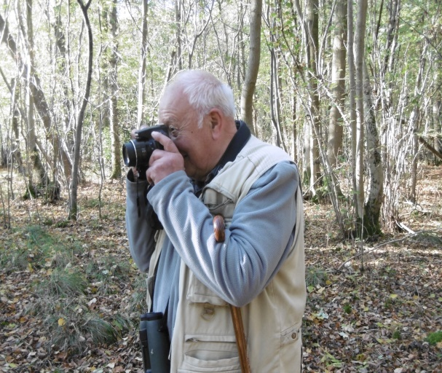

Gemma and her fellow volunteer, Clare Sterling, (both registered Dormouse licence handlers), took Phil and I into a section of this lime wood and coppiced area, for us to observe their skills in monitoring 50 nest boxes.
We were to have four solid hours of a fascinating, and fact finding tour, around the nest boxes, observing these two young ladies carrying out important conservation work for the protection and benefit of the Hazel Dormouse. Furthermore, Gemma and Clare were delighted to show Phil and I what they do, and I list some of the highlights of our morning in this Lincolnshire Lime woods.

On inspecting the nest-boxes, which were head-high (to facilitate checking that the box was inhabited or not): if they were, Clare took the boxes down and placed them in a large, clear bag: holding our breath for the first five boxes, nothing found! So Clare cleaned out any 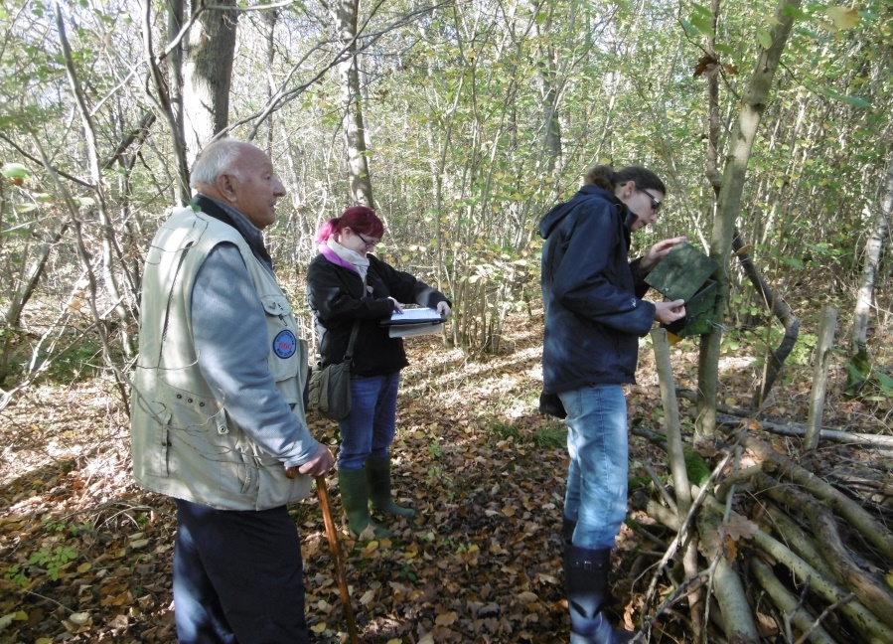debris inside.
It was amazing to note the contents of some of the nest boxes: remains of old tit nests, wasp nests, and one had a female wood mouse , Apodemus sylvaticus, jump out, and live young were found inside; cue for swift action, in replacing the box back in position!
Although Phil Langston was thoroughly enjoying the experience, he was getting a little worried that we were perhaps too late before the mice hibernated for the winter. Gemma had mentioned earlier that there was no guarantee of seeing a Dormouse at this late stage.
But, ‘hey presto’ the girls at last found a total of five individuals, and this included two in one box, ‘ magnificent!
We were then treated to the process of the weighing, and sexing of the creatures, and looking if they were ‘marked’ earlier in the season. Clare wrote copious notes for the data sheets.

I have to make it clear that Phil and I were in the company of licenced Dormouse handlers, and this is the reason we were allowed to hold the ‘sleepy’ rodents in the palm of our hands. This was the ‘icing on the cake’ for both of us; breath taking moments indeed, and very much appreciated! I emphasise that one has to be in the company of the licensed holders,

and that this is at the discretion of the holders. Clare and Gemma were very good to us and willing to give us this opportunity.

As naturalists, I am sure most of you know this: that the nest box holes open inwards towards the tree, but it certainly does not deter hole nesting birds, Wood Mice, Wasps nests, etc. Phil and I were really impressed when we asked about the habitat, and management. The Dormouse group carry out their own habitat management; includes coppicing, by agreement with the Forestry Commission.
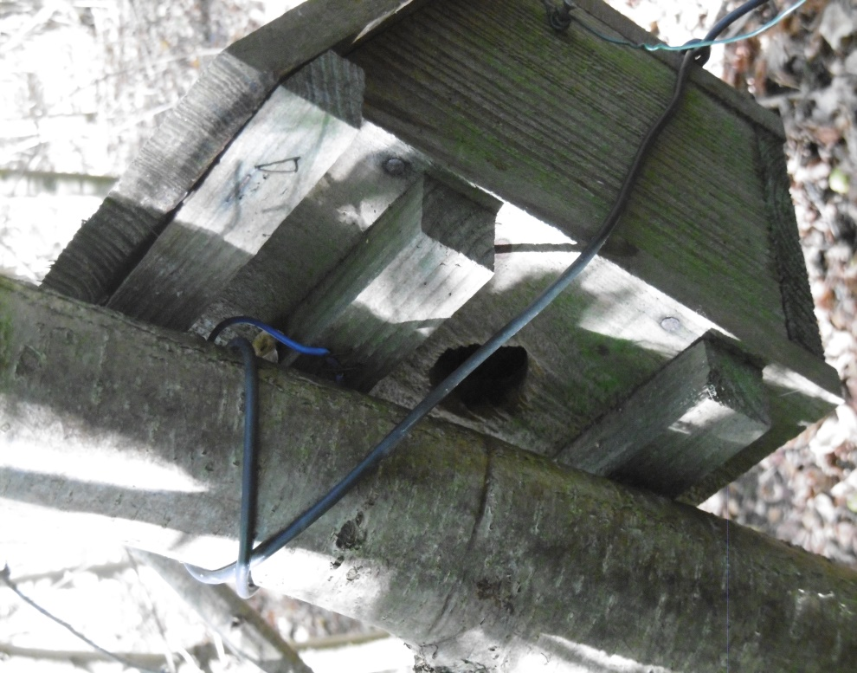

Gemma Watkinson provides the following information: Dormice were considered extinct in Lincolnshire in the 20th Century, though to be due to habitat loss, removal of hedgerows and lack of management in woodland. In 2002 a project was undertaken to reintroduce the species back into the county; coordinated by PTES with local volunteers (including Anne Goodall). The Lincolnshire Dormouse Group was established in 2010, to take over monitoring of the population of reintroduced dormice in Ivy Wood, in Chambers Farm Woods, near Wragby.
Through provisioning of boxes throughout the woodland complex, we know that the population of dormice are thriving, and have spread up to 1.5km from Ivy Wood, and are now found in Minting triangle, and Little Scrubbs Wood, within the Chambers Farm Wood complex. Last year we set up

new monitoring areas within Goslings Corner Wood to establish wether dormice have successfully dispersed into other areas of connected woodland.
All data is submitted to the National Dormouse Monitoring Program; which is coordinated by Peoples Trust for Endangered Species (PTES).

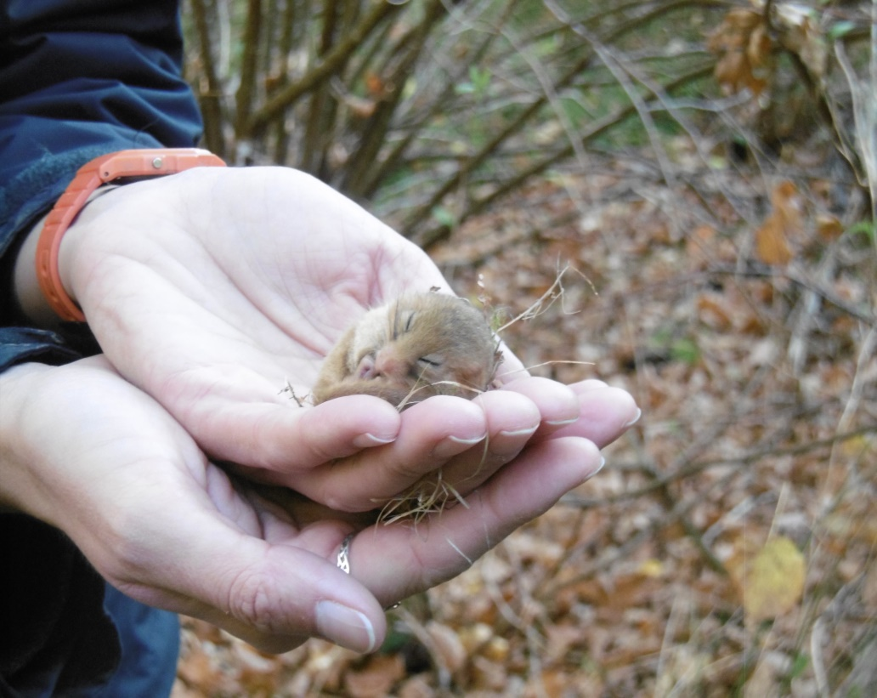

Lincolnshire Dormouse Group Meetings.
The Lincolnshire Dormouse Group meet monthly at: Chambers Farm Woods. We always welcome visitors and new members. Dormice are legally protected and sensitive to disturbance; attending the group’s meetings provides the opportunity to see dormice legally, with licenced surveyors.
If you are interested, please email: lincsdormousegroup@gmail.com

I have the last word: Phil Langston and l learned so much in those four hours, thanks to Gemma and Clare; to whom we are so grateful!

Photographs by: Phil Rudkin.

Philip Rudkin,
Rutland Natural History Society.
3 Nov 2018

