Rutland Natural History Society

Plant Gall Report 2020. Recorder: Roy Lemmon

It was a difficult year due to Covid-19 restrictions but nevertheless some 33 sites in the County were visited, bringing a total of 640 records, including seven which were new to our records. The random nature of these observations makes it difficult to spot trends in local plant galls, but those caused by rusts and mites were more numerous than they were in 2019. There were 26 rust records last year as opposed to 36 this, one of which was a new record; this compared to 34 mites in 2019 and 44 in 2020, including three being new to us.

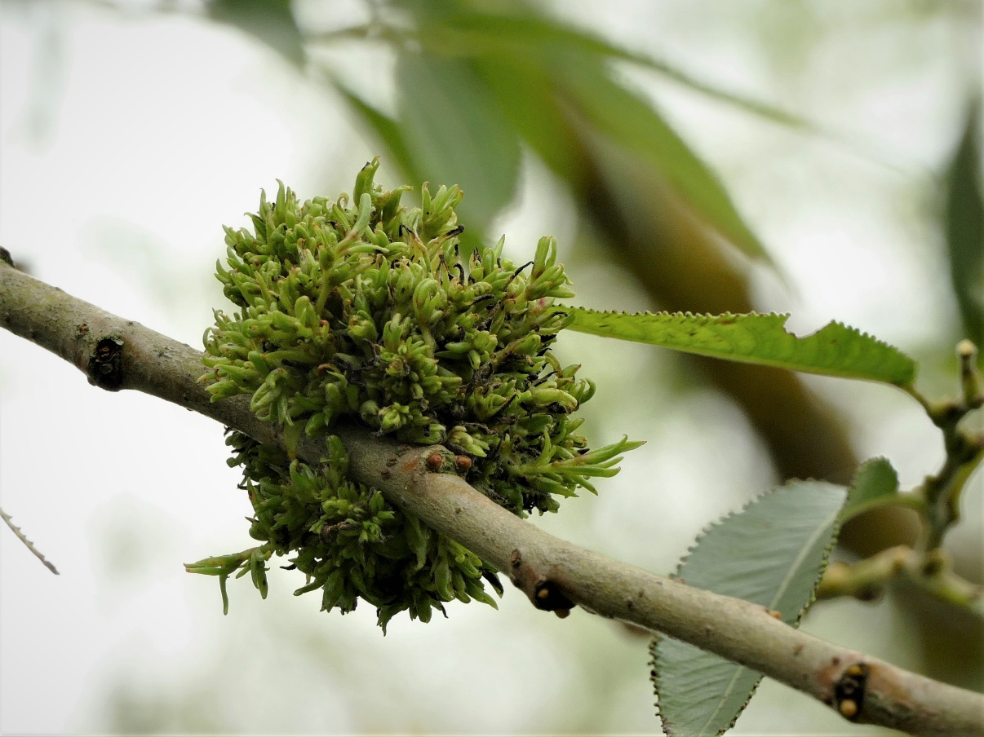

Photo – Carolyn Baxter – Gall on Willow Tree

Galls on Oaks, Quercus sp., are the most numerous on any plant in the UK but of recent years these numbers have been depressed, at least locally. In 2020 we saw an increase of gall numbers per leaf of the common ones such as the spangle galls, in fact they seemed to be as numerous as previously; but the less common ones seemed to be missing, apparently totally.

Thanks are due to the members who have contributed to these findings.

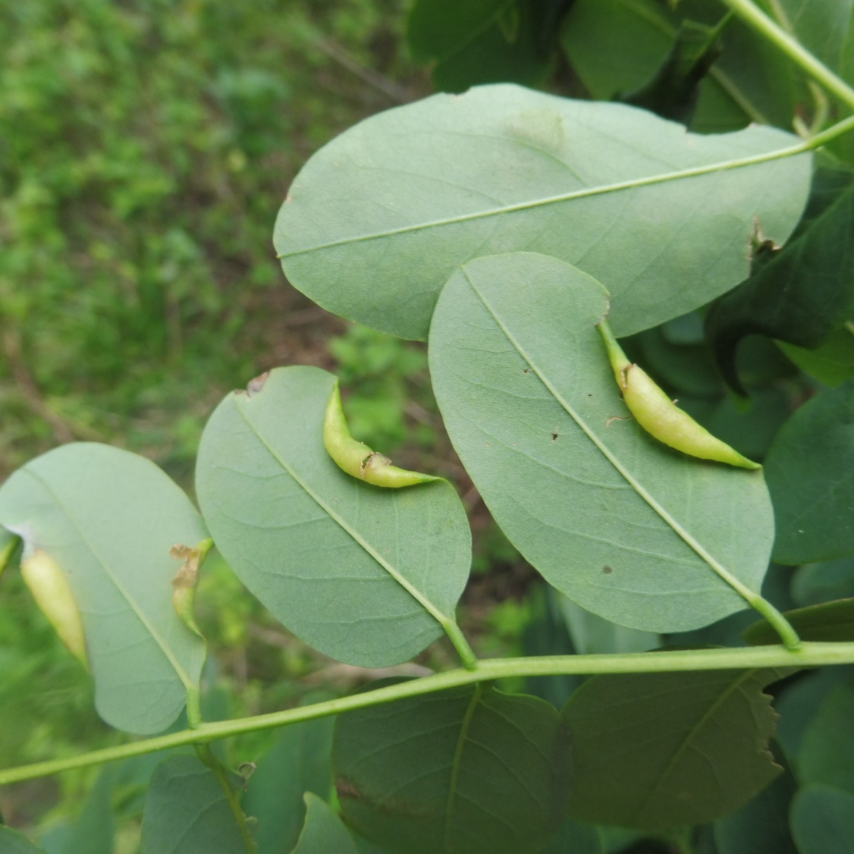

Photo – Martin Grimes - Obolodiplosis robiniae, on Robinia pseudacasia

