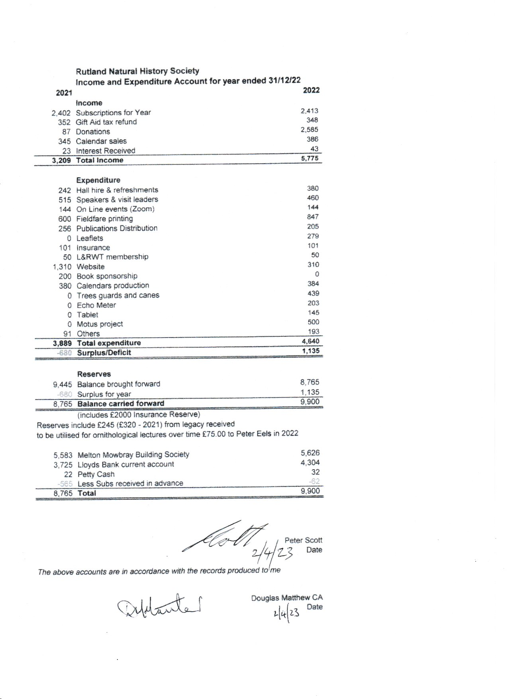

Treasurer’s Report to the AGM March 2023

I would like to say a few words about the workings of the Treasurers role over the last 12 months.
In particular I would like to thank Margaret Conner for her work over the last few years both as treasurer and membership secretary and to thank her for continuing to provide guidance even after her period in office had come to an end as no one had come forward to take on the position.
Secondly, I would like to thank Linda Clark who agreed to be book keeper so that Margaret was able to pass on some of the tasks. Without Linda doing this we would have been in a mess. This was a real challenge for Linda who was also Secretary and a Recorder.
As many of you will be aware due to personal reasons Linda has had to step back from these various roles and we have had to re-allocate them on a temporary basis.
Martin Grimes is looking at the Gift Aid this year and I have taken over the Treasurer role to ensure we had some accounts to present to this AGM.
Unfortunately, I have not had time to have the accounts formerly audited as is best practice but I will get that done retrospectively.
A copy is also on the website. I will also give the secretary a copy of this report to go with the minutes

The following points may be of interest: -
- We still show a healthy balance at the Melton Mowbray Bldg. Soc and at Lloyds Bank
- However, both accounts are old accounts and we cannot add further funds to the Melton Account and we are in the process of updating the |Lloyds account
- The present position has been influenced by two large donations in 2022 of £500 and £2000 without these donations we would not have been able to make the contributions we did without using reserves
- Other income sources remained similar to the previous year
- I would point out that the Expenditure figures may not reflect like for like in the two years
- Website costs are reduced as 2021 included the development of the new site

Peter Scott
Acting Treasurer

